**1. INTRODUCTION**

Nowadays personal data we are digitally producing are scattered in different online systems managed by different providers (e.g., online social media, hospitals, banks, airlines, etc.). In this way, on the one hand users are losing control on their data, whose protection is under the responsibility of the data provider, and, on the other, they cannot fully exploit their data, since each provider keeps a separate view of them. To overcome this scenario, Personal Data Storage (PDS) has inaugurated a substantial change to the way people can store and control their personal data, by moving from a service-centric to a user-centric model. PDSs enable individuals to collect into a single logical vault personal information they are producing. Such data can then be connected and exploited by proper analytical tools, as well as shared with third parties under the control of end users. This view is also enabled by recent developments in privacy legislation and, in particular, by the new EU General Data Protection Regulation (GDPR), whose art. 20 states the right to data portability, according to which the data subject shall have the right to receive the personal data concerning him or her, which he or she has provided to a controller, in a structured, commonly used and machine-readable format, thus making possible data collection into a PDS.

Up to now, most of the research on PDS has focused on how to enforce user privacy preferences and how to secure data when stored into the PDS. In contrast, the key issue of helping users to specify their privacy preferences on PDS data has not been so far deeply investigated. This is a fundamental issue since average PDS users are not skilled enough to understand how to translate their privacy requirements into a set of privacy preferences. As several studies have shown, average users might have difficulties in properly setting potentially complex privacy preferences. For example, let us consider facebook privacy setting, where users need to configure the options manually according to their desire. In authors survey users awareness, attitudes and privacy concerns on profile information and find that only a small number of users change the default privacy preferences on Facebook. Interestingly, in authors find that even when users have changed their default privacy settings, the modified settings do not match the expectations (these are reached only for 39% of users). Moreover, another survey in has shown that Facebook users are not aware enough on protection tools that designed to protect their personal data. According to their study the majority (about 88%) of users had never read the Facebook privacy policy.

To help users on protecting their PDS data, in we have evaluated the use of different semi-supervised machine learning approaches for learning privacy preferences of PDS owners. The idea is to find a learning algorithm that, after a training period by the PDS owner, returns a classifier able to automatically decide if access requests submitted by third parties are to be authorized or denied. In we have shown that, among different semi-supervised learning approaches, the one that better fits the considered scenario is ensemble learning.

Even though the identification of the learning approach is an essential step, the design of a Privacy-aware Personal Data Storage (P-PDS), that is, a PDS able to automatically take privacy-aware decisions on third parties access requests requires further investigation. One critical aspect to consider is the usability of the system. Even if semi-supervised techniques require less users effort, compared to manually setting privacy preferences, they still require many interactions with PDS owners to collect a good training dataset.

To further reduce the required user effort, in the current paper, we leverage on active learning (AL) to minimize user burden for getting the training dataset by, at the same time, achieving better accuracy in determining user privacy preferences. The main idea of active learning is to select from the training dataset the most representative instances to be labeled by users. Literature offers several methods driving the selection of these new instances. The most commonly adopted method is uncertainty sampling. According to this approach, to be labeled by human annotators, active learning selects those instances for which it is highly uncertain how to label them according to the preliminary built model. As reported in Section 6, this improvement brings benefits in term of accuracy and usability. Additionally, to further improve the performance of the system, we define an alternative uncertainty sampling strategy, which is based on the observation that, for taking a privacy-related decision, some fields of access requests (i.e., data consumer and type of service requesting the data) are more informative than others. Thus, if a new access request presents new values for these fields, the system pushes for a new training (i.e., asking data owner a label for the access request). To enforce this behavior, we introduce a penalization of the uncertainty measure based on the distance of the new access request w.r.t. the access requests previously labeled by the P-PDS owner (we call this strategy history-based active learning).

As it will show in the experiments, history-based active learning shows better results than AL in terms of users satisfaction. As a further improvement, in this paper, we propose a revised version of the ensemble learning algorithm proposed into enforce a more conservative approach w.r.t. users privacy. In particular, we reconsider how ensemble learning handles decisions for access requests for which classifiers return conflicting classes. In general, the final decision is taken selecting the class with the highest aggregated probabilities. However, this presents the limit of not considering user perspective, in that, it does not take into account which classifier is more relevant for the considered user. To cope with this issue, we propose an alternative strategy for aggregating the class labels returned by the classifiers. According to this approach, we assign a personalized weight to each single classifier used in ensemble learning. Experiments show that this approach increases users satisfaction as well as the learning effectiveness.

**1.1 EXISTING SYSTEM:**

Oort is a user-centric cloud storage system that organizes data by users rather than applications, considering global queries which find and combine relevant data fields from relevant users. Moreover, it allows users to choose which applications can access their own data, and which types of data to be shared with which users. Sieve allows user to upload encrypted data to a single cloud storage. It utilizes key-homomorphic scheme to provide cryptographically enforced access control.

Amber has proposed an architecture where users can choose applications to manipulate their data but it does not mention either how the global queries work or how the application providers interact with. In authors developed a user-centric framework that share with third parity only the answers to a query instead of the raw data. have proposed a trusted platform called Databox, which can manage personal data by a fine grained access control mechanism but do not focus on policy learning. Recently, proposed a Block chain-based Personal Data Store (BC-PDS) framework, which leverages on BlockChain to secure the storage of personal data. However, all the above proposals focus on access control enforcement, whereas they do not consider user preference or policy learning.

Privacy preference enforcement have been also investigated in different domains, such as for instance social networks where most of the platforms offer users a privacy setting page to manually set their privacy preferences. Research works have tried to alleviate the burden of this setting, by exploiting machine learning tools. For instance, have investigated the use of semi-supervised and unsupervised approaches to automatically extract privacy settings in social media. In authors have considered location based data. They have compared the accuracy of manually set privacy preferences with the one of an automated mechanism based on machine learning. The results show that machine learning approaches provide better result than user-defined policies. also present a privacy preference framework that (semi)automatically predicts sharing decision, based on personal and contextual features. The authors focus only on g location information.

**DISADVANTAGES**

* In the existing work, the system doesn't have strong techniques to implement Privacy-aware Personal Data Storage (P-PDS).
* The system doesn't have active learning which is to select from the training dataset the most representative instances to be labeled by users.

**1.2 PROPOSED SYSTEM:**

The system proposes a revised version of the ensemble learning algorithm proposed into enforce a more conservative approach w.r.t. users privacy. In particular, we reconsider how ensemble learning handles decisions for access requests for which classifiers return conflicting classes. In general, the final decision is taken selecting the class with the highest aggregated probabilities. However, this presents the limit of not considering user perspective, in that, it does not take into account which classifier is more relevant for the considered user.

To cope with this issue, we propose an alternative strategy for aggregating the class labels returned by the classifiers. According to this approach, we assign a personalized weight to each single classifier used in ensemble learning. We also show how it is possible to learn these weights from the training dataset, thus without the need of further input from the P-PDS owner. Experiments show that this approach increases users satisfaction as well as the learning effectiveness.

**ADVANTAGES**

* PDS able to automatically take privacy-aware decisions on third parties access requests requires further investigation.
* The system proposes a revised version of the ensemble learning algorithm proposed in this system, to enforce a more conservative approach with respect to users privacy.

**2.LITERATURE SURVEY**

**1. LEARNING PRIVACY HABITS OF PDS OWNERS**

**AUTHORS:** Bikash Chandra Singh DiSTA

The concept of Personal Data Storage (PDS) has recently emerged as an alternative and innovative way of managing personal data w.r.t. the service-centric one commonly used today. The PDS offers a unique logical repository, allowing individuals to collect, store, and give access to their data to third parties. The research on PDS has so far mainly focused on the enforcement mechanisms, that is, on how user privacy preferences can be enforced. In contrast, the fundamental issue of preference specification has been so far not deeply investigated. In this paper, we do a step in this direction by proposing different learning algorithms that allow a fine-grained learning of the privacy aptitudes of PDS owners. The learned models are then used to answer third party access requests. The extensive experiments we have performed show the effectiveness of the proposed approach.

**2. A RISK-BENEFIT DRIVEN ARCHITECTURE FOR PERSONAL DATA RELEASE (INVITED PAPER)**

**AUTHORS:** B. C. Singh, B. Carminati, E. Ferrari

Personal data storages (PDSs) give individuals the ability to store their personal data in a data unified repository and control release of their data-to-data consumers. Being able to gather personal data from different data sources (e.g., banks, hospitals), PDSs will play strategic role in individual privacy management. As such, PDS demands for new privacy models for protecting personal data. In this paper, we propose a new technical approach that empowers individuals to better control data in PDS. Particularly, we present a privacy-aware PDS architecture by focusing on two logical data zones based on the categories of personal data. Moreover, we propose a strategy for regulating personal data release that takes in consideration both user preferences and possible risks and benefits of the data release.

**3. A STUDY OF PRIVACY SETTINGS ERRORS IN AN ONLINE SOCIAL NETWORK**

**AUTHORS:** Michelle Madejski, Maritza Johnson.

Access control policies are notoriously difficult to configure correctly, even people who are professionally trained system administrators experience difficulty with the task. With the increasing popularity of online social networks (OSN) users of all levels are sharing an unprecedented amount of personal information on the Internet. Most OSNs give users the ability to specify what they share with whom, but the difficulty of the task raises the question of whether users' privacy settings match their sharing intentions. We present the results of a study that measures sharing intentions to identify potential violations in users' real Facebook privacy settings. Our results indicate a serious mismatch between intentions and reality: every one of the 65 participants in our study had at least one confirmed sharing violation. In other words, OSN users are unable to correctly manage their privacy settings. Furthermore, a majority of users cannot or will not fix such errors.

**4. PRIVACY SETTINGS RECOMMENDER FOR ONLINE SOCIAL NETWORK**

**AUTHORS:** Davide Alberto Albertini, Barbara Carminati.

In recent years Relationship Based Access Control (ReBAC) has become the reference paradigm for controlled information sharing in Online Social Network (OSN) scenarios. Nevertheless, many of the most popular OSN providers do not implement in their platforms an access control model fully compliant with ReBAC. This fact, thus, limits the capability of OSN users to define customized and fine-grained access control policies. Moreover, average users might have difficulties in properly setting, potentially, complex access control policies. As results, many users give up in defining proper privacy setting, simply accepting the default setting proposed by OSN provider. To cope with this problem, we see the need of tools in support of policy specification. At this aim, in this paper we present a recommendation system that, exploiting an association rules mining process, learns OSN users' habits in releasing resources in online social networks, and exploit them to suggest customized access control policies. We also prove the feasibility of the presented techniques by illustrating an experiment which has been conducted on 30 human users by building customized access control policies from the data learnt from each of them.

**5. A STREAM-BASED SEMI-SUPERVISED ACTIVE LEARNING APPROACH FOR DOCUMENT CLASSIFICATION**

**AUTHORS:** Mohamed-Rafik Bouguelia, Yolande Belaid.

We consider an industrial context where we deal with a stream of unlabelled documents that become available progressively over time. Based on an adaptive incremental neural gas algorithm (AING), we propose a new stream-based semi supervised active learning method (A2ING) for document classification, which is able to actively query (from a human annotator) the class-labels of documents that are most informative for learning, according to an uncertainty measure. The method maintains a model as a dynamically evolving graph topology of labelled document-representatives that we call neurons. Experiments on different real datasets show that the proposed method requires on average only 36.3% of the incoming documents to be labelled, in order to learn a model which achieves an average gain of 2.15-3.22% in precision, compared to the traditional supervised learning with fully labelled training documents.

**2.1 PRELIMINARY INVESTIGATION**

The first and foremost strategy for development of a project starts from the thought of designing a mail enabled platform for a small firm in which it is easy and convenient of sending and receiving messages, there is a search engine, address book and also including some entertaining games. When it is approved by the organization and our project guide the first activity, ie. preliminary investigation begins. The activity has three parts:

* Request Clarification
* Feasibility Study
* Request Approval

**2.1.1 REQUEST CLARIFICATION**

After the approval of the request to the organization and project guide, with an investigation being considered, the project request must be examined to determine precisely what the system requires. Here our project is basically meant for users within the company whose systems can be interconnected by the Local Area Network (LAN). In today’s busy schedule man need everything should be provided in a readymade manner. So taking into consideration of the vastly use of the net in day to day life, the corresponding development of the portal came into existence.

**2.1.2 FEASIBILITY STUDY**

An important outcome of preliminary investigation is the determination that the system request is feasible. This is possible only if it is feasible within limited resource and time. The different feasibilities that have to be analyzed are

* Operational Feasibility
* Economic Feasibility
* Technical Feasibility

###### OPERATIONAL FEASIBILITY

Operational Feasibility deals with the study of prospects of the system to be developed. This system operationally eliminates all the tensions of the admin and helps him in effectively tracking the project progress. This kind of automation will surely reduce the time and energy, which previously consumed in manual work. Based on the study, the system is proved to be operationally feasible.

**ECONOMIC FEASIBILITY**

Economic Feasibility or Cost-benefit is an assessment of the economic justification for a computer based project. As hardware was installed from the beginning & for lots of purposes thus the cost on project of hardware is low. Since the system is a network based, any number of employees connected to the LAN within that organization can use this tool from at anytime. The Virtual Private Network is to be developed using the existing resources of the organization. So the project is economically feasible.

###### TECHNICAL FEASIBILITY

According to Roger S. Pressman, Technical Feasibility is the assessment of the technical resources of the organization. The organization needs IBM compatible machines with a graphical web browser connected to the Internet and Intranet. The system is developed for platform Independent environment. Java Server Pages, JavaScript, HTML, SQL server and WebLogic Server are used to develop the system. The system is technically feasible for development and can be developed with the existing facility.

**2.1.3 REQUEST APPROVAL**

Not all request projects are desirable or feasible. Some organization receives so many project requests from client users that only few of them are pursued. However, those projects that are both feasible and desirable should be put into schedule. After a project request is approved, it cost, priority, completion time and personnel requirement is estimated and used to determine where to add it to any project list. Truly speaking, the approval of those above factors, development works can be launched.

**3.SYSTEM DESIGN**

**3.1** **SYSTEM ARCHITECTURE**

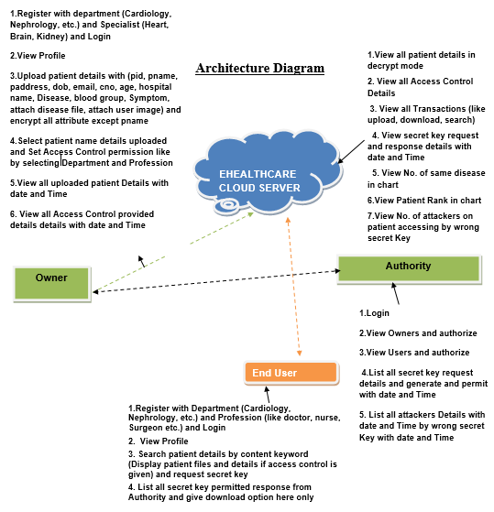

**FIG 1: SYSTEM ARCHITECTURE**

**3.2 MODULES**

* Data Owner
* Ehealthcare Cloud Server
* Authority
* End User

**DATA OWNER**

In this module, Data owner has to register to cloud and logs in, Encrypts and uploads a file to cloud server and also performs the following operations such as Register with department(Cardiology, Nephrology, etc.) and Specialist(Heart, Brain, Kidney) and Login and View Profile, Upload patient details with(pid, pname, paddress, dob, email, cno, age, hospital name, Disease, blood group, Symptom, attach disease file, attach user image) and encrypt all attribute except pname ,Select patient name details uploaded and Set Access Control permission like by selecting Department and Profession and View all uploaded patient Details with date and Time ,View all Access Control provided details with date and Time.

**EHEALTHCARE CLOUD SERVER**

In this module the cloud will authorize both the owner and the user and also performs the following operations such as View all patient details in decrypt mode and View all Access Control Details, View all Transactions (like upload, download, search) and View secret key request and response details with date and Time View No. of same disease in chart, View Patient Rank in chart and View No. of attackers on patient accessing by wrong secret key.

**AUTHORITY**

In this module, the Authority performs the following operations such as Login, view Owners and authorize and View Users and authorize, list all secret key request details and generate and permit with date and Time and List all attackers Details with date and Time by wrong secret Key with date and Time.

**END USER**

In this module, the user has to register to cloud and log in and performs the following operations such as Register with Department (Cardiology, Nephrology, etc.) and Profession (like doctor, nurse, Surgeon etc.) and Login, View Profile and Search patient details by content keyword (Display patient files and details if access control is given) and request secret key and list all secret key permitted response from Authority and give download option here only.

**3.3 DATA FLOW DIAGRAM**

1. The DFD is also called as bubble chart. It is a simple graphical formalism that can be used to represent a system in terms of input data to the system, various processing carried out on this data, and the output data is generated by this system.
2. The data flow diagram (DFD) is one of the most important modeling tools. It is used to model the system components. These components are the system process, the data used by the process, an external entity that interacts with the system and the information flows in the system.
3. DFD shows how the information moves through the system and how it is modified by a series of transformations. It is a graphical technique that depicts information flow and the transformations that are applied as data moves from input to output.
4. DFD is also known as bubble chart. A DFD may be used to represent a system at any level of abstraction. DFD may be partitioned into levels that represent increasing information flow and functional detail.

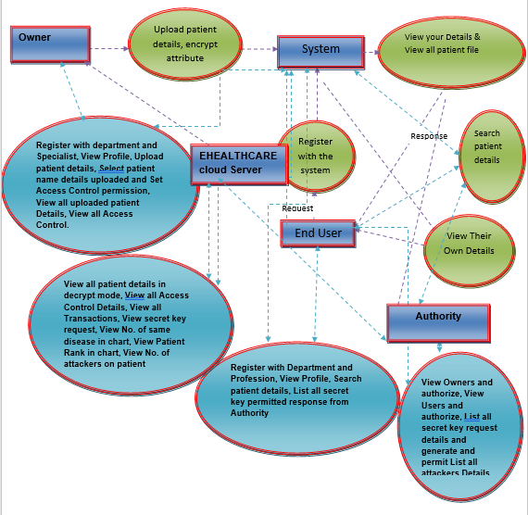

**FIG 2: DATAFLOW DIAGRAM**

**3.4 UNIFIED MODELING LANGUAGE**

UML stands for Unified Modeling Language. UML is a standardized general-purpose modeling language in the field of object-oriented software engineering. The standard is managed, and was created by, the Object Management Group.

The goal is for UML to become a common language for creating models of object-oriented computer software. In its current form UML is comprised of two major components: a Meta-model and a notation. In the future, some form of method or process may also be added to; or associated with, UML. The Unified Modeling Language is a standard language for specifying, Visualization, Constructing and documenting the artifacts of software system, as well as for business modeling and other non-software systems.

The UML represents a collection of best engineering practices that have proven successful in the modeling of large and complex systems.

The UML is a very important part of developing objects-oriented software and the software development process. The UML uses mostly graphical notations to express the design of software projects.

**GOALS:**

The Primary goals in the design of the UML are as follows:

1. Provide users a ready-to-use, expressive visual modeling Language so that they can develop and exchange meaningful models.
2. Provide extendibility and specialization mechanisms to extend the core concepts.
3. Be independent of particular programming languages and development process.
4. Provide a formal basis for understanding the modeling language.
5. Encourage the growth of OO tools market.
6. Support higher level development concepts such as collaborations, frameworks, patterns and components.
7. Integrate best practices.

**3.4.1 USE CASE DIAGRAM**

A use case diagram in the Unified Modeling Language (UML) is a type of behavioral diagram defined by and created from a Use-case analysis. Its purpose is to present a graphical overview of the functionality provided by a system in terms of actors, their goals (represented as use cases), and any dependencies between those use cases. The main purpose of a use case diagram is to show what system functions are performed for which actor. Roles of the actors in the system can be depicted.

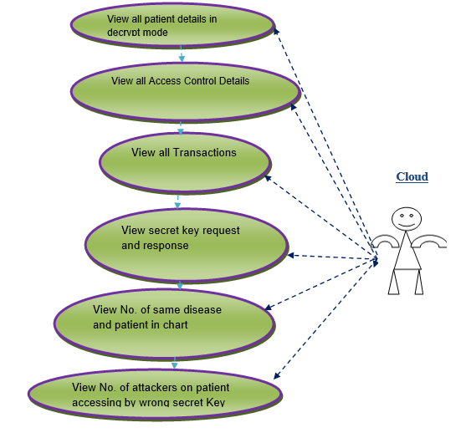

**FIG 3: USECASE CLOUD DIAGRAM**

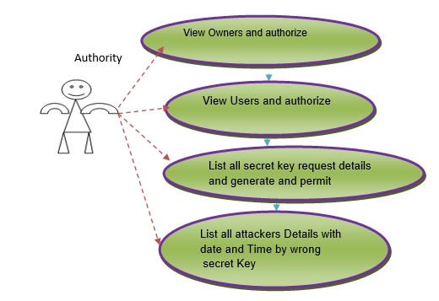

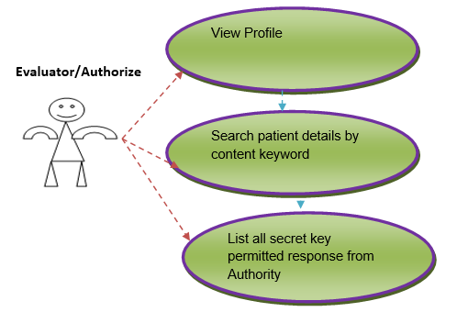

**FIG 4: USECASE AUTHORITY DIAGRAM**

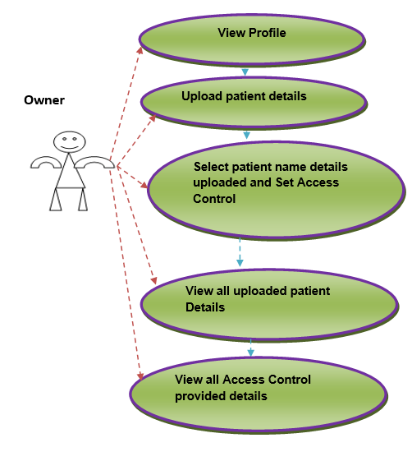

**FIG 5: USECASE OWNER DIAGRAM**

**3.4.2 SEQUENCE DIAGRAM**

A sequence diagram in Unified Modeling Language (UML) is a kind of interaction diagram that shows how processes operate with one another and in what order. It is a construct of a Message Sequence Chart. Sequence diagrams are sometimes called event diagrams, event scenarios, and timing diagrams.

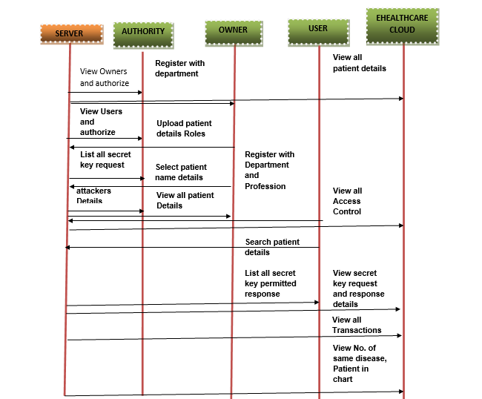

**FIG 6: SEQUENCE DIAGRAM**

**3.4.3 CLASS DIAGRAM**

In software engineering, a class diagram in the Unified Modeling Language (UML) is a type of static structure diagram that describes the structure of a system by showing the system's classes, their attributes, operations (or methods), and the relationships among the classes. It explains which class contains information.

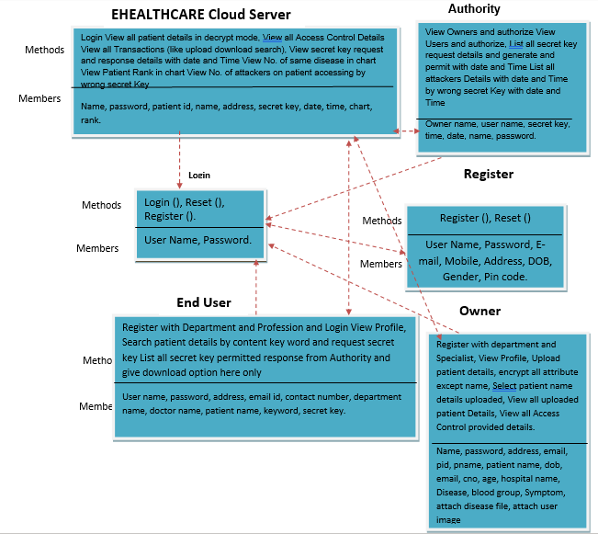

**FIG 7: CLASS DIAGRAM**

**3.5 SYSTEM REQUIRMENTS**

**3.5.1 HARDWARE REQUIREMENTS:**

* Processor - Pentium –IV
* RAM - 4 GB (min)
* Hard Disk - 20 GB
* Key Board - Standard Windows Keyboard
* Mouse - Two or Three Button Mouse
* Monitor - SVGA

**3.5.2 SOFTWARE REQUIREMENTS:**

* Operating System - Windows
* Coding Language - Java/J2EE(JSP,Servlet)
* Front End - J2EE
* Backend - MySQL

**4. IMPLEMENTATION**

Implementation is a realization of a technical specification or algorithm as a program, software component, or other computer system through computer programming and deployment. Many implementations may exit for a given specification or standard.

**4.1 SOFTWARE ENVIRONMENT**

Java technology is both a programming language and a platform.

### THE JAVA PROGRAMMING LANGUAGE:

### The Java programming language is a high-level language that can be characterized by all of the following buzzwords:

* + - Simple
    - Architecture neutral
    - Object oriented
    - Portable
    - Distributed
    - High performance
    - Interpreted
    - Multithreaded
    - Robust
    - Dynamic
    - Secure

With most programming languages, you either compile or interpret a program so that you can run it on your computer. The Java programming language is unusual in that a program is both compiled and interpreted. With the compiler, first you translate a program into an intermediate language called Java byte codes the platform-independent codes interpreted by the interpreter on the Java platform. The interpreter parses and runs each Java byte code instruction on the computer. Compilation happens just once; interpretation occurs each time the program is executed. The following figure illustrates how this works.

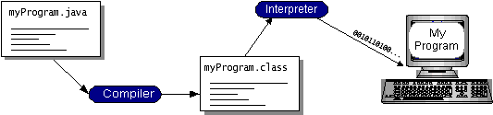

**FIG 8: WORKING OF JAVA**

You can think of Java byte codes as the machine code instructions for the Java Virtual Machine (Java VM). Every Java interpreter, whether it’s a development tool or a Web browser that can run applets, is an implementation of the Java VM. Java byte codes help make “write once, run anywhere” possible.

You can compile your program into byte codes on any platform that has a Java compiler. The byte codes can then be run on any implementation of the Java VM. That means that as long as a computer has a Java VM, the same program written in the Java programming language can run on Windows 2000, a Solaris workstation, or on an iMac.

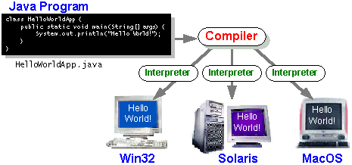

### FIG 9: JAVA COMPLIER

### THE JAVA PLATFORM

Aplatform is the hardware or software environment in which a program runs. We’ve already mentioned some of the most popular platforms like Windows 2000, Linux, Solaris, and MacOS. Most platforms can be described as a combination of the operating system and hardware. The Java platform differs from most other platforms in that it’s a software-only platform that runs on top of other hardware-based platforms.

The Java platform has two components:

* The Java Virtual Machine (Java VM)
* TheJava Application Programming Interface(Java API)

You’ve already been introduced to the Java VM. It’s the base for the Java platform and is ported onto various hardware-based platforms.

The Java API is a large collection of ready-made software components that provide many useful capabilities, such as graphical user interface (GUI) widgets. The Java API is grouped into libraries of related classes and interfaces; these libraries are known aspackages*.* The next section, What Can Java Technology Do Highlights what functionality some of the packages in the Java API provide.

The following figure depicts a program that’s running on the Java platform. As the figure shows, the Java API and the virtual machine insulate the program from the hardware.

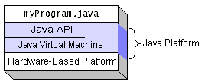

**FIG 10: JAVA PLATFORM**

Native code is code that after you compile it, the compiled code runs on a specific hardware platform. As a platform-independent environment, the Java platform can be a bit slower than native code. However, smart compilers, well-tuned interpreters, and just-in-time byte code compilers can bring performance close to that of native code without threatening portability. The most common types of programs written in the Java programming language are applets and applications. If you’ve surfed the Web, you’re probably already familiar with applets. An applet is a program that adheres to certain conventions that allow it to run within a Java-enabled browser.

However, the Java programming language is not just for writing cute, entertaining applets for the Web. The general-purpose, high-level Java programming language is also a powerful software platform. Using the generous API, you can write many types of programs.

An application is a standalone program that runs directly on the Java platform. A special kind of application known as a server serves and supports clients on a network. Examples of servers are Web servers, proxy servers, mail servers, and print servers. Another specialized program is a servlet. A servlet can almost be thought of as an applet that runs on the server side. Java Servlets are a popular choice for building interactive web applications, replacing the use of CGI scripts. Servlets are similar to applets in that they are runtime extensions of applications. Instead of working in browsers, though, servlets run within Java Web servers, configuring or tailoring the server.

How does the API support all these kinds of programs. It does so with packages of software components that provides a wide range of functionality. Every full implementation of the Java platform gives you the following features:

* **THE ESSENTIALS**: Objects, strings, threads, numbers, input and output, data structures, system properties, date and time, and so on.
* **APPLETS**: The set of conventions used by applets.
* **NETWORKING**: URLs, TCP (Transmission Control Protocol), UDP (User Data gram Protocol) sockets, and IP (Internet Protocol) addresses.
* **INTERNATIONALIZATION**: Help for writing programs that can be localized for users worldwide. Programs can automatically adapt to specific locales and be displayed in the appropriate language.
* **SECURITY**: Both low level and high level, including electronic signatures, public and private key management, access control, and certificates.
* **SOFTWARE COMPONENTS**: Known as JavaBeansTM, can plug into existing component architectures.
* **OBJECT SERIALIZATION**: Allows lightweight persistence and communication via Remote Method Invocation (RMI).
* **JAVA DATABASE CONNECTIVITY (JDBCTM)**: Provides uniform access to a wide range of relational databases.

The Java platform also has APIs for 2D and 3D graphics, accessibility, servers, collaboration, telephony, speech, animation, and more. The following figure depicts what is included in the Java 2 SDK.

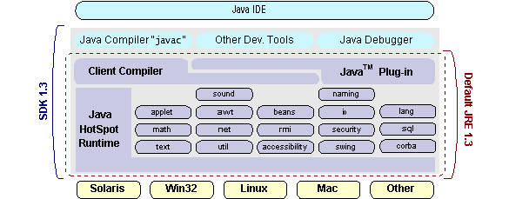

**FIG 11: JAVA PLATFORM 2D AND 3D GRAPHICS**

We can’t promise you fame, fortune, or even a job if you learn the Java programming language. Still, it is likely to make your programs better and requires less effort than other languages. We believe that Java technology will help you do the following:

* **GET STARTED QUICKLY**: Although the Java programming language is a powerful object-oriented language, it’s easy to learn, especially for programmers already familiar with C or C++.
* **WRITE LESS CODE**: Comparisons of program metrics (class counts, method counts, and so on) suggest that a program written in the Java programming language can be four times smaller than the same program in C++.
* **WRITE BETTER CODE**: The Java programming language encourages good coding practices, and its garbage collection helps you avoid memory leaks. Its object orientation, its JavaBeans component architecture, and its wide-ranging, easily extendible API let you reuse other people’s tested code and introduce fewer bugs.
* **DEVELOP PROGRAMS MORE QUICKLY**: Your development time may be as much as twice as fast versus writing the same program in C++. You write fewer lines of code and it is a simpler programming language than C++.
* **AVOID PLATFORM DEPENDENCIES WITH 100% PURE JAVA**: You can keep your program portable by avoiding the use of libraries written in other languages. The 100% Pure JavaTM Product Certification Program has a repository of historical process manuals, white papers, brochures, and similar materials online.
* **WRITE ONCE, RUN ANYWHERE**: Because 100% Pure Java programs are compiled into machine-independent byte codes, they run consistently on any Java platform.
* **DISTRIBUTE SOFTWARE MORE EASILY**: You can upgrade applets easily from a central server. Applets take advantage of the feature of allowing new classes to be loaded “on the fly,” without recompiling the entire program.

### OPEN DATABASE CONNECTIVITY

Microsoft Open Database Connectivity (ODBC) is a standard programming interface for application developers and database systems providers. Before ODBC became a de facto standard for Windows programs to interface with database systems, programmers had to use proprietary languages for each database they wanted to connect to. Now, ODBC has made the choice of the database system almost irrelevant from a coding perspective, which is as it should be. Application developers have much more important things to worry about than the syntax that is needed to port their program from one database to another when business needs suddenly change.

Through the ODBC Administrator in Control Panel, you can specify the particular database that is associated with a data source that an ODBC application program is written to use. Think of an ODBC data source as a door with a name on it. Each door will lead you to a particular database. For example, the data source named Sales Figures might be a SQL Server database, whereas the Accounts Payable data source could refer to an Access database. The physical database referred to by a data source can reside anywhere on the LAN.

The ODBC system files are not installed on your system by Windows 95. Rather, they are installed when you setup a separate database application, such as SQL Server Client or Visual Basic 4.0. When the ODBC icon is installed in Control Panel, it uses a file called ODBCINST.DLL. It is also possible to administer your ODBC data sources through a stand-alone program called ODBCADM.EXE. There is a 16-bit and a 32-bit version of this program and each maintains a separate list of ODBC data sources.

From a programming perspective, the beauty of ODBC is that the application can be written to use the same set of function calls to interface with any data source, regardless of the database vendor. The source code of the application doesn’t change whether it talks to Oracle or SQL Server. We only mention these two as an example. There are ODBC drivers available for several dozen popular database systems. Even Excel spreadsheets and plain text files can be turned into data sources. The operating system uses the Registry information written by ODBC Administrator to determine which low-level ODBC drivers are needed to talk to the data source (such as the interface to Oracle or SQL Server). The loading of the ODBC drivers is transparent to the ODBC application program. In a client/server environment, the ODBC API even handles many of the network issues for the application programmer.

The advantages of this scheme are so numerous that you are probably thinking there must be some catch. The only disadvantage of ODBC is that it isn’t as efficient as talking directly to the native database interface. ODBC has had many detractors make the charge that it is too slow. Microsoft has always claimed that the critical factor in performance is the quality of the driver software that is used. In our humble opinion, this is true. The availability of good ODBC drivers has improved a great deal recently. And anyway, the criticism about performance is somewhat analogous to those who said that compilers would never match the speed of pure assembly language. Maybe not, but the compiler (or ODBC) gives you the opportunity to write cleaner programs, which means you finish sooner. Meanwhile, computers get faster every year.

**JAVA DATABASE CONNECTIVITY**

In an effort to set an independent database standard API for Java; Sun Microsystems developed Java Database Connectivity, or JDBC. JDBC offers a generic SQL database access mechanism that provides a consistent interface to a variety of RDBMSs. This consistent interface is achieved through the use of “plug-in” database connectivity modules, or drivers. If a database vendor wishes to have JDBC support, he or she must provide the driver for each platform that the database and Java run on.

To gain a wider acceptance of JDBC, Sun based JDBC’s framework on ODBC. As you discovered earlier in this chapter, ODBC has widespread support on a variety of platforms. Basing JDBC on ODBC will allow vendors to bring JDBC drivers to market much faster than developing a completely new connectivity solution.

JDBC was announced in March of 1996. It was released for a 90 day public review that ended June 8, 1996. Because of user input, the final JDBC v1.0 specification was released soon after. The remainder of this section will cover enough information about JDBC for you to know what it is about and how to use it effectively. This is by no means a complete overview of JDBC.

### JDBC GOALS

Few software packages are designed without goals in mind. JDBC is one that, because of its many goals, drove the development of the API. These goals, in conjunction with early reviewer feedback, have finalized the JDBC class library into a solid framework for building database applications in Java.

The goals that were set for JDBC are important. They will give you some insight as to why certain classes and functionalities behave the way they do.

The eight design goals for JDBC are as follows:

**1. SQL LEVEL API**

The designers felt that their main goal was to define a SQL interface for Java. Although not the lowest database interface level possible, it is at a low enough level for higher-level tools and APIs to be created. Conversely, it is at a high enough level for application programmers to use it confidently. Attaining this goal allows for future tool vendors to “generate” JDBC code and to hide many of JDBC’s complexities from the end user.

**2**.**SQL CONFORMANCE**

SQL syntax varies as you move from database vendor to database vendor. In an effort to support a wide variety of vendors, JDBC will allow any query statement to be passed through it to the underlying database driver. This allows the connectivity module to handle non-standard functionality in a manner that is suitable for its users.

**3.JDBC MUST BE IMPLEMENTAL ON TOP OF COMMON DATABASE INTERFACES**

The JDBC SQL API must “sit” on top of other common SQL level APIs. This goal allows JDBC to use existing ODBC level drivers by the use of a software interface. This interface would translate JDBC calls to ODBC and vice versa.

**4.PROVIDE A JAVA INTERFACE THAT IS CONSISTENT WITH THE REST OF THE JAVA SYSTEM**

Because of Java’s acceptance in the user community thus far, the designers feel that they should not stray from the current design of the core Java system.

**5.KEEP IT SIMPLE**

This goal probably appears in all software design goal listings. JDBC is no exception. Sun felt that the design of JDBC should be very simple, allowing for only one method of completing a task per mechanism. Allowing duplicate functionality only serves to confuse the users of the API.

**6.USE STRONG, STATIC TYPING WHEREVER POSSIBLE**

Strong typing allows for more error checking to be done at compile time; also, less error appear at runtime.

**7.KEEP THE COMMON CASES SIMPLE**

Because more often than not, the usual SQL calls used by the programmer are simple SELECT’s, INSERT’s, DELETE’s and UPDATE’s, these queries should be simple to perform with JDBC. However, more complex SQL statements should also be possible. Finally, we decided to proceed the implementation using Java Networking. And for dynamically updating the cache table we go for MS Access database.

Java is also unusual in that each Java program is both compiled and interpreted. With a compileyou translate a Java program into an intermediate language called Java byte codes the platform-independent code instruction is passed and run on the computer. Compilation happens just once; interpretation occurs each time the program is executed. Thefigure illustrates how this works.

**Java Program**

**Compilers**

**Interpreter**

**My Program**

**FIG 12: JAVA COMPILER AND INTERPRETER**

You can think of Java byte codes as the machine code instructions for the Java Virtual Machine (Java VM). Every Java interpreter, whether it’s a Java development tool or a Web browser that can run Java applets, is an implementation of the Java VM. The Java VM can also be implemented in hardware.

Java byte codes help make “write once, run anywhere” possible. You can compile your Java program into byte codes on my platform that has a Java compiler. The byte codes can then be run any implementation of the Java VM. For example, the same Java program can run Windows NT, Solaris, and Macintosh.

4.1.1 NETWORKING

### TCP/IP STACK

### The TCP/IP stack is shorter than the OSI one:

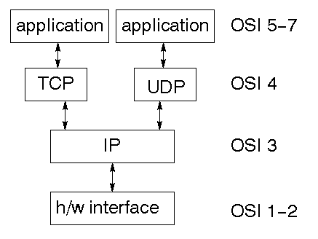

**FIG 13: TCP/IP STACK**

TCP is a connection-oriented protocol; UDP (User Datagram Protocol) is a connectionless protocol.

**IP DATAGRAM’S**

The IP layer provides a connectionless and unreliable delivery system. It considers each datagram independently of the others. Any association between datagram must be supplied by the higher layers. The IP layer supplies a checksum that includes its own header. The header includes the source and destination addresses. The IP layer handles routing through an Internet. It is also responsible for breaking up large datagram into smaller ones for transmission and reassembling them at the other end.

**UDP**

It is also connectionless and unreliable. What it adds to IP is a checksum for the contents of the datagram and port numbers. These are used to give a client/server model - see later.

**TCP**

TCP supplies logic to give a reliable connection-oriented protocol above IP. It provides a virtual circuit that two processes can use to communicate.

### INTERNET ADDRESSES

In order to use a service, you must be able to find it. The Internet uses an address scheme for machines so that they can be located. The address is a 32-bit integer which gives the IP address. This encodes a network ID and more addressing. The network ID falls into various classes according to the size of the network address.

### NETWORK ADDRESS

### Class A uses 8 bits for the network address with 24-bits left over for other addressing. Class B uses 16- bit network addressing. Class C uses 24-bit network addressing and class D uses all 32.

### SUBNET ADDRESS

### Internally, the UNIX network is divided into sub networks. Building 11 is currently on one sub network and uses 10-bit addressing, allowing 1024 different hosts.

### HOST ADDRESS

8 bits are finally used for host addresses within our subnet. This places a limit of 256 machines that can be on the subnet. The 32 bit address is usually written as 4 integers separated by dots.

### TOTAL ADRESSES

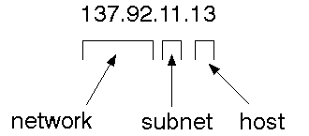

**FIG 14: HOST ADDRESS**

### PORT ADDRESSES

### A service exists on a host, and is identified by its port. This is a 16 bit number. To send a message to a server, you send it to the port for that service of the host that it is running on. This is not location transparency! Certain of these ports are "well known".

### SOCKETS

### A socket is a data structure maintained by the system to handle network connections. A socket is created using the call socket. It returns an integer that is like a file descriptor. In fact, under Windows, this handle can be used with Read File and Write File functions.

#include <sys/types.h>

#include <sys/socket.h>

int socket(int family, int type, int protocol);

Here "family" will be AF_INET for IP communications, protocol will be zero, and type will depend on whether TCP or UDP is used. Two processes wishing to communicate over a network create a socket each. These are similar to two ends of a pipe - but the actual pipe does not yet exist.

**JFREE CHART**

JFreeChart is a free 100% Java chart library that makes it easy for developers to display professional quality charts in their applications. JFreeChart's extensive feature set includes:

* A consistent and well-documented API, supporting a wide range of chart types;
* A flexible design that is easy to extend, and targets both server-side and client-side applications;
* Support for many output types, including Swing components, image files (including PNG and JPEG), and vector graphics file formats (including PDF, EPS and SVG);

JFreeChart is "open source" or, more specifically, [free software](http://www.gnu.org/philosophy/free-sw.html). It is distributed under the terms of the [GNU Lesser General Public Licence](http://www.gnu.org/licenses/lgpl.html) (LGPL), which permits use in proprietary applications.

**1.MAP VISUALIZATION**

Charts showing values that relate to geographical areas. Some examples include:

* population density in each state of the United States
* income per capita for each country in Europe
* life expectancy in each country of the world.

The tasks in this project include:

* Sourcing freely redistributable vector outlines for the countries of the world, states/provinces in particular countries (USA in particular, but also other areas);
* Creating an appropriate dataset interface (plus default implementation), a rendered, and integrating this with the existing XYPlot class in JFreeChart;
* Testing, documenting, testing some more, documenting some more.

**2.TIME SERIES CHART INTERACTIVITY**

Implement a new feature for interactive time series charts to display a separate control that shows a small version of ALL the time series data, with a sliding "view" rectangle that allows you to select the subset of the time series data to display in the main chart.

**3.DASH BOARDS**

There is currently a lot of interest in dashboard displays. Create a flexible dashboard mechanism that supports a subset of JFreeChart chart types (dials, pies, thermometers, bars, and lines/time series) that can be delivered easily via both Java Web Start and an applet.

**4.PROPERTY EDITIORS**

The property editor mechanism in JFreeChart only handles a small subset of the properties that can be set for charts. Extend (or reimplement) this mechanism to provide greater end-user control over the appearance of the charts.

**JAVA 2 MICRO EDITION**

Sun Microsystems defines J2ME as "a highly optimized Java run-time environment targeting a wide range of consumer products, including pagers, cellular phones, screen-phones, digital set-top boxes and car navigation systems." Announced in June 1999 at the Java One Developer Conference, J2ME brings the cross-platform functionality of the Java language to smaller devices, allowing mobile wireless devices to share applications. With J2ME, Sun has adapted the Java platform for consumer products that incorporate or are based on small computing devices.

**1. GENERAL J2ME ARCHITECTURE**



**FIG 15: GENERAL J2ME ARCHITECTURE**

J2ME uses configurations and profiles to customize the Java Runtime Environment (JRE). As a complete JRE, J2ME is comprised of a configuration, which determines the JVM used, and a profile, which defines the application by adding domain-specific classes. The configuration defines the basic run-time environment as a set of core classes and a specific JVM that run on specific types of devices. We'll discuss configurations in detail in the The profile defines the application; specifically, it adds domain-specific classes to the J2ME configuration to define certain uses for devices. We'll cover profiles in depth in the following graphic depicts the relationship between the different virtual machines, configurations, and profiles. It also draws a parallel with the J2SE API and its Java virtual machine. While the J2SE virtual machine is generally referred to as a JVM, the J2ME virtual machines, KVM and CVM, are subsets of JVM. Both KVM and CVM can be thought of as a kind of Java virtual machine -- it's just that they are shrunken versions of the J2SE JVM and are specific to J2ME.

**2.DEVELOPING J2ME APPLICATIONS**

Introduction In this section, we will go over some considerations you need to keep in mind when developing applications for smaller devices. We'll take a look at the way the compiler is invoked when using J2SE to compile J2ME applications. Finally, we'll explore packaging and deployment and the role preverification plays in this process.

**3.DESIGN CONSIDERATIONS FOR SMALL DEVICES**

Developing applications for small devices requires you to keep certain strategies in mind during the design phase. It is best to strategically design an application for a small device before you begin coding. Correcting the code because you failed to consider all of the "gotchas" before developing the application can be a painful process. Here are some design strategies to consider:

* Keep it simple. Remove unnecessary features, possibly making those features a separate, secondary application.
* Smaller is better. This consideration should be a "no brainer" for all developers. Smaller applications use less memory on the device and require shorter installation times. Consider packaging your Java applications as compressed Java Archive (jar) files.
* Minimize run-time memory use. To minimize the amount of memory used at run time, use scalar types in place of object types. Also, do not depend on the garbage collector.

You should manage the memory efficiently yourself by setting object references to null when you are finished with them. Another way to reduce run-time memory is to use lazy instantiation, only allocating objects on an as-needed basis. Other ways of reducing overall and peak memory use on small devices are to release resources quickly, reuse objects, and avoid exceptions.

**4.CONFIGURATIONS OVERVIEW**

The configuration defines the basic run-time environment as a set of core classes and a specific JVM that run on specific types of devices. Currently, two configurations exist for J2ME, though others may be defined in the future:

**CONNECTED LIMITED DEVICE CONFIGURATION (CLDC)**

It is used specifically with the KVM for 16-bit or 32-bit devices with limited amounts of memory. This is the configuration (and the virtual machine) used for developing small J2ME applications. Its size limitations make CLDC more interesting and challenging (from a development point of view) than CDC. CLDC is also the configuration that we will use for developing our drawing tool application. An example of a small wireless device running small applications is a Palm hand-held computer.

**CONNECTED DEVICE CONFIGURATION (CDC)**

It is used with the C virtual machine (CVM) and is used for 32-bit architectures requiring more than 2 MB of memory. An example of such a device is a Net TV box.

**J2ME PROFILES**

As we mentioned earlier in this tutorial, a profile defines the type of device supported. The Mobile Information Device Profile (MIDP), for example, defines classes for cellular phones. It adds domain-specific classes to the J2ME configuration to define uses for similar devices. Two profiles have been defined for J2ME and are built upon CLDC: KJava and MIDP. Both KJava and MIDP are associated with CLDC and smaller devices. Profiles are built on top of configurations. Because profiles are specific to the size of the device (amount of memory) on which an application runs, certain profiles are associated with certain configurations. A skeleton profile upon which you can create your own profile, the Foundation Profile, is available for CDC.

**PROFILE 1: KJAVA**

KJava is Sun's proprietary profile and contains the KJava API. The KJava profile is built on top of the CLDC configuration. The KJava virtual machine, KVM, accepts the same byte codes and class file format as the classic J2SE virtual machine. KJava contains a Sun-specific API that runs on the Palm OS. The KJava API has a great deal in common with the J2SE Abstract Windowing Toolkit (AWT). However, because it is not a standard J2ME package, its main package is com.sun.kjava. We'll learn more about the KJava API later in this tutorial when we develop some sample applications.

**PROFILE 2: MIDP**

MIDP is geared toward mobile devices such as cellular phones and pagers. The MIDP, like KJava, is built upon CLDC and provides a standard run-time environment that allows new applications and services to be deployed dynamically on end user devices. MIDP is a common, industry-standard profile for mobile devices that is not dependent on a specific vendor. It is a complete and supported foundation for mobile application development. MIDP contains the following packages, the first three of which are core CLDC packages, plus three MIDP-specific packages.

* java.lang
* java.io
* java.util
* javax.microedition.io
* javax.microedition.lcdui
* javax.microedition.midlet
* javax.microedition.rms

#### **4.1.2 CLIENT SERVER**

#### **OVER VIEW:**

With the varied topic in existence in the fields of computers, Client Server is one, which has generated more heat than light, and also more hype than reality. This technology has acquired a certain critical mass attention with its dedication conferences and magazines. Major computer vendors such as IBM and DEC, have declared that Client Servers is their main future market. A survey of DBMS magazine revealed that 76% of its readers were actively looking at the client server solution. The growth in the client server development tools from $200 million in 1992 to more than $1.2 billion in 1996.

Client server implementations are complex but the underlying concept is simple and powerful. A client is an application running with local resources but able to request the database and relate the services from separate remote server. The software mediating this client server interaction is often referred to as MIDDLEWARE.

The typical client either a PC or a Work Station connected through a network to a more powerful PC, Workstation, Midrange or Main Frames server usually capable of handling request from more than one client. However, with some configuration server may also act as client. A server may need to access other server in order to process the original client request.

The key client server idea is that client as user is essentially insulated from the physical location and formats of the data needs for their application. With the proper middleware, a client input from or report can transparently access and manipulate both local database on the client machine and remote databases on one or more servers. An added bonus is the client server opens the door to multi-vendor database access indulging heterogeneous table joins.

**WHAT IS CLIENT SERVER:**

Two prominent systems in existence are client server and file server systems. It is essential to distinguish between client servers and file server systems. Both provide shared network access to data but the comparison dens there! The file server simply provides a remote disk drive that can be accessed by LAN applications on a file by file basis. The client server offers full relational database services such as SQL-Access, Record modifying, Insert, Delete with full relational integrity backup/ restore performance for high volume of transactions, etc. the client server middleware provides a flexible interface between client and server, who does what, when and to whom.

#### **WHY CLIENT SERVER:**

Client server has evolved to solve a problem that has been around since the earliest days of computing: how best to distribute your computing, data generation and data storage resources in order to obtain efficient, cost effective departmental an enterprise wide data processing. During mainframe era choices were quite limited. A central machine housed both the CPU and DATA (cards, tapes, drums and later disks). Access to these resources was initially confined to FRbatched runs that produced departmental reports at the appropriate intervals. A strong central information service department ruled the corporation. The role of the rest of the corporation limited to requesting new or more frequent reports and to provide hand written forms from which the central data banks were created and updated. The earliest client server solutions therefore could best be characterized as “SLAVE-MASTER”.

**FRONT END OR USER INTERFACE DESIGN**

The entire user interface is planned to be developed in browser specific environment with a touch of Intranet-Based Architecture for achieving the Distributed Concept. The browser specific components are designed by using the HTML standards, and the dynamism of the designed by concentrating on the constructs of the Java Server Pages.

**COMMUNICATION OR DATABASE CONNECTIVITY TIER**

The Communication architecture is designed by concentrating on the Standards of Servlets and Enterprise Java Beans. The database connectivity is established by using the Java Data Base Connectivity.

**ABOUT JAVA**

Initially the language was called as “oak” but it was renamed as “Java” in 1995. The primary motivation of this language was the need for a platform-independent (i.e., architecture neutral) language that could be used to create software to be embedded in various consumer electronic devices.

* Java is a programmer’s language.
* Java is cohesive and consistent.
* Except for those constraints imposed by the Internet environment, Java gives the programmer, full control.

Finally, Java is to Internet programming where C was to system programming.

#### **IMPORTANCE OF JAVA TO THE INTERNET**

#### Java has had a profound effect on the Internet. This is because; Java expands the Universe of objects that can move about freely in Cyberspace. In a network, two categories of objects are transmitted between the Server and the Personal computer. They are: Passive information and Dynamic active programs.

Java can be used to create two types of programs:

**APPLICATIONS AND APPLETS**

An application is a program that runs on our Computer under the operating system of that computer. It is more or less like one creating using C or C++. Java’s ability to create Applets makes it important. An Applet is an application designed to be transmitted over the Internet and executed by a Java –compatible web browser. An applet is actually a tiny Java program, dynamically downloaded across the network, just like an image. But the difference is, it is an intelligent program, not just a media file. It can react to the user input and dynamically change.

**FEATURE OF JAVA**

#### **SECURITY**

Every time you that you download a “normal” program, you are risking a viral infection. Prior to Java, most users did not download executable programs frequently, and those who did scanned them for viruses prior to execution. Most users still worried about the possibility of infecting their systems with a virus. In addition, another type of malicious program exists that must be guarded against.

This type of program can gather private information, such as credit card numbers, bank account balances, and passwords. Java answers both these concerns by providing a “firewall” between a network application and your computer. When you use a Java-compatible Web browser, you can safely download Java applets without fear of virus infection or malicious intent.

**PORTABILITY**

For programs to be dynamically downloaded to all the various types of platforms connected to the Internet, some means of generating portable executable code is needed. As you will see, the same mechanism that helps ensure security also helps create portability. Indeed, Java’s solution to these two problems is both elegant and efficient.

**THE BYTE CODE**

The key that allows the Java to solve the security and portability problems is that the output of Java compiler is Byte code. Byte code is a highly optimized set of instructions designed to be executed by the Java run-time system, which is called the Java Virtual Machine (JVM). That is, in its standard form, the JVM is an interpreter for byte code.

Translating a Java program into byte code helps makes it much easier to run a program in a wide variety of environments. The reason is, once the run-time package exists for a given system, any Java program can run on it.

Although Java was designed for interpretation, there is technically nothing about Java that prevents on-the-fly compilation of byte code into native code. Sun has just completed its Just In Time (JIT) compiler for byte code. When the JIT compiler is a part of JVM, it compiles byte code into executable code in real time, on a piece-by-piece, demand basis. It is not possible to compile an entire Java program into executable code all at once, because Java performs various run-time checks that can be done only at run time. The JIT compiles code, as it is needed, during execution.

**JAVA VIRTUAL MACHINE (JVM)**

Beyond the language, there is the Java virtual machine. The Java virtual machine is an important element of the Java technology. The virtual machine can be embedded within a web browser or an operating system. Once a piece of Java code is loaded onto a machine, it is verified. As part of the loading process, a class loader is invoked and does byte code verification makes sure that the code that’s has been generated by the compiler will not corrupt the machine that it’s loaded on. Byte code verification takes place at the end of the compilation process to make sure that is all accurate and correct. So byte code verification is integral to the compiling and executing of Java code.

# Java Source

## Java byte code

# JavaVM

Java

.Class

#### **FIG 16: PICTURE SHOWING THE DEVELOPMENT PROCESS OF JAVA PROGRAM**

Java programming uses to produce byte codes and executes them. The first box indicates that the Java source code is located in a. Java file that is processed with a Java compiler called javac. The Java compiler produces a file called a. class file, which contains the byte code. The. Class file is then loaded across the network or loaded locally on your machine into the execution environment is the Java virtual machine, which interprets and executes the byte code.

**JAVA ARCHITECTURE**

Java architecture provides a portable, robust, high performing environment for development. Java provides portability by compiling the byte codes for the Java Virtual Machine, which is then interpreted on each platform by the run-time environment. Java is a dynamic system, able to load code when needed from a machine in the same room or across the planet.

**COMPILATION OF CODE**

When you compile the code, the Java compiler creates machine code (called byte code) for a hypothetical machine called Java Virtual Machine (JVM). The JVM is supposed to execute the byte code. The JVM is created for overcoming the issue of portability. The code is written and compiled for one machine and interpreted on all machines. This machine is called Java Virtual Machine.

**Source**

**Code**

**………..**

**………..**

**………..**

**…………**

# PC Compiler

**Macintosh**

**Compiler**

**SPARC**

###### Compiler

**Java**

**Byte code**

**(Platform**

**independent**

**dent)**

**Java**

**Interpreter**

**(PC)**

**Java**

**Interpreter**

**(Macintosh)**

**Java**

**Interpreter**

**(Sparc)**

**FIG 17: COMPILATION OF CODE**

**COMPILING AND INTERPRETING JAVA SOURCE CODE**

During run-time the Java interpreter tricks the byte code file into thinking that it is running on a Java Virtual Machine. In reality this could be a Intel Pentium Windows 95 or Sun SARC station running Solaris or Apple Macintosh running system and all could receive code from any computer through Internet and run the Applets

**SIMPLE**

Java was designed to be easy for the Professional programmer to learn and to use effectively. If you are an experienced C++ programmer, learning Java will be even easier. Because Java inherits the C/C++ syntax and many of the object-oriented features of C++. Most of the confusing concepts from C++ are either left out of Java or implemented in a cleaner, more approachable manner.

**OBJECT-ORIENTED**

Java was not designed to be source-code compatible with any other language. This allowed the Java team the freedom to design with a blank slate. One outcome of this was a clean usable, pragmatic approach to objects. The object model in Java is simple and easy to extend, while simple types, such as integers, are kept as high-performance non-objects.

**ROBUST**

The multi-platform environment of the Web places extraordinary demands on a program, because the program must execute reliably in a variety of systems. The ability to create robust programs was given a high priority in the design of Java. Java is strictly typed language; it checks your code at compile time and run time.

Java virtually eliminates the problems of memory management and deallocation, which is completely automatic. In a well-written Java program, all run time errors can –and should –be managed by your program.

**4*.*13 JAVASCRIPT**

JavaScript is a script-based programming language that was developed by Netscape Communication Corporation. JavaScript was originally called Live Script and renamed as JavaScript to indicate its relationship with Java. JavaScript supports the development of both client and server components of Web-based applications. On the client side, it can be used to write programs that are executed by a Web browser within the context of a Web page. On the server side, it can be used to write Web server programs that can process information submitted by a Web browser and then updates the browser’s display accordingly. Even though JavaScript supports both client and server Web programming, we prefer JavaScript at Client-side programming since most of the browsers supports it. JavaScript is almost as easy to learn as HTML, and JavaScript statements can be included in HTML documents by enclosing the statements between a pair of scripting tags.

<SCRIPTS>..</SCRIPT>.

<SCRIPT LANGUAGE = “JavaScript”>

JavaScript statements

</SCRIPT>

Here are a few things we can do with JavaScript:

* Validate the contents of a form and make calculations.
* Add scrolling or changing messages to the Browser’s status line.
* Animate images or rotate images that change when we move the mouse over them.
* Detect the browser in use and display different content for different browsers.
* Detect installed plug-ins and notify the user if a plug-in is required.

We can do much more with JavaScript, including creating entire application.

**JAVASCRIPT VS JAVA**

JavaScript and Java are entirely different languages. A few of the most glaring differences are:

* Java applets are generally displayed in a box within the web document; JavaScript can affect any part of the Web document itself.
* While JavaScript is best suited to simple applications and adding interactive features to Web pages; Java can be used for incredibly complex applications.

There are many other differences but the important thing to remember is that JavaScript and Java are separate languages. They are both useful for different things; in fact they can be used together to combine their advantages.

**ADVANTAGES**

* JavaScript can be used for Sever-side and Client-side scripting.
* It is more flexible than VBScript.
* JavaScript is the default scripting languages at Client-side since all the browsers supports it.

**HYPER TEXT MARKUP LANGUAGE**

Hypertext Markup Language (HTML), the languages of the World Wide Web (WWW), allows users to produces Web pages that include text, graphics and pointer to other Web pages (Hyperlinks).

HTML is not a programming language but it is an application of ISO Standard 8879, SGML (Standard Generalized Markup Language), but specialized to hypertext and adapted to the Web. The idea behind Hypertext is that instead of reading text in rigid linear structure, we can easily jump from one point to another point. We can navigate through the information based on our interest and preference. A markup language is simply a series of elements, each delimited with special characters that define how text or other items enclosed within the elements should be displayed. Hyperlinks are underlined or emphasized works that load to other documents or some portions of the same document.

**BASIC HTML TAGS:**

**<!-- -->** Specifies comments

**<A>……….</A>** Creates hypertext links

**<B>……….</B>** Formats text as bold

**<BIG>……….</BIG>** Formats text in large font.

**<BODY>…</BODY>** Contains all tags and text in the HTML document

**<CENTER>...</CENTER>** Creates text

**<DD>…</DD>** Definition of a term

**<DL>...</DL>**  Creates definition list

**<FONT>…</FONT>** Formats text with a particular font

**<FORM>...</FORM>** Encloses a fill-out form

**<FRAME>...</FRAME>** Defines a particular frame in a set of frames

**<H#>…</H#>** Creates headings of different levels

**<HEAD>...</HEAD>** Contains tags that specify information about a document

**<HR>...</HR>** Creates a horizontal rule

**<HTML>…</HTML>** Contains all other HTML tags

**<META>...</META>** Provides meta-information about a document

**<SCRIPT>…</SCRIPT>** Contains client-side or server-side script

**<TABLE>…</TABLE>**  Creates a table

**<TD>…</TD>** Indicates table data in a table

**<TR>…</TR>** Designates a table row

**<TH>…</TH>** Creates a heading in a table

**ADVANTAGES**

* A HTML document is small and hence easy to send over the net. It is small because it does not include formatted information.
* HTML is platform independent.
* HTML tags are not case-sensitive.

**JAVA DATABASE CONNECTIVITY**

JDBC is a Java API for executing SQL statements. (As a point of interest, JDBC is a trademarked name and is not an acronym; nevertheless, JDBC is often thought of as standing for Java Database Connectivity. It consists of a set of classes and interfaces written in the Java programming language. JDBC provides a standard API for tool/database developers and makes it possible to write database applications using a pure Java API.

Using JDBC, it is easy to send SQL statements to virtually any relational database. One can write a single program using the JDBC API, and the program will be able to send SQL statements to the appropriate database. The combinations of Java and JDBC lets a programmer write it once and run it anywhere.

What Does JDBC Do:

Simply put, JDBC makes it possible to do three things:

* Establish a connection with a database
* Send SQL statements
* Process the results.

**JDBC VERSUS ODBC AND OTHER APIS**

At this point, Microsoft's ODBC (Open Database Connectivity) API is that probably the most widely used programming interface for accessing relational databases. It offers the ability to connect to almost all databases on almost all platforms.

So why not just use ODBC from Java? The answer is that you can use ODBC from Java, but this is best done with the help of JDBC in the form of the JDBC-ODBC Bridge, which we will cover shortly. The question now becomes "Why do you need JDBC?" There are several answers to this question:

1. ODBC is not appropriate for direct use from Java because it uses a C interface. Calls from Java to native C code have a number of drawbacks in the security, implementation, robustness, and automatic portability of applications.
2. A literal translation of the ODBC C API into a Java API would not be desirable. For example, Java has no pointers, and ODBC makes copious use of them, including the notoriously error-prone generic pointer "void *". You can think of JDBC as ODBC translated into an object-oriented interface that is natural for Java programmers.
3. ODBC is hard to learn. It mixes simple and advanced features together, and it has complex options even for simple queries. JDBC, on the other hand, was designed to keep simple things simple while allowing more advanced capabilities where required.
4. A Java API like JDBC is needed in order to enable a "pure Java" solution. When ODBC is used, the ODBC driver manager and drivers must be manually installed on every client machine. When the JDBC driver is written completely in Java, however, JDBC code is automatically installable, portable, and secure on all Java platforms from network computers to mainframes.

**TWO-TIER AND THREE-TIER MODELS**

The JDBC API supports both two-tier and three-tier models for database access.

In the two-tier model, a Java applet or application talks directly to the database. This requires a JDBC driver that can communicate with the particular database management system being accessed. A user's SQL statements are delivered to the database, and the results of those statements are sent back to the user. The database may be located on another machine to which the user is connected via a network. This is referred to as a client/server configuration, with the user's machine as the client, and the machine housing the database as the server. The network can be an Intranet, which, for example, connects employees within a corporation, or it can be the Internet.

In the three-tier model, commands are sent to a "middle tier" of services, which then send SQL statements to the database. The database processes the SQL statements and sends the results back to the middle tier, which then sends them to the user. MIS directors find the three-tier model very attractive because the middle tier makes it possible to maintain control over access and the kinds of updates that can be made to corporate data.

Until now the middle tier has typically been written in languages such as C or C++, which offer fast performance. However, with the introduction of optimizing compilers that translate Java byte code into efficient machine-specific code, it is becoming practical to implement the middle tier in Java. This is a big plus, making it possible to take advantage of Java's robustness, multithreading, and security features. JDBC is important to allow database access from a Java middle tier.

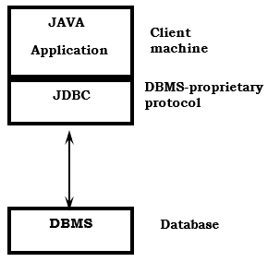 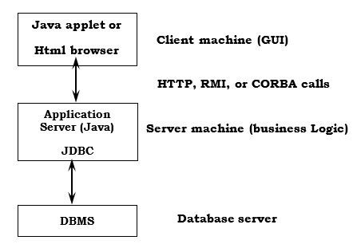

**FIG 18: TWO-TIER FIG 19: THREE-TIER**

**JDBC DRIVER TYPES**

The JDBC drivers that we are aware of at this time fit into one of four categories:

* JDBC-ODBC bridge plus ODBC driver
* Native-API partly-Java driver
* JDBC-Net pure Java driver
* Native-protocol pure Java driver

**JDBC-ODBC BRIDGE**

If possible, use a Pure Java JDBC driver instead of the Bridge and an ODBC driver. This completely eliminates the client configuration required by ODBC. It also eliminates the potential that the Java VM could be corrupted by an error in the native code brought in by the Bridge (that is, the Bridge native library, the ODBC driver manager library, the ODBC driver library, and the database client library).

**WHAT IS THE JDBC- ODBC BRIDGE:**

The JDBC-ODBC Bridge is a JDBC driver, which implements JDBC operations by translating them into ODBC operations. To ODBC it appears as a normal application program. The Bridge implements JDBC for any database for which an ODBC driver is available. The Bridge is implemented as the sun.jdbc.odbc Java package and contains a native library used to access ODBC. The Bridge is a joint development of Intervolve and JavaSoft.

**JAVA SERVER PAGES (JSP)**

Java server Pages is a simple, yet powerful technology for creating and maintaining dynamic-content web pages. Based on the Java programming language, Java Server Pages offers proven portability, open standards, and a mature re-usable component model. The Java Server Pages architecture enables the separation of content generation from content presentation. This separation not eases maintenance headaches, it also allows web team members to focus on their areas of expertise. Now, web page designer can concentrate on layout, and web application designers on programming, with minimal concern about impacting each other’s work.

**FEATURES OF JSP**

**PORTABILITY:**

Java Server Pages files can be run on any web server or web-enabled application server that provides support for them. Dubbed the JSP engine, this support involves recognition, translation, and management of the Java Server Page lifecycle and its interaction components.

**COMPONENTS**

It was mentioned earlier that the Java Server Pages architecture can include reusable Java components. The architecture also allows for the embedding of a scripting language directly into the Java Server Pages file. The components current supported include Java Beans, and Servlets.

**PROCESSING**

A Java Server Pages file is essentially an HTML document with JSP scripting or tags. The Java Server Pages file has a JSP extension to the server as a Java Server Pages file. Before the page is served, the Java Server Pages syntax is parsed and processed into a Servlet on the server side. The Servlet that is generated outputs real content in straight HTML for responding to the client.

**ACCESS MODELS:**

A Java Server Pages file may be accessed in at least two different ways. A client’s request comes directly into a Java Server Page. In this scenario, suppose the page accesses reusable Java Bean components that perform particular well-defined computations like accessing a database. The result of the Beans computations, called result sets is stored within the Bean as properties.

**STEPS IN THE EXECUTION OF A JSP APPLICATION:**

1. The client sends a request to the web server for a JSP file by giving the name of the JSP file within the form tag of a HTML page.
2. This request is transferred to the JavaWebServer. At the server side JavaWebServer receives the request and if it is a request for a jsp file server gives this request to the JSP engine.
3. JSP engine is program which can understands the tags of the jsp and then it converts those tags into a Servlet program and it is stored at the server side.

**JDBC CONNECTIVITY**

The JDBC provides database-independent connectivity between the J2EE platform and a wide range of tabular data sources. JDBC technology allows an Application Component Provider to:

* Perform connection and authentication to a database server
* Manager transactions
* Move SQL statements to a database engine for preprocessing and execution
* Execute stored procedures
* Inspect and modify the results from Select statements.

# TOMCAT WEB SERVER:

Tomcat is an open-source web server developed by Apache Group. Apache Tomcat is the servlet container that is used in the official Reference Implementation for the Java Servlet and Java Server Pages technologies. The Java Servlet and Java Server Pages specifications are developed by Sun under the Java Community Process. Web Servers like Apache Tomcat support only web components while an application server supports web components as well as business components (BEAs WebLogic, is one of the popular application server).

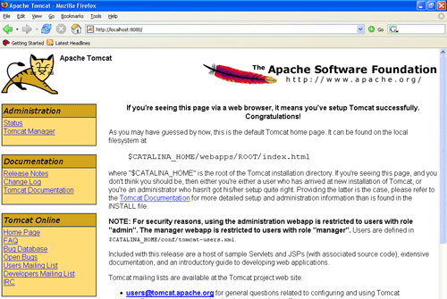

**FIG 20: TOMCAT WEB SERVER**

**5.SAMPLE CODE**

**5.1 MYSQL DATABASE QUERIES**

**create** database ppds;

use ppds;

**SET** FOREIGN_KEY_CHECKS=0;

-- ----------------------------

-- Table structure for acc_control_per

-- ----------------------------

**DROP** **TABLE** IF **EXISTS** `acc_control_per`;

**CREATE** **TABLE** `acc_control_per` (

`id` **int**(7) **NOT** **NULL** auto_increment,

`pname` text,

`department` text,

`profession` text,

`dt` text,

`owner` text,

**PRIMARY** **KEY** (`id`)

) ENGINE=InnoDB **DEFAULT** CHARSET=utf8;

-- ----------------------------

-- Table structure for attacker

-- ----------------------------

**DROP** **TABLE** IF **EXISTS** `attacker`;

**CREATE** **TABLE** `attacker` (

`id` **int**(7) **NOT** **NULL** auto_increment,

`**user**` text,

`pname` text,

`**type**` text,

`dt` text,

**PRIMARY** **KEY** (`id`)

) ENGINE=InnoDB **DEFAULT** CHARSET=utf8;

-- ----------------------------

-- Table structure for au_down_req

-- ----------------------------

**DROP** **TABLE** IF **EXISTS** `au_down_req`;

**CREATE** **TABLE** `au_down_req` (

`id` **int**(7) **NOT** **NULL** auto_increment,

`username` text,

`pname` text,

`per` text,

`dt` text,

`fname` text,

**PRIMARY** **KEY** (`id`)

) ENGINE=InnoDB **DEFAULT** CHARSET=utf8;

-- ----------------------------

-- Table structure for authority

-- ----------------------------

**DROP** **TABLE** IF **EXISTS** `authority`;

**CREATE** **TABLE** `authority` (

`name` text,

`pass` text

) ENGINE=InnoDB **DEFAULT** CHARSET=utf8;

-- ----------------------------

-- Table structure for external

-- ----------------------------

**DROP** **TABLE** IF **EXISTS** `external`;

**CREATE** **TABLE** `external` (

`aname` text,

`pname` text,

`dt` text,

`aurl` text

) ENGINE=InnoDB **DEFAULT** CHARSET=latin1;

-- ----------------------------

-- Table structure for owner

-- ----------------------------

**DROP** **TABLE** IF **EXISTS** `owner`;

**CREATE** **TABLE** `owner` (

`id` **int**(7) **NOT** **NULL** auto_increment,

`name` text,

`pass` text,

`dept` text,

`spec` text,

`image` longblob,

`status` text,

`email` text,

`mobile` text,

`addr` text,

`dob` text,

`gender` text,

`pin` text,

**PRIMARY** **KEY** (`id`)

) ENGINE=InnoDB **DEFAULT** CHARSET=utf8;

-- ----------------------------

-- Table structure for patient_details

-- ----------------------------

**DROP** **TABLE** IF **EXISTS** `patient_details`;

**CREATE** **TABLE** `patient_details` (

`id` **int**(7) **NOT** **NULL** auto_increment,

`pname` text,

`paddress` text,

`dob` text,

`email` text,

`mobile` text,

`age` text,

`hospital` text,

`disease` text,

`bg` text,

`sym` text,

`fname` text,

`cont` text,

`image` blob,

`dt` text,

`owname` text,

`sk` text,

`down_rank` text,

`search_rank` text,

**PRIMARY** **KEY** (`id`)

) ENGINE=InnoDB **DEFAULT** CHARSET=utf8;

-- ----------------------------

-- Table structure for server

-- ----------------------------

**DROP** **TABLE** IF **EXISTS** `server`;

**CREATE** **TABLE** `server` (

`name` text,

`pass` text

) ENGINE=InnoDB **DEFAULT** CHARSET=utf8;

-- ----------------------------

-- Table structure for transaction

-- ----------------------------

**DROP** **TABLE** IF **EXISTS** `transaction`;

**CREATE** **TABLE** `transaction` (

`id` **int**(7) **NOT** **NULL** auto_increment,

`**user**` text,

`f_p_name` text,

`task` text,

`dt` text,

**PRIMARY** **KEY** (`id`)

) ENGINE=InnoDB **DEFAULT** CHARSET=utf8;

-- ----------------------------

-- Table structure for user

-- ----------------------------

**DROP** **TABLE** IF **EXISTS** `**user**`;

**CREATE** **TABLE** `**user**` (

`id` **int**(7) **NOT** **NULL** auto_increment,

`name` text,

`pass` text,

`dept` text,

`prof` text,

`image` longblob,

`status` text,

`email` text,

`mobile` text,

`addr` text,

`dob` text,

`gender` text,

`pin` text,

**PRIMARY** **KEY** (`id`)

) ENGINE=InnoDB **DEFAULT** CHARSET=utf8;

**5.2 JSP, HTML & CSS CODE**

**1.A EXTERNAL ATTACKER.JSP**

<style type=*"text/css"*>

<!--

*.style1* {color: *#FFFFFF*}

-->

</style>

<table width=*"691"* border=*"1"* align=*"center"* cellpadding=*"0"* cellspacing=*"0"* ">

<tr>

<td width=*"180"* height=*"49"* valign=*"middle"* bgcolor=*"#FF0000"* style="color: *#2c83b0*;"><div align=*"center"* class=*"style1 style21 style15 style4 style5"*><strong>Attack Name</strong></div></td>

<td width=*"192"* height=*"49"* valign=*"middle"* bgcolor=*"#FF0000"* style="color: *#2c83b0*;"><div align=*"center"* class=*"style1 style21 style15 style4 style5"*><strong>Patient Name </strong></div></td>

<td width=*"127"* height=*"49"* valign=*"middle"* bgcolor=*"#FF0000"* style="color: *#2c83b0*;"><div align=*"center"* class=*"style1 style21 style15 style4 style5"*><strong> Date and Time </strong></div></td>

<td width=*"179"* height=*"49"* valign=*"middle"* bgcolor=*"#FF0000"* style="color: *#2c83b0*;"><div align=*"center"* class=*"style6 style7 style21 style15 style4 style5 style1"*><strong>Url</strong></div></td>

</tr>

<%@ include file=*"connect.jsp"* %>

<%

String s1,s2,s3,s4,s5,s6,s7;

**int** i=0;

**try**

{

String query="select * from external";

Statement st=connection.createStatement();

ResultSet rs=st.executeQuery(query);

**while** ( rs.next() )

{

s1=rs.getString(1);

s2=rs.getString(2);

s3=rs.getString(3);//pn

s4=rs.getString(4);

%>

<tr>

<td height=*"0"* valign=*"baseline"* bgcolor=*"#FFFF00"*><p class=*"style6 style4 style22"*>&nbsp;</p>

<div align=*"center"* class=*"style22 style4 style6 style8"*>

<%out.println(s1);%>

<p>&nbsp; </p>

</div></td>

<td height=*"0"* valign=*"baseline"* bgcolor=*"#FFFF00"*><p class=*"style6 style4 style22"*>&nbsp;</p>

<div align=*"center"* class=*"style22 style4 style6 style10"*>

<%out.println(s2);%>

<p>&nbsp; </p>

</div></td>

<td height=*"0"* valign=*"baseline"* bgcolor=*"#FFFF00"*><p class=*"style6 style4 style22"*>&nbsp;</p>

<div align=*"center"* class=*"style22 style4 style6 style12"*>

<%out.println(s3);%>

<p>&nbsp; </p>

</div></td>

<td height=*"0"* valign=*"baseline"* bgcolor=*"#FFFF00"*><p class=*"style6 style4 style22"*>&nbsp;</p>

<div align=*"center"* class=*"style22 style4 style6 style14"*>

<%out.println(s4);%>

<p>&nbsp; </p>

</div></td>

</tr>

<%

}

connection.close();

}

**catch**(Exception e)

{

out.println(e.getMessage());

}

%>

<tr>

<td valign=*"baseline"* height=*"0"*>&nbsp;</td>

<td valign=*"baseline"* height=*"0"*>&nbsp;</td>

<td valign=*"baseline"* height=*"0"*>&nbsp;</td>

<td valign=*"baseline"* height=*"0"*>&nbsp;</td>

<td width=*"8"* height=*"0"* valign=*"baseline"*>&nbsp;</td>

</tr>

</table>

**2. ATTACK.JSP**

<%@ page import=*"java.sql.*"*%>

<%@ include file=*"connect.jsp"* %>

<%@ page import=*"java.util.Date"* %>

<%@ page import=*"com.oreilly.servlet.*"*%>

<%@ page import =*"java.text.SimpleDateFormat"* %>

<%@ page import =*"javax.crypto.Cipher"* %>

<%@ page import =*"org.bouncycastle.util.encoders.*"* %>

<%

**try**

{

String username=request.getParameter("userid");

String Password=request.getParameter("pass");

String pname=(String)application.getAttribute("pname");

String aname="External Attack";

String aurl=String.valueOf(request.getRequestURL());

SimpleDateFormat sdfDate = **new** SimpleDateFormat("dd/MM/yyyy");

SimpleDateFormat sdfTime = **new** SimpleDateFormat("HH:mm:ss");

Date now = **new** Date();

String strDate = sdfDate.format(now);

String strTime = sdfTime.format(now);

String date = strDate + " " + strTime;

String sql="SELECT * FROM external where aurl='"+aurl+"' and pname='"+pname+"' ";

Statement stmt = connection.createStatement();

ResultSet rs =stmt.executeQuery(sql);

**if** (rs.next()==**true**)

{

%>

<style type=*"text/css"*>

<!--

*.style1* {

color: *#FF0000*;

font-weight: *bold*;

}

-->

</style>

<br/>

<p class=*"style1"*>External Attack is Resisted!! </p>

<br/><br/><a href=*"index.html"*>Home</a>

<%

}

**else**

{

String sql1="insert into external (aname,pname,dt,aurl)values('"+aname+"','"+pname+"','"+date+"','"+aurl+"') ";

Statement stmt1 = connection.createStatement();

stmt1.executeUpdate(sql1); %>

<style type=*"text/css"*>

<!--

*.style1* {

color: *#FF0000*;

font-weight: *bold*;

}

-->

</style>

<br/>

<p class=*"style1"*>External User Attacked Successfull!! </p>

<br/><br/><a href=*"index.html"*>Home</a>

<%

}

}

**catch**(Exception e)

{

out.print(e);

}

%>

**3.AUTHORITY ALL ATTACKER**

<!DOCTYPE html PUBLIC "-//W3C//DTD XHTML 1.0 Transitional//EN" "http://www.w3.org/TR/xhtml1/DTD/xhtml1-transitional.dtd">

<html xmlns=*"http://www.w3.org/1999/xhtml"*>

<head>

<title>View Attacker</title>

<meta http-equiv=*"Content-Type"* content=*"text/html; charset=utf-8"* />

<link href=*"css/style.css"* rel=*"stylesheet"* type=*"text/css"* />

<link rel=*"stylesheet"* type=*"text/css"* href=*"css/coin-slider.css"* />

<script type=*"text/javascript"* src=*"js/cufon-yui.js"*></script>

<script type=*"text/javascript"* src=*"js/cufon-aller.js"*></script>

<script type=*"text/javascript"* src=*"js/jquery-1.4.2.min.js"*></script>

<script type=*"text/javascript"* src=*"js/script.js"*></script>

<script type=*"text/javascript"* src=*"js/coin-slider.min.js"*></script>

<script language=*"javascript"* type=*"text/javascript"*>

</script>

<style type=*"text/css"*>

<!--

*.style1* {

font-size: *25px*;

color: *#33FF99*;

}

*.style2* {font-size: *25px*}

*.style4* {font-size: *18px*}

-->

</style>

</head>

<body>

<div class=*"main"*>

<div class=*"header"*>

<div class=*"header_resize"*>

<div class=*"logo"*>

<h1><a href=*"index.html"* class=*"style1 style2"*>Privacy-aware Personal Data Storage( P-PDS) Learning how to Protect User Privacy from External Applications</a></h1>

</div>

<div class=*"menu_nav"*>

<ul>

<li><a href=*"index.html"*><span>Home Page</span></a></li>

<li><a href=*"owner_login.jsp"*><span>PDS Owner</span></a></li>

<li><a href=*"user_login.jsp"*><span>User</span></a></li>

<li><a href=*"cs_login.jsp"*><span>Cloud Server</span></a></li>

<li class=*"active"*><a href=*"au_login.jsp"*><span>Authority</span></a></li>

</ul>

</div>

<div class=*"clr"*></div>

<div class=*"slider"*>

<div id=*"coin-slider"*> <a href=*"#"*><img src=*"images/slide1.jpg"* width=*"960"* height=*"320"* alt=*""* /> </a> <a href=*"#"*><img src=*"images/slide2.jpg"* width=*"960"* height=*"320"* alt=*""* /> </a> <a href=*"#"*><img src=*"images/slide3.jpg"* width=*"960"* height=*"320"* alt=*""* /> </a> </div>

<div class=*"clr"*></div>

</div>

<div class=*"clr"*></div>

</div>

</div>

<div class=*"content"*>

<div class=*"content_resize"*>

<div class=*"mainbar"*>

<div class=*"article"*>

<h2 align=*"center"*> View All Credentials Attackers Details </h2>

<p align=*"center"*>&nbsp;</p>

<table width=*"691"* border=*"1"* align=*"center"* cellpadding=*"0"* cellspacing=*"0"* ">

<tr>

<td width=*"31"* height=*"49"* valign=*"middle"* bgcolor=*"#66CCFF"* style="color: *#2c83b0*;"><div align=*"center"* class=*"style5 style6 style7 style21 style15 style4"*><strong>ID</strong></div></td>

<td width=*"181"* height=*"49"* valign=*"middle"* bgcolor=*"#66CCFF"* style="color: *#2c83b0*;"><div align=*"center"* class=*"style5 style6 style7 style21 style15 style4"*><strong>Patient Name</strong></div></td>

<td width=*"193"* height=*"49"* valign=*"middle"* bgcolor=*"#66CCFF"* style="color: *#2c83b0*;"><div align=*"center"* class=*"style5 style6 style7 style21 style15 style4"*><strong>Attacker Name </strong></div></td>

<td width=*"128"* height=*"49"* valign=*"middle"* bgcolor=*"#66CCFF"* style="color: *#2c83b0*;"><div align=*"center"* class=*"style5 style6 style7 style21 style15 style4"*><strong> Type </strong></div></td>

<td width=*"146"* height=*"49"* valign=*"middle"* bgcolor=*"#66CCFF"* style="color: *#2c83b0*;"><div align=*"center"* class=*"style5 style6 style7 style21 style15 style4"*><strong>Date</strong></div></td>

</tr>

<%@ include file=*"connect.jsp"* %>

<%

String s1,s2,s3,s4,s5,s6,s7;

**int** i=0;

**try**

{

String query="select * from attacker";

Statement st=connection.createStatement();

ResultSet rs=st.executeQuery(query);

**while** ( rs.next() )

{

i=rs.getInt(1);

s2=rs.getString(2);

s3=rs.getString(3);//pn

s4=rs.getString(4);

s5=rs.getString(5);

%>

<tr>

<td valign=*"baseline"* height=*"0"*><p class=*"style22 style4 style5"*>&nbsp;</p>

<div align=*"center"* class=*"style22 style4 style5"*>

<%out.println(i);%>

<p>&nbsp; </p>

</div></td>

<td valign=*"baseline"* height=*"0"*><p class=*"style22 style4 style5"*>&nbsp;</p>

<div align=*"center"* class=*"style22 style4 style5"*>

<%out.println(s3);%>

<p>&nbsp; </p>

</div></td>

<td valign=*"baseline"* height=*"0"*><p class=*"style22 style4 style5"*>&nbsp;</p>

<div align=*"center"* class=*"style22 style4 style5"*>

<%out.println(s2);%>

<p>&nbsp; </p>

</div></td>

<td valign=*"baseline"* height=*"0"*><p class=*"style22 style4 style5"*>&nbsp;</p>

<div align=*"center"* class=*"style22 style4 style5"*>

<%out.println(s4);%>

<p>&nbsp; </p>

</div></td>

<td valign=*"baseline"* height=*"0"*><p class=*"style22 style4 style5"*>&nbsp;</p>

<div align=*"center"* class=*"style22 style4 style5"*>

<%out.println(s5);%>

<p>&nbsp; </p>

</div></td>

</tr>

<%

}

connection.close();

}

**catch**(Exception e)

{

out.println(e.getMessage());

}

%>

<tr>

<td valign=*"baseline"* height=*"0"*>&nbsp;</td>

<td valign=*"baseline"* height=*"0"*>&nbsp;</td>

<td valign=*"baseline"* height=*"0"*>&nbsp;</td>

<td valign=*"baseline"* height=*"0"*>&nbsp;</td>

<td valign=*"baseline"* height=*"0"*>&nbsp;</td>

</tr>

</table>

<p>&nbsp;</p>

<p>&nbsp;</p>

<p>&nbsp;</p>

<p align=*"center"*><a href=*"au_main.jsp"* class=*"style14"*>Back</a></p>

<p>&nbsp;</p>

</div>

</div>

<div class=*"sidebar"*>

<div class=*"gadget"*>

<h2 class=*"star"*><span>Authority</span> Menu</h2>

<div class=*"clr"*></div>

<ul class=*"sb_menu"*>

<li><a href=*"au_main.jsp"*><span> Authority Main</span></a></li>

<li><a href=*"au_login.jsp"*><span>Log Out</span></a></li>

</ul>

</div>

</div>

<div class=*"clr"*></div>

</div>

</div>

<div class=*"fbg"*></div>

<div class=*"footer"*>

<div class=*"footer_resize"*>

<div style="clear:*both*;"></div>

</div>

</div>

</div>

<div align=*center*></div>

</body>

</html>

**4.AUTHORITY ALL INFERENCE ATTACKER**

<!DOCTYPE html PUBLIC "-//W3C//DTD XHTML 1.0 Transitional//EN" "http://www.w3.org/TR/xhtml1/DTD/xhtml1-transitional.dtd">

<html xmlns=*"http://www.w3.org/1999/xhtml"*>

<head>

<title>View Attacker</title>

<meta http-equiv=*"Content-Type"* content=*"text/html; charset=utf-8"* />

<link href=*"css/style.css"* rel=*"stylesheet"* type=*"text/css"* />

<link rel=*"stylesheet"* type=*"text/css"* href=*"css/coin-slider.css"* />

<script type=*"text/javascript"* src=*"js/cufon-yui.js"*></script>

<script type=*"text/javascript"* src=*"js/cufon-aller.js"*></script>

<script type=*"text/javascript"* src=*"js/jquery-1.4.2.min.js"*></script>

<script type=*"text/javascript"* src=*"js/script.js"*></script>

<script type=*"text/javascript"* src=*"js/coin-slider.min.js"*></script>

<script language=*"javascript"* type=*"text/javascript"*>

</script>

<style type=*"text/css"*>

<!--

*.style1* {

font-size: *25px*;

color: *#33FF99*;

}

*.style2* {font-size: *25px*}

*.style4* {font-size: *18px*}

*.style5* {color: *#FFFFFF*}

*.style6* {color: *#FF0000*}

*.style7* {

font-weight: *bold*;

color: *#FFFFFF*;

}

*.style8* {font-weight: *bold*}

*.style10* {font-weight: *bold*}

*.style12* {font-weight: *bold*}

*.style14* {font-weight: *bold*}

-->

</style>

</head>

<body>

<div class=*"main"*>

<div class=*"header"*>

<div class=*"header_resize"*>

<div class=*"logo"*>

<h1><a href=*"index.html"* class=*"style1 style2"*>Privacy-aware Personal Data Storage( P-PDS) Learning how to Protect User Privacy from External Applications</a></h1>

</div>

<div class=*"menu_nav"*>

<ul>

<li><a href=*"index.html"*><span>Home Page</span></a></li>

<li><a href=*"owner_login.jsp"*><span>PDS Owner</span></a></li>

<li><a href=*"user_login.jsp"*><span>User</span></a></li>

<li><a href=*"cs_login.jsp"*><span>Cloud Server</span></a></li>

<li class=*"active"*><a href=*"au_login.jsp"*><span>Authority</span></a></li>

</ul>

</div>

<div class=*"clr"*></div>

<div class=*"slider"*>

<div id=*"coin-slider"*> <a href=*"#"*><img src=*"images/slide1.jpg"* width=*"960"* height=*"320"* alt=*""* /> </a> <a href=*"#"*><img src=*"images/slide2.jpg"* width=*"960"* height=*"320"* alt=*""* /> </a> <a href=*"#"*><img src=*"images/slide3.jpg"* width=*"960"* height=*"320"* alt=*""* /> </a> </div>

<div class=*"clr"*></div>

</div>

<div class=*"clr"*></div>

</div>

</div>

<div class=*"content"*>

<div class=*"content_resize"*>

<div class=*"mainbar"*>

<div class=*"article"*>

<h2 align=*"center"*> View All External Attackers Details !!! </h2>

<p align=*"center"*>&nbsp;</p>

<iframe src=*"A_External_Attackers.jsp"* height=*"300"* width=*"800"*></iframe>

<p>&nbsp;</p>

<p>&nbsp;</p>

<p>&nbsp;</p>

<p align=*"center"*><a href=*"au_main.jsp"* class=*"style14"*>Back</a></p>

<p>&nbsp;</p>

</div>

</div>

<div class=*"sidebar"*>

<div class=*"gadget"*>

<h2 class=*"star"*><span>Authority</span> Menu</h2>

<div class=*"clr"*></div>

<ul class=*"sb_menu"*>

<li><a href=*"au_main.jsp"*><span> Authority Main</span></a></li>

<li><a href=*"au_login.jsp"*><span>Log Out</span></a></li>

</ul>

</div>

</div>

<div class=*"clr"*></div>

</div>

</div>

<div class=*"fbg"*></div>

<div class=*"footer"*>

<div class=*"footer_resize"*>

<div style="clear:*both*;"></div>

</div>

</div>

</div>

<div align=*center*></div>

</body>

</html>

**5.AUTHORITY ALL OWNERS .JSP**

<!DOCTYPE html PUBLIC "-//W3C//DTD XHTML 1.0 Transitional//EN" "http://www.w3.org/TR/xhtml1/DTD/xhtml1-transitional.dtd">

<html xmlns=*"http://www.w3.org/1999/xhtml"*>

<head>

<title>View Owners</title>

<meta http-equiv=*"Content-Type"* content=*"text/html; charset=utf-8"* />

<link href=*"css/style.css"* rel=*"stylesheet"* type=*"text/css"* />

<link rel=*"stylesheet"* type=*"text/css"* href=*"css/coin-slider.css"* />

<script type=*"text/javascript"* src=*"js/cufon-yui.js"*></script>

<script type=*"text/javascript"* src=*"js/cufon-aller.js"*></script>

<script type=*"text/javascript"* src=*"js/jquery-1.4.2.min.js"*></script>

<script type=*"text/javascript"* src=*"js/script.js"*></script>

<script type=*"text/javascript"* src=*"js/coin-slider.min.js"*></script>

<script language=*"javascript"* type=*"text/javascript"*>

</script>

<style type=*"text/css"*>

<!--

*.style1* {

font-size: *25px*;

color: *#33FF99*;

}

*.style2* {font-size: *25px*}

*.style4* {font-size: *20px*}

*.style5* {font-size: *15px*}

*.style7* {font-size: *14px*}

*.style8* {color: *#FFFFFF*}

*.style9* {

color: *#FF0000*;

font-weight: *bold*;

}

-->

</style>

</head>

<body>

<div class=*"main"*>

<div class=*"header"*>

<div class=*"header_resize"*>

<div class=*"logo"*>

<h1><a href=*"index.html"* class=*"style1 style2"*>Privacy-aware Personal Data Storage( P-PDS) Learning how to Protect User Privacy from External Applications</a></h1>

</div>

<div class=*"menu_nav"*>

<ul>

<li><a href=*"index.html"*><span>Home Page</span></a></li>

<li><a href=*"owner_login.jsp"*><span>PDS Owner</span></a></li>

<li><a href=*"user_login.jsp"*><span>User</span></a></li>

<li><a href=*"cs_login.jsp"*><span>Cloud Server</span></a></li>

<li class=*"active"*><a href=*"au_login.jsp"*><span>Authority</span></a></li>

</ul>

</div>

<div class=*"clr"*></div>

<div class=*"slider"*>

<div id=*"coin-slider"*> <a href=*"#"*><img src=*"images/slide1.jpg"* width=*"960"* height=*"320"* alt=*""* /> </a> <a href=*"#"*><img src=*"images/slide2.jpg"* width=*"960"* height=*"320"* alt=*""* /> </a> <a href=*"#"*><img src=*"images/slide3.jpg"* width=*"960"* height=*"320"* alt=*""* /> </a> </div>

<div class=*"clr"*></div>

</div>

<div class=*"clr"*></div>

</div>

</div>

<div class=*"content"*>

<div class=*"content_resize"*>

<div class=*"mainbar"*>

<div class=*"article"*>

<h2 align=*"center"* class=*"style9"*> View All PDS Owners and Authorise</h2>

<p align=*"center"*>&nbsp;</p>

<table width=*"737"* border=*"1"* align=*"center"* cellpadding=*"0"* cellspacing=*"0"*>

<tr>

<td width=*"25"* height=*"66"* valign=*"middle"* bgcolor=*"#FF0000"* style="color: *#2c83b0*;"><div align=*"center"* class=*"style8 style7 style15 style21"*><strong>ID</strong></div></td>

<td width=*"121"* height=*"66"* valign=*"middle"* bgcolor=*"#FF0000"* style="color: *#2c83b0*;"><div align=*"center"* class=*"style8 style7 style15 style21"*><strong>PDS Owner Image</strong></div></td>

<td width=*"116"* height=*"66"* valign=*"middle"* bgcolor=*"#FF0000"* style="color: *#2c83b0*;"><div align=*"center"* class=*"style8 style7 style15 style21"*><strong>PDS Owner Name </strong></div></td>

<td width=*"118"* height=*"66"* valign=*"middle"* bgcolor=*"#FF0000"* style="color: *#2c83b0*;"><div align=*"center"* class=*"style8 style7 style15 style21"*><strong> Department </strong></div></td>

<td width=*"157"* height=*"66"* valign=*"middle"* bgcolor=*"#FF0000"* style="color: *#2c83b0*;"><div align=*"center"* class=*"style8 style7 style15 style21"*><strong>Specilisation</strong></div></td>

<td width=*"157"* height=*"66"* valign=*"middle"* bgcolor=*"#FF0000"* style="color: *#2c83b0*;"><div align=*"center"* class=*"style8 style7 style15 style21"*><strong>Status</strong></div></td>

</tr>

<%@ include file=*"connect.jsp"* %>

<%

String s1,s2,s3,s4,s5,s6,s7;

**int** i=0;

**try**

{

String query="select * from owner";

Statement st=connection.createStatement();

ResultSet rs=st.executeQuery(query);

**while** ( rs.next() )

{

i=rs.getInt(1);

s2=rs.getString(2);

s4=rs.getString(4);

s5=rs.getString(5);

s6=rs.getString(6);//img

s7=rs.getString(7);

%>

<tr>

<td valign=*"baseline"* height=*"0"*><p class=*"style22 style4 style5"*>&nbsp;</p>

<div align=*"center"* class=*"style22 style4 style5"*>

<%out.println(i);%>

<p>&nbsp; </p>

</div></td>

<td width=*"121"* rowspan=*"1"* ><div class=*"style22 style4 style5"* style="margin:*10px 13px 10px 13px*;" > <a class=*"#"* id=*"img1"* href=*"#"* >

<input name=*"image"* type=*"image"* src=*"ow_Pic.jsp?id=*<%=i%>*"* style="width:*90px*; height:*90px*;">

</a> </div></td>

<td valign=*"baseline"* height=*"0"*><p class=*"style22 style4 style5"*>&nbsp;</p>

<div align=*"center"* class=*"style22 style4 style5"*>

<a href=*"au_profiles.jsp?user=*<%=s2%>*"*><%out.println(s2);%></a>

<p>&nbsp; </p>

</div></td>

<td valign=*"baseline"* height=*"0"*><p class=*"style22 style4 style5"*>&nbsp;</p>

<div align=*"center"* class=*"style22 style4 style5"*>

<%out.println(s4);%>

<p>&nbsp; </p>

</div></td>

<td valign=*"baseline"* height=*"0"*><p class=*"style22 style4 style5"*>&nbsp;</p>

<div align=*"center"* class=*"style22 style4 style5"*>

<%out.println(s5);%>

<p>&nbsp; </p>

</div></td>

<%

**if**(s7.equalsIgnoreCase("waiting"))

{

%>

<td width=*"157"* valign=*"baseline"* height=*"0"* style="color:*#000000*;"align=*"center"*><div align=*"center"* class=*"style22 style4 style5"*>

<p>&nbsp;</p>

<a href=*"ow_Status.jsp?id=*<%=i%>*"*>waiting</a> </div></td>

<%

}

**else**

{

%>

<td width=*"27"* height=*"0"* valign=*"baseline"*><p class=*"style22 style4 style5"*>&nbsp;</p>

<div align=*"center"* class=*"style22 style4 style5"*>

<%out.println(s7);%>

</div></td>

<%

}

%>

</tr>

<%

}

connection.close();

}

**catch**(Exception e)

{

out.println(e.getMessage());

}

%>

<tr>

<td valign=*"baseline"* height=*"0"*>&nbsp;</td>

<td valign=*"baseline"* height=*"0"*>&nbsp;</td>

<td valign=*"baseline"* height=*"0"*>&nbsp;</td>

<td valign=*"baseline"* height=*"0"*>&nbsp;</td>

<td valign=*"baseline"* height=*"0"*>&nbsp;</td>

<td valign=*"baseline"* height=*"0"*>&nbsp;</td>

</tr>

</table>

<p>&nbsp;</p>

<p>&nbsp;</p>

<p>&nbsp;</p>

<p align=*"center"*><a href=*"au_main.jsp"* class=*"style14"*>Back</a></p>

<p>&nbsp;</p>

</div>

</div>

<div class=*"sidebar"*>

<div class=*"gadget"*>

<h2 class=*"star"*><span>Authority</span> Menu</h2>

<div class=*"clr"*></div>

<ul class=*"sb_menu"*>

<li><a href=*"au_main.jsp"*><span> Authority Main</span></a></li>

<li><a href=*"au_login.jsp"*><span>Log Out</span></a></li>

</ul>

</div>

</div>

<div class=*"clr"*></div>

</div>

</div>

<div class=*"fbg"*></div>

<div class=*"footer"*>

<div class=*"footer_resize"*>

<div style="clear:*both*;"></div>

</div>

</div>

</div>

<div align=*center*></div>

</body>

</html>

**6.AUTHORITY ALL USER.JSP**

<!DOCTYPE html PUBLIC "-//W3C//DTD XHTML 1.0 Transitional//EN" "http://www.w3.org/TR/xhtml1/DTD/xhtml1-transitional.dtd">

<html xmlns=*"http://www.w3.org/1999/xhtml"*>

<head>

<title>View Users</title>

<meta http-equiv=*"Content-Type"* content=*"text/html; charset=utf-8"* />

<link href=*"css/style.css"* rel=*"stylesheet"* type=*"text/css"* />

<link rel=*"stylesheet"* type=*"text/css"* href=*"css/coin-slider.css"* />

<script type=*"text/javascript"* src=*"js/cufon-yui.js"*></script>

<script type=*"text/javascript"* src=*"js/cufon-aller.js"*></script>

<script type=*"text/javascript"* src=*"js/jquery-1.4.2.min.js"*></script>

<script type=*"text/javascript"* src=*"js/script.js"*></script>

<script type=*"text/javascript"* src=*"js/coin-slider.min.js"*></script>

<script language=*"javascript"* type=*"text/javascript"*>

</script>

<style type=*"text/css"*>

<!--

*.style1* {

font-size: *25px*;

color: *#33FF99*;

}

*.style2* {font-size: *25px*}

*.style4* {font-size: *18px*}

*.style5* {color: *#FFFFFF*}

*.style6* {font-size: *14px*}

*.style7* {font-weight: *bold*}

*.style8* {color: *#FF0000*}

-->

</style>

</head>

<body>

<div class=*"main"*>

<div class=*"header"*>

<div class=*"header_resize"*>

<div class=*"logo"*>

<h1><a href=*"index.html"* class=*"style1 style2"*>Privacy-aware Personal Data Storage( P-PDS) Learning how to Protect User Privacy from External Applications</a></h1>

</div>

<div class=*"menu_nav"*>

<ul>

<li><a href=*"index.html"*><span>Home Page</span></a></li>

<li><a href=*"owner_login.jsp"*><span>PDS Owner</span></a></li>

<li><a href=*"user_login.jsp"*><span>User</span></a></li>

<li><a href=*"cs_login.jsp"*><span>Cloud Server</span></a></li>

<li class=*"active"*><a href=*"au_login.jsp"*><span>Authority</span></a></li>

</ul>

</div>

<div class=*"clr"*></div>

<div class=*"slider"*>

<div id=*"coin-slider"*> <a href=*"#"*><img src=*"images/slide1.jpg"* width=*"960"* height=*"320"* alt=*""* /> </a> <a href=*"#"*><img src=*"images/slide2.jpg"* width=*"960"* height=*"320"* alt=*""* /> </a> <a href=*"#"*><img src=*"images/slide3.jpg"* width=*"960"* height=*"320"* alt=*""* /> </a> </div>

<div class=*"clr"*></div>

</div>

<div class=*"clr"*></div>

</div>

</div>

<div class=*"content"*>

<div class=*"content_resize"*>

<div class=*"mainbar"*>

<div class=*"article"*>

<h2 align=*"center"*><strong> View All Users and Authorise</strong>!!!</h2>

<p align=*"center"*>&nbsp;</p>

<table width=*"732"* border=*"1"* align=*"center"* cellpadding=*"0"* cellspacing=*"0"* >

<tr>

<td width=*"25"* height=*"66"* valign=*"middle"* bgcolor=*"#FF0000"* style="color: *#2c83b0*;"><div align=*"center"* class=*"style7 style21 style15 style5 style6"*><strong>ID</strong></div></td>

<td width=*"122"* height=*"66"* valign=*"middle"* bgcolor=*"#FF0000"* style="color: *#2c83b0*;"><div align=*"center"* class=*"style7 style21 style15 style5 style6"*><strong>User Image</strong></div></td>

<td width=*"108"* height=*"66"* valign=*"middle"* bgcolor=*"#FF0000"* style="color: *#2c83b0*;"><div align=*"center"* class=*"style7 style21 style15 style5 style6"*><strong>User Name </strong></div></td>

<td width=*"128"* height=*"66"* valign=*"middle"* bgcolor=*"#FF0000"* style="color: *#2c83b0*;"><div align=*"center"* class=*"style7 style21 style15 style5 style6"*><strong> Department </strong></div></td>

<td width=*"159"* height=*"66"* valign=*"middle"* bgcolor=*"#FF0000"* style="color: *#2c83b0*;"><div align=*"center"* class=*"style7 style21 style15 style5 style6"*><strong>Profession</strong></div></td>

<td width=*"111"* height=*"66"* valign=*"middle"* bgcolor=*"#FF0000"* style="color: *#2c83b0*;"><div align=*"center"* class=*"style7 style21 style15 style5 style6"*><strong>Status</strong></div></td>

</tr>

<%@ include file=*"connect.jsp"* %>

<%

String s1,s2,s3,s4,s5,s6,s7;

**int** i=0;

**try**

{

String query="select * from user ";

Statement st=connection.createStatement();

ResultSet rs=st.executeQuery(query);

**while** ( rs.next() )

{

i=rs.getInt(1);

s2=rs.getString(2);

s4=rs.getString(4);

s5=rs.getString(5);

s6=rs.getString(6);//img

s7=rs.getString(7);

%>

<tr>

<td valign=*"baseline"* height=*"0"*><p class=*"style22 style4 style5"*>&nbsp;</p>

<div align=*"center"* class=*"style22 style4 style5"*>

<%out.println(i);%>

<p>&nbsp; </p>

</div></td>

<td width=*"122"* rowspan=*"1"* ><div class=*"style22 style4 style5"* style="margin:*10px 13px 10px 13px*;" > <a class=*"#"* id=*"img1"* href=*"#"* >

<input name=*"image"* type=*"image"* src=*"u_Pic.jsp?id=*<%=i%>*"* style="width:*90px*; height:*90px*;">

</a> </div></td>

<td valign=*"baseline"* height=*"0"*><p class=*"style22 style4 style8"*>&nbsp;</p>

<div align=*"center"* class=*"style22 style4 style8"*>

<a href=*"au_profiles1.jsp?user=*<%=s2%>*"*><%out.println(s2);%></a>

<p>&nbsp; </p>

</div></td>

<td valign=*"baseline"* height=*"0"*><p class=*"style22 style4 style8"*>&nbsp;</p>

<div align=*"center"* class=*"style22 style4 style8"*>

<%out.println(s4);%>

<p>&nbsp; </p>

</div></td>

<td valign=*"baseline"* height=*"0"*><p class=*"style22 style4 style8"*>&nbsp;</p>

<div align=*"center"* class=*"style22 style4 style8"*>

<%out.println(s5);%>

<p>&nbsp; </p>

</div></td>

<%

**if**(s7.equalsIgnoreCase("waiting"))

{

%>

<td width=*"111"* valign=*"baseline"* height=*"0"* style="color:*#000000*;"align=*"center"*><div align=*"center"* class=*"style22 style4 style8"*>

<p>&nbsp;</p>

<a href=*"u_Status.jsp?id=*<%=i%>*"*>waiting</a> </div></td>

<%

}

**else**

{

%>

<td width=*"63"* height=*"0"* valign=*"baseline"*><p class=*"style22 style4 style8"*>&nbsp;</p>

<div align=*"center"* class=*"style22 style4 style8"*>

<%out.println(s7);%>

</div></td>

<%

}

%>

</tr>

<%

}

connection.close();

}

**catch**(Exception e)

{

out.println(e.getMessage());

}

%>

<tr>

<td valign=*"baseline"* height=*"0"*>&nbsp;</td>

<td valign=*"baseline"* height=*"0"*>&nbsp;</td>

<td valign=*"baseline"* height=*"0"*>&nbsp;</td>

<td valign=*"baseline"* height=*"0"*>&nbsp;</td>

<td valign=*"baseline"* height=*"0"*>&nbsp;</td>

<td valign=*"baseline"* height=*"0"*>&nbsp;</td>

</tr>

</table>

<p align=*"center"*><a href=*"au_main.jsp"* class=*"style14"*>Back</a></p>

<p>&nbsp;</p>

</div>

</div>

<div class=*"sidebar"*>

<div class=*"gadget"*>

<h2 class=*"star"*><span>Authority</span> Menu</h2>

<div class=*"clr"*></div>

<ul class=*"sb_menu"*>

<li><a href=*"au_main.jsp"*><span> Authority Main</span></a></li>

<li><a href=*"au_login.jsp"*><span>Log Out</span></a></li>

</ul>

</div>

</div>

<div class=*"clr"*></div>

</div>

</div>

<div class=*"fbg"*></div>

<div class=*"footer"*>

<div class=*"footer_resize"*>

<div style="clear:*both*;"></div>

</div>

</div>

</div>

<div align=*center*></div>

</body>

</html>

**7.AUTHORITY AUTHENTICATION.JSP**

<%@ page import=*"java.sql.*"*%>

<%@ include file=*"connect.jsp"* %>

<%@ page import=*"java.util.Date"* %>

<%@ page import=*"com.oreilly.servlet.*"*%>

<%@ page import =*"java.text.SimpleDateFormat"* %>

<%@ page import =*"javax.crypto.Cipher"* %>

<%@ page import =*"org.bouncycastle.util.encoders.Base64"* %>

<%

**try**

{

String username=request.getParameter("userid");

String Password=request.getParameter("pass");

String sql="SELECT * FROM authority where name='"+username+"' and pass='"+Password+"'";

Statement stmt = connection.createStatement();

ResultSet rs =stmt.executeQuery(sql);

**if** (rs.next()==**true**)

{

response.sendRedirect("au_main.jsp");

}

**else**

{

out.print("Invalid Login Details");

%><br/><br/><a href=*"au_login.jsp"*>Back</a><%

}

}

**catch**(Exception e)

{

out.print(e);

}

%>

**8.AUTHORITY DOWNLOAD PERMIT.JSP**

<%@ include file=*"connect.jsp"* %>

<%@ page import=*"java.util.*"*%>

<%@ page import=*"java.text.*"*%>

<%@ page import=*"java.util.Date"*%>

<%@ page import=*"java.sql.*"*%>

<%@ page import=*"com.oreilly.servlet.*,java.lang.*,java.text.SimpleDateFormat,java.io.*,javax.servlet.*, javax.servlet.http.*"* %>

<%@ page import =*"java.util.*,java.security.Key,java.util.Random,javax.crypto.Cipher,javax.crypto.spec.SecretKeySpec"*%>

<%@ page import=*"org.bouncycastle.util.encoders.Base64"*%>

<%@ page import=*"java.util.Random,java.io.PrintStream, java.io.FileOutputStream, java.io.FileInputStream, java.security.DigestInputStream, java.math.BigInteger, java.security.MessageDigest, java.io.BufferedInputStream"* %>

<html><style type=*"text/css"*>

<!--

**body** {

background-color: *#FFFFFF*;

}

-->

</style>

<body>

<%

**int** uid = Integer.parseInt(request.getParameter("usid"));

SimpleDateFormat sdfDate = **new** SimpleDateFormat("dd/MM/yyyy");

SimpleDateFormat sdfTime = **new** SimpleDateFormat("HH:mm:ss");

Date now = **new** Date();

String strDate = sdfDate.format(now);

String strTime = sdfTime.format(now);

String dt = strDate + " " + strTime;

**try** {

String str="Permitted";

Statement st1 = connection.createStatement();

String query1 ="update au_down_req set per='"+str+"', dt='"+dt+"' where id='"+uid+"' ";

st1.executeUpdate (query1);

connection.close();

}

**catch**(Exception e)

{

out.println(e.getMessage());

}

response.sendRedirect("au_sk_req.jsp");

%>

</body></html>

**9.AUTHORITY LOGIN.JSP**

<!DOCTYPE html PUBLIC "-//W3C//DTD XHTML 1.0 Transitional//EN" "http://www.w3.org/TR/xhtml1/DTD/xhtml1-transitional.dtd">

<html xmlns=*"http://www.w3.org/1999/xhtml"*>

<head>

<title>Authority LogIn</title>

<meta http-equiv=*"Content-Type"* content=*"text/html; charset=utf-8"* />

<link href=*"css/style.css"* rel=*"stylesheet"* type=*"text/css"* />

<link rel=*"stylesheet"* type=*"text/css"* href=*"css/coin-slider.css"* />

<script type=*"text/javascript"* src=*"js/cufon-yui.js"*></script>

<script type=*"text/javascript"* src=*"js/cufon-aller.js"*></script>

<script type=*"text/javascript"* src=*"js/jquery-1.4.2.min.js"*></script>

<script type=*"text/javascript"* src=*"js/script.js"*></script>

<script type=*"text/javascript"* src=*"js/coin-slider.min.js"*></script>

<script language=*"javascript"* type=*"text/javascript"*>

**function** valid()

{

**var** na3=document.s.userid.value;

**if**(na3=="")

{

alert("Please Enter Name");

document.s.userid.focus();

**return** **false**;

}

**else**

{

}

**var** na4=document.s.pass.value;

**if**(na4=="")

{

alert("Please Enter Password");

document.s.pass.focus();

**return** **false**;

}

}

</script>

<style type=*"text/css"*>

<!--

*.style1* {

font-size: *25px*;

color: *#33FF99*;

}

*.style2* {font-size: *25px*}

*.style3* {font-family: *"Times New Roman", Times, serif*}

*.style4* {color: *#FFFFFF*}

*.style6* {font-size: *14px*}

-->

</style>

</head>

<body>

<div class=*"main"*>

<div class=*"header"*>

<div class=*"header_resize"*>

<div class=*"logo"*>

<h1><a href=*"index.html"* class=*"style1 style2"*>Inference Attack-Resistant E-Healthcare Cloud System with <br />

Fine-Grained Access Control</a></h1>

</div>

<div class=*"menu_nav"*>

<ul>

<li><a href=*"index.html"*><span>Home Page</span></a></li>

<li><a href=*"owner_login.jsp"*><span>PDS Owner</span></a></li>

<li><a href=*"user_login.jsp"*><span>User</span></a></li>

<li><a href=*"cs_login.jsp"*><span>Cloud Server</span></a></li>

<li class=*"active"*><a href=*"au_login.jsp"*><span>Authority</span></a></li>

</ul>

</div>

<div class=*"clr"*></div>

<div class=*"slider"*>

<div id=*"coin-slider"*> <a href=*"#"*><img src=*"images/slide1.jpg"* width=*"960"* height=*"320"* alt=*""* /> </a> <a href=*"#"*><img src=*"images/slide2.jpg"* width=*"960"* height=*"320"* alt=*""* /> </a> <a href=*"#"*><img src=*"images/slide3.jpg"* width=*"960"* height=*"320"* alt=*""* /> </a> </div>

<div class=*"clr"*></div>

</div>

<div class=*"clr"*></div>

</div>

</div>

<div class=*"content"*>

<div class=*"content_resize"*>

<div class=*"mainbar"*>

<div class=*"article"*>

<h2 align=*"center"*> Authority Log In</h2>

<form name=*"s"* action=*"au_authentication.jsp"* method=*"post"* onSubmit="return valid()" ons target=*"_top"*>

<p>&nbsp;</p>

<div align=*"center"*>

<table border=*"0"* width=*"57%"* height=*"165"*>

<tr>

<td height=*"25"* colspan=*"2"*><img src=*"images/ALogin.jpg"* width=*"275"* height=*"107"* /></td>

</tr>

<tr>

<td width=*"48%"* height=*"25"* bgcolor=*"#FF0000"*><span class=*"style3 style4 style6"*><strong> Name </strong></span></td>

<td width=*"52%"* height=*"25"*><input type=*"text"* name=*"userid"* size=*"25"* /></td>

</tr>

<tr>

<td width=*"48%"* height=*"25"* bgcolor=*"#FF0000"*><span class=*"style4 style3 style6"*><strong> Pasword</strong></span></td>

<td width=*"52%"* height=*"25"*><input type=*"password"* name=*"pass"* size=*"25"* /></td>

</tr>

<tr>

<td height=*"78"* colspan=*"2"*><p align=*"center"*>

<input type=*"submit"* value=*"Login"* name=*"B1"* />

<input type=*"reset"* value=*"Reset"* name=*"B2"* />

</p></td>

</tr>

</table>

</div>

</form>

</div>

</div>

<div class=*"sidebar"*>

<div class=*"gadget"*>

<h2 class=*"star"*><span>Sidebar</span> Menu</h2>

<div class=*"clr"*></div>

<ul class=*"sb_menu"*>

<li><a href=*"index.html"*><span>Home Page</span></a></li>

<li><a href=*"owner_login.jsp"*><span>PDS Owner</span></a></li>

<li><a href=*"user_login.jsp"*><span>User</span></a></li>

<li><a href=*"cs_login.jsp"*><span>Cloud Server</span></a></li>

<li><a href=*"au_login.jsp"*><span>Authority</span></a></li>

</ul>

</div>

</div>

<div class=*"clr"*></div>

</div>

</div>

<div class=*"fbg"*></div>

<div class=*"footer"*>

<div class=*"footer_resize"*>

<div style="clear:*both*;"></div>

</div>

</div>

</div>

<div align=*center*></div>

</body>

</html>

**10.AUTHORITY MAIN.JSP:**<!DOCTYPE html PUBLIC "-//W3C//DTD XHTML 1.0 Transitional//EN" "http://www.w3.org/TR/xhtml1/DTD/xhtml1-transitional.dtd">

<html xmlns=*"http://www.w3.org/1999/xhtml"*>

<head>

<title>Authority Main</title>

<meta http-equiv=*"Content-Type"* content=*"text/html; charset=utf-8"* />

<link href=*"css/style.css"* rel=*"stylesheet"* type=*"text/css"* />

<link rel=*"stylesheet"* type=*"text/css"* href=*"css/coin-slider.css"* />

<script type=*"text/javascript"* src=*"js/cufon-yui.js"*></script>

<script type=*"text/javascript"* src=*"js/cufon-aller.js"*></script>

<script type=*"text/javascript"* src=*"js/jquery-1.4.2.min.js"*></script>

<script type=*"text/javascript"* src=*"js/script.js"*></script>

<script type=*"text/javascript"* src=*"js/coin-slider.min.js"*></script>

<script language=*"javascript"* type=*"text/javascript"*>

</script>

<style type=*"text/css"*>

<!--

*.style1* {

font-size: *25px*;

color: *#33FF99*;

}

*.style2* {font-size: *25px*}

*.style4* {font-weight: *bold*}

-->

</style>

</head>

<body>

<div class=*"main"*>

<div class=*"header"*>

<div class=*"header_resize"*>

<div class=*"logo"*>

<h1><a href=*"index.html"* class=*"style1 style2"*>Privacy-aware Personal Data Storage( P-PDS) Learning how to Protect User Privacy from External Applications</a></h1>

</div>

<div class=*"menu_nav"*>

<ul>

<li><a href=*"index.html"*><span>Home Page</span></a></li>

<li><a href=*"owner_login.jsp"*><span>PDS Owner</span></a></li>

<li><a href=*"user_login.jsp"*><span>User</span></a></li>

<li><a href=*"cs_login.jsp"*><span>Cloud Server</span></a></li>

<li class=*"active"*><a href=*"au_login.jsp"*><span>Authority</span></a></li>

</ul>

</div>

<div class=*"clr"*></div>

<div class=*"slider"*>

<div id=*"coin-slider"*> <a href=*"#"*><img src=*"images/slide1.jpg"* width=*"960"* height=*"320"* alt=*""* /> </a> <a href=*"#"*><img src=*"images/slide2.jpg"* width=*"960"* height=*"320"* alt=*""* /> </a> <a href=*"#"*><img src=*"images/slide3.jpg"* width=*"960"* height=*"320"* alt=*""* /> </a> </div>

<div class=*"clr"*></div>

</div>

<div class=*"clr"*></div>

</div>

</div>

<div class=*"content"*>

<div class=*"content_resize"*>

<div class=*"mainbar"*>

<div class=*"article"*>

<h2 align=*"center"*> Welcome to Authority Main</h2>

<p><img src=*"images/gal4.jpg"* width=*"521"* height=*"316"* /></p>

</div>

</div>

<div class=*"sidebar"*>

<div class=*"gadget"*>

<h2 class=*"star"*><span>Authority</span> Menu</h2>

<div class=*"clr"*></div>

<ul class=*"sb_menu"*>

<li class=*"style4"*><a href=*"au_all_owners.jsp"*>View All PDS Owners and Authorize</a></li>

<li><strong><a href=*"au_all_users.jsp"*>View All Users and Authorize</a></strong></li>

<li><strong><a href=*"au_sk_req.jsp"*>View All SK Requests and Permit</a></strong></li>

<li><strong><a href=*"au_all_attacker.jsp"*> View All Credential Attackers Details </a></strong></li>

<li><strong><a href=*"au_all_Inference_attackers.jsp"*> View All External Attackers Details </a></strong></li>

<li><a href=*"au_login.jsp"*><span>Log Out</span></a></li>

</ul>

</div>

</div>

<div class=*"clr"*></div>

</div>

</div>

<div class=*"fbg"*></div>

<div class=*"footer"*>

<div class=*"footer_resize"*>

<div style="clear:*both*;"></div>

</div>

</div>

</div>

<div align=*center*></div>

</body>

</html>

**11.AUTHORITY PROFILES.JSP**

<!DOCTYPE html PUBLIC "-//W3C//DTD XHTML 1.0 Transitional//EN" "http://www.w3.org/TR/xhtml1/DTD/xhtml1-transitional.dtd">

<html xmlns=*"http://www.w3.org/1999/xhtml"*>

<head>

<title>User Profile</title>

<meta http-equiv=*"Content-Type"* content=*"text/html; charset=utf-8"* />

<link href=*"css/style.css"* rel=*"stylesheet"* type=*"text/css"* />

<link rel=*"stylesheet"* type=*"text/css"* href=*"css/coin-slider.css"* />

<script type=*"text/javascript"* src=*"js/cufon-yui.js"*></script>

<script type=*"text/javascript"* src=*"js/cufon-aller.js"*></script>

<script type=*"text/javascript"* src=*"js/jquery-1.4.2.min.js"*></script>

<script type=*"text/javascript"* src=*"js/script.js"*></script>

<script type=*"text/javascript"* src=*"js/coin-slider.min.js"*></script>

<script language=*"javascript"* type=*"text/javascript"*>

</script>

<style type=*"text/css"*>

<!--

*.style1* {

font-size: *25px*;

color: *#33FF99*;

}

*.style2* {font-size: *25px*}

*.style5* {font-size: *15px*}

*.style6* {font-size: *18px*}

*.style7* {color: *#666666*}

*.style8* {color: *#FFFFFF*}

-->

</style>

</head>

<body>

<div class=*"main"*>

<div class=*"header"*>

<div class=*"header_resize"*>

<div class=*"logo"*>

<h1><a href=*"index.html"* class=*"style1 style2"*>Inference Attack-Resistant E-Healthcare Cloud System<br />

</a><a href=*"index.html"* class=*"style1 style2"*>with Fine-Grained Access Control</a></h1>

</div>

<div class=*"menu_nav"*>

<ul>

<li><a href=*"index.html"*><span>Home Page</span></a></li>

<li><a href=*"owner_login.jsp"*><span>PDS Owner</span></a></li>

<li><a href=*"user_login.jsp"*><span>User</span></a></li>

<li><a href=*"cs_login.jsp"*><span>Cloud Server</span></a></li>

<li class=*"active"*><a href=*"au_login.jsp"*><span>Authority</span></a></li>

</ul>

</div>

<div class=*"clr"*></div>

<div class=*"slider"*>

<div id=*"coin-slider"*> <a href=*"#"*><img src=*"images/slide1.jpg"* width=*"960"* height=*"320"* alt=*""* /> </a> <a href=*"#"*><img src=*"images/slide2.jpg"* width=*"960"* height=*"320"* alt=*""* /> </a> <a href=*"#"*><img src=*"images/slide3.jpg"* width=*"960"* height=*"320"* alt=*""* /> </a> </div>

<div class=*"clr"*></div>

</div>

<div class=*"clr"*></div>

</div>

</div>

<div class=*"content"*>

<div class=*"content_resize"*>

<div class=*"mainbar"*>

<div class=*"article"*>

<h2 align=*"center"*>User Profile </h2>

<p>&nbsp;</p>

<table width=*"547"* border=*"1.5"* align=*"center"* cellpadding=*"0"* cellspacing=*"0"* >

<%@ include file=*"connect.jsp"* %>

<%@ page import=*"org.bouncycastle.util.encoders.*"*%>

<%

String user=request.getParameter("user");

String s1,s2,s3,s4,s5,s6,s7;

**int** i=0;

**try**

{

String query="select * from owner where name='"+user+"'";

Statement st=connection.createStatement();

ResultSet rs=st.executeQuery(query);

**if** ( rs.next() )

{

i=rs.getInt(1);

s2=rs.getString(8);

s3=rs.getString(9);

s4=rs.getString(10);

s5=rs.getString(11);

s6=rs.getString(12);

s7=rs.getString(13);

%>

<tr>

<td width=*"230"* rowspan=*"7"* ><div class=*"style7"* style="margin:*10px 13px 10px 13px*;" ><a class=*"#"* id=*"img1"* href=*"#"* >

<input name=*"image"* type=*"image"* src=*"ow_Pic.jsp?id=*<%=i%>*"* style="width:*200px*; height:*200px*;" />

</a></div></td>

</tr>

<tr>

<td width=*"145"* height=*"40"* valign=*"middle"* bgcolor=*"#FF0000"* style="color: *#2c83b0*;"><div align=*"left"* class=*"style14 style15 style20 style9 style5 style8"* style="margin-left:*20px*;"><strong>Email</strong></div></td>

<td width=*"164"* valign=*"middle"* height=*"40"* style="color:*#000000*;"><div align=*"left"* class=*"style23 style9 style10 style6 style7"* style="margin-left:*20px*;">

<%out.println(s2);%>

</div></td>

</tr>

<tr>

<td width=*"145"* height=*"40"* valign=*"middle"* bgcolor=*"#FF0000"* style="color: *#2c83b0*;"><div align=*"left"* class=*"style14 style15 style20 style9 style5 style8"* style="margin-left:*20px*;"><strong>Mobile</strong></div></td>

<td width=*"164"* valign=*"middle"* height=*"40"*><div align=*"left"* class=*"style23 style9 style10 style6 style7"* style="margin-left:*20px*;">

<%out.println(s3);%>

</div></td>

</tr>

<tr>

<td width=*"145"* height=*"40"* align=*"left"* valign=*"middle"* bgcolor=*"#FF0000"* style="color: *#2c83b0*;"><div align=*"left"* class=*"style14 style15 style20 style9 style5 style8"* style="margin-left:*20px*;"><strong>Address</strong></div></td>

<td width=*"164"* align=*"left"* valign=*"middle"* height=*"40"*><div align=*"left"* class=*"style23 style9 style10 style6 style7"* style="margin-left:*20px*;">

<%out.println(s4);%>

</div></td>

</tr>

<tr>

<td width=*"145"* height=*"51"* align=*"left"* valign=*"middle"* bgcolor=*"#FF0000"* style="color: *#2c83b0*;"><div align=*"left"* class=*"style14 style15 style20 style9 style5 style8"* style="margin-left:*20px*;"><strong>Date of Birth </strong></div ></td>

<td width=*"164"* align=*"left"* valign=*"middle"* height=*"51"* style="color: *#2c83b0*;"><div align=*"left"* class=*"style7"*>

<div align=*"left"* class=*"style23 style9 style10 style6"* style="margin-left:*20px*;">

<%out.println(s5);%>

</div>

</div></td>

</tr>

<tr>

<td width=*"145"* height=*"51"* align=*"left"* valign=*"middle"* bgcolor=*"#FF0000"* style="color: *#2c83b0*;"><div align=*"left"* class=*"style14 style15 style20 style9 style5 style8"* style="margin-left:*20px*;"><strong>Gender</strong></div ></td>

<td width=*"164"* align=*"left"* valign=*"middle"* height=*"51"* style="color: *#2c83b0*;"><div align=*"left"* class=*"style7"*>

<div align=*"left"* class=*"style23 style9 style10 style6"* style="margin-left:*20px*;">

<%out.println(s6);%>

</div>

</div></td>

</tr>

<tr>

<td width=*"145"* height=*"51"* align=*"left"* valign=*"middle"* bgcolor=*"#FF0000"* style="color: *#2c83b0*;"><div align=*"left"* class=*"style14 style15 style20 style9 style5 style8"* style="margin-left:*20px*;"><strong>Pincode</strong></div ></td>

<td width=*"164"* align=*"left"* valign=*"middle"* height=*"51"* style="color: *#2c83b0*;"><div align=*"left"* class=*"style7"*>

<div align=*"left"* class=*"style23 style9 style10 style6"* style="margin-left:*20px*;">

<%out.println(s7);%>

</div>

</div></td>

</tr>

<%

}

connection.close();

}

**catch**(Exception e)

{

out.println(e.getMessage());

}

%>

</table>

<p>&nbsp;</p>

<p align=*"right"*><a href=*"au_all_owners.jsp"* class=*"style4"*>Back</a></p>

</div>

</div>

<div class=*"sidebar"*>

<div class=*"gadget"*>

<h2 class=*"star"*><span>Authority</span> Menu</h2>

<div class=*"clr"*></div>

<ul class=*"sb_menu"*>

<li><a href=*"au_main.jsp"*><span> Authority Main</span></a></li>

<li><a href=*"au_login.jsp"*><span>Log Out</span></a></li>

</ul>

</div>

</div>

<div class=*"clr"*></div>

</div>

</div>

<div class=*"fbg"*></div>

<div class=*"footer"*>

<div class=*"footer_resize"*>

<div style="clear:*both*;"></div>

</div>

</div>

</div>

<div align=*center*></div>

</body>

</html>

**12.AUTHORITY PROFILES 1.JSP**

<!DOCTYPE html PUBLIC "-//W3C//DTD XHTML 1.0 Transitional//EN" "http://www.w3.org/TR/xhtml1/DTD/xhtml1-transitional.dtd">

<html xmlns=*"http://www.w3.org/1999/xhtml"*>

<head>

<title>User Profile</title>

<meta http-equiv=*"Content-Type"* content=*"text/html; charset=utf-8"* />

<link href=*"css/style.css"* rel=*"stylesheet"* type=*"text/css"* />

<link rel=*"stylesheet"* type=*"text/css"* href=*"css/coin-slider.css"* />

<script type=*"text/javascript"* src=*"js/cufon-yui.js"*></script>

<script type=*"text/javascript"* src=*"js/cufon-aller.js"*></script>

<script type=*"text/javascript"* src=*"js/jquery-1.4.2.min.js"*></script>

<script type=*"text/javascript"* src=*"js/script.js"*></script>

<script type=*"text/javascript"* src=*"js/coin-slider.min.js"*></script>

<script language=*"javascript"* type=*"text/javascript"*>

</script>

<style type=*"text/css"*>

<!--

*.style1* {

font-size: *25px*;

color: *#33FF99*;

}

*.style2* {font-size: *25px*}

*.style5* {font-size: *15px*}

*.style6* {font-size: *18px*}

*.style7* {color: *#666666*}

*.style8* {color: *#FFFFFF*}

*.style9* {color: *#FF0000*}

*.style10* {color: *#FF0000*; font-weight: *bold*; }

-->

</style>

</head>

<body>

<div class=*"main"*>

<div class=*"header"*>

<div class=*"header_resize"*>

<div class=*"logo"*>

<h1><a href=*"index.html"* class=*"style1 style2"*>Privacy-aware Personal Data Storage( P-PDS) Learning how to Protect User Privacy from External Applications</a></h1>

</div>

<div class=*"menu_nav"*>

<ul>

<li><a href=*"index.html"*><span>Home Page</span></a></li>

<li><a href=*"owner_login.jsp"*><span>PDS Owner</span></a></li>

<li><a href=*"user_login.jsp"*><span>User</span></a></li>

<li><a href=*"cs_login.jsp"*><span>Cloud Server</span></a></li>

<li class=*"active"*><a href=*"au_login.jsp"*><span>Authority</span></a></li>

</ul>

</div>

<div class=*"clr"*></div>

<div class=*"slider"*>

<div id=*"coin-slider"*> <a href=*"#"*><img src=*"images/slide1.jpg"* width=*"960"* height=*"320"* alt=*""* /> </a> <a href=*"#"*><img src=*"images/slide2.jpg"* width=*"960"* height=*"320"* alt=*""* /> </a> <a href=*"#"*><img src=*"images/slide3.jpg"* width=*"960"* height=*"320"* alt=*""* /> </a> </div>

<div class=*"clr"*></div>

</div>

<div class=*"clr"*></div>

</div>

</div>

<div class=*"content"*>

<div class=*"content_resize"*>

<div class=*"mainbar"*>

<div class=*"article"*>

<h2 align=*"center"* class=*"style10"*>User Profile !!! </h2>

<p>&nbsp;</p>

<table width=*"547"* border=*"1.5"* align=*"center"* cellpadding=*"0"* cellspacing=*"0"* >

<%@ include file=*"connect.jsp"* %>

<%@ page import=*"org.bouncycastle.util.encoders.Base64"*%>

<%

String user=request.getParameter("user");

String s1,s2,s3,s4,s5,s6,s7;

**int** i=0;

**try**

{

String query="select * from user where name='"+user+"'";

Statement st=connection.createStatement();

ResultSet rs=st.executeQuery(query);

**if** ( rs.next() )

{

i=rs.getInt(1);

s2=rs.getString(8);

s3=rs.getString(9);

s4=rs.getString(10);

s5=rs.getString(11);

s6=rs.getString(12);

s7=rs.getString(13);

%>

<tr>

<td width=*"230"* rowspan=*"7"* ><div class=*"style7"* style="margin:*10px 13px 10px 13px*;" ><a class=*"#"* id=*"img1"* href=*"#"* >

<input name=*"image"* type=*"image"* src=*"u_Pic.jsp?id=*<%=i%>*"* style="width:*200px*; height:*200px*;" />

</a></div></td>

</tr>

<tr>

<td width=*"145"* height=*"40"* valign=*"middle"* bgcolor=*"#FFFF00"* style="color: *#2c83b0*;"><div align=*"left"* class=*"style14 style15 style20 style9 style5 style8 style9"* style="margin-left:*20px*;"><strong>Email</strong></div></td>

<td width=*"164"* valign=*"middle"* height=*"40"* style="color:*#000000*;"><div align=*"left"* class=*"style23 style9 style10 style6 style7"* style="margin-left:*20px*;">

<%out.println(s2);%>

</div></td>

</tr>

<tr>

<td width=*"145"* height=*"40"* valign=*"middle"* bgcolor=*"#FFFF00"* style="color: *#2c83b0*;"><div align=*"left"* class=*"style14 style15 style20 style9 style5 style8 style9"* style="margin-left:*20px*;"><strong>Mobile</strong></div></td>

<td width=*"164"* valign=*"middle"* height=*"40"*><div align=*"left"* class=*"style23 style9 style10 style6 style7"* style="margin-left:*20px*;">

<%out.println(s3);%>

</div></td>

</tr>

<tr>

<td width=*"145"* height=*"40"* align=*"left"* valign=*"middle"* bgcolor=*"#FFFF00"* style="color: *#2c83b0*;"><div align=*"left"* class=*"style14 style15 style20 style9 style5 style8 style9"* style="margin-left:*20px*;"><strong>Address</strong></div></td>

<td width=*"164"* align=*"left"* valign=*"middle"* height=*"40"*><div align=*"left"* class=*"style23 style9 style10 style6 style7"* style="margin-left:*20px*;">

<%out.println(s4);%>

</div></td>

</tr>

<tr>

<td width=*"145"* height=*"51"* align=*"left"* valign=*"middle"* bgcolor=*"#FFFF00"* style="color: *#2c83b0*;"><div align=*"left"* class=*"style14 style15 style20 style9 style5 style8 style9"* style="margin-left:*20px*;"><strong>Date of Birth </strong></div ></td>

<td width=*"164"* align=*"left"* valign=*"middle"* height=*"51"* style="color: *#2c83b0*;"><div align=*"left"* class=*"style7"*>

<div align=*"left"* class=*"style23 style9 style10 style6"* style="margin-left:*20px*;">

<%out.println(s5);%>

</div>

</div></td>

</tr>

<tr>

<td width=*"145"* height=*"51"* align=*"left"* valign=*"middle"* bgcolor=*"#FFFF00"* style="color: *#2c83b0*;"><div align=*"left"* class=*"style14 style15 style20 style9 style5 style8 style9"* style="margin-left:*20px*;"><strong>Gender</strong></div ></td>

<td width=*"164"* align=*"left"* valign=*"middle"* height=*"51"* style="color: *#2c83b0*;"><div align=*"left"* class=*"style7"*>

<div align=*"left"* class=*"style23 style9 style10 style6"* style="margin-left:*20px*;">

<%out.println(s6);%>

</div>

</div></td>

</tr>

<tr>

<td width=*"145"* height=*"51"* align=*"left"* valign=*"middle"* bgcolor=*"#FFFF00"* style="color: *#2c83b0*;"><div align=*"left"* class=*"style14 style15 style20 style9 style5 style8 style9"* style="margin-left:*20px*;"><strong>Pincode</strong></div ></td>

<td width=*"164"* align=*"left"* valign=*"middle"* height=*"51"* style="color: *#2c83b0*;"><div align=*"left"* class=*"style7"*>

<div align=*"left"* class=*"style23 style9 style10 style6"* style="margin-left:*20px*;">

<%out.println(s7);%>

</div>

</div></td>

</tr>

<%

}

connection.close();

}

**catch**(Exception e)

{

out.println(e.getMessage());

}

%>

</table>

<p>&nbsp;</p>

<p>&nbsp;</p>

<p align=*"right"*><a href=*"au_all_users.jsp"* class=*"style4"*>Back</a></p>

</div>

</div>

<div class=*"sidebar"*>

<div class=*"gadget"*>

<h2 class=*"star"*><span>Authority</span> Menu</h2>

<div class=*"clr"*></div>

<ul class=*"sb_menu"*>

<li><a href=*"au_main.jsp"*><span> Authority Main</span></a></li>

<li><a href=*"au_login.jsp"*><span>Log Out</span></a></li>

</ul>

</div>

</div>

<div class=*"clr"*></div>

</div>

</div>

<div class=*"fbg"*>

<div class=*"fbg_resize"*>

<div class=*"clr"*></div>

</div>

</div>

<div class=*"footer"*>

<div class=*"footer_resize"*>

<div style="clear:*both*;"></div>

</div>

</div>

</div>

<div align=*center*></div>

</body>

</html>

**13.AUTHORITY SECRET KEY REQUEST**

<!DOCTYPE html PUBLIC "-//W3C//DTD XHTML 1.0 Transitional//EN" "http://www.w3.org/TR/xhtml1/DTD/xhtml1-transitional.dtd">

<html xmlns=*"http://www.w3.org/1999/xhtml"*>

<head>

<title>View Sk Request/Response</title>

<meta http-equiv=*"Content-Type"* content=*"text/html; charset=utf-8"* />

<link href=*"css/style.css"* rel=*"stylesheet"* type=*"text/css"* />

<link rel=*"stylesheet"* type=*"text/css"* href=*"css/coin-slider.css"* />

<script type=*"text/javascript"* src=*"js/cufon-yui.js"*></script>

<script type=*"text/javascript"* src=*"js/cufon-aller.js"*></script>

<script type=*"text/javascript"* src=*"js/jquery-1.4.2.min.js"*></script>

<script type=*"text/javascript"* src=*"js/script.js"*></script>

<script type=*"text/javascript"* src=*"js/coin-slider.min.js"*></script>

<script language=*"javascript"* type=*"text/javascript"*>

</script>

<style type=*"text/css"*>

<!--

*.style1* {

font-size: *25px*;

color: *#33FF99*;

}

*.style2* {font-size: *25px*}

*.style4* {font-size: *14px*}

*.style5* {color: *#FFFFFF*}

*.style6* {font-size: *18px*}

*.style7* {font-size: *18px*; color: *#FF0000*; }

*.style8* {font-size: *18px*; color: *#FF0000*; font-weight: *bold*; }

-->

</style>

</head>

<body>

<div class=*"main"*>

<div class=*"header"*>

<div class=*"header_resize"*>

<div class=*"logo"*>

<h1><a href=*"index.html"* class=*"style1 style2"*>Privacy-aware Personal Data Storage P-PDS Learning how to Protect User Privacy from External Applications</a></h1>

</div>

<div class=*"menu_nav"*>

<ul>

<li><a href=*"index.html"*><span>Home Page</span></a></li>

<li><a href=*"owner_login.jsp"*><span>PDS Owner</span></a></li>

<li><a href=*"user_login.jsp"*><span>User</span></a></li>

<li><a href=*"cs_login.jsp"*><span>Cloud Server</span></a></li>

<li class=*"active"*><a href=*"au_login.jsp"*><span>Authority</span></a></li>

</ul>

</div>

<div class=*"clr"*></div>

<div class=*"slider"*>

<div id=*"coin-slider"*> <a href=*"#"*><img src=*"images/slide1.jpg"* width=*"960"* height=*"320"* alt=*""* /> </a> <a href=*"#"*><img src=*"images/slide2.jpg"* width=*"960"* height=*"320"* alt=*""* /> </a> <a href=*"#"*><img src=*"images/slide3.jpg"* width=*"960"* height=*"320"* alt=*""* /> </a> </div>

<div class=*"clr"*></div>

</div>

<div class=*"clr"*></div>

</div>

</div>

<div class=*"content"*>

<div class=*"content_resize"*>

<div class=*"mainbar"*>

<div class=*"article"*>

<h2 align=*"center"* class=*"style8"*>View All SK Request From Users and Permit </h2>

<p align=*"center"*>&nbsp;</p>

<table width=*"622"* border=*"1.5"* cellpadding=*"0"* cellspacing=*"0"* align=*"center"*>

<tr bgcolor=*"#00FF33"*>

<td width=*"59"* height=*"30"* bgcolor=*"#FFFF00"*><div align=*"center"* class=*"style7 style20 style26 style21 style4 style5 style5"*><strong> ID </strong></div></td>

<td width=*"141"* bgcolor=*"#FFFF00"*><div align=*"center"* class=*"style7 style20 style27 style4 style5 style5"*><strong> User </strong></div></td>

<td width=*"161"* bgcolor=*"#FFFF00"*><div align=*"center"* class=*"style7 style20 style27 style4 style5 style5"*><strong><span class=*"style28"*>Patient Name </span></strong></div></td>

<td width=*"141"* bgcolor=*"#FFFF00"*><div align=*"center"* class=*"style7 style20 style27 style4 style5 style5"*><strong> Date </strong></div></td>

<td width=*"156"* bgcolor=*"#FFFF00"*><div align=*"center"* class=*"style7 style20 style27 style4 style5 style5"*><strong>View/Permit</strong></div></td>

<%@ include file=*"connect.jsp"* %>

<%

String s1="",s2="",s3="",s4="",s5="",s6="",s7="",s8,s9="",s10,s11,s12,s13;

**int** i=0,j=0,k=0;

**try**

{

String query="select * from au_down_req ";

Statement st=connection.createStatement();

ResultSet rs=st.executeQuery(query);

**while** ( rs.next() )

{

i=rs.getInt(1);

s2=rs.getString(2);//user

s3=rs.getString(3);//fname

s4=rs.getString(4);//permission

s5=rs.getString(5);//dt

%>

</tr>

<tr>

<td height=*"53"*><div align=*"center"*><%=i%></div></td>

<td><div align=*"center"*><%=s2%></div></td>

<td><div align=*"center"*><%=s3%></div></td>

<td><div align=*"center"*><%=s5%></div></td>

<%

**if**(s4.equalsIgnoreCase("Requested"))

{

%>

<td><div>

<div align=*"center"*><a href=*"au_download_permit.jsp?usid=*<%=i%>*"* class=*"style6"*>Permit</a></div>

</div></td>

<%

}

**else** **if**(s4.equalsIgnoreCase("No"))

{

%>

<td><div>

<div align=*"center"*>Not Requested</div>

</div></td>

<%

}

**else**

{

%>

<td width=*"22"*><div>

<div align=*"center"*><%=s4%></div>

</div></td>

</tr>

<%

}

}

connection.close();

}

**catch**(Exception e)

{

out.println(e.getMessage());

}

%>

</table>

<p>&nbsp;</p>

<p align=*"center"*><a href=*"au_main.jsp"* class=*"style14"*>Back</a></p>

<p>&nbsp;</p>

</div>

</div>

<div class=*"sidebar"*>

<div class=*"gadget"*>

<h2 class=*"star"*><span>Authority</span> Menu</h2>

<div class=*"clr"*></div>

<ul class=*"sb_menu"*>

<li><a href=*"au_main.jsp"*><span> Authority Main</span></a></li>

<li><a href=*"au_login.jsp"*><span>Log Out</span></a></li>

</ul>

</div>

</div>

<div class=*"clr"*></div>

</div>

</div>

<div class=*"fbg"*></div>

<div class=*"footer"*>

<div class=*"footer_resize"*>

<div style="clear:*both*;"></div>

</div>

</div>

</div>

<div align=*center*></div>

</body>

</html>

**14. CONNECTION:**<%@ page import=*"java.sql.*"*%>

<%@ page import=*"java.util.*"* %>

<%

Connection connection = **null**;

**try** {

Class.forName("com.mysql.jdbc.Driver");

connection = DriverManager.getConnection("jdbc:mysql://localhost:3306/ppds","root","root");

String sql="";

}

**catch**(Exception e)

{

System.out.println(e);

}

%>

**15.CLOUD SERVER ACCESS CONTROL DETAILS:**<!DOCTYPE html PUBLIC "-//W3C//DTD XHTML 1.0 Transitional//EN" "http://www.w3.org/TR/xhtml1/DTD/xhtml1-transitional.dtd">

<html xmlns=*"http://www.w3.org/1999/xhtml"*>

<head>

<title> Patients Access Control Details</title>

<meta http-equiv=*"Content-Type"* content=*"text/html; charset=utf-8"* />

<link href=*"css/style.css"* rel=*"stylesheet"* type=*"text/css"* />

<link rel=*"stylesheet"* type=*"text/css"* href=*"css/coin-slider.css"* />

<script type=*"text/javascript"* src=*"js/cufon-yui.js"*></script>

<script type=*"text/javascript"* src=*"js/cufon-aller.js"*></script>

<script type=*"text/javascript"* src=*"js/jquery-1.4.2.min.js"*></script>

<script type=*"text/javascript"* src=*"js/script.js"*></script>

<script type=*"text/javascript"* src=*"js/coin-slider.min.js"*></script>

<script language=*"javascript"* type=*"text/javascript"*>

</script>

<style type=*"text/css"*>

<!--

*.style1* {

font-size: *25px*;

color: *#33FF99*;

}

*.style2* {font-size: *25px*}

*.style16* {font-size: *15px*; }

*.style17* {font-size: *12px*; }

*.style18* {color: *#FFFFFF*}

*.style19* {font-size: *14px*}

-->

</style>

</head>

<body>

<div class=*"main"*>

<div class=*"header"*>

<div class=*"header_resize"*>

<div class=*"logo"*>

<h1><a href=*"index.html"* class=*"style1 style2"*>Privacy-aware Personal Data Storage P-PDS Learning how to Protect User Privacy from External Applications</a></h1>

</div>

<div class=*"menu_nav"*>

<ul>

<li><a href=*"index.html"*><span>Home Page</span></a></li>

<li><a href=*"owner_login.jsp"*><span>PDS Owner</span></a></li>

<li><a href=*"user_login.jsp"*><span>User</span></a></li>

<li class=*"active"*><a href=*"cs_login.jsp"*><span>Cloud Server</span></a></li>

<li><a href=*"au_login.jsp"*><span>Authority</span></a></li>

</ul>

</div>

<div class=*"clr"*></div>

<div class=*"slider"*>

<div id=*"coin-slider"*> <a href=*"#"*><img src=*"images/slide1.jpg"* width=*"960"* height=*"320"* alt=*""* /> </a> <a href=*"#"*><img src=*"images/slide2.jpg"* width=*"960"* height=*"320"* alt=*""* /> </a> <a href=*"#"*><img src=*"images/slide3.jpg"* width=*"960"* height=*"320"* alt=*""* /> </a> </div>

<div class=*"clr"*></div>

</div>

<div class=*"clr"*></div>

</div>

</div>

<div class=*"content"*>

<div class=*"content_resize"*>

<div class=*"mainbar"*>

<div class=*"article"*>

<h2 align=*"center"*>View All Access Control Provided Patients and Details</h2>

<p align=*"center"*>&nbsp;</p>

<table width=*"704"* border=*"1"* align=*"center"* cellspacing=*"0"* cellpadding=*"5"*>

<tr>

<td width=*"79"* bgcolor=*"#FF0000"*><div align=*"center"* class=*"style18 style19"*><strong>Id</strong></div></td>

<td width=*"175"* bgcolor=*"#FF0000"*><div align=*"center"* class=*"style18 style19"*><strong>Patient Name </strong></div></td>

<td width=*"155"* bgcolor=*"#FF0000"*><div align=*"center"* class=*"style18 style19"*><strong>Department</strong></div></td>

<td width=*"141"* bgcolor=*"#FF0000"*><div align=*"center"* class=*"style18 style19"*><strong>Profession</strong></div></td>

<td width=*"92"* bgcolor=*"#FF0000"*><div align=*"center"* class=*"style19 style18"*><strong>Date</strong></div></td>

</tr>

<%@page import=*"java.io.BufferedInputStream"*%>

<%@page import=*"java.security.DigestInputStream"*%>

<%@page import=*"java.io.FileInputStream"*%>

<%@page import=*"java.io.PrintStream"*%>

<%@page import=*"java.io.FileOutputStream"*%>

<%@page import=*"java.math.BigInteger"*%>

<%@ page

import=*"java.security.Key,java.security.KeyPair,java.security.KeyPairGenerator,javax.crypto.Cipher"*%>

<%@ include file=*"connect.jsp"*%>

<%@page

import=*"java.util.*,java.security.Key,java.util.Random,javax.crypto.Cipher,javax.crypto.spec.SecretKeySpec,org.bouncycastle.util.encoders.Base64"*%>

<%@page import=*"java.security.MessageDigest"*%>

<%@page import=*"java.sql.Statement"*%>

<%@page import=*"java.sql.ResultSet"*%>

<%@page import=*"java.text.SimpleDateFormat"*%>

<%@page import=*"java.util.Date"*%>

<%

String s1 = "", s2 = "", s3 = "", s4 = "", s5 = "", s6 = "", s7 = "", s8, s9 = "", s10, s11, s12, s13,s14,s15,s16,s17;

**int** i = 0, j = 0, k = 0;

String user=(String)application.getAttribute("ow");

**try** {

String query = "select * from acc_control_per ";

Statement st = connection.createStatement();

ResultSet rs = st.executeQuery(query);

**while** (rs.next()) {

i = rs.getInt(1);

s2 = rs.getString(2);

s3 = rs.getString(3);

s4 = rs.getString(4);

s5 = rs.getString(5);

s6 = rs.getString(6);

%> <tr>

<td height=*"29"*>

<div align=*"center"* class=*"style16"*><%=i%></div> </td>

<td height=*"29"*>

<div align=*"center"* class=*"style16"*><%=s2%></div> </td>

<td>

<div align=*"center"* class=*"style16"*><%=s3%></div> </td>

<td>

<div align=*"center"* class=*"style16"*><%=s4%></div> </td>

<td>

<div align=*"center"* class=*"style16"*><%=s5%></div> </td>

</tr>

<%

}

connection.close();

}

**catch** (Exception e)

{

out.println(e.getMessage());

}

%>

</table>

<p>&nbsp;</p>

<p align=*"center"*><a href=*"s_main.jsp"* class=*"style17"*>Back</a></p>

<p>&nbsp;</p>

</div>

</div>

<div class=*"sidebar"*>

<div class=*"gadget"*>

<h2 class=*"star"*><span>Server</span> Menu</h2>

<div class=*"clr"*></div>

<ul class=*"sb_menu"*>

<li><a href=*"s_main.jsp"*><span>Server Main</span></a></li>

<li><a href=*"cs_login.jsp"*><span>Log Out</span></a></li>

</ul>

</div>

</div>

<div class=*"clr"*></div>

</div>

</div>

<div class=*"fbg"*></div>

<div class=*"footer"*>

<div class=*"footer_resize"*>

<div style="clear:*both*;"></div>

</div>

</div>

</div>

<div align=*center*></div>

</body>

</html>

**16.CLOUD SERVER ALL ATTACKER.JSP**

<!DOCTYPE html PUBLIC "-//W3C//DTD XHTML 1.0 Transitional//EN" "http://www.w3.org/TR/xhtml1/DTD/xhtml1-transitional.dtd">

<html xmlns=*"http://www.w3.org/1999/xhtml"*>

<head>

<title>View Attackers</title>

<meta http-equiv=*"Content-Type"* content=*"text/html; charset=utf-8"* />

<link href=*"css/style.css"* rel=*"stylesheet"* type=*"text/css"* />

<link rel=*"stylesheet"* type=*"text/css"* href=*"css/coin-slider.css"* />

<script type=*"text/javascript"* src=*"js/cufon-yui.js"*></script>

<script type=*"text/javascript"* src=*"js/cufon-aller.js"*></script>

<script type=*"text/javascript"* src=*"js/jquery-1.4.2.min.js"*></script>

<script type=*"text/javascript"* src=*"js/script.js"*></script>

<script type=*"text/javascript"* src=*"js/coin-slider.min.js"*></script>

<script language=*"javascript"* type=*"text/javascript"*>

</script>

<style type=*"text/css"*>

<!--

*.style1* {

font-size: *25px*;

color: *#33FF99*;

}

*.style2* {font-size: *25px*}

*.style4* {font-size: *16px*}

*.style5* {color: *#FFFFFF*}

*.style6* {font-size: *14px*}

*.style7* {color: *#FF0000*}

*.style9* {font-weight: *bold*}

*.style11* {font-weight: *bold*}

*.style13* {font-weight: *bold*}

*.style14* {font-weight: *bold*}

*.style15* {font-weight: *bold*}

*.style16* {color: *#FFFF00*}

-->

</style>

</head>

<body>

<div class=*"main"*>

<div class=*"header"*>

<div class=*"header_resize"*>

<div class=*"logo"*>

<h1><a href=*"index.html"* class=*"style1 style2"*>Privacy-aware Personal Data Storage P-PDS Learning how to Protect User Privacy from External Applications</a></h1>

</div>

<div class=*"menu_nav"*>

<ul>

<li><a href=*"index.html"*><span>Home Page</span></a></li>

<li><a href=*"owner_login.jsp"*><span>PDS Owner</span></a></li>

<li><a href=*"user_login.jsp"*><span>User</span></a></li>

<li class=*"active"*><a href=*"cs_login.jsp"*><span>Cloud Server</span></a></li>

<li><a href=*"au_login.jsp"*><span>Authority</span></a></li>

</ul>

</div>

<div class=*"clr"*></div>

<div class=*"slider"*>

<div id=*"coin-slider"*> <a href=*"#"*><img src=*"images/slide1.jpg"* width=*"960"* height=*"320"* alt=*""* /> </a> <a href=*"#"*><img src=*"images/slide2.jpg"* width=*"960"* height=*"320"* alt=*""* /> </a> <a href=*"#"*><img src=*"images/slide3.jpg"* width=*"960"* height=*"320"* alt=*""* /> </a> </div>

<div class=*"clr"*></div>

</div>

<div class=*"clr"*></div>

</div>

</div>

<div class=*"content"*>

<div class=*"content_resize"*>

<div class=*"mainbar"*>

<div class=*"article"*>

<h2 align=*"center"* class=*"style4"*> View All Attacker Details [ <a href=*"cs_chart4.jsp"*>Click Here to View in Chart</a> ]</h2>

<p align=*"center"*>&nbsp;</p>

<table width=*"691"* border=*"1"* align=*"center"* cellpadding=*"0"* cellspacing=*"0"* ">

<tr>

<td width=*"31"* height=*"46"* valign=*"middle"* bgcolor=*"#FF0000"* style="color: *#2c83b0*;"><div align=*"center"* class=*"style7 style21 style15 style5 style6"*><strong>ID</strong></div></td>

<td width=*"181"* height=*"46"* valign=*"middle"* bgcolor=*"#FF0000"* style="color: *#2c83b0*;"><div align=*"center"* class=*"style16 style6 style21"*><strong><strong>Patient Name</strong></strong></div></td>

<td width=*"193"* height=*"46"* valign=*"middle"* bgcolor=*"#FF0000"* style="color: *#2c83b0*;"><div align=*"center"* class=*"style16 style6 style21"*><strong><strong>Attacker Name </strong></strong></div></td>

<td width=*"128"* height=*"46"* valign=*"middle"* bgcolor=*"#FF0000"* style="color: *#2c83b0*;"><div align=*"center"* class=*"style16 style6 style21"*><strong><strong> Type </strong></strong></div></td>

<td width=*"146"* height=*"46"* valign=*"middle"* bgcolor=*"#FF0000"* style="color: *#2c83b0*;"><div align=*"center"* class=*"style16 style6 style21"*><strong><strong>Date</strong></strong></div></td>

</tr>

<%@ include file=*"connect.jsp"* %>

<%

String s1,s2,s3,s4,s5,s6,s7;

**int** i=0;

**try**

{

String query="select * from attacker";

Statement st=connection.createStatement();

ResultSet rs=st.executeQuery(query);

**while** ( rs.next() )

{

i=rs.getInt(1);

s2=rs.getString(2);

s3=rs.getString(3);//pn

s4=rs.getString(4);

s5=rs.getString(5);

%>

<tr>

<td valign=*"baseline"* height=*"0"*><p class=*"style22 style4 style5"*>&nbsp;</p>

<div align=*"center"* class=*"style22 style4 style5"*>

<%out.println(i);%>

<p>&nbsp; </p>

</div></td>

<td valign=*"baseline"* height=*"0"*><p class=*"style7 style4 style22"*>&nbsp;</p>

<div align=*"center"* class=*"style22 style4 style7 style9"*>

<%out.println(s3);%>

<p>&nbsp; </p>

</div></td>

<td valign=*"baseline"* height=*"0"*><p class=*"style7 style4 style22"*>&nbsp;</p>

<div align=*"center"* class=*"style22 style4 style7 style11"*>

<%out.println(s2);%>

<p>&nbsp; </p>

</div></td>

<td valign=*"baseline"* height=*"0"*><p class=*"style7 style4 style22"*>&nbsp;</p>

<div align=*"center"* class=*"style22 style4 style7 style13"*>

<%out.println(s4);%>

<p>&nbsp; </p>

</div></td>

<td valign=*"baseline"* height=*"0"*><p class=*"style7 style4 style22"*>&nbsp;</p>

<div align=*"center"* class=*"style22 style4 style7 style15"*>

<%out.println(s5);%>

<p>&nbsp; </p>

</div></td>

</tr>

<%

}

connection.close();

}

**catch**(Exception e)

{

out.println(e.getMessage());

}

%>

<tr>

<td valign=*"baseline"* height=*"0"*>&nbsp;</td>

<td valign=*"baseline"* height=*"0"*>&nbsp;</td>

<td valign=*"baseline"* height=*"0"*>&nbsp;</td>

<td valign=*"baseline"* height=*"0"*>&nbsp;</td>

<td valign=*"baseline"* height=*"0"*>&nbsp;</td>

</tr>

</table>

<p>&nbsp;</p>

<p align=*"center"*><a href=*"s_main.jsp"* class=*"style14"*>Back</a></p>

<p>&nbsp;</p>

</div>

</div>

<div class=*"sidebar"*>

<div class=*"gadget"*>

<h2 class=*"star"*><span>Server</span> Menu</h2>

<div class=*"clr"*></div>

<ul class=*"sb_menu"*>

<li><a href=*"s_main.jsp"*><span> Server Main</span></a></li>

<li><a href=*"cs_login.jsp"*><span>Log Out</span></a></li>

</ul>

</div>

</div>

<div class=*"clr"*></div>

</div>

</div>

<div class=*"fbg"*></div>

<div class=*"footer"*>

<div class=*"footer_resize"*>

<div style="clear:*both*;"></div>

</div>

</div>

</div>

<div align=*center*></div>

</body>

</html>

**17.CLOUD ALL PATIENT.JSP**

<!DOCTYPE html PUBLIC "-//W3C//DTD XHTML 1.0 Transitional//EN" "http://www.w3.org/TR/xhtml1/DTD/xhtml1-transitional.dtd">

<html xmlns=*"http://www.w3.org/1999/xhtml"*>

<head>

<title>Uploaded Patients</title>

<meta http-equiv=*"Content-Type"* content=*"text/html; charset=utf-8"* />

<link href=*"css/style.css"* rel=*"stylesheet"* type=*"text/css"* />

<link rel=*"stylesheet"* type=*"text/css"* href=*"css/coin-slider.css"* />

<script type=*"text/javascript"* src=*"js/cufon-yui.js"*></script>

<script type=*"text/javascript"* src=*"js/cufon-aller.js"*></script>

<script type=*"text/javascript"* src=*"js/jquery-1.4.2.min.js"*></script>

<script type=*"text/javascript"* src=*"js/script.js"*></script>

<script type=*"text/javascript"* src=*"js/coin-slider.min.js"*></script>

<script language=*"javascript"* type=*"text/javascript"*>

</script>

<style type=*"text/css"*>

<!--

*.style1* {

font-size: *25px*;

color: *#33FF99*;

}

*.style2* {font-size: *25px*}

-->

</style>

</head>

<body>

<div class=*"main"*>

<div class=*"header"*>

<div class=*"header_resize"*>

<div class=*"logo"*>

<h1><a href=*"index.html"* class=*"style1 style2"*>Privacy-aware Personal Data Storage P-PDS Learning how to Protect User Privacy from External Applications</a></h1>

</div>

<div class=*"menu_nav"*>

<ul>

<li><a href=*"index.html"*><span>Home Page</span></a></li>

<li><a href=*"owner_login.jsp"*><span>PDS Owner</span></a></li>

<li><a href=*"user_login.jsp"*><span>User</span></a></li>

<li class=*"active"*><a href=*"cs_login.jsp"*><span>Cloud Server</span></a></li>

<li><a href=*"au_login.jsp"*><span>Authority</span></a></li>

</ul>

</div>

<div class=*"clr"*></div>

<div class=*"slider"*>

<div id=*"coin-slider"*> <a href=*"#"*><img src=*"images/slide1.jpg"* width=*"960"* height=*"320"* alt=*""* /> </a> <a href=*"#"*><img src=*"images/slide2.jpg"* width=*"960"* height=*"320"* alt=*""* /> </a> <a href=*"#"*><img src=*"images/slide3.jpg"* width=*"960"* height=*"320"* alt=*""* /> </a> </div>

<div class=*"clr"*></div>

</div>

<div class=*"clr"*></div>

</div>

</div>

<div class=*"content"*>

<div class=*"content_resize"*>

<div class=*"mainbar"*>

<div class=*"article"*>

<h2 align=*"center"*>View All Patient Details</h2>

<p align=*"center"*>&nbsp;</p>

<p> <iframe src=*"patient_details2.jsp"* style="border:*3px*;" width=*"820"* height=*"300"*></iframe> </p>

<p>&nbsp;</p>

<p align=*"center"*><a href=*"s_main.jsp"* class=*"style14"*>Back</a></p>

<p>&nbsp;</p>

</div>

</div>

<div class=*"sidebar"*>

<div class=*"gadget"*>

<h2 class=*"star"*><span>Server</span> Menu</h2>

<div class=*"clr"*></div>

<ul class=*"sb_menu"*>

<li><a href=*"s_main.jsp"*><span>Server Main</span></a></li>

<li><a href=*"cs_login.jsp"*><span>Log Out</span></a></li>

</ul>

</div>

</div>

<div class=*"clr"*></div>

</div>

</div>

<div class=*"fbg"*></div>

<div class=*"footer"*>

<div class=*"footer_resize"*>

<div style="clear:*both*;"></div>

</div>

</div>

</div>

<div align=*center*></div>

</body>

</html>

**18.CLOUD SERVER ALL SERCET KEY REQUEST RESPONSE**

<!DOCTYPE html PUBLIC "-//W3C//DTD XHTML 1.0 Transitional//EN" "http://www.w3.org/TR/xhtml1/DTD/xhtml1-transitional.dtd">

<html xmlns=*"http://www.w3.org/1999/xhtml"*>

<head>

<title> All Request and Resposes</title>

<meta http-equiv=*"Content-Type"* content=*"text/html; charset=utf-8"* />

<link href=*"css/style.css"* rel=*"stylesheet"* type=*"text/css"* />

<link rel=*"stylesheet"* type=*"text/css"* href=*"css/coin-slider.css"* />

<script type=*"text/javascript"* src=*"js/cufon-yui.js"*></script>

<script type=*"text/javascript"* src=*"js/cufon-aller.js"*></script>

<script type=*"text/javascript"* src=*"js/jquery-1.4.2.min.js"*></script>

<script type=*"text/javascript"* src=*"js/script.js"*></script>

<script type=*"text/javascript"* src=*"js/coin-slider.min.js"*></script>

<script language=*"javascript"* type=*"text/javascript"*>

</script>

<style type=*"text/css"*>

<!--

*.style1* {

font-size: *25px*;

color: *#33FF99*;

}

*.style2* {font-size: *25px*}

*.style5* {font-size: *15px*}

*.style6* {color: *#FFFFFF*}

*.style8* {font-weight: *bold*}

*.style9* {font-size: *14px*}

-->

</style>

</head>

<body>

<div class=*"main"*>

<div class=*"header"*>

<div class=*"header_resize"*>

<div class=*"logo"*>

<h1><a href=*"index.html"* class=*"style1 style2"*>Privacy-aware Personal Data Storage P-PDS Learning how to Protect User Privacy from External Applications</a></h1>

</div>

<div class=*"menu_nav"*>

<ul>

<li><a href=*"index.html"*><span>Home Page</span></a></li>

<li><a href=*"owner_login.jsp"*><span>PDS Owner</span></a></li>

<li><a href=*"user_login.jsp"*><span>User</span></a></li>

<li class=*"active"*><a href=*"cs_login.jsp"*><span>Cloud Server</span></a></li>

<li><a href=*"au_login.jsp"*><span>Authority</span></a></li>

</ul>

</div>

<div class=*"clr"*></div>

<div class=*"slider"*>

<div id=*"coin-slider"*> <a href=*"#"*><img src=*"images/slide1.jpg"* width=*"960"* height=*"320"* alt=*""* /> </a> <a href=*"#"*><img src=*"images/slide2.jpg"* width=*"960"* height=*"320"* alt=*""* /> </a> <a href=*"#"*><img src=*"images/slide3.jpg"* width=*"960"* height=*"320"* alt=*""* /> </a> </div>

<div class=*"clr"*></div>

</div>

<div class=*"clr"*></div>

</div>

</div>

<div class=*"content"*>

<div class=*"content_resize"*>

<div class=*"mainbar"*>

<div class=*"article"*>

<h2 align=*"center"*> View All SK Requests and Response </h2>

<p align=*"center"*>&nbsp;</p>

<table width=*"694"* border=*"1"* align=*"center"* cellspacing=*"0"* cellpadding=*"5"*>

<tr>

<td width=*"79"* bgcolor=*"#FF0000"*><div align=*"center"* class=*"style6 style1 style9"*><strong>Id</strong></div></td>

<td width=*"124"* bgcolor=*"#FF0000"*><div align=*"center"* class=*"style6 style1 style9"*><strong>Patient Name</strong></div></td>

<td width=*"103"* bgcolor=*"#FF0000"*><div align=*"center"* class=*"style6 style1 style9"*><strong>File Name</strong></div></td>

<td width=*"116"* bgcolor=*"#FF0000"*><div align=*"center"* class=*"style6 style1 style9"*><strong>Requested User</strong></div></td>

<td width=*"113"* bgcolor=*"#FF0000"*><div align=*"center"* class=*"style6 style1 style9"*><strong>Permission</strong></div></td>

<td width=*"85"* bgcolor=*"#FF0000"*><div align=*"center"* class=*"style6 style1 style9"*><strong>Date</strong></div></td>

</tr>

<%@page import=*"java.io.BufferedInputStream"*%>

<%@page import=*"java.security.DigestInputStream"*%>

<%@page import=*"java.io.FileInputStream"*%>

<%@page import=*"java.io.PrintStream"*%>

<%@page import=*"java.io.FileOutputStream"*%>

<%@page import=*"java.math.BigInteger"*%>

<%@ page

import=*"java.security.Key,java.security.KeyPair,java.security.KeyPairGenerator,javax.crypto.Cipher"*%>

<%@ include file=*"connect.jsp"*%>

<%@page

import=*"java.util.*,java.security.Key,java.util.Random,javax.crypto.Cipher,javax.crypto.spec.SecretKeySpec,org.bouncycastle.util.encoders.Base64"*%>

<%@page import=*"java.security.MessageDigest"*%>

<%@page import=*"java.sql.Statement"*%>

<%@page import=*"java.sql.ResultSet"*%>

<%@page import=*"java.text.SimpleDateFormat"*%>

<%@page import=*"java.util.Date"*%>

<%

String s1 = "", s2 = "", s3 = "", s4 = "", s5 = "", s6 = "", s7 = "", s8, s9 = "", s10, s11, s12, s13,s14,s15,s16,s17;

**int** i = 0, j = 0, k = 0;

**try** {

String query = "select * from au_down_req ";

Statement st = connection.createStatement();

ResultSet rs = st.executeQuery(query);

**while** (rs.next()) {

i = rs.getInt(1);

s2 = rs.getString(2);

s3 = rs.getString(3);

s4 = rs.getString(4);

s5 = rs.getString(5);

s6 = rs.getString(6);

%> <tr>

<td height=*"29"*>

<div align=*"center"* class=*"style8 style5"*><%=i%></div> </td>

<td height=*"29"*>

<div align=*"center"* class=*"style8 style5"*><%=s3%></div> </td>

<td>

<div align=*"center"* class=*"style8 style5"*><%=s6%></div> </td>

<td>

<div align=*"center"* class=*"style8 style5"*><%=s2%></div> </td>

<td>

<div align=*"center"* class=*"style8 style5"*><%=s4%></div> </td>

<td>

<div align=*"center"* class=*"style8 style5"*><%=s5%></div> </td>

</tr>

<%

}

connection.close();

}

**catch** (Exception e)

{

out.println(e.getMessage());

}

%>

</table>

<p align=*"center"*><a href=*"s_main.jsp"* class=*"style14"*>Back</a></p>

</div>

</div>

<div class=*"sidebar"*>

<div class=*"gadget"*>

<h2 class=*"star"*><span>Server</span> Menu</h2>

<div class=*"clr"*></div>

<ul class=*"sb_menu"*>

<li><a href=*"s_main.jsp"*><span>Server Main</span></a></li>

<li><a href=*"cs_login.jsp"*><span>Log Out</span></a></li>

</ul>

</div>

</div>

<div class=*"clr"*></div>

</div>

</div>

<div class=*"fbg"*></div>

<div class=*"footer"*>

<div class=*"footer_resize"*>

<div style="clear:*both*;"></div>

</div>

</div>

</div>

<div align=*center*></div>

</body>

</html>

**19.CLOUD SERVER ALL TRANSACTION**

<!DOCTYPE html PUBLIC "-//W3C//DTD XHTML 1.0 Transitional//EN" "http://www.w3.org/TR/xhtml1/DTD/xhtml1-transitional.dtd">

<html xmlns=*"http://www.w3.org/1999/xhtml"*>

<head>

<title> All Transactions</title>

<meta http-equiv=*"Content-Type"* content=*"text/html; charset=utf-8"* />

<link href=*"css/style.css"* rel=*"stylesheet"* type=*"text/css"* />

<link rel=*"stylesheet"* type=*"text/css"* href=*"css/coin-slider.css"* />

<script type=*"text/javascript"* src=*"js/cufon-yui.js"*></script>

<script type=*"text/javascript"* src=*"js/cufon-aller.js"*></script>

<script type=*"text/javascript"* src=*"js/jquery-1.4.2.min.js"*></script>

<script type=*"text/javascript"* src=*"js/script.js"*></script>

<script type=*"text/javascript"* src=*"js/coin-slider.min.js"*></script>

<script language=*"javascript"* type=*"text/javascript"*>

</script>

<style type=*"text/css"*>

<!--

*.style1* {

font-size: *25px*;

color: *#33FF99*;

}

*.style2* {font-size: *25px*}

*.style5* {font-size: *15px*}

*.style6* {color: *#FFFFFF*}

*.style7* {font-size: *14px*}

*.style8* {font-weight: *bold*}

*.style9* {font-weight: *bold*}

-->

</style>

</head>

<body>

<div class=*"main"*>

<div class=*"header"*>

<div class=*"header_resize"*>

<div class=*"logo"*>

<h1><a href=*"index.html"* class=*"style1 style2"*>Privacy-aware Personal Data Storage P-PDS Learning how to Protect User Privacy from External Applications</a></h1>

</div>

<div class=*"menu_nav"*>

<ul>

<li><a href=*"index.html"*><span>Home Page</span></a></li>

<li><a href=*"owner_login.jsp"*><span>PDS Owner</span></a></li>

<li><a href=*"user_login.jsp"*><span>User</span></a></li>

<li class=*"active"*><a href=*"cs_login.jsp"*><span>Cloud Server</span></a></li>

<li><a href=*"au_login.jsp"*><span>Authority</span></a></li>

</ul>

</div>

<div class=*"clr"*></div>

<div class=*"slider"*>

<div id=*"coin-slider"*> <a href=*"#"*><img src=*"images/slide1.jpg"* width=*"960"* height=*"320"* alt=*""* /> </a> <a href=*"#"*><img src=*"images/slide2.jpg"* width=*"960"* height=*"320"* alt=*""* /> </a> <a href=*"#"*><img src=*"images/slide3.jpg"* width=*"960"* height=*"320"* alt=*""* /> </a> </div>

<div class=*"clr"*></div>

</div>

<div class=*"clr"*></div>

</div>

</div>

<div class=*"content"*>

<div class=*"content_resize"*>

<div class=*"mainbar"*>

<div class=*"article"*>

<h2 align=*"center"*> View All Transactions !!! </h2>

<p align=*"center"*>&nbsp;</p>

<table width=*"694"* border=*"1"* align=*"center"* cellspacing=*"0"* cellpadding=*"5"*>

<tr>

<td width=*"79"* bgcolor=*"#FF0000"*><div align=*"center"* class=*"style7 style6 style1"*><strong>Id</strong></div></td>

<td width=*"155"* bgcolor=*"#FF0000"*><div align=*"center"* class=*"style7 style6 style1"*><strong>User / PDS Owner</strong></div></td>

<td width=*"175"* bgcolor=*"#FF0000"*><div align=*"center"* class=*"style1 style6 style7 style9"*>

<p>Patient </p>

</div></td>

<td width=*"141"* bgcolor=*"#FF0000"*><div align=*"center"* class=*"style7 style6 style1"*><strong>Task</strong></div></td>

<td width=*"82"* bgcolor=*"#FF0000"*><div align=*"center"* class=*"style7 style6 style1"*><strong>Date</strong></div></td>

</tr>

<%@page import=*"java.io.BufferedInputStream"*%>

<%@page import=*"java.security.DigestInputStream"*%>

<%@page import=*"java.io.FileInputStream"*%>

<%@page import=*"java.io.PrintStream"*%>

<%@page import=*"java.io.FileOutputStream"*%>

<%@page import=*"java.math.BigInteger"*%>

<%@ page

import=*"java.security.Key,java.security.KeyPair,java.security.KeyPairGenerator,javax.crypto.Cipher"*%>

<%@ include file=*"connect.jsp"*%>

<%@page

import=*"java.util.*,java.security.Key,java.util.Random,javax.crypto.Cipher,javax.crypto.spec.SecretKeySpec,org.bouncycastle.util.encoders.Base64"*%>

<%@page import=*"java.security.MessageDigest"*%>

<%@page import=*"java.sql.Statement"*%>

<%@page import=*"java.sql.ResultSet"*%>

<%@page import=*"java.text.SimpleDateFormat"*%>

<%@page import=*"java.util.Date"*%>

<%

String s1 = "", s2 = "", s3 = "", s4 = "", s5 = "", s6 = "", s7 = "", s8, s9 = "", s10, s11, s12, s13,s14,s15,s16,s17;

**int** i = 0, j = 0, k = 0;

**try** {

String query = "select * from transaction ";

Statement st = connection.createStatement();

ResultSet rs = st.executeQuery(query);

**while** (rs.next()) {

i = rs.getInt(1);

s2 = rs.getString(2);

s3 = rs.getString(3);

s4 = rs.getString(4);

s5 = rs.getString(5);

//s6 = rs.getString(6);

%> <tr>

<td height=*"29"*>

<div align=*"center"* class=*"style8 style5"*><%=i%></div> </td>

<td height=*"29"*>

<div align=*"center"* class=*"style8 style5"*><%=s2%></div> </td>

<td>

<div align=*"center"* class=*"style8 style5"*><%=s3%></div> </td>

<td>

<div align=*"center"* class=*"style8 style5"*><%=s4%></div> </td>

<td>

<div align=*"center"* class=*"style8 style5"*><%=s5%></div> </td>

</tr>

<%

}

connection.close();

}

**catch** (Exception e)

{

out.println(e.getMessage());

}

%>

</table>

<p align=*"center"*><a href=*"s_main.jsp"* class=*"style14"*>Back</a></p>

</div>

</div>

<div class=*"sidebar"*>

<div class=*"gadget"*>

<h2 class=*"star"*><span>Server</span> Menu</h2>

<div class=*"clr"*></div>

<ul class=*"sb_menu"*>

<li><a href=*"s_main.jsp"*><span>Server Main</span></a></li>

<li><a href=*"cs_login.jsp"*><span>Log Out</span></a></li>

</ul>

</div>

</div>

<div class=*"clr"*></div>

</div>

</div>

<div class=*"fbg"*></div>

<div class=*"footer"*>

<div class=*"footer_resize"*>

<div style="clear:*both*;"></div>

</div>

</div>

</div>

<div align=*center*></div>

</body>

</html>

**20.CLOUD CHART 1**

<!DOCTYPE html PUBLIC "-//W3C//DTD XHTML 1.0 Transitional//EN" "http://www.w3.org/TR/xhtml1/DTD/xhtml1-transitional.dtd">

<html xmlns=*"http://www.w3.org/1999/xhtml"*>

<head>

<title>Patient Disease Chart</title>

<meta http-equiv=*"Content-Type"* content=*"text/html; charset=utf-8"* />

<link href=*"css/style.css"* rel=*"stylesheet"* type=*"text/css"* />

<link rel=*"stylesheet"* type=*"text/css"* href=*"css/coin-slider.css"* />

<script type=*"text/javascript"* src=*"js/cufon-yui.js"*></script>

<script type=*"text/javascript"* src=*"js/cufon-aller.js"*></script>

<script type=*"text/javascript"* src=*"js/jquery-1.4.2.min.js"*></script>

<script type=*"text/javascript"* src=*"js/script.js"*></script>

<script type=*"text/javascript"* src=*"js/coin-slider.min.js"*></script>

<script language=*"javascript"* type=*"text/javascript"*>

</script>

<style type=*"text/css"*>

<!--

*.style1* {

font-size: *25px*;

color: *#33FF99*;

}

*.style2* {font-size: *25px*}

-->

</style>

</head>

<body>

<div class=*"main"*>

<div class=*"header"*>

<div class=*"header_resize"*>

<div class=*"logo"*>

<h1><a href=*"index.html"* class=*"style1 style2"*>Privacy-aware Personal Data Storage P-PDS Learning how to Protect User Privacy from External Applications</a></h1>

</div>

<div class=*"menu_nav"*>

<ul>

<li><a href=*"index.html"*><span>Home Page</span></a></li>

<li><a href=*"owner_login.jsp"*><span>PDS Owner</span></a></li>

<li><a href=*"user_login.jsp"*><span>User</span></a></li>

<li class=*"active"*><a href=*"cs_login.jsp"*><span>Cloud Server</span></a></li>

<li><a href=*"au_login.jsp"*><span>Authority</span></a></li>

</ul>

</div>

<div class=*"clr"*></div>

<div class=*"slider"*>

<div id=*"coin-slider"*> <a href=*"#"*><img src=*"images/slide1.jpg"* width=*"960"* height=*"320"* alt=*""* /> </a> <a href=*"#"*><img src=*"images/slide2.jpg"* width=*"960"* height=*"320"* alt=*""* /> </a> <a href=*"#"*><img src=*"images/slide3.jpg"* width=*"960"* height=*"320"* alt=*""* /> </a> </div>

<div class=*"clr"*></div>

</div>

<div class=*"clr"*></div>

</div>

</div>

<div class=*"content"*>

<div class=*"content_resize"*>

<div class=*"mainbar"*>

<div class=*"article"*>

<h2 align=*"center"*>View No.of Same Disease in Chart</h2>

<p align=*"center"*>&nbsp;</p>

<p>

<iframe align=*"middle"* width=*"555"* height=*"400"* src=*"graph1.jsp"*></iframe></p>

<p align=*"center"*><a href=*"s_main.jsp"* class=*"style14"*>Back</a></p>

</div>

</div>

<div class=*"sidebar"*>

<div class=*"gadget"*>

<h2 class=*"star"*><span>Server</span> Menu</h2>

<div class=*"clr"*></div>

<ul class=*"sb_menu"*>

<li><a href=*"s_main.jsp"*><span>Server Main</span></a></li>

<li><a href=*"cs_login.jsp"*><span>Log Out</span></a></li>

</ul>

</div>

</div>

<div class=*"clr"*></div>

</div>

</div>

<div class=*"fbg"*></div>

<div class=*"footer"*>

<div class=*"footer_resize"*>

<div style="clear:*both*;"></div>

</div>

</div>

</div>

<div align=*center*></div>

</body>

</html>

**21.CLOUD SERVER CHART 2**

<!DOCTYPE html PUBLIC "-//W3C//DTD XHTML 1.0 Transitional//EN" "http://www.w3.org/TR/xhtml1/DTD/xhtml1-transitional.dtd">

<html xmlns=*"http://www.w3.org/1999/xhtml"*>

<head>

<title>Patient Searched Rank Chart</title>

<meta http-equiv=*"Content-Type"* content=*"text/html; charset=utf-8"* />

<link href=*"css/style.css"* rel=*"stylesheet"* type=*"text/css"* />

<link rel=*"stylesheet"* type=*"text/css"* href=*"css/coin-slider.css"* />

<script type=*"text/javascript"* src=*"js/cufon-yui.js"*></script>

<script type=*"text/javascript"* src=*"js/cufon-aller.js"*></script>

<script type=*"text/javascript"* src=*"js/jquery-1.4.2.min.js"*></script>

<script type=*"text/javascript"* src=*"js/script.js"*></script>

<script type=*"text/javascript"* src=*"js/coin-slider.min.js"*></script>

<script language=*"javascript"* type=*"text/javascript"*>

</script>

<style type=*"text/css"*>

<!--

*.style1* {

font-size: *25px*;

color: *#33FF99*;

}

*.style2* {font-size: *25px*}

-->

</style>

</head>

<body>

<div class=*"main"*>

<div class=*"header"*>

<div class=*"header_resize"*>

<div class=*"logo"*>

<h1><a href=*"index.html"* class=*"style1 style2"*>Privacy-aware Personal Data Storage P-PDS Learning how to Protect User Privacy from External Applications</a></h1>

</div>

<div class=*"menu_nav"*>

<ul>

<li><a href=*"index.html"*><span>Home Page</span></a></li>

<li><a href=*"owner_login.jsp"*><span>PDS Owner</span></a></li>

<li><a href=*"user_login.jsp"*><span>User</span></a></li>

<li class=*"active"*><a href=*"cs_login.jsp"*><span>Cloud Server</span></a></li>

<li><a href=*"au_login.jsp"*><span>Authority</span></a></li>

</ul>

</div>

<div class=*"clr"*></div>

<div class=*"slider"*>

<div id=*"coin-slider"*> <a href=*"#"*><img src=*"images/slide1.jpg"* width=*"960"* height=*"320"* alt=*""* /> </a> <a href=*"#"*><img src=*"images/slide2.jpg"* width=*"960"* height=*"320"* alt=*""* /> </a> <a href=*"#"*><img src=*"images/slide3.jpg"* width=*"960"* height=*"320"* alt=*""* /> </a> </div>

<div class=*"clr"*></div>

</div>

<div class=*"clr"*></div>

</div>

</div>

<div class=*"content"*>

<div class=*"content_resize"*>

<div class=*"mainbar"*>

<div class=*"article"*>

<h2 align=*"center"*>Patient Searched Rank in Chart</h2>

<p align=*"center"*>&nbsp;</p>

<p> <iframe align=*"middle"* width=*"555"* height=*"400"* src=*"graph2.jsp"*></iframe></p>

<p>&nbsp;</p>

<p align=*"center"*><a href=*"s_main.jsp"* class=*"style14"*>Back</a></p>

<p>&nbsp;</p>

</div>

</div>

<div class=*"sidebar"*>

<div class=*"gadget"*>

<h2 class=*"star"*><span>Server</span> Menu</h2>

<div class=*"clr"*></div>

<ul class=*"sb_menu"*>

<li><a href=*"s_main.jsp"*><span>Server Main</span></a></li>

<li><a href=*"cs_login.jsp"*><span>Log Out</span></a></li>

</ul>

</div>

</div>

<div class=*"clr"*></div>

</div>

</div>

<div class=*"fbg"*></div>

<div class=*"footer"*>

<div class=*"footer_resize"*>

<div style="clear:*both*;"></div>

</div>

</div>

</div>

<div align=*center*></div>

</body>

</html>

**22.CLOUD CHART 3**

<!DOCTYPE html PUBLIC "-//W3C//DTD XHTML 1.0 Transitional//EN" "http://www.w3.org/TR/xhtml1/DTD/xhtml1-transitional.dtd">

<html xmlns=*"http://www.w3.org/1999/xhtml"*>

<head>

<title>Patient Download Rank Chart</title>

<meta http-equiv=*"Content-Type"* content=*"text/html; charset=utf-8"* />

<link href=*"css/style.css"* rel=*"stylesheet"* type=*"text/css"* />

<link rel=*"stylesheet"* type=*"text/css"* href=*"css/coin-slider.css"* />

<script type=*"text/javascript"* src=*"js/cufon-yui.js"*></script>

<script type=*"text/javascript"* src=*"js/cufon-aller.js"*></script>

<script type=*"text/javascript"* src=*"js/jquery-1.4.2.min.js"*></script>

<script type=*"text/javascript"* src=*"js/script.js"*></script>

<script type=*"text/javascript"* src=*"js/coin-slider.min.js"*></script>

<script language=*"javascript"* type=*"text/javascript"*>

</script>

<style type=*"text/css"*>

<!--

*.style1* {

font-size: *25px*;

color: *#33FF99*;

}

*.style2* {font-size: *25px*}

-->

</style>

</head>

<body>

<div class=*"main"*>

<div class=*"header"*>

<div class=*"header_resize"*>

<div class=*"logo"*>

<h1><a href=*"index.html"* class=*"style1 style2"*>Privacy-aware Personal Data Storage P-PDS Learning how to Protect User Privacy from External Applications</a></h1>

</div>

<div class=*"menu_nav"*>

<ul>

<li><a href=*"index.html"*><span>Home Page</span></a></li>

<li><a href=*"owner_login.jsp"*><span>PDS Owner</span></a></li>

<li><a href=*"user_login.jsp"*><span>User</span></a></li>

<li class=*"active"*><a href=*"cs_login.jsp"*><span>Cloud Server</span></a></li>

<li><a href=*"au_login.jsp"*><span>Authority</span></a></li>

</ul>

</div>

<div class=*"clr"*></div>

<div class=*"slider"*>

<div id=*"coin-slider"*> <a href=*"#"*><img src=*"images/slide1.jpg"* width=*"960"* height=*"320"* alt=*""* /> </a> <a href=*"#"*><img src=*"images/slide2.jpg"* width=*"960"* height=*"320"* alt=*""* /> </a> <a href=*"#"*><img src=*"images/slide3.jpg"* width=*"960"* height=*"320"* alt=*""* /> </a> </div>

<div class=*"clr"*></div>

</div>

<div class=*"clr"*></div>

</div>

</div>

<div class=*"content"*>

<div class=*"content_resize"*>

<div class=*"mainbar"*>

<div class=*"article"*>

<h2 align=*"center"*>Patient File Downloaded Rank in Chart</h2>

<p align=*"center"*>&nbsp;</p>

<p>

<iframe align=*"middle"* width=*"555"* height=*"400"* src=*"graph3.jsp"*></iframe></p>

<p align=*"center"*><a href=*"s_main.jsp"* class=*"style14"*>Back</a></p>

<p>&nbsp;</p>

</div>

</div>

<div class=*"sidebar"*>

<div class=*"gadget"*>

<h2 class=*"star"*><span>Server</span> Menu</h2>

<div class=*"clr"*></div>

<ul class=*"sb_menu"*>

<li><a href=*"s_main.jsp"*><span>Server Main</span></a></li>

<li><a href=*"cs_login.jsp"*><span>Log Out</span></a></li>

</ul>

</div>

</div>

<div class=*"clr"*></div>

</div>

</div>

<div class=*"fbg"*></div>

<div class=*"footer"*>

<div class=*"footer_resize"*>

<div style="clear:*both*;"></div>

</div>

</div>

</div>

<div align=*center*></div>

</body>

</html>

**23.CLOUD SERVER CHART 4**

<!DOCTYPE html PUBLIC "-//W3C//DTD XHTML 1.0 Transitional//EN" "http://www.w3.org/TR/xhtml1/DTD/xhtml1-transitional.dtd">

<html xmlns=*"http://www.w3.org/1999/xhtml"*>

<head>

<title>Patients Attacked Rank Chart</title>

<meta http-equiv=*"Content-Type"* content=*"text/html; charset=utf-8"* />

<link href=*"css/style.css"* rel=*"stylesheet"* type=*"text/css"* />

<link rel=*"stylesheet"* type=*"text/css"* href=*"css/coin-slider.css"* />

<script type=*"text/javascript"* src=*"js/cufon-yui.js"*></script>

<script type=*"text/javascript"* src=*"js/cufon-aller.js"*></script>

<script type=*"text/javascript"* src=*"js/jquery-1.4.2.min.js"*></script>

<script type=*"text/javascript"* src=*"js/script.js"*></script>

<script type=*"text/javascript"* src=*"js/coin-slider.min.js"*></script>

<script language=*"javascript"* type=*"text/javascript"*>

</script>

<style type=*"text/css"*>

<!--

*.style1* {

font-size: *25px*;

color: *#33FF99*;

}

*.style2* {font-size: *25px*}

-->

</style>

</head>

<body>

<div class=*"main"*>

<div class=*"header"*>

<div class=*"header_resize"*>

<div class=*"logo"*>

<h1><a href=*"index.html"* class=*"style1 style2"*>Privacy-aware Personal Data Storage P-PDS Learning how to Protect User Privacy from External Applications</a></h1>

</div>

<div class=*"menu_nav"*>

<ul>

<li><a href=*"index.html"*><span>Home Page</span></a></li>

<li><a href=*"owner_login.jsp"*><span>PDS Owner</span></a></li>

<li><a href=*"user_login.jsp"*><span>User</span></a></li>

<li class=*"active"*><a href=*"cs_login.jsp"*><span>Cloud Server</span></a></li>

<li><a href=*"au_login.jsp"*><span>Authority</span></a></li>

</ul>

</div>

<div class=*"clr"*></div>

<div class=*"slider"*>

<div id=*"coin-slider"*> <a href=*"#"*><img src=*"images/slide1.jpg"* width=*"960"* height=*"320"* alt=*""* /> </a> <a href=*"#"*><img src=*"images/slide2.jpg"* width=*"960"* height=*"320"* alt=*""* /> </a> <a href=*"#"*><img src=*"images/slide3.jpg"* width=*"960"* height=*"320"* alt=*""* /> </a> </div>

<div class=*"clr"*></div>

</div>

<div class=*"clr"*></div>

</div>

</div>

<div class=*"content"*>

<div class=*"content_resize"*>

<div class=*"mainbar"*>

<div class=*"article"*>

<h2 align=*"center"*>View No.Of Attackers on Patient Accessing by Wrong Secret Key</h2>

<p align=*"center"*>&nbsp;</p>

<p>

<iframe align=*"middle"* width=*"555"* height=*"400"* src=*"graph4.jsp"*></iframe></p>

<p align=*"center"*><a href=*"cs_all_attacker.jsp"* class=*"style14"*>Back</a></p>

</div>

</div>

<div class=*"sidebar"*>

<div class=*"gadget"*>

<h2 class=*"star"*><span>Server</span> Menu</h2>

<div class=*"clr"*></div>

<ul class=*"sb_menu"*>

<li><a href=*"s_main.jsp"*><span>Server Main</span></a></li>

<li><a href=*"cs_login.jsp"*><span>Log Out</span></a></li>

</ul>

</div>

</div>

<div class=*"clr"*></div>

</div>

</div>

<div class=*"fbg"*></div>

<div class=*"footer"*>

<div class=*"footer_resize"*>

<div style="clear:*both*;"></div>

</div>

</div>

</div>

<div align=*center*></div>

</body>

</html>

**24.CLOUD SERVER LOGIN**

<!DOCTYPE html PUBLIC "-//W3C//DTD XHTML 1.0 Transitional//EN" "http://www.w3.org/TR/xhtml1/DTD/xhtml1-transitional.dtd">

<html xmlns=*"http://www.w3.org/1999/xhtml"*>

<head>

<title>Serevr LogIn</title>

<meta http-equiv=*"Content-Type"* content=*"text/html; charset=utf-8"* />

<link href=*"css/style.css"* rel=*"stylesheet"* type=*"text/css"* />

<link rel=*"stylesheet"* type=*"text/css"* href=*"css/coin-slider.css"* />

<script type=*"text/javascript"* src=*"js/cufon-yui.js"*></script>

<script type=*"text/javascript"* src=*"js/cufon-aller.js"*></script>

<script type=*"text/javascript"* src=*"js/jquery-1.4.2.min.js"*></script>

<script type=*"text/javascript"* src=*"js/script.js"*></script>

<script type=*"text/javascript"* src=*"js/coin-slider.min.js"*></script>

<script language=*"javascript"* type=*"text/javascript"*>

**function** valid()

{

**var** na3=document.s.userid.value;

**if**(na3=="")

{

alert("Please Enter Name");

document.s.userid.focus();

**return** **false**;

}

**else**

{

}

**var** na4=document.s.pass.value;

**if**(na4=="")

{

alert("Please Enter Password");

document.s.pass.focus();

**return** **false**;

}

}

</script>

<style type=*"text/css"*>

<!--

*.style1* {

font-size: *25px*;

color: *#33FF99*;

}

*.style2* {font-size: *25px*}

*.style3* {color: *#FF0000*}

-->

</style>

</head>

<body>

<div class=*"main"*>

<div class=*"header"*>

<div class=*"header_resize"*>

<div class=*"logo"*>

<h1><a href=*"index.html"* class=*"style1 style2"*>Privacy-aware Personal Data Storage P-PDS Learning how to Protect User Privacy from External Applications</a></h1>

</div>

<div class=*"menu_nav"*>

<ul>

<li><a href=*"index.html"*><span>Home Page</span></a></li>

<li><a href=*"owner_login.jsp"*><span>PDS Owner</span></a></li>

<li><a href=*"user_login.jsp"*><span>User</span></a></li>

<li class=*"active"*><a href=*"cs_login.jsp"*><span>Cloud Server</span></a></li>

<li><a href=*"au_login.jsp"*><span>Authority</span></a></li>

</ul>

</div>

<div class=*"clr"*></div>

<div class=*"slider"*>

<div id=*"coin-slider"*> <a href=*"#"*><img src=*"images/slide1.jpg"* width=*"960"* height=*"320"* alt=*""* /> </a> <a href=*"#"*><img src=*"images/slide2.jpg"* width=*"960"* height=*"320"* alt=*""* /> </a> <a href=*"#"*><img src=*"images/slide3.jpg"* width=*"960"* height=*"320"* alt=*""* /> </a> </div>

<div class=*"clr"*></div>

</div>

<div class=*"clr"*></div>

</div>

</div>

<div class=*"content"*>

<div class=*"content_resize"*>

<div class=*"mainbar"*>

<div class=*"article"*>

<h2 align=*"center"*> Cloud Server Log In</h2>

<form name=*"s"* action=*"s_authentication.jsp"* method=*"post"* onSubmit="return valid()" ons target=*"_top"*>

<div align=*"center"*>

<table border=*"0"* width=*"71%"* height=*"165"*>

<tr>

<td height=*"25"* colspan=*"2"*><div align=*"center"*><em><strong><img src=*"images/Login.jpg"* width=*"244"* height=*"93"* /></strong></em></div></td>

</tr>

<tr>

<td width=*"48%"* height=*"25"*><span class=*"style2 style3"*><em><strong><font size=*"5"* face=*"Courier New, Courier, monospace"*> Name</font> </strong></em></span></td>

<td width=*"52%"* height=*"25"*><input name=*"userid"* type=*"text"* size=*"25"* /></td>

</tr>

<tr>

<td width=*"48%"* height=*"25"*><span class=*"style2 style3"*><em><strong> <font size=*"5"* face=*"Courier New, Courier, monospace"*>Pasword</font></strong></em></span></td>

<td width=*"52%"* height=*"25"*><input name=*"pass"* type=*"password"* size=*"25"* /></td>

</tr>

<tr>

<td height=*"78"* colspan=*"2"*><p align=*"center"*>

<input type=*"submit"* value=*"Login"* name=*"B1"* />

<input type=*"reset"* value=*"Reset"* name=*"B2"* />

</p></td>

</tr>

</table>

</div>

</form>

<p>&nbsp;</p>

</div>

</div>

<div class=*"sidebar"*>

<div class=*"gadget"*>

<h2 class=*"star"*><span>Sidebar</span> Menu</h2>

<div class=*"clr"*></div>

<ul class=*"sb_menu"*>

<li><a href=*"index.html"*><span>Home Page</span></a></li>

<li><a href=*"owner_login.jsp"*><span>PDS Owner</span></a></li>

<li><a href=*"user_login.jsp"*><span>User</span></a></li>

<li><a href=*"cs_login.jsp"*><span>Cloud Server</span></a></li>

<li><a href=*"au_login.jsp"*><span>Authority</span></a></li>

</ul>

</div>

</div>

<div class=*"clr"*></div>

</div>

</div>

<div class=*"fbg"*></div>

<div class=*"footer"*>

<div class=*"footer_resize"*>

<div style="clear:*both*;"></div>

</div>

</div>

</div>

<div align=*center*></div>

</body>

</html>

**25.CLOUD SERVER VIEW FILE.JSP**

<%@page import=*"javax.crypto.spec.SecretKeySpec"*%>

<%@page import=*"java.util.*"*%>

<%@ include file=*"connect.jsp"*%>

<%@page import=*"java.util.*,java.security.Key,java.util.Random,org.bouncycastle.util.encoders.Base64"*%>

<%@ page import=*"java.sql.*,java.util.Random,java.io.PrintStream,java.io.FileOutputStream,java.io.FileInputStream,java.security.DigestInputStream,java.math.BigInteger,java.security.MessageDigest,java.io.BufferedInputStream"*%>

<%@ page import=*"java.security.Key,java.security.KeyPair,java.security.KeyPairGenerator,javax.crypto.Cipher"*%>

<%@page import=*"java.util.*,java.text.SimpleDateFormat,java.util.Date,java.io.FileInputStream,java.io.FileOutputStream,java.io.PrintStream"*%>

<%

**try** {

String fn = request.getParameter("fname");

String pn = request.getParameter("pname");

String strQuery = "select cont from patient_details where pname='"+pn+ "' and fname='"+fn+"' ";

ResultSet rs = connection.createStatement().executeQuery(strQuery);

**if** (rs.next() == **true**)

{

String ct = rs.getString(1);//content

String keys="q2e34rrfgfgfgg2a";

**byte**[] keyValue1 = keys.getBytes();

Key key1 = **new** SecretKeySpec(keyValue1, "AES");

Cipher c1 = Cipher.getInstance("AES");

c1.init(Cipher.DECRYPT_MODE, key1);

//String decryptedValue = new String(Base64.decode(ct.getBytes()));

String file = **new** String(Base64.decode(fn.getBytes()));

%>

</p>

<style type=*"text/css"*>

<!--

*.style1* {

color: *#FF0000*;

font-weight: *bold*;

}

-->

</style>

<p align=*"center"* class=*"style1 style11 style12 style1"*>Patient File Content(Encrypted)</p>

<td> <input type=*"hidden"* id=*"fn"* value=*"*<%=file %>*"* ></input></td>

<label>

<div align=*"center"*>

<textarea name=*"text"* id=*"textarea"* cols=*"45"* rows=*"17"*><%=ct%></textarea>

<br/>

<br/>

<p>&nbsp;</p>

</div>

</label>

<p>

<%

}

**else** {

}

connection.close();

} //try close

**catch** (Exception e) {

out.println(e.getMessage());

}

%>

**26.GRAPH 1**

<%@ include file=*"connect.jsp"* %>

<%@ page import=*"java.util.*"*%>

<%@ page import=*"java.text.*"*%>

<%@ page import=*"java.util.Date"*%>

<%@ page import=*"java.sql.*"*%>

<%@ page import=*"com.oreilly.servlet.*,java.lang.*,java.text.SimpleDateFormat,java.io.*,javax.servlet.*, javax.servlet.http.*"* %>

<%@ page import =*"java.util.*,java.security.Key,java.util.Random,javax.crypto.Cipher,javax.crypto.spec.SecretKeySpec"*%>

<%@ page import=*"org.bouncycastle.util.encoders.Base64"*%>

<%@ page import=*"java.util.Random,java.io.PrintStream, java.io.FileOutputStream, java.io.FileInputStream, java.security.DigestInputStream, java.math.BigInteger, java.security.MessageDigest, java.io.BufferedInputStream"* %>

<%

**try**

{

ResultSet rs=connection.createStatement().executeQuery("select distinct disease from patient_details");

%><html>

<head>

<script type=*"text/javascript"* src=*"sources/jscharts.js"*></script>

<style type=*"text/css"*>

<!--

*.style2* {color: *#C1FFFF*}

*.style3* {color: *#F0F0F0*}

-->

</style>

</head>

<body>

<div id=*"graph"*>Loading graph...</div>

<script type=*"text/javascript"*>

**var** myData=**new** Array();

**var** colors=[];

<%

**int** i=0,count=0;

String s1=**null**;

**while**(rs.next())

{

s1=rs.getString(1);

String keys="q2e34rrfgfgfgg2a";

**byte**[] keyValue1 = keys.getBytes();

Key key1 = **new** SecretKeySpec(keyValue1, "AES");

Cipher c1 = Cipher.getInstance("AES");

c1.init(Cipher.DECRYPT_MODE, key1);

String ds1 = **new** String(Base64.decode(s1.getBytes()));

count=0;

ResultSet rs1=connection.createStatement().executeQuery("select * from patient_details where disease='"+s1+"' ");

**while**(rs1.next())

{

count++;

}

%>

myData["<%=i%>"]=["<%= ds1%>",<%= count%>];

<%

i++;}

%>

**var** myChart = **new** JSChart('graph', 'bar');

myChart.setDataArray(myData);

myChart.setBarColor('#FF3300');

myChart.setBarOpacity(0.8);

myChart.setBarBorderColor('#D9EDF7');

myChart.setBarValues(**true**);

myChart.setTitleColor('#8C8383');

myChart.setAxisColor('#777E89');

myChart.setAxisValuesColor('#777E81');

myChart.draw();

</script>

<span class=*"style3"*></span><span class=*"style2"*></span>

</body>

</html>

<%

}

**catch**(Exception e)

{

e.printStackTrace();

}

%>

**27. GRAPH 2**

<%@ include file=*"connect.jsp"* %>

<%@ page import=*"java.util.*"*%>

<%@ page import=*"java.text.*"*%>

<%@ page import=*"java.util.Date"*%>

<%@ page import=*"java.sql.*"*%>

<%@ page import=*"com.oreilly.servlet.*,java.lang.*,java.text.SimpleDateFormat,java.io.*,javax.servlet.*, javax.servlet.http.*"* %>

<%@ page import =*"java.util.*,java.security.Key,java.util.Random,javax.crypto.Cipher,javax.crypto.spec.SecretKeySpec"*%>

<%@ page import=*"org.bouncycastle.util.encoders.Base64"*%>

<%@ page import=*"java.util.Random,java.io.PrintStream, java.io.FileOutputStream, java.io.FileInputStream, java.security.DigestInputStream, java.math.BigInteger, java.security.MessageDigest, java.io.BufferedInputStream"* %>

<%

**try**

{

ResultSet rs=connection.createStatement().executeQuery("select * from patient_details");

%><html>

<head>

<script type=*"text/javascript"* src=*"sources/jscharts.js"*></script>

<style type=*"text/css"*>

<!--

*.style2* {color: *#C1FFFF*}

*.style3* {color: *#F0F0F0*}

-->

</style>

</head>

<body>

<div id=*"graph"*>Loading graph...</div>

<script type=*"text/javascript"*>

**var** myData=**new** Array();

**var** colors=[];

<%

**int** i=0,count=0;

String s1=**null**;

**while**(rs.next())

{

s1=rs.getString(2);

**int** s2=rs.getInt(19);

%>

myData["<%=i%>"]=["<%= s1%>",<%= s2%>];

<%

i++;}

%>

**var** myChart = **new** JSChart('graph', 'bar');

myChart.setDataArray(myData);

myChart.setBarColor('#FF3300');

myChart.setBarOpacity(0.8);

myChart.setBarBorderColor('#D9EDF7');

myChart.setBarValues(**true**);

myChart.setTitleColor('#8C8383');

myChart.setAxisColor('#777E89');

myChart.setAxisValuesColor('#777E81');

myChart.draw();

</script>

<span class=*"style3"*></span><span class=*"style2"*></span>

</body>

</html>

<%

}

**catch**(Exception e)

{

e.printStackTrace();

}

%>

**28. GRAPH 3**

<%@ include file=*"connect.jsp"* %>

<%@ page import=*"java.util.*"*%>

<%@ page import=*"java.text.*"*%>

<%@ page import=*"java.util.Date"*%>

<%@ page import=*"java.sql.*"*%>

<%@ page import=*"com.oreilly.servlet.*,java.lang.*,java.text.SimpleDateFormat,java.io.*,javax.servlet.*, javax.servlet.http.*"* %>

<%@ page import =*"java.util.*,java.security.Key,java.util.Random,javax.crypto.Cipher,javax.crypto.spec.SecretKeySpec"*%>

<%@ page import=*"org.bouncycastle.util.encoders.Base64"*%>

<%@ page import=*"java.util.Random,java.io.PrintStream, java.io.FileOutputStream, java.io.FileInputStream, java.security.DigestInputStream, java.math.BigInteger, java.security.MessageDigest, java.io.BufferedInputStream"* %>

<%

**try**

{

ResultSet rs=connection.createStatement().executeQuery("select * from patient_details");

%><html>

<head>

<script type=*"text/javascript"* src=*"sources/jscharts.js"*></script>

<style type=*"text/css"*>

<!--

*.style2* {color: *#C1FFFF*}

*.style3* {color: *#F0F0F0*}

-->

</style>

</head>

<body>

<div id=*"graph"*>Loading graph...</div>

<script type=*"text/javascript"*>

**var** myData=**new** Array();

**var** colors=[];

<%

**int** i=0,count=0;

String s1=**null**;

**while**(rs.next())

{

s1=rs.getString(2);

**int** s2=rs.getInt(18);

%>

myData["<%=i%>"]=["<%= s1%>",<%= s2%>];

<%

i++;}

%>

**var** myChart = **new** JSChart('graph', 'bar');

myChart.setDataArray(myData);

myChart.setBarColor('#FF3300');

myChart.setBarOpacity(0.8);

myChart.setBarBorderColor('#D9EDF7');

myChart.setBarValues(**true**);

myChart.setTitleColor('#8C8383');

myChart.setAxisColor('#777E89');

myChart.setAxisValuesColor('#777E81');

myChart.draw();

</script>

<span class=*"style3"*></span><span class=*"style2"*></span>

</body>

</html>

<%

}

**catch**(Exception e)

{

e.printStackTrace();

}

%>

**29. GRAPH 4**

<%@ include file=*"connect.jsp"* %>

<%@ page import=*"java.util.*"*%>

<%@ page import=*"java.text.*"*%>

<%@ page import=*"java.util.Date"*%>

<%@ page import=*"java.sql.*"*%>

<%@ page import=*"com.oreilly.servlet.*,java.lang.*,java.text.SimpleDateFormat,java.io.*,javax.servlet.*, javax.servlet.http.*"* %>

<%@ page import =*"java.util.*,java.security.Key,java.util.Random,javax.crypto.Cipher,javax.crypto.spec.SecretKeySpec"*%>

<%@ page import=*"org.bouncycastle.util.encoders.Base64"*%>

<%@ page import=*"java.util.Random,java.io.PrintStream, java.io.FileOutputStream, java.io.FileInputStream, java.security.DigestInputStream, java.math.BigInteger, java.security.MessageDigest, java.io.BufferedInputStream"* %>

<%

**try**

{

ResultSet rs=connection.createStatement().executeQuery("select distinct pname from attacker");

%><html>

<head>

<title>Attacker Results</title>

<script type=*"text/javascript"* src=*"sources/jscharts.js"*></script>

<style type=*"text/css"*>

<!--

*.style2* {color: *#C1FFFF*}

*.style3* {color: *#F0F0F0*}

-->

</style>

</head>

<body>

<div id=*"graph"*>Loading graph...</div>

<script type=*"text/javascript"*>

**var** myData=**new** Array();

**var** colors=[];

<%

**int** i=0,count=0;

String s1=**null**;

**while**(rs.next())

{

s1=rs.getString(1);

count=0;

ResultSet rs1=connection.createStatement().executeQuery("select * from attacker where pname='"+s1+"' ");

**while**(rs1.next())

{

count++;

}

%>

myData["<%=i%>"]=["<%= s1%>",<%= count%>];

<%

i++;}

%>

**var** myChart = **new** JSChart('graph', 'bar');

myChart.setDataArray(myData);

myChart.setBarColor('#FF3300');

myChart.setBarOpacity(0.8);

myChart.setBarBorderColor('#D9EDF7');

myChart.setBarValues(**true**);

myChart.setTitleColor('#8C8383');

myChart.setAxisColor('#777E89');

myChart.setAxisValuesColor('#777E81');

myChart.draw();

</script>

<span class=*"style3"*></span><span class=*"style2"*></span>

</body>

</html>

<%

}

**catch**(Exception e)

{

e.printStackTrace();

}

%>

**30. INDEX.HTML:**<!DOCTYPE html PUBLIC "-//W3C//DTD XHTML 1.0 Transitional//EN" "http://www.w3.org/TR/xhtml1/DTD/xhtml1-transitional.dtd">

<html xmlns=*"http://www.w3.org/1999/xhtml"*>

<head>

<title>Home Page</title>

<meta http-equiv=*"Content-Type"* content=*"text/html; charset=utf-8"* />

<link href=*"css/style.css"* rel=*"stylesheet"* type=*"text/css"* />

<link rel=*"stylesheet"* type=*"text/css"* href=*"css/coin-slider.css"* />

<script type=*"text/javascript"* src=*"js/cufon-yui.js"*></script>

<script type=*"text/javascript"* src=*"js/cufon-aller.js"*></script>

<script type=*"text/javascript"* src=*"js/jquery-1.4.2.min.js"*></script>

<script type=*"text/javascript"* src=*"js/script.js"*></script>

<script type=*"text/javascript"* src=*"js/coin-slider.min.js"*></script>

<style type=*"text/css"*>

<!--

*.style1* {

font-size: *25px*;

color: *#33FF99*;

}

*.style2* {

color: *#FF0000*;

font-weight: *bold*;

}

*.style3* {

font-size: *16px*;

color: *#FF0000*;

font-weight: *bold*;

font-style: *italic*;

}

*.style4* {color: *#FF0000*}

-->

</style>

</head>

<body>

<div class=*"main"*>

<div class=*"header"*>

<div class=*"header_resize"*>

<div class=*"logo"*>

<h1><a href=*"index.html"* class=*"style1"*>Privacy-aware Personal Data Storage( P-PDS) Learning how to Protect User Privacy from External Applications </a></h1>

</div>

<div class=*"menu_nav"*>

<ul>

<li class=*"active"*><a href=*"index.html"*><span>Home Page</span></a></li>

<li><a href=*"owner_login.jsp"*><span>PDS Owner</span></a></li>

<li><a href=*"user_login.jsp"*><span>User</span></a></li>

<li><a href=*"cs_login.jsp"*><span>E Helathcare Cloud Server</span></a></li>

<li><a href=*"au_login.jsp"*><span>Authority</span></a></li>

</ul>

</div>

<div class=*"clr"*></div>

<div class=*"slider"*>

<div id=*"coin-slider"*> <a href=*"#"*><img src=*"images/slide1.jpg"* width=*"960"* height=*"320"* alt=*""* /> </a> <a href=*"#"*><img src=*"images/slide2.jpg"* width=*"960"* height=*"320"* alt=*""* /> </a> <a href=*"#"*><img src=*"images/slide3.jpg"* width=*"960"* height=*"320"* alt=*""* /> </a> </div>

<div class=*"clr"*></div>

</div>

<div class=*"clr"*></div>

</div>

</div>

<div class=*"content"*>

<div class=*"content_resize"*>

<div class=*"mainbar"*>

<div class=*"article"*>

<h2>Privacy-aware Personal Data Storage( P-PDS) Learning how to Protect User Privacy from External Applications </h2>

<p class=*"infopost style4"*><strong>Personal Data Storage (PDS), History-based Active Learning, Personalized Privacy Preference.</strong></p>

<div class=*"clr"*></div>

<div class=*"img"*><img src=*"images/img1.jpg"* width=*"191"* height=*"387"* alt=*""* class=*"fl"* /></div>

<div class=*"post_content"*>

<p align=*"justify"* class=*"style2"*>Recently, Personal Data Storage (PDS) has inaugurated a substantial change to the way people can store and control their personal data, by moving from a service-centric to a user-centric model. PDS offers individuals the capability to keep their data in a unique logical repository, that can be connected and exploited by proper analytical tools, or shared with third parties under the control of end users. Up to now, most of the research on PDS has focused on how to enforce user privacy preferences and how to secure data when stored into the PDS. In contrast, in this paper we aim at designing a Privacy-aware Personal Data Storage (P-PDS), that is, a PDS able to automatically take privacy-aware decisions on third parties access requests in accordance with user preferences. The proposed P-PDS is based on preliminary results presented in [1], where it has been demonstrated that semi-supervised learning can be successfully exploited to make a PDS able to automatically decide whether an access request has to be authorized or not. In this paper, we have deeply revised the learning process so as to have a more usable P-PDS, in terms of reduced effort for the training phase, as well as a more conservative approach w.r.t. users privacy, when handling conflicting access requests. We run several experiments on a realistic dataset exploiting a group of 360 evaluators. The obtained results show the effectiveness of the proposed approach.</p>

</div>

<div class=*"clr"*></div>

</div>

</div>

<div class=*"sidebar"*>

<div class=*"clr"*></div>

<div class=*"gadget"*>

<h2 class=*"star"*><span>Sidebar</span> Menu</h2>

<div class=*"clr"*></div>

<ul class=*"sb_menu"*>

<li><a href=*"index.html"*><span>Home Page</span></a></li>

<li><a href=*"owner_login.jsp"*><span>PDS Owner</span></a></li>

<li><a href=*"user_login.jsp"*><span>User</span></a></li>

<li><a href=*"cs_login.jsp"*><span>Cloud Server</span></a></li>

<li><a href=*"au_login.jsp"*><span>Authority</span></a></li>

</ul>

</div>

<div class=*"gadget"*>

<h2 class=*"star"*><span>Concepts</span></h2>

<div class=*"clr"*></div>

<ul class=*"ex_menu"*><li class=*"style3"*>

<div align=*"center"*>Personal Data Storage (PDS), History-based Active Learning, Personalized Privacy Preference.

</div>

</li>

</ul>

</div>

</div>

<div class=*"clr"*></div>

</div>

</div>

<div class=*"fbg"*>

<div class=*"fbg_resize"*>

<div class=*"clr"*></div>

</div>

</div>

<div class=*"footer"*>

<div class=*"footer_resize"*>

<div style="clear:*both*;"></div>

</div>

</div>

</div>

<div align=*center*></div>

</body>

</html>

**31. OWNER ACCESS CONTROL DETAILS**

<!DOCTYPE html PUBLIC "-//W3C//DTD XHTML 1.0 Transitional//EN" "http://www.w3.org/TR/xhtml1/DTD/xhtml1-transitional.dtd">

<html xmlns=*"http://www.w3.org/1999/xhtml"*>

<head>

<title>Access Control Provided Details </title>

<meta http-equiv=*"Content-Type"* content=*"text/html; charset=utf-8"* />

<link href=*"css/style.css"* rel=*"stylesheet"* type=*"text/css"* />

<link rel=*"stylesheet"* type=*"text/css"* href=*"css/coin-slider.css"* />

<script type=*"text/javascript"* src=*"js/cufon-yui.js"*></script>

<script type=*"text/javascript"* src=*"js/cufon-aller.js"*></script>

<script type=*"text/javascript"* src=*"js/jquery-1.4.2.min.js"*></script>

<script type=*"text/javascript"* src=*"js/script.js"*></script>

<script type=*"text/javascript"* src=*"js/coin-slider.min.js"*></script>

<script language=*"javascript"* type=*"text/javascript"*>

</script>

<style type=*"text/css"*>

<!--

*.style1* {

font-size: *25px*;

color: *#33FF99*;

}

*.style2* {font-size: *25px*}

*.style5* {font-size: *18px*}

*.style6* {font-size: *15px*}

*.style8* {font-weight: *bold*}

*.style9* {color: *#F0F0F0*}

*.style10* {font-size: *14px*}

-->

</style>

</head>

<body>

<div class=*"main"*>

<div class=*"header"*>

<div class=*"header_resize"*>

<div class=*"logo"*>

<h1><a href=*"index.html"* class=*"style1 style2"*>Privacy-aware Personal Data Storage P-PDS Learning how to Protect User Privacy from External Applications</a></h1>

</div>

<div class=*"menu_nav"*>

<ul>

<li><a href=*"index.html"*><span>Home Page</span></a></li>

<li class=*"active"*><a href=*"owner_login.jsp"*><span>PDS Owner</span></a></li>

<li><a href=*"user_login.jsp"*><span>User</span></a></li>

<li><a href=*"cs_login.jsp"*><span>Cloud Server</span></a></li>

<li><a href=*"au_login.jsp"*><span>Authority</span></a></li>

</ul>

</div>

<div class=*"clr"*></div>

<div class=*"slider"*>

<div id=*"coin-slider"*> <a href=*"#"*><img src=*"images/slide1.jpg"* width=*"960"* height=*"320"* alt=*""* /> </a> <a href=*"#"*><img src=*"images/slide2.jpg"* width=*"960"* height=*"320"* alt=*""* /> </a> <a href=*"#"*><img src=*"images/slide3.jpg"* width=*"960"* height=*"320"* alt=*""* /> </a> </div>

<div class=*"clr"*></div>

</div>

<div class=*"clr"*></div>

</div>

</div>

<div class=*"content"*>

<div class=*"content_resize"*>

<div class=*"mainbar"*>

<div class=*"article"*>

<h2 align=*"center"*>View All Access Control Provided Patients and Details</h2>

<p align=*"center"*>&nbsp;</p>

<table width=*"715"* border=*"1"* align=*"center"* cellspacing=*"0"* cellpadding=*"5"*>

<tr>

<td width=*"79"* bgcolor=*"#FF0000"*><div align=*"center"* class=*"style1 style9 style10"*><strong>Id</strong></div></td>

<td width=*"175"* bgcolor=*"#FF0000"*><div align=*"center"* class=*"style1 style9 style10"*><strong>Patient Name </strong></div></td>

<td width=*"155"* bgcolor=*"#FF0000"*><div align=*"center"* class=*"style1 style9 style10"*><strong>Department</strong></div></td>

<td width=*"141"* bgcolor=*"#FF0000"*><div align=*"center"* class=*"style1 style9 style10"*><strong>Profession</strong></div></td>

<td width=*"103"* bgcolor=*"#FF0000"*><div align=*"center"* class=*"style9 style1 style10"*><strong>Date</strong></div></td>

</tr>

<%@page import=*"java.io.BufferedInputStream"*%>

<%@page import=*"java.security.DigestInputStream"*%>

<%@page import=*"java.io.FileInputStream"*%>

<%@page import=*"java.io.PrintStream"*%>

<%@page import=*"java.io.FileOutputStream"*%>

<%@page import=*"java.math.BigInteger"*%>

<%@ page

import=*"java.security.Key,java.security.KeyPair,java.security.KeyPairGenerator,javax.crypto.Cipher"*%>

<%@ include file=*"connect.jsp"*%>

<%@page

import=*"java.util.*,java.security.Key,java.util.Random,javax.crypto.Cipher,javax.crypto.spec.SecretKeySpec,org.bouncycastle.util.encoders.Base64"*%>

<%@page import=*"java.security.MessageDigest"*%>

<%@page import=*"java.sql.Statement"*%>

<%@page import=*"java.sql.ResultSet"*%>

<%@page import=*"java.text.SimpleDateFormat"*%>

<%@page import=*"java.util.Date"*%>

<%

String s1 = "", s2 = "", s3 = "", s4 = "", s5 = "", s6 = "", s7 = "", s8, s9 = "", s10, s11, s12, s13,s14,s15,s16,s17;

**int** i = 0, j = 0, k = 0;

String user=(String)application.getAttribute("ow");

**try** {

String query = "select * from acc_control_per where owner='"+user+"' ";

Statement st = connection.createStatement();

ResultSet rs = st.executeQuery(query);

**while** (rs.next()) {

i = rs.getInt(1);

s2 = rs.getString(2);

s3 = rs.getString(3);

s4 = rs.getString(4);

s5 = rs.getString(5);

s6 = rs.getString(6);

%> <tr>

<td height=*"29"* class=*"style5"*>

<div align=*"center"* class=*"style8 style6"*><%=i%></div> </td>

<td height=*"29"* class=*"style5"*>

<div align=*"center"* class=*"style8 style6"*><%=s2%></div> </td>

<td class=*"style5"*>

<div align=*"center"* class=*"style8 style6"*><%=s3%></div> </td>

<td class=*"style5"*>

<div align=*"center"* class=*"style8 style6"*><%=s4%></div> </td>

<td class=*"style5"*>

<div align=*"center"* class=*"style8 style6"*><%=s5%></div> </td>

</tr>

<%

}

connection.close();

}

**catch** (Exception e)

{

out.println(e.getMessage());

}

%>

</table>

<p>&nbsp;</p>

<p align=*"center"*><a href=*"ow_main.jsp"* class=*"style14"*>Back</a></p>

<p>&nbsp;</p>

</div>

</div>

<div class=*"sidebar"*>

<div class=*"gadget"*>

<h2 class=*"star"*><span>PDS Owner</span> Menu</h2>

<div class=*"clr"*></div>

<ul class=*"sb_menu"*>

<li><a href=*"ow_main.jsp"*><span>PDS Owner Main</span></a></li>

<li><a href=*"owner_login.jsp"*><span>Log Out</span></a></li>

</ul>

</div>

</div>

<div class=*"clr"*></div>

</div>

</div>

<div class=*"fbg"*></div>

<div class=*"footer"*>

<div class=*"footer_resize"*>

<div style="clear:*both*;"></div>

</div>

</div>

</div>

<div align=*center*></div>

</body>

</html>

**32. OWNER ACCESS CONTROL PERMISSION**

<!DOCTYPE html PUBLIC "-//W3C//DTD XHTML 1.0 Transitional//EN" "http://www.w3.org/TR/xhtml1/DTD/xhtml1-transitional.dtd">

<html xmlns=*"http://www.w3.org/1999/xhtml"*>

<head>

<title>Access Control Permission</title>

<meta http-equiv=*"Content-Type"* content=*"text/html; charset=utf-8"* />

<link href=*"css/style.css"* rel=*"stylesheet"* type=*"text/css"* />

<link rel=*"stylesheet"* type=*"text/css"* href=*"css/coin-slider.css"* />

<script type=*"text/javascript"* src=*"js/cufon-yui.js"*></script>

<script type=*"text/javascript"* src=*"js/cufon-aller.js"*></script>

<script type=*"text/javascript"* src=*"js/jquery-1.4.2.min.js"*></script>

<script type=*"text/javascript"* src=*"js/script.js"*></script>

<script type=*"text/javascript"* src=*"js/coin-slider.min.js"*></script>

<script language=*"javascript"* type=*"text/javascript"*>

**function** valid()

{

**var** na3=document.s.qt.value;

**if**(na3=="-Select-")

{

alert("Please Select Patient Name ");

document.s.qt.focus();

**return** **false**;

}

**var** na33=document.s.tm.value;

**if**(na33=="-Select-")

{

alert("Please Select Department ");

document.s.tm.focus();

**return** **false**;

}

**var** na333=document.s.cl.value;

**if**(na333=="-Select-")

{

alert("Please Select Profession ");

document.s.cl.focus();

**return** **false**;

}

}

</script>

<style type=*"text/css"*>

<!--

*.style1* {

font-size: *25px*;

color: *#33FF99*;

}

*.style2* {font-size: *25px*}

*.style3* {color: *#FF0000*}

*.style5* {color: *#FF0000*; font-weight: *bold*; }

-->

</style>

</head>

<body>

<div class=*"main"*>

<div class=*"header"*>

<div class=*"header_resize"*>

<div class=*"logo"*>

<h1><a href=*"index.html"* class=*"style1 style2"*>Privacy-aware Personal Data Storage P-PDS Learning how to Protect User Privacy from External Applications</a></h1>

</div>

<div class=*"menu_nav"*>

<ul>

<li><a href=*"index.html"*><span>Home Page</span></a></li>

<li class=*"active"*><a href=*"owner_login.jsp"*><span>PDS Owner</span></a></li>

<li><a href=*"user_login.jsp"*><span>User</span></a></li>

<li><a href=*"cs_login.jsp"*><span>Cloud Server</span></a></li>

<li><a href=*"au_login.jsp"*><span>Authority</span></a></li>

</ul>

</div>

<div class=*"clr"*></div>

<div class=*"slider"*>

<div id=*"coin-slider"*> <a href=*"#"*><img src=*"images/slide1.jpg"* width=*"960"* height=*"320"* alt=*""* /> </a> <a href=*"#"*><img src=*"images/slide2.jpg"* width=*"960"* height=*"320"* alt=*""* /> </a> <a href=*"#"*><img src=*"images/slide3.jpg"* width=*"960"* height=*"320"* alt=*""* /> </a> </div>

<div class=*"clr"*></div>

</div>

<div class=*"clr"*></div>

</div>

</div>

<div class=*"content"*>

<div class=*"content_resize"*>

<div class=*"mainbar"*>

<div class=*"article"*>

<h2 align=*"center"*><strong> Set Fine-Gained Access Control !!! </strong></h2>

<p align=*"center"*>&nbsp;</p>

<form name=*"s"* action=*"ow_access_control_per1.jsp"* method=*"post"* onSubmit="return valid()" ons target=*"_top"*>

<table><tr>

<td bgcolor=*"#FFFF00"*><div align=*"center"*><span class=*"style5"*>Select Patient Name

</span> </div> <p align=*"center"* class=*"style3"*><strong>

<select id=*"qt"* name=*"qt"* style="width:*220px*;" class=*"text"*>

<option>-Select-</option>

<%@ include file=*"connect.jsp"* %>

<%@ page import=*"java.util.*"*%>

<%@ page import=*"java.text.*"*%>

<%@ page import=*"java.util.Date"*%>

<%@ page import=*"java.sql.*"*%>

<%@ page import=*"com.oreilly.servlet.*,java.lang.*,java.text.SimpleDateFormat,java.io.*,javax.servlet.*, javax.servlet.http.*"* %>

<%@ page import =*"java.util.*,java.security.Key,java.util.Random,javax.crypto.Cipher,javax.crypto.spec.SecretKeySpec"*%>

<%@ page import=*"org.bouncycastle.util.encoders.Base64"*%>

<%@ page import=*"java.util.Random,java.io.PrintStream, java.io.FileOutputStream, java.io.FileInputStream, java.security.DigestInputStream, java.math.BigInteger, java.security.MessageDigest, java.io.BufferedInputStream"* %>

<%

**try**

{

String on=(String)application.getAttribute("ow");

Statement stmt1=connection.createStatement();

String strQuery1 = "select pname from patient_details where owname='"+on+"' ";

ResultSet rs1 = stmt1.executeQuery(strQuery1);

**while**(rs1.next())

{

String pn = rs1.getString(1);

%>

<option> <%=pn%></option>

<%

}

%>

</select>

</strong></p> </td>

<td bgcolor=*"#FFFF00"*>

<div align=*"center"*><span class=*"style3 style5"*><strong>Select Department </strong></span> </div>

<p align=*"center"* class=*"style3"*><strong>

<select id=*"tm"* name=*"tm"* style="width:*180px*;" class=*"text"*>

<option>-Select-</option>

<option>Cardiology</option>

<option>Neurology</option>

<option>Nephrology</option>

<option>Other</option>

</select>

</strong></p> </td>

<td bgcolor=*"#FFFF00"*>

<div align=*"center"*><span class=*"style3 style5"*><strong> Select Profession </strong></span> </div>

<p align=*"center"* class=*"style3"*><strong>

<select id=*"cl"* name=*"cl"* style="width:*180px*;" class=*"text"*>

<option>-Select-</option>

<option>Doctor</option>

<option>Nurse</option>

<option>Surgeon</option>

<option>Dentist</option>

<option>Insurance_company</option>

<option>Other</option>

</select>

</strong></p> </td>

</tr>

<tr>

<td></td>

<td>

<p>&nbsp; </p>

<p align=*"center"*> <input name=*"submit"* type=*"submit"* class=*"style5"* value=*" Set Access Control"* /> </p> </td>

</tr></table>

</form>

<%

}

**catch**(Exception e)

{

out.println(e.getMessage());

}

%>

<p align=*"center"*><a href=*"ow_main.jsp"* class=*"style14"*>Back</a></p>

<p>&nbsp;</p>

</div>

</div>

<div class=*"sidebar"*>

<div class=*"gadget"*>

<h2 class=*"star"*><span>PDS Owner</span> Menu</h2>

<div class=*"clr"*></div>

<ul class=*"sb_menu"*>

<li><a href=*"ow_main.jsp"*><span>PDS Owner Main</span></a></li>

<li><a href=*"owner_login.jsp"*><span>Log Out</span></a></li>

</ul>

</div>

</div>

<div class=*"clr"*></div>

</div>

</div>

<div class=*"fbg"*></div>

<div class=*"footer"*>

<div class=*"footer_resize"*>

<div style="clear:*both*;"></div>

</div>

</div>

</div>

<div align=*center*></div>

</body>

</html>

**33. OWNER ACCESS CONTROL PERMISSION 1**

<!DOCTYPE html PUBLIC "-//W3C//DTD XHTML 1.0 Transitional//EN" "http://www.w3.org/TR/xhtml1/DTD/xhtml1-transitional.dtd">

<html xmlns=*"http://www.w3.org/1999/xhtml"*>

<head>

<title>Access Control Permission</title>

<meta http-equiv=*"Content-Type"* content=*"text/html; charset=utf-8"* />

<link href=*"css/style.css"* rel=*"stylesheet"* type=*"text/css"* />

<link rel=*"stylesheet"* type=*"text/css"* href=*"css/coin-slider.css"* />

<script type=*"text/javascript"* src=*"js/cufon-yui.js"*></script>

<script type=*"text/javascript"* src=*"js/cufon-aller.js"*></script>

<script type=*"text/javascript"* src=*"js/jquery-1.4.2.min.js"*></script>

<script type=*"text/javascript"* src=*"js/script.js"*></script>

<script type=*"text/javascript"* src=*"js/coin-slider.min.js"*></script>

<script language=*"javascript"* type=*"text/javascript"*>

</script>

<style type=*"text/css"*>

<!--

*.style1* {

font-size: *25px*;

color: *#33FF99*;

}

*.style2* {font-size: *25px*}

-->

</style>

</head>

<body>

<div class=*"main"*>

<div class=*"header"*>

<div class=*"header_resize"*>

<div class=*"logo"*>

<h1><a href=*"index.html"* class=*"style1 style2"*>Privacy-aware Personal Data Storage P-PDS Learning how to Protect User Privacy from External Applications</a></h1>

</div>

<div class=*"menu_nav"*>

<ul>

<li><a href=*"index.html"*><span>Home Page</span></a></li>

<li class=*"active"*><a href=*"owner_login.jsp"*><span>PDS Owner</span></a></li>

<li><a href=*"user_login.jsp"*><span>User</span></a></li>

<li><a href=*"cs_login.jsp"*><span>Cloud Server</span></a></li>

<li><a href=*"au_login.jsp"*><span>Authority</span></a></li>

</ul>

</div>

<div class=*"clr"*></div>

<div class=*"slider"*>

<div id=*"coin-slider"*> <a href=*"#"*><img src=*"images/slide1.jpg"* width=*"960"* height=*"320"* alt=*""* /> </a> <a href=*"#"*><img src=*"images/slide2.jpg"* width=*"960"* height=*"320"* alt=*""* /> </a> <a href=*"#"*><img src=*"images/slide3.jpg"* width=*"960"* height=*"320"* alt=*""* /> </a> </div>

<div class=*"clr"*></div>

</div>

<div class=*"clr"*></div>

</div>

</div>

<div class=*"content"*>

<div class=*"content_resize"*>

<div class=*"mainbar"*>

<div class=*"article"*>

<h2 align=*"center"*><strong> Set Access Control Permission Status !!! </strong></h2>

<p align=*"center"*>&nbsp;</p>

<%@ include file=*"connect.jsp"* %>

<%@ page import=*"java.util.*"*%>

<%@ page import=*"java.text.*"*%>

<%@ page import=*"java.util.Date"*%>

<%@ page import=*"java.sql.*"*%>

<%@ page import=*"com.oreilly.servlet.*,java.lang.*,java.text.SimpleDateFormat,java.io.*,javax.servlet.*, javax.servlet.http.*"* %>

<%@ page import =*"java.util.*,java.security.Key,java.util.Random,javax.crypto.Cipher,javax.crypto.spec.SecretKeySpec"*%>

<%@ page import=*"org.bouncycastle.util.encoders.Base64"*%>

<%@ page import=*"java.util.Random,java.io.PrintStream, java.io.FileOutputStream, java.io.FileInputStream, java.security.DigestInputStream, java.math.BigInteger, java.security.MessageDigest, java.io.BufferedInputStream"* %>

<%

**try** {

String pn = request.getParameter("qt");

String dept = request.getParameter("tm");

String prof = request.getParameter("cl");

String user=(String)application.getAttribute("ow");

SimpleDateFormat sdfDate = **new** SimpleDateFormat("dd/MM/yyyy");

SimpleDateFormat sdfTime = **new** SimpleDateFormat("HH:mm:ss");

Statement st22 = connection.createStatement();

Date now = **new** Date();

String strDate = sdfDate.format(now);

String strTime = sdfTime.format(now);

String dt = strDate + " " + strTime;

String query1="select * from acc_control_per where pname='"+pn+"'";

Statement st1=connection.createStatement();

ResultSet rs1=st1.executeQuery(query1);

PreparedStatement ps=connection.prepareStatement("insert into acc_control_per (pname,department,profession,dt,owner) values(?,?,?,?,?)");

ps.setString(1,pn);

ps.setString(2,dept);

ps.setString(3,prof);

ps.setString(4,dt);

ps.setString(5,user);

**int** x=ps.executeUpdate();

**if**(x>0){

out.println("Access Control Permission Sucessfully Set");

}

}

**catch** (Exception e)

{

out.println(e.getMessage());

e.printStackTrace();

}

%>

<p>&nbsp;</p>

<p align=*"center"*><a href=*"ow_access_control_per.jsp"* class=*"style14"*>Back</a></p>

<p>&nbsp;</p>

</div>

</div>

<div class=*"sidebar"*>

<div class=*"gadget"*>

<h2 class=*"star"*><span>PDS Owner</span> Menu</h2>

<div class=*"clr"*></div>

<ul class=*"sb_menu"*>

<li><a href=*"ow_main.jsp"*><span>PDS Owner Main</span></a></li>

<li><a href=*"owner_login.jsp"*><span>Log Out</span></a></li>

</ul>

</div>

</div>

<div class=*"clr"*></div>

</div>

</div>

<div class=*"fbg"*></div>

<div class=*"footer"*>

<div class=*"footer_resize"*>

<div style="clear:*both*;"></div>

</div>

</div>

</div>

<div align=*center*></div>

</body>

</html>

**34.OWNER AUTHENTICATION**

<%@ page import=*"java.sql.*"*%>

<%@ include file=*"connect.jsp"* %>

<%@ page import=*"java.util.Date"* %>

<%@ page import=*"com.oreilly.servlet.*"*%>

<%@ page import =*"java.text.SimpleDateFormat"* %>

<%@ page import =*"javax.crypto.Cipher"* %>

<%@ page import =*"org.bouncycastle.util.encoders.Base64"* %>

<%

**try**

{

**int** count=0;

String username=request.getParameter("userid");

String Password=request.getParameter("pass");

application.setAttribute("ow",username);

String sql="SELECT * FROM owner where name='"+username+"' and pass='"+Password+"'";

Statement stmt = connection.createStatement();

ResultSet rs =stmt.executeQuery(sql);

**if** (rs.next()==**true**)

{

String sql1="SELECT * FROM owner where name='"+username+"' and status='Authorized' ";

Statement stmt1 = connection.createStatement();

ResultSet rs1 =stmt1.executeQuery(sql1);

**if**(rs1.next()==**true**)

{

response.sendRedirect("ow_main.jsp");

}

**else**

{

%>

<br/><p>You are not Authorized, Please wait!! </p><br/><br/><a href=*"owner_login.jsp"*>Back</a>

<%

}

}

**else**

{

out.print("Invalid Login Details");

%><br/><br/><a href=*"owner_login.jsp"*>Back</a><%

}

}

**catch**(Exception e)

{

out.print(e);

}

%>

**35.OWNER MAIN**

<!DOCTYPE html PUBLIC "-//W3C//DTD XHTML 1.0 Transitional//EN" "http://www.w3.org/TR/xhtml1/DTD/xhtml1-transitional.dtd">

<html xmlns=*"http://www.w3.org/1999/xhtml"*>

<head>

<title>Owner Main</title>

<meta http-equiv=*"Content-Type"* content=*"text/html; charset=utf-8"* />

<link href=*"css/style.css"* rel=*"stylesheet"* type=*"text/css"* />

<link rel=*"stylesheet"* type=*"text/css"* href=*"css/coin-slider.css"* />

<script type=*"text/javascript"* src=*"js/cufon-yui.js"*></script>

<script type=*"text/javascript"* src=*"js/cufon-aller.js"*></script>

<script type=*"text/javascript"* src=*"js/jquery-1.4.2.min.js"*></script>

<script type=*"text/javascript"* src=*"js/script.js"*></script>

<script type=*"text/javascript"* src=*"js/coin-slider.min.js"*></script>

<script language=*"javascript"* type=*"text/javascript"*>

</script>

<style type=*"text/css"*>

<!--

*.style1* {

font-size: *25px*;

color: *#33FF99*;

}

*.style2* {font-size: *25px*}

*.style3* {color: *#FF0000*}

*.style4* {font-weight: *bold*}

-->

</style>

</head>

<body>

<div class=*"main"*>

<div class=*"header"*>

<div class=*"header_resize"*>

<div class=*"logo"*>

<h1><a href=*"index.html"* class=*"style1 style2"*>Privacy-aware Personal Data Storage P-PDS Learning how to Protect User Privacy from External Applications</a></h1>

</div>

<div class=*"menu_nav"*>

<ul>

<li><a href=*"index.html"*><span>Home Page</span></a></li>

<li class=*"active"*><a href=*"owner_login.jsp"*><span>PDS Owner</span></a></li>

<li><a href=*"user_login.jsp"*><span>User</span></a></li>

<li><a href=*"cs_login.jsp"*><span>Cloud Server</span></a></li>

<li><a href=*"au_login.jsp"*><span>Authority</span></a></li>

</ul>

</div>

<div class=*"clr"*></div>

<div class=*"slider"*>

<div id=*"coin-slider"*> <a href=*"#"*><img src=*"images/slide1.jpg"* width=*"960"* height=*"320"* alt=*""* /> </a> <a href=*"#"*><img src=*"images/slide2.jpg"* width=*"960"* height=*"320"* alt=*""* /> </a> <a href=*"#"*><img src=*"images/slide3.jpg"* width=*"960"* height=*"320"* alt=*""* /> </a> </div>

<div class=*"clr"*></div>

</div>

<div class=*"clr"*></div>

</div>

</div>

<div class=*"content"*>

<div class=*"content_resize"*>

<div class=*"mainbar"*>

<div class=*"article"*>

<h2 align=*"center"*> Welcome to PDS Owner Main : <span class=*"style3"*><%=application.getAttribute("ow")%></span></h2>

<p><img src=*"images/Owner.jpg"* width=*"618"* height=*"269"* /></p>

</div>

</div>

<div class=*"sidebar"*>

<div class=*"gadget"*>

<h2 class=*"star"*><span>PDS Owner</span> Menu</h2>

<div class=*"clr"*></div>

<ul class=*"sb_menu style4"*>

<li><a href=*"ow_profile.jsp"*>View Profile</a></li>

<li><a href=*"ow_upload_patientt.jsp"*>Upload Patient Details </a></li>

<li><a href=*"ow_access_control_per.jsp"*>Set Access Control Permission</a></li>

<li><a href=*"ow_patient_det.jsp"*>View All Uploaded Patient Details </a></li>

<li><a href=*"ow_acc_con_det.jsp"*>View All Access Control Provided Details </a></li>

<li><a href=*"owner_login.jsp"*>Log Out</a></li>

</ul>

</div>

</div>

<div class=*"clr"*></div>

</div>

</div>

<div class=*"fbg"*></div>

<div class=*"footer"*>

<div class=*"footer_resize"*>

<div style="clear:*both*;"></div>

</div>

</div>

</div>

<div align=*center*></div>

</body>

</html>

**36. OWNER PATIENT DETAILS**<!DOCTYPE html PUBLIC "-//W3C//DTD XHTML 1.0 Transitional//EN" "http://www.w3.org/TR/xhtml1/DTD/xhtml1-transitional.dtd">

<html xmlns=*"http://www.w3.org/1999/xhtml"*>

<head>

<title>Uploaded Patients</title>

<meta http-equiv=*"Content-Type"* content=*"text/html; charset=utf-8"* />

<link href=*"css/style.css"* rel=*"stylesheet"* type=*"text/css"* />

<link rel=*"stylesheet"* type=*"text/css"* href=*"css/coin-slider.css"* />

<script type=*"text/javascript"* src=*"js/cufon-yui.js"*></script>

<script type=*"text/javascript"* src=*"js/cufon-aller.js"*></script>

<script type=*"text/javascript"* src=*"js/jquery-1.4.2.min.js"*></script>

<script type=*"text/javascript"* src=*"js/script.js"*></script>

<script type=*"text/javascript"* src=*"js/coin-slider.min.js"*></script>

<script language=*"javascript"* type=*"text/javascript"*>

</script>

<style type=*"text/css"*>

<!--

*.style1* {

font-size: *25px*;

color: *#33FF99*;

}

*.style2* {font-size: *25px*}

-->

</style>

</head>

<body>

<div class=*"main"*>

<div class=*"header"*>

<div class=*"header_resize"*>

<div class=*"logo"*>

<h1><a href=*"index.html"* class=*"style1 style2"*>Privacy-aware Personal Data Storage P-PDS Learning how to Protect User Privacy from External Applications</a></h1>

</div>

<div class=*"menu_nav"*>

<ul>

<li><a href=*"index.html"*><span>Home Page</span></a></li>

<li class=*"active"*><a href=*"owner_login.jsp"*><span>PDS Owner</span></a></li>

<li><a href=*"user_login.jsp"*><span>User</span></a></li>

<li><a href=*"cs_login.jsp"*><span>Cloud Server</span></a></li>

<li><a href=*"au_login.jsp"*><span>Authority</span></a></li>

</ul>

</div>

<div class=*"clr"*></div>

<div class=*"slider"*>

<div id=*"coin-slider"*> <a href=*"#"*><img src=*"images/slide1.jpg"* width=*"960"* height=*"320"* alt=*""* /> </a> <a href=*"#"*><img src=*"images/slide2.jpg"* width=*"960"* height=*"320"* alt=*""* /> </a> <a href=*"#"*><img src=*"images/slide3.jpg"* width=*"960"* height=*"320"* alt=*""* /> </a> </div>

<div class=*"clr"*></div>

</div>

<div class=*"clr"*></div>

</div>

</div>

<div class=*"content"*>

<div class=*"content_resize"*>

<div class=*"mainbar"*>

<div class=*"article"*>

<h2 align=*"center"*>View All Uploaded Patient Details</h2>

<p align=*"center"*>&nbsp;</p>

<p>

<iframe src=*"patient_details.jsp"* style="border:*3px*;" width=*"820"* height=*"300"*></iframe> </p>

<p align=*"center"*><a href=*"ow_main.jsp"* class=*"style14"*>Back</a></p>

</div>

</div>

<div class=*"sidebar"*>

<div class=*"gadget"*>

<h2 class=*"star"*><span>PDS Owner</span> Menu</h2>

<div class=*"clr"*></div>

<ul class=*"sb_menu"*>

<li><a href=*"ow_main.jsp"*><span>PDS Owner Main</span></a></li>

<li><a href=*"owner_login.jsp"*><span>Log Out</span></a></li>

</ul>

</div>

</div>

<div class=*"clr"*></div>

</div>

</div>

<div class=*"fbg"*></div>

<div class=*"footer"*>

<div class=*"footer_resize"*>

<div style="clear:*both*;"></div>

</div>

</div>

</div>

<div align=*center*></div>

</body>

</html>

**37.OWNER PICTURE**

<%@ include file=*"connect.jsp"* %>

<%@ page import=*"java.sql.*,java.io.*,java.util.*"* %>

<%

**try**{

**int** id = Integer.parseInt(request.getParameter("id"));

Statement st=connection.createStatement();

String strQuery = "select image from owner where id="+id+"" ;

ResultSet rs = st.executeQuery(strQuery);

String imgLen="";

**if**(rs.next())

{

imgLen = rs.getString(1);

}

rs = st.executeQuery(strQuery);

**if**(rs.next())

{

**int** len = imgLen.length();

**byte** [] rb = **new** **byte**[len];

InputStream readImg = rs.getBinaryStream(1);

**int** index=readImg.read(rb, 0, len);

st.close();

response.reset();

response.getOutputStream().write(rb,0,len);

response.getOutputStream().flush();

}

}

**catch** (Exception e){

e.printStackTrace();

}

%>

</body>

</html>

**38. OWNER PROFILE**

<!DOCTYPE html PUBLIC "-//W3C//DTD XHTML 1.0 Transitional//EN" "http://www.w3.org/TR/xhtml1/DTD/xhtml1-transitional.dtd">

<html xmlns=*"http://www.w3.org/1999/xhtml"*>

<head>

<title>Owner Profile</title>

<meta http-equiv=*"Content-Type"* content=*"text/html; charset=utf-8"* />

<link href=*"css/style.css"* rel=*"stylesheet"* type=*"text/css"* />

<link rel=*"stylesheet"* type=*"text/css"* href=*"css/coin-slider.css"* />

<script type=*"text/javascript"* src=*"js/cufon-yui.js"*></script>

<script type=*"text/javascript"* src=*"js/cufon-aller.js"*></script>

<script type=*"text/javascript"* src=*"js/jquery-1.4.2.min.js"*></script>

<script type=*"text/javascript"* src=*"js/script.js"*></script>

<script type=*"text/javascript"* src=*"js/coin-slider.min.js"*></script>

<script language=*"javascript"* type=*"text/javascript"*>

</script>

<style type=*"text/css"*>

<!--

*.style1* {

font-size: *25px*;

color: *#33FF99*;

}

*.style2* {font-size: *25px*}

*.style3* {color: *#FFFF00*}

-->

</style>

</head>

<body>

<div class=*"main"*>

<div class=*"header"*>

<div class=*"header_resize"*>

<div class=*"logo"*>

<h1><a href=*"index.html"* class=*"style1 style2"*>Privacy-aware Personal Data Storage P-PDS Learning how to Protect User Privacy from External Applications</a></h1>

</div>

<div class=*"menu_nav"*>

<ul>

<li><a href=*"index.html"*><span>Home Page</span></a></li>

<li class=*"active"*><a href=*"owner_login.jsp"*><span>PDS Owner</span></a></li>

<li><a href=*"user_login.jsp"*><span>User</span></a></li>

<li><a href=*"cs_login.jsp"*><span>Cloud Server</span></a></li>

<li><a href=*"au_login.jsp"*><span>Authority</span></a></li>

</ul>

</div>

<div class=*"clr"*></div>

<div class=*"slider"*>

<div id=*"coin-slider"*> <a href=*"#"*><img src=*"images/slide1.jpg"* width=*"960"* height=*"320"* alt=*""* /> </a> <a href=*"#"*><img src=*"images/slide2.jpg"* width=*"960"* height=*"320"* alt=*""* /> </a> <a href=*"#"*><img src=*"images/slide3.jpg"* width=*"960"* height=*"320"* alt=*""* /> </a> </div>

<div class=*"clr"*></div>

</div>

<div class=*"clr"*></div>

</div>

</div>

<div class=*"content"*>

<div class=*"content_resize"*>

<div class=*"mainbar"*>

<div class=*"article"*>

<h2 align=*"center"*> My Profile!!! </h2>

<p align=*"center"*>&nbsp;</p>

<table width=*"547"* border=*"1.5"* align=*"center"* cellpadding=*"0"* cellspacing=*"0"* >

<%@ include file=*"connect.jsp"* %>

<%@ page import=*"org.bouncycastle.util.encoders.Base64"*%>

<%

String user=(String )application.getAttribute("ow");

String s1,s2,s3,s4,s5,s6,s7;

**int** i=0;

**try**

{

String query="select * from owner where name='"+user+"'";

Statement st=connection.createStatement();

ResultSet rs=st.executeQuery(query);

**if** ( rs.next() )

{

i=rs.getInt(1);

s2=rs.getString(2);

//s3=rs.getString(3);

s4=rs.getString(4);

s5=rs.getString(5);

s6=rs.getString(6);

s7=rs.getString(7);

%>

<tr>

<td width=*"230"* rowspan=*"6"* ><div class=*"style7"* style="margin:*10px 13px 10px 13px*;" ><a class=*"#"* id=*"img1"* href=*"#"* >

<input name=*"image"* type=*"image"* src=*"ow_Pic.jsp?id=*<%=i%>*"* style="width:*200px*; height:*200px*;" />

</a></div></td>

</tr>

<tr>

<td width=*"145"* height=*"40"* valign=*"middle"* bgcolor=*"#FF0000"* style="color: *#2c83b0*;"><div align=*"left"* class=*"style14 style15 style20 style8 style9 style5 style3"* style="margin-left:*20px*;"><strong>PDS Owner Name </strong></div></td>

<td width=*"164"* valign=*"middle"* height=*"40"* style="color:*#000000*;"><div align=*"left"* class=*"style23 style9 style10 style6"* style="margin-left:*20px*;">

<%out.println(s2);%>

</div></td>

</tr>

<tr>

<td width=*"145"* height=*"40"* valign=*"middle"* bgcolor=*"#FF0000"* style="color: *#2c83b0*;"><div align=*"left"* class=*"style14 style15 style20 style8 style9 style5 style3"* style="margin-left:*20px*;"><strong>Department</strong></div></td>

<td width=*"164"* valign=*"middle"* height=*"40"*><div align=*"left"* class=*"style23 style9 style10 style6"* style="margin-left:*20px*;">

<%out.println(s4);%>

</div></td>

</tr>

<tr>

<td width=*"145"* height=*"40"* align=*"left"* valign=*"middle"* bgcolor=*"#FF0000"* style="color: *#2c83b0*;"><div align=*"left"* class=*"style14 style15 style20 style8 style9 style5 style3"* style="margin-left:*20px*;"><strong>Specilisation</strong></div></td>

<td width=*"164"* align=*"left"* valign=*"middle"* height=*"40"*><div align=*"left"* class=*"style23 style9 style10 style6"* style="margin-left:*20px*;">

<%out.println(s5);%>

</div></td>

</tr>

<tr>

<td width=*"145"* height=*"51"* align=*"left"* valign=*"middle"* bgcolor=*"#FF0000"* style="color: *#2c83b0*;"><div align=*"left"* class=*"style14 style15 style20 style8 style9 style5 style3"* style="margin-left:*20px*;"><strong>Status</strong></div ></td>

<td width=*"164"* align=*"left"* valign=*"middle"* height=*"51"* style="color: *#2c83b0*;"><div align=*"left"*>

<div align=*"left"* class=*"style23 style9 style10 style6"* style="margin-left:*20px*;">

<%out.println(s7);%>

</div>

</div></td>

</tr>

<%

}

connection.close();

}

**catch**(Exception e)

{

out.println(e.getMessage());

}

%>

</table>

<p align=*"center"*><a href=*"ow_main.jsp"* class=*"style14"*>Back</a></p>

</div>

</div>

<div class=*"sidebar"*>

<div class=*"gadget"*>

<h2 class=*"star"*><span>PDS Owner</span> Menu</h2>

<div class=*"clr"*></div>

<ul class=*"sb_menu"*>

<li><a href=*"ow_main.jsp"*><span>PDS Owner Main</span></a></li>

<li><a href=*"owner_login.jsp"*><span>Log Out</span></a></li>

</ul>

</div>

</div>

<div class=*"clr"*></div>

</div>

</div>

<div class=*"fbg"*></div>

<div class=*"footer"*>

<div class=*"footer_resize"*>

<div style="clear:*both*;"></div>

</div>

</div>

</div>

<div align=*center*></div>

</body>

</html>

**39.OWNER REGISTER AUTHORTICATION**

<title>Registration authentication</title>

<%@ include file=*"connect.jsp"* %>

<%@ page import=*"java.io.*"*%>

<%@ page import=*"java.util.*"* %>

<%@ page import=*"java.util.Date"* %>

<%@ page import=*"com.oreilly.servlet.*"*%>

<%@ page import =*"java.text.SimpleDateFormat"* %>

<%@ page import =*"javax.crypto.Cipher"* %>

<%@ page import =*"javax.crypto.spec.SecretKeySpec"* %>

<%@ page import =*"java.security.KeyPairGenerator,java.security.KeyPair,java.security.Key"* %>

<%

ArrayList list = **new** ArrayList();

ServletContext context = getServletContext();

String dirName =context.getRealPath("Gallery\\");

String paramname=**null**;

String file=**null**;

String a=**null**,b=**null**,c=**null**,d=**null**,image=**null**,email=**null**,mno=**null**;

String ee[]=**null**;

String checkBok=" ";

**int** ff=0;

String bin = "";

String uname=**null**;

String pass=**null**;

String deptt=**null**;

String specc=**null**;

String addr=**null**;

String dob=**null**;

String location=**null**;

String status="Waiting";

String gender=**null**;

String pincode=**null**;

FileInputStream fs=**null**;

File file1 = **null**;

**try** {

MultipartRequest multi = **new** MultipartRequest(request, dirName, 10 * 1024 * 1024); // 10MB

Enumeration params = multi.getParameterNames();

**while** (params.hasMoreElements())

{

paramname = (String) params.nextElement();

**if**(paramname.equalsIgnoreCase("userid"))

{

uname=multi.getParameter(paramname);

}

**if**(paramname.equalsIgnoreCase("pass"))

{

pass=multi.getParameter(paramname);

}

**if**(paramname.equalsIgnoreCase("dept"))

{

deptt=multi.getParameter(paramname);

}

**if**(paramname.equalsIgnoreCase("spec"))

{

specc=multi.getParameter(paramname);

}

**if**(paramname.equalsIgnoreCase("email"))

{

email=multi.getParameter(paramname);

}

**if**(paramname.equalsIgnoreCase("mobile"))

{

mno=multi.getParameter(paramname);

}

**if**(paramname.equalsIgnoreCase("address"))

{

addr=multi.getParameter(paramname);

}

**if**(paramname.equalsIgnoreCase("dob"))

{

dob=multi.getParameter(paramname);

}

**if**(paramname.equalsIgnoreCase("gender"))

{

gender=multi.getParameter(paramname);

}

**if**(paramname.equalsIgnoreCase("pincode"))

{

pincode=multi.getParameter(paramname);

}

**if**(paramname.equalsIgnoreCase("pic"))

{

image=multi.getParameter(paramname);

}

}

**int** f = 0;

Enumeration files = multi.getFileNames();

**while** (files.hasMoreElements())

{

paramname = (String) files.nextElement();

**if**(paramname != **null**)

{

f = 1;

image = multi.getFilesystemName(paramname);

String fPath = context.getRealPath("Gallery\\"+image);

file1 = **new** File(fPath);

fs = **new** FileInputStream(file1);

list.add(fs);

String ss=fPath;

FileInputStream fis = **new** FileInputStream(ss);

StringBuffer sb1=**new** StringBuffer();

**int** i = 0;

**while** ((i = fis.read()) != -1) {

**if** (i != -1) {

//System.out.println(i);

String hex = Integer.toHexString(i);

// session.put("hex",hex);

sb1.append(hex);

// sb1.append(",");

String binFragment = "";

**int** iHex;

**for**(**int** i1= 0; i1 < hex.length(); i1++){

iHex = Integer.parseInt(""+hex.charAt(i1),16);

binFragment = Integer.toBinaryString(iHex);

**while**(binFragment.length() < 4){

binFragment = "0" + binFragment;

}

bin += binFragment;

//System.out.print(bin);

}

}

}

}

}

FileInputStream fs1 = **null**;

//name=dirName+"\\Gallery\\"+image;

**int** lyke=0;

//String as="0";

//image = image.replace(".", "_b.");

String query1="select * from owner where name='"+uname+"'";

Statement st1=connection.createStatement();

ResultSet rs1=st1.executeQuery(query1);

**if** ( rs1.next() )

{

out.println("Owner Name Already Exist");

%>

<p><a href=*"ow_register.jsp"*>Back</a> <a href=*"index.html"*>Home</a> </p>

<%

}

**else**

{

PreparedStatement ps=connection.prepareStatement("insert into owner (name,pass,dept,spec,image,status,email,mobile,addr,dob,gender,pin) values(?,?,?,?,?,?,?,?,?,?,?,?)");

ps.setString(1,uname);

ps.setString(2,pass);

ps.setString(3,deptt);

ps.setString(4,specc);

ps.setString(6,"Waiting");

ps.setBinaryStream(5, (InputStream)fs, (**int**)(file1.length()));

ps.setString(7,email);

ps.setString(8,mno);

ps.setString(9,addr);

ps.setString(10,dob);

ps.setString(11,gender);

ps.setString(12,pincode);

**if**(f == 0)

ps.setObject(5,**null**);

**else** **if**(f == 13)

{

fs1 = (FileInputStream)list.get(0);

ps.setBinaryStream(5,fs1,fs1.available());

}

**int** x=ps.executeUpdate();

**if**(x>0){

out.println("Registered Sucessfully as Owner");

%>

<p><a href=*"ow_register.jsp"*>Back</a> <a href=*"index.html"*>Home</a> </p>

<%

}

}

}

**catch** (Exception e)

{

out.println(e.getMessage());

e.printStackTrace();

}

%>

**40.OWNER REGISTER**

<!DOCTYPE html PUBLIC "-//W3C//DTD XHTML 1.0 Transitional//EN" "http://www.w3.org/TR/xhtml1/DTD/xhtml1-transitional.dtd">

<html xmlns=*"http://www.w3.org/1999/xhtml"*>

<head>

<title>Owner Reister</title>

<meta http-equiv=*"Content-Type"* content=*"text/html; charset=utf-8"* />

<link href=*"css/style.css"* rel=*"stylesheet"* type=*"text/css"* />

<link rel=*"stylesheet"* type=*"text/css"* href=*"css/coin-slider.css"* />

<script type=*"text/javascript"* src=*"js/cufon-yui.js"*></script>

<script type=*"text/javascript"* src=*"js/cufon-aller.js"*></script>

<script type=*"text/javascript"* src=*"js/jquery-1.4.2.min.js"*></script>

<script type=*"text/javascript"* src=*"js/script.js"*></script>

<script type=*"text/javascript"* src=*"js/coin-slider.min.js"*></script>

<script language=*"javascript"* type=*"text/javascript"*>

**function** valid()

{

**var** na3=document.s.userid.value;

**if**(na3=="")

{

alert("Please Enter Owner Name");

document.s.userid.focus();

**return** **false**;

}

**else**

{

}

**var** na4=document.s.pass.value;

**if**(na4=="")

{

alert("Please Enter Password");

document.s.pass.focus();

**return** **false**;

}

**var** na9=document.s.dept.value;

**if**(na9=="--Select--")

{

alert("Please Select Your Department");

document.s.dept.focus();

**return** **false**;

}

**var** na99=document.s.spec.value;

**if**(na99=="--Select--")

{

alert("Please Select Your Specialist");

document.s.spec.focus();

**return** **false**;

}

**var** na6=document.s.email.value;

**if**(na6=="")

{

alert("Please Enter the Email");

document.s.email.focus();

**return** **false**;

}

**if** (na6.indexOf("@", 0) < 0)

{

alert("Please enter a valid e-mail address.");

document.s.T3.focus();

**return** **false**;

}

**if** (na6.indexOf(".", 0) < 0)

{

alert("Please enter a valid e-mail address.");

document.s.T3.focus();

**return** **false**;

}

**var** na7=document.s.mobile.value;

**if**(na7.length!=10)

{

alert("Please Enter Valid Mobile number or Enter 10 Digit number");

document.s.mobile.focus();

**return** **false**;

}

**if**(na7=="")

{

alert("Please Enter Mobile number");

document.s.mobile.focus();

**return** **false**;

}

**var** na5=document.s.address.value;

**if**(na5=="")

{

alert("Please Enter Your address");

document.s.address.focus();

**return** **false**;

}

**var** dob=document.s.dob.value;

**if**(dob=="")

{

alert("please Enter Your Date Of Birth");

document.s.dob.focus();

**return** **false**;

}

**var** na9=document.s.gender.value;

**if**(na9=="--Select--")

{

alert("Please Enter Your Gender");

document.s.gender.focus();

**return** **false**;

}

**var** na10=document.s.pincode.value;

**if**(na10=="")

{

alert("please Enter Your Pincode");

document.s.pincode.focus();

**return** **false**;

}

**var** na11=document.s.pic.value;

**if**(na11=="")

{

alert("Please Select Picture");

document.s.pic.focus();

**return** **false**;

}

}

</script>

<style type=*"text/css"*>

<!--

*.style1* {

font-size: *20px*;

color: *#33FF99*;

}

*.style2* {font-size: *25px*}

*.style3* {

color: *#FF0000*;

font-weight: *bold*;

}

-->

</style>

</head>

<body>

<div class=*"main"*>

<div class=*"header"*>

<div class=*"header_resize"*>

<div class=*"logo"*>

<h1><a href=*"index.html"* class=*"style1 style2"*>Privacy-aware Personal Data Storage P-PDS Learning how to Protect User Privacy from External Applications</a></h1>

</div>

<div class=*"menu_nav"*>

<ul>

<li><a href=*"index.html"*><span>Home Page</span></a></li>

<li class=*"active"*><a href=*"owner_login.jsp"*><span>PDS Owner</span></a></li>

<li><a href=*"user_login.jsp"*><span>User</span></a></li>

<li><a href=*"cs_login.jsp"*><span>Cloud Server</span></a></li>

<li><a href=*"au_login.jsp"*><span>Authority</span></a></li>

</ul>

</div>

<div class=*"clr"*></div>

<div class=*"slider"*>

<div id=*"coin-slider"*> <a href=*"#"*><img src=*"images/slide1.jpg"* width=*"960"* height=*"320"* alt=*""* /> </a> <a href=*"#"*><img src=*"images/slide2.jpg"* width=*"960"* height=*"320"* alt=*""* /> </a> <a href=*"#"*><img src=*"images/slide3.jpg"* width=*"960"* height=*"320"* alt=*""* /> </a> </div>

<div class=*"clr"*></div>

</div>

<div class=*"clr"*></div>

</div>

</div>

<div class=*"content"*>

<div class=*"content_resize"*>

<div class=*"mainbar"*>

<div class=*"article"*>

<p align=*"center"*><img src=*"images/Register.jpg"* width=*"343"* height=*"65"* /></p>

<form name=*"s"* action=*"ow_RegIns.jsp"* method=*"post"* enctype=*"multipart/form-data"* onSubmit="return valid()" ons target=*"_top"*>

<label for=*"name"*>

<span class=*"style3"*><strong>PDS Owner Name (required)<br />

</strong></span></label>

<p class=*"style3"*><strong>

<input id=*"name"* name=*"userid"* class=*"text"* />

</strong></p>

<span class=*"style3"*>

<label for=*"password"*>

Password (required)<br />

</label>

</span>

<p class=*"style3"*><strong>

<input type=*"password"* id=*"password"* name=*"pass"* class=*"text"* />

</strong></p>

<span class=*"style3"*><strong>

<label for=*"gender"*> Department (required)<br />

</label>

</strong></span>

<p class=*"style3"*><strong>

<select id=*"s1"* name=*"dept"* class=*"text"* style="width:*170px*;">

<option>--Select--</option>

<option>Cardiology</option>

<option>Neurology</option>

<option>Nephrology</option>

<option>Other</option>

</select>

</strong></p>

<span class=*"style3"*><strong>

<label for=*"gender"*> Specialist (required)<br />

</label>

</strong></span>

<p class=*"style3"*><strong>

<select id=*"s1"* name=*"spec"* class=*"text"* style="width:*170px*;">

<option>--Select--</option>

<option>Heart</option>

<option>Brain</option>

<option>Kidney</option>

<option>Other</option>

</select>

</strong></p>

<span class=*"style3"*><strong>

<label for=*"email"*>Email Address (required)<br />

</label>

</strong></span>

<p class=*"style3"*><strong>

<input id=*"email"* name=*"email"* class=*"text"* />

</strong></p>

<span class=*"style3"*><strong>

<label for=*"mobile"*>Mobile Number (required)<br />

</label>

</strong></span>

<p class=*"style3"*><strong>

<input id=*"mobile"* name=*"mobile"* class=*"text"* />

</strong></p>

<span class=*"style3"*><strong>

<label for=*"address"*>Your Address<br />

</label>

</strong></span>

<p class=*"style3"*><strong>

<textarea name=*"address"* cols=*"50"* id=*"address"*></textarea>

</strong></p>

<span class=*"style3"*><strong>

<label for=*"dob"*>Date of Birth (required)<br />

</label>

</strong></span>

<p class=*"style3"*><strong>

<input id=*"dob"* name=*"dob"* class=*"text"* />

</strong></p>

<span class=*"style3"*><strong>

<label for=*"gender"*>Select Gender (required)<br />

</label>

</strong></span>

<p class=*"style3"*><strong>

<select id=*"s1"* name=*"gender"* class=*"text"*>

<option>-Select-</option>

<option>Male</option>

<option>Female</option>

</select>

</strong></p>

<span class=*"style3"*><strong>

<label for=*"pincode"*>Enter Pincode (required)<br />

</label>

</strong></span>

<p class=*"style3"*><strong>

<input id=*"pincode"* name=*"pincode"* class=*"text"* />

</strong></p>

<span class=*"style3"*><strong>

<label for=*"pic"*>Select Profile Picture (required)</label>

</strong></span>

<span class=*"style3"*>

<label for=*"pic"*></label>

</span>

<strong>

<label for=*"pic"*></label>

</strong>

<label for=*"pic"*><br />

</label>

<p>

<input type=*"file"* id=*"pic"* name=*"pic"* class=*"text"* />

</p>

<p>

<input name=*"submit"* type=*"submit"* value=*"REGISTER"* />

</p>

<p align=*"right"*><a href=*"owner_login.jsp"*>Back</a></p>

</form>

<p>&nbsp;</p>

</div>

</div>

<div class=*"sidebar"*>

<div class=*"gadget"*>

<h2 class=*"star"*><span>Sidebar</span> Menu</h2>

<div class=*"clr"*></div>

<ul class=*"sb_menu"*>

<li><a href=*"index.html"*><span>Home Page</span></a></li>

<li><a href=*"owner_login.jsp"*><span>PDS Owner</span></a></li>

<li><a href=*"user_login.jsp"*><span>User</span></a></li>

<li><a href=*"cs_login.jsp"*><span>Cloud Server</span></a></li>

<li><a href=*"au_login.jsp"*><span>Authority</span></a></li>

</ul>

</div>

</div>

<div class=*"clr"*></div>

</div>

</div>

<div class=*"fbg"*></div>

<div class=*"footer"*>

<div class=*"footer_resize"*>

<div style="clear:*both*;"></div>

</div>

</div>

</div>

<div align=*center*></div>

</body>

</html>

**41.OWNER STATUS**

<%@ include file=*"connect.jsp"* %>

<%

**try** {

String id=request.getParameter("id");

String str = "Authorized";

Statement st1 = connection.createStatement();

String query1 ="update owner set status='"+str+"' where id="+id+" ";

st1.executeUpdate (query1);

connection.close();

response.sendRedirect("au_all_owners.jsp");

}

**catch**(Exception e)

{

out.println(e.getMessage());

}

%>

**42.OWNER UPLOAD PATIENT**

<!DOCTYPE html PUBLIC "-//W3C//DTD XHTML 1.0 Transitional//EN" "http://www.w3.org/TR/xhtml1/DTD/xhtml1-transitional.dtd">

<html xmlns=*"http://www.w3.org/1999/xhtml"*>

<head>

<title>Upload Patient</title>

<meta http-equiv=*"Content-Type"* content=*"text/html; charset=utf-8"* />

<link href=*"css/style.css"* rel=*"stylesheet"* type=*"text/css"* />

<link rel=*"stylesheet"* type=*"text/css"* href=*"css/coin-slider.css"* />

<script type=*"text/javascript"* src=*"js/cufon-yui.js"*></script>

<script type=*"text/javascript"* src=*"js/cufon-aller.js"*></script>

<script type=*"text/javascript"* src=*"js/jquery-1.4.2.min.js"*></script>

<script type=*"text/javascript"* src=*"js/script.js"*></script>

<script type=*"text/javascript"* src=*"js/coin-slider.min.js"*></script>

<script language=*"javascript"* type=*"text/javascript"*>

**function** valid()

{

**var** na3=document.s.pname.value;

**if**(na3=="")

{

alert("Please Enter Patient Name");

document.s.pname.focus();

**return** **false**;

}

**var** na6=document.s.email.value;

**if**(na6=="")

{

alert("Please Enter the Email");

document.s.email.focus();

**return** **false**;

}

**if** (na6.indexOf("@", 0) < 0)

{

alert("Please enter a valid e-mail address.");

document.s.T3.focus();

**return** **false**;

}

**if** (na6.indexOf(".", 0) < 0)

{

alert("Please enter a valid e-mail address.");

document.s.T3.focus();

**return** **false**;

}

**var** na7=document.s.mobile.value;

**if**(na7.length!=10)

{

alert("Please Enter Valid Mobile number or Enter 10 Digit number");

document.s.mobile.focus();

**return** **false**;

}

**if**(na7=="")

{

alert("Please Enter Mobile number");

document.s.mobile.focus();

**return** **false**;

}

**var** na5=document.s.address.value;

**if**(na5=="")

{

alert("Please Enter Patient Address");

document.s.address.focus();

**return** **false**;

}

**var** na55=document.s.dob.value;

**if**(na55=="")

{

alert("Please Enter Patient Date of Birth");

document.s.dob.focus();

**return** **false**;

}

**var** na555=document.s.hn.value;

**if**(na555=="")

{

alert("Please Enter Hospital Name");

document.s.hn.focus();

**return** **false**;

}

**var** dob=document.s.bg.value;

**if**(dob=="")

{

alert("please Enter Blood Group");

document.s.bg.focus();

**return** **false**;

}

**var** na10=document.s.dis.value;

**if**(na10=="")

{

alert("Please Enter Patient Disease");

document.s.dis.focus();

**return** **false**;

}

**var** na101=document.s.sym.value;

**if**(na101=="")

{

alert("Please Write Disease Symptom");

document.s.sym.focus();

**return** **false**;

}

**var** na11=document.s.age.value;

**if**(na11=="")

{

alert("Please Eneter Age ");

document.s.age.focus();

**return** **false**;

}

**var** na111=document.s.pic.value;

**if**(na111=="")

{

alert("please Select Picture");

document.s.pic.focus();

**return** **false**;

}

**var** na33=document.s.fn.value;

**if**(na33=="")

{

alert("Please Enter File Name ");

document.s.fn.focus();

**return** **false**;

}

}

</script>

<style type=*"text/css"*>

<!--

*.style1* {

font-size: *25px*;

color: *#33FF99*;

}

*.style2* {font-size: *25px*}

*.style3* {

color: *#FF0000*;

font-weight: *bold*;

}

*.style11* {font-weight: *bold*}

*.style14* {font-weight: *bold*}

-->

</style>

</head>

<body>

<div class=*"main"*>

<div class=*"header"*>

<div class=*"header_resize"*>

<div class=*"logo"*>

<h1><a href=*"index.html"* class=*"style1 style2"*>Privacy-aware Personal Data Storage P-PDS Learning how to Protect User Privacy from External Applications</a></h1>

</div>

<div class=*"menu_nav"*>

<ul>

<li><a href=*"index.html"*><span>Home Page</span></a></li>

<li class=*"active"*><a href=*"owner_login.jsp"*><span>PDS Owner</span></a></li>

<li><a href=*"user_login.jsp"*><span>User</span></a></li>

<li><a href=*"cs_login.jsp"*><span>Cloud Server</span></a></li>

<li><a href=*"au_login.jsp"*><span>Authority</span></a></li>

</ul>

</div>

<div class=*"clr"*></div>

<div class=*"slider"*>

<div id=*"coin-slider"*> <a href=*"#"*><img src=*"images/slide1.jpg"* width=*"960"* height=*"320"* alt=*""* /> </a> <a href=*"#"*><img src=*"images/slide2.jpg"* width=*"960"* height=*"320"* alt=*""* /> </a> <a href=*"#"*><img src=*"images/slide3.jpg"* width=*"960"* height=*"320"* alt=*""* /> </a> </div>

<div class=*"clr"*></div>

</div>

<div class=*"clr"*></div>

</div>

</div>

<div class=*"content"*>

<div class=*"content_resize"*>

<div class=*"mainbar"*>

<div class=*"article"*>

<h2 align=*"center"*> Upload Patient Details !!! </h2>

<p align=*"center"*>&nbsp;</p>

<form name=*"s"* action=*"ow_upload_patient1.jsp"* method=*"post"* enctype=*"multipart/form-data"* onSubmit="return valid()" ons target=*"_top"*>

<span class=*"style11"*>

<label for=*"name"*> <br />

<span class=*"style3"*>Patient Name (required)<br />

</span></label>

</span>

<p class=*"style3"*><strong>

<input id=*"pname"* name=*"pname"* class=*"text"* />

</strong></p>

<span class=*"style3"*><strong>

<label for=*"email"*>Email Id (required)<br />

</label>

</strong></span>

<p class=*"style3"*><strong>

<input id=*"email"* name=*"email"* class=*"text"* />

</strong></p>

<span class=*"style3"*><strong>

<label for=*"mobile"*>Mobile Number (required)<br />

</label>

</strong></span>

<p class=*"style3"*><strong>

<input id=*"mobile"* name=*"mobile"* class=*"text"* />

</strong></p>

<span class=*"style3"*><strong>

<label for=*"address"*>Patient Address<br />

</label>

</strong></span>

<p class=*"style3"*><strong>

<textarea name=*"address"* cols=*"50"* id=*"address"*></textarea>

</strong></p>

<span class=*"style3"*><strong>

<label for=*"dob"*>Date of Birth (required)<br />

</label>

</strong></span>

<p class=*"style3"*><strong>

<input id=*"dob"* name=*"dob"* class=*"text"* />

</strong></p>

<span class=*"style3"*><strong>

<label for=*"dob"*>Hospital Name (required)<br />

</label>

</strong></span>

<p class=*"style3"*><strong>

<input id=*"hn"* name=*"hn"* class=*"text"* />

</strong></p>

<span class=*"style3"*><strong>

<label for=*"dob"*>Blood Group (required)<br />

</label>

</strong></span>

<p class=*"style3"*><strong>

<input id=*"bg"* name=*"bg"* class=*"text"* />

</strong></p>

<span class=*"style3"*><strong>

<label for=*"dob"*>Disease Name (required)<br />

</label>

</strong></span>

<p class=*"style3"*><strong>

<input id=*"dis"* name=*"dis"* class=*"text"* />

</strong></p>

<span class=*"style3"*><strong>

<label for=*"address"*>Disease Symptom<br />

</label>

</strong></span>

<p class=*"style3"*><strong>

<textarea name=*"sym"* cols=*"50"* id=*"sym"*></textarea>

</strong></p>

<span class=*"style3"*><strong>

<label for=*"dob"*>Age (required)<br />

</label>

</strong></span>

<p class=*"style3"*><strong>

<input id=*"age"* name=*"age"* class=*"text"* />

</strong></p>

<span class=*"style3"*><strong>

<label for=*"pic"*>Select Patient Picture (required)</label>

</strong></span>

<span class=*"style3"*>

<label for=*"pic"*></label>

</span>

<strong>

<label for=*"pic"*></label>

</strong>

<label for=*"pic"*><br />

</label>

<p>

<input type=*"file"* id=*"pic"* name=*"pic"* class=*"text"* />

</p>

<p>&nbsp; </p>

<p>

<input name=*"submit"* type=*"submit"* value=*"Upload"* />

</p>

</form>

<p>&nbsp;</p>

<p align=*"center"*><a href=*"ow_main.jsp"* class=*"style14"*>Back</a></p>

</div>

</div>

<div class=*"sidebar"*>

<div class=*"gadget"*>

<h2 class=*"star"*><span>PDS Owner</span> Menu</h2>

<ul class=*"sb_menu"*>

<li><a href=*"ow_main.jsp"*><span>PDS Owner Main</span></a></li>

<li><a href=*"owner_login.jsp"*><span>Log Out</span></a></li>

</ul>

</div>

</div>

<div class=*"clr"*></div>

</div>

</div>

<div class=*"fbg"*></div>

<div class=*"footer"*>

<div class=*"footer_resize"*>

<div style="clear:*both*;"></div>

</div>

</div>

</div>

<div align=*center*></div>

</body>

</html>

**43.OWNER VIEW FILE**

<%@page import=*"java.util.*"*%>

<%@ include file=*"connect.jsp"*%>

<%@page import=*"java.util.*,java.security.Key,java.util.Random,javax.crypto.Cipher,javax.crypto.spec.SecretKeySpec,org.bouncycastle.util.encoders.Base64"*%>

<%@ page import=*"java.sql.*,java.util.Random,java.io.PrintStream,java.io.FileOutputStream,java.io.FileInputStream,java.security.DigestInputStream,java.math.BigInteger,java.security.MessageDigest,java.io.BufferedInputStream"*%>

<%@ page import=*"java.security.Key,java.security.KeyPair,java.security.KeyPairGenerator,javax.crypto.Cipher"*%>

<%@page import=*"java.util.*,java.text.SimpleDateFormat,java.util.Date,java.io.FileInputStream,java.io.FileOutputStream,java.io.PrintStream"*%>

<%

**try** {

String fn = request.getParameter("fname");

String pn = request.getParameter("pname");

String strQuery = "select cont from patient_details where pname='"+pn+ "' and fname='"+fn+"' ";

ResultSet rs = connection.createStatement().executeQuery(strQuery);

**if** (rs.next() == **true**)

{

String ct = rs.getString(1);//content

String keys="q2e34rrfgfgfgg2a";

**byte**[] keyValue1 = keys.getBytes();

Key key1 = **new** SecretKeySpec(keyValue1, "AES");

Cipher c1 = Cipher.getInstance("AES");

c1.init(Cipher.DECRYPT_MODE, key1);

String decryptedValue = **new** String(Base64.decode(ct.getBytes()));

String file = **new** String(Base64.decode(fn.getBytes()));

%>

</p>

<style type=*"text/css"*>

<!--

*.style1* {

color: *#FF0000*;

font-weight: *bold*;

}

-->

</style>

<p align=*"center"* class=*"style1 style11 style12 style1"*>Patient File Content(Decrypted)</p>

<td> <input type=*"hidden"* id=*"fn"* value=*"*<%=file %>*"* ></input></td>

<label>

<div align=*"center"*>

<textarea name=*"text"* id=*"textarea"* cols=*"45"* rows=*"17"*><%=ct%></textarea>

<br/>

<br/>

<p>&nbsp;</p>

</div>

</label>

<p>

<%

}

**else** {

}

connection.close();

} //try close

**catch** (Exception e) {

out.println(e.getMessage());

}

%>

**44.OWNER LOGIN**

<!DOCTYPE html PUBLIC "-//W3C//DTD XHTML 1.0 Transitional//EN" "http://www.w3.org/TR/xhtml1/DTD/xhtml1-transitional.dtd">

<html xmlns=*"http://www.w3.org/1999/xhtml"*>

<head>

<title>Owner LogIn</title>

<meta http-equiv=*"Content-Type"* content=*"text/html; charset=utf-8"* />

<link href=*"css/style.css"* rel=*"stylesheet"* type=*"text/css"* />

<link rel=*"stylesheet"* type=*"text/css"* href=*"css/coin-slider.css"* />

<script type=*"text/javascript"* src=*"js/cufon-yui.js"*></script>

<script type=*"text/javascript"* src=*"js/cufon-aller.js"*></script>

<script type=*"text/javascript"* src=*"js/jquery-1.4.2.min.js"*></script>

<script type=*"text/javascript"* src=*"js/script.js"*></script>

<script type=*"text/javascript"* src=*"js/coin-slider.min.js"*></script>

<script language=*"javascript"* type=*"text/javascript"*>

**function** valid()

{

**var** na3=document.s.userid.value;

**if**(na3=="")

{

alert("Please Enter Owner Name");

document.s.userid.focus();

**return** **false**;

}

**else**

{

}

**var** na4=document.s.pass.value;

**if**(na4=="")

{

alert("Please Enter Password");

document.s.pass.focus();

**return** **false**;

}

}

</script>

<style type=*"text/css"*>

<!--

*.style1* {

font-size: *25px*;

color: *#33FF99*;

}

*.style2* {font-size: *25px*}

*.style3* {color: *#FF0000*}

*.style5* {color: *#FF0000*; font-weight: *bold*; }

-->

</style>

</head>

<body>

<div class=*"main"*>

<div class=*"header"*>

<div class=*"header_resize"*>

<div class=*"logo"*>

<h1><a href=*"index.html"* class=*"style1 style2"*>Privacy-aware Personal Data Storage P-PDS Learning how to Protect User Privacy from External Applications</a></h1>

</div>

<div class=*"menu_nav"*>

<ul>

<li><a href=*"index.html"*><span>Home Page</span></a></li>

<li class=*"active"*><a href=*"owner_login.jsp"*><span>PDS Owner</span></a></li>

<li><a href=*"user_login.jsp"*><span>User</span></a></li>

<li><a href=*"cs_login.jsp"*><span>Cloud Server</span></a></li>

<li><a href=*"au_login.jsp"*><span>Authority</span></a></li>

</ul>

</div>

<div class=*"clr"*></div>

<div class=*"slider"*>

<div id=*"coin-slider"*> <a href=*"#"*><img src=*"images/slide1.jpg"* width=*"960"* height=*"320"* alt=*""* /> </a> <a href=*"#"*><img src=*"images/slide2.jpg"* width=*"960"* height=*"320"* alt=*""* /> </a> <a href=*"#"*><img src=*"images/slide3.jpg"* width=*"960"* height=*"320"* alt=*""* /> </a> </div>

<div class=*"clr"*></div>

</div>

<div class=*"clr"*></div>

</div>

</div>

<div class=*"content"*>

<div class=*"content_resize"*>

<div class=*"mainbar"*>

<div class=*"article"*>

<h2 align=*"center"*> PDS Owner Log In</h2>

<form name=*"s"* action=*"ow_authentication.jsp"* method=*"post"* onSubmit="return valid()" ons target=*"_top"*>

<div align=*"center"*>

<table border=*"0"* width=*"67%"* height=*"165"*>

<tr>

<td height=*"25"* colspan=*"2"*><div align=*"center"*><img src=*"images/ALogin.jpg"* width=*"275"* height=*"107"* /></div></td>

</tr>

<tr>

<td width=*"48%"* height=*"25"*><span class=*"style3 style2"*><strong><font size=*"5"* face=*"Courier New, Courier, monospace"*> Name</font> </strong></span></td>

<td width=*"52%"* height=*"25"*><input type=*"text"* name=*"userid"* size=*"25"* /></td>

</tr>

<tr>

<td width=*"48%"* height=*"25"*><span class=*"style3 style2"*><strong> <font size=*"5"* face=*"Courier New, Courier, monospace"*>Pasword</font></strong></span></td>

<td width=*"52%"* height=*"25"*><input type=*"password"* name=*"pass"* size=*"25"* /></td>

</tr>

<tr>

<td height=*"78"* colspan=*"2"*><p align=*"center"*>

<input type=*"submit"* value=*"Login"* name=*"B1"* />

<input type=*"reset"* value=*"Reset"* name=*"B2"* />

</p></td>

</tr>

</table>

<p><span class=*"style5"*>New User?</span> <a href=*"ow_register.jsp"*>click here to Register</a><br />

</p>

</div>

</form>

<p>&nbsp;</p>

<p>&nbsp;</p>

</div>

</div>

<div class=*"sidebar"*>

<div class=*"gadget"*>

<h2 class=*"star"*><span>Sidebar</span> Menu</h2>

<div class=*"clr"*></div>

<ul class=*"sb_menu"*>

<li><a href=*"index.html"*><span>Home Page</span></a></li>

<li><a href=*"owner_login.jsp"*><span>PDS Owner</span></a></li>

<li><a href=*"user_login.jsp"*><span>User</span></a></li>

<li><a href=*"cs_login.jsp"*><span>Cloud Server</span></a></li>

<li><a href=*"au_login.jsp"*><span>Authority</span></a></li>

</ul>

</div>

</div>

<div class=*"clr"*></div>

</div>

</div>

<div class=*"fbg"*></div>

<div class=*"footer"*>

<div class=*"footer_resize"*>

<div style="clear:*both*;"></div>

</div>

</div>

</div>

<div align=*center*></div>

</body>

</html>

**45.PATIENT DETAILS**

<%@page import=*"java.io.BufferedInputStream"*%>

<%@page import=*"java.security.DigestInputStream"*%>

<%@page import=*"java.io.FileInputStream"*%>

<%@page import=*"java.io.PrintStream"*%>

<%@page import=*"java.io.FileOutputStream"*%>

<%@page import=*"java.math.BigInteger"*%>

<%@ page

import=*"java.security.Key,java.security.KeyPair,java.security.KeyPairGenerator,javax.crypto.Cipher"*%>

<%@ include file=*"connect.jsp"*%>

<%@page

import=*"java.util.*,java.security.Key,java.util.Random,javax.crypto.Cipher,javax.crypto.spec.SecretKeySpec,org.bouncycastle.util.encoders.Base64"*%>

<%@page import=*"java.security.MessageDigest"*%>

<%@page import=*"java.sql.Statement"*%>

<%@page import=*"java.sql.ResultSet"*%>

<%@page import=*"java.text.SimpleDateFormat"*%>

<%@page import=*"java.util.Date"*%>

<html>

<style type=*"text/css"*>

<!--

*.style2* {color: *#FFFFFF*}

-->

</style>

<body>

<p>

<table width=*"965"* border=*"1"* align=*"center"* cellspacing=*"0"* cellpadding=*"5"*>

<tr>

<td width=*"47"* bgcolor=*"#FF0000"*><div align=*"center"* class=*"style2 style6"*><strong>Id</strong></div></td>

<td width=*"69"* bgcolor=*"#FF0000"*><div align=*"center"* class=*"style2 style6"*><strong>Patient Name </strong></div></td>

<td width=*"106"* bgcolor=*"#FF0000"*><div align=*"center"* class=*"style2 style6"*><strong>Patient Image </strong></div></td>

<td width=*"74"* bgcolor=*"#FF0000"*><div align=*"center"* class=*"style2 style6"*><strong>Address</strong></div></td>

<td width=*"67"* bgcolor=*"#FF0000"*><div align=*"center"* class=*"style2 style6"*><strong>Date of Birth</strong></div></td>

<td width=*"41"* bgcolor=*"#FF0000"*><div align=*"center"* class=*"style2 style6"*><strong>Email</strong></div></td>

<td width=*"56"* bgcolor=*"#FF0000"*><div align=*"center"* class=*"style2 style6"*><strong>Mobile</strong></div></td>

<td width=*"41"* bgcolor=*"#FF0000"*><div align=*"center"* class=*"style2 style6"*><strong>Age</strong></div></td>

<td width=*"62"* bgcolor=*"#FF0000"*><div align=*"center"* class=*"style2 style6"*><strong>Hospital</strong></div></td>

<td width=*"59"* bgcolor=*"#FF0000"*><div align=*"center"* class=*"style2 style6"*><strong>Disease</strong></div></td>

<td width=*"46"* bgcolor=*"#FF0000"*><div align=*"center"* class=*"style2 style6"*><strong>Blood Group</strong></div></td>

<td width=*"81"* bgcolor=*"#FF0000"*><div align=*"center"* class=*"style2 style6"*><strong>Symptoms</strong></div></td>

<td width=*"58"* bgcolor=*"#FF0000"*><div align=*"center"* class=*"style2 style6"*><strong>Patient File </strong></div></td>

</tr>

<%

String s1 = "", s2 = "", s3 = "", s4 = "", s5 = "", s6 = "", s7 = "", s8, s9 = "", s10, s11, s12, s13,s14,s15,s16,s17;

**int** i = 0, j = 0, k = 0;

String user=(String)application.getAttribute("ow");

**try** {

String query = "select * from patient_details where owname='"+user+"' ";

Statement st = connection.createStatement();

ResultSet rs = st.executeQuery(query);

**while** (rs.next()) {

i = rs.getInt(1);

s2 = rs.getString(2);

s3 = rs.getString(3);

s4 = rs.getString(4);

s5 = rs.getString(5);

s6 = rs.getString(6);

s7 = rs.getString(7);

s8 = rs.getString(8);

s9 = rs.getString(9);

s10 = rs.getString(10);

s11 = rs.getString(11);

s12 = rs.getString(12);

s13 = rs.getString(13);

s14 = rs.getString(14);//img

s15 = rs.getString(15);

s16 = rs.getString(16);

String keys="q2e34rrfgfgfgg2a";

**byte**[] keyValue1 = keys.getBytes();

Key key1 = **new** SecretKeySpec(keyValue1, "AES");

Cipher c1 = Cipher.getInstance("AES");

c1.init(Cipher.DECRYPT_MODE, key1);

String decrys3 = **new** String(Base64.decode(s3.getBytes()));

String decrys4 = **new** String(Base64.decode(s4.getBytes()));

String decrys5 = **new** String(Base64.decode(s5.getBytes()));

String decrys6 = **new** String(Base64.decode(s6.getBytes()));

String decrys7 = **new** String(Base64.decode(s7.getBytes()));

String decrys8 = **new** String(Base64.decode(s8.getBytes()));

String decrys9 = **new** String(Base64.decode(s9.getBytes()));

String decrys10 = **new** String(Base64.decode(s10.getBytes()));

String decrys11 = **new** String(Base64.decode(s11.getBytes()));

String decrys12= **new** String(Base64.decode(s12.getBytes()));

String decrys13 = **new** String(Base64.decode(s13.getBytes()));

%>

<tr>

<td height=*"29"*>

<div align=*"center"* class=*"style8"*><%=i%></div> </td>

<td height=*"29"*>

<div align=*"center"* class=*"style8"*><%=s2%></div> </td>

<td height=*"80"*>

<div align=*"center"* class=*"style8"*><input name=*"image"* type=*"image"* src=*"patient_Pic.jsp?id=*<%=i%>*"* style="width:*90px*; height:*90px*;"></div> </td>

<td>

<div align=*"center"* class=*"style8"*><%=decrys3%></div> </td>

<td>

<div align=*"center"* class=*"style8"*><%=decrys4%></div> </td>

<td>

<div align=*"center"* class=*"style8"*><%=decrys5%></div> </td>

<td height=*"29"*>

<div align=*"center"* class=*"style8"*><%=decrys6%></div> </td>

<td height=*"29"*>

<div align=*"center"* class=*"style8"*><%=decrys7%></div> </td>

<td>

<div align=*"center"* class=*"style8"*><%=decrys8%></div> </td>

<td>

<div align=*"center"* class=*"style8"*><%=decrys9%></div> </td>

<td>

<div align=*"center"* class=*"style8"*><%=decrys10%></div> </td>

<td>

<div align=*"center"* class=*"style8"*><%=decrys11%></div> </td>

<td>

<div align=*"center"* class=*"style8"*><a href=*"ow_view_file.jsp?fname=*<%=s12%>*&pname=*<%=s2%>*"*><%=decrys12%></a></div> </td>

</tr>

<%

}

connection.close();

}

**catch** (Exception e) {

// out.println(e.getMessage());

}

%>

</table>

</body>

</html>

**46.PATIENT PICS**

<%@ include file=*"connect.jsp"* %>

<%@ page import=*"java.sql.*,java.io.*,java.util.*"* %>

<%

**try**{

**int** id = Integer.parseInt(request.getParameter("id"));

Statement st=connection.createStatement();

String strQuery = "select image from patient_details where id="+id+" ";

ResultSet rs = st.executeQuery(strQuery);

String imgLen="";

**if**(rs.next())

{

imgLen = rs.getString(1);

}

rs = st.executeQuery(strQuery);

**if**(rs.next())

{

**int** len = imgLen.length();

**byte** [] rb = **new** **byte**[len];

InputStream readImg = rs.getBinaryStream(1);

**int** index=readImg.read(rb, 0, len);

st.close();

response.reset();

response.getOutputStream().write(rb,0,len);

response.getOutputStream().flush();

}

}

**catch** (Exception e){

e.printStackTrace();

}

%>

</body>

</html>

**47. CLOUD SERVER AUTHENTICATION**

<%@ page import=*"java.sql.*"*%>

<%@ include file=*"connect.jsp"* %>

<%@ page import=*"java.util.Date"* %>

<%@ page import=*"com.oreilly.servlet.*"*%>

<%@ page import =*"java.text.SimpleDateFormat"* %>

<%@ page import =*"javax.crypto.Cipher"* %>

<%@ page import =*"org.bouncycastle.util.encoders.Base64"* %>

<%

**try**

{

String username=request.getParameter("userid");

String Password=request.getParameter("pass");

String sql="SELECT * FROM server where name='"+username+"' and pass='"+Password+"'";

Statement stmt = connection.createStatement();

ResultSet rs =stmt.executeQuery(sql);

**if** (rs.next()==**true**)

{

response.sendRedirect("s_main.jsp");

}

**else**

{

out.print("Invalid Login Details");

%><br/><br/><a href=*"cs_login.jsp"*>Back</a><%

}

}

**catch**(Exception e)

{

out.print(e);

}

%>

**48.COLUD SERVER MAIN**

<!DOCTYPE html PUBLIC "-//W3C//DTD XHTML 1.0 Transitional//EN" "http://www.w3.org/TR/xhtml1/DTD/xhtml1-transitional.dtd">

<html xmlns=*"http://www.w3.org/1999/xhtml"*>

<head>

<title>Server Main</title>

<meta http-equiv=*"Content-Type"* content=*"text/html; charset=utf-8"* />

<link href=*"css/style.css"* rel=*"stylesheet"* type=*"text/css"* />

<link rel=*"stylesheet"* type=*"text/css"* href=*"css/coin-slider.css"* />

<script type=*"text/javascript"* src=*"js/cufon-yui.js"*></script>

<script type=*"text/javascript"* src=*"js/cufon-aller.js"*></script>

<script type=*"text/javascript"* src=*"js/jquery-1.4.2.min.js"*></script>

<script type=*"text/javascript"* src=*"js/script.js"*></script>

<script type=*"text/javascript"* src=*"js/coin-slider.min.js"*></script>

<script language=*"javascript"* type=*"text/javascript"*>

</script>

<style type=*"text/css"*>

<!--

*.style1* {

font-size: *25px*;

color: *#33FF99*;

}

*.style2* {font-size: *25px*}

*.style4* {font-weight: *bold*}

-->

</style>

</head>

<body>

<div class=*"main"*>

<div class=*"header"*>

<div class=*"header_resize"*>

<div class=*"logo"*>

<h1><a href=*"index.html"* class=*"style1 style2"*>Privacy-aware Personal Data Storage P-PDS Learning how to Protect User Privacy from External Applications</a></h1>

</div>

<div class=*"menu_nav"*>

<ul>

<li><a href=*"index.html"*><span>Home Page</span></a></li>

<li><a href=*"owner_login.jsp"*><span>PDS Owner</span></a></li>

<li><a href=*"user_login.jsp"*><span>User</span></a></li>

<li class=*"active"*><a href=*"cs_login.jsp"*><span>Cloud Server</span></a></li>

<li><a href=*"au_login.jsp"*><span>Authority</span></a></li>

</ul>

</div>

<div class=*"clr"*></div>

<div class=*"slider"*>

<div id=*"coin-slider"*> <a href=*"#"*><img src=*"images/slide1.jpg"* width=*"960"* height=*"320"* alt=*""* /> </a> <a href=*"#"*><img src=*"images/slide2.jpg"* width=*"960"* height=*"320"* alt=*""* /> </a> <a href=*"#"*><img src=*"images/slide3.jpg"* width=*"960"* height=*"320"* alt=*""* /> </a> </div>

<div class=*"clr"*></div>

</div>

<div class=*"clr"*></div>

</div>

</div>

<div class=*"content"*>

<div class=*"content_resize"*>

<div class=*"mainbar"*>

<div class=*"article"*>

<h2 align=*"center"*><strong> Welcome to Cloud Server Main!!!</strong></h2>

<p><img src=*"images/Cloudserver.jpg"* width=*"625"* height=*"291"* /></p>

</div>

</div>

<div class=*"sidebar"*>

<div class=*"gadget"*>

<h2 class=*"star"*><span>Server</span> Menu</h2>

<div class=*"clr"*></div>

<ul class=*"sb_menu style4"*>

<li><a href=*"cs_all_patient.jsp"*> View All Patient Details </a></li>

<li><a href=*"cs_acc_con_det.jsp"*> View All Access Control Details </a></li>

<li><a href=*"cs_all_transaction.jsp"*> View All Transactions </a></li>

<li><a href=*"cs_all_sk_req_res.jsp"*> View All SK Request and Response Details </a></li>

<li><a href=*"cs_chart1.jsp"*> View No.of Same Disease in Chart </a></li>

<li><a href=*"cs_chart2.jsp"*> View Patient Searched Rank in chart </a></li>

<li><a href=*"cs_chart3.jsp"*> View Patient File Rank in chart </a></li>

<li><a href=*"cs_all_attacker.jsp"*> View No.Of Attackers on Patient</a></li>

<li><a href=*"cs_login.jsp"*>Log Out</a></li>

</ul>

</div>

</div>

<div class=*"clr"*></div>

</div>

</div>

<div class=*"fbg"*></div>

<div class=*"footer"*>

<div class=*"footer_resize"*>

<div style="clear:*both*;"></div>

</div>

</div>

</div>

<div align=*center*></div>

</body>

</html>

**49. COULD SERVER UPLOAD PATIENT**

<title>Upload Patient</title>

<%@page import=*"java.io.BufferedInputStream"*%>

<%@page import=*"java.security.DigestInputStream"*%>

<%@page import=*"java.io.FileInputStream"*%>

<%@page import=*"java.io.PrintStream"*%>

<%@page import=*"java.io.FileOutputStream"*%>

<%@page import=*"java.math.BigInteger"*%>

<%@ page import=*"java.security.Key,java.security.KeyPair,java.security.KeyPairGenerator,javax.crypto.Cipher"*%>

<%@page import=*"java.util.*,java.security.Key,java.util.Random,javax.crypto.Cipher,javax.crypto.spec.SecretKeySpec,org.bouncycastle.util.encoders.Base64"*%>

<%@page import=*"java.security.MessageDigest"*%>

<%@page import=*"java.sql.Statement"*%>

<%@page import=*"java.sql.ResultSet"*%>

<%@page import=*"java.text.SimpleDateFormat"*%>

<%@page import=*"java.util.Date"*%>

<%@ include file=*"connect.jsp"*%>

<%@ page import=*"java.sql.*,java.util.Random,java.security.KeyPair,java.security.KeyPairGenerator,java.security.NoSuchAlgorithmException,java.security.PublicKey,javax.crypto.Cipher,javax.crypto.NoSuchPaddingException"* %>

<%@page import=*"com.oreilly.servlet.*,java.sql.*,java.lang.*,java.text.SimpleDateFormat,java.util.*,java.io.*,javax.servlet.*,javax.servlet.http.*"* %>

<%@ page

import=*"java.security.Key,java.security.KeyPair,java.security.KeyPairGenerator,javax.crypto.Cipher"*%>

<%@page

import=*"java.util.*,java.security.Key,java.util.Random,javax.crypto.Cipher,javax.crypto.spec.SecretKeySpec,org.bouncycastle.util.encoders.Base64"*%>

<%

String oname=(String)application.getAttribute("ow");

ArrayList list = **new** ArrayList();

ServletContext context = getServletContext();

String dirName =context.getRealPath("Gallery\\");

String paramname=**null**;

String file=**null**,aname=**null**,cont=**null**,mac=**null**,cld=**null**;

String a=**null**,b=**null**,d=**null**;

String ee[]=**null**;

String checkBok=" ";

**int** ff=0;

String bin = "";

String tname=**null**;

String desc=**null**;

**int** rank=0;

String pname=**null**;

String email=**null**;

String mno=**null**;

String addr=**null**;

String dob=**null**;

String hos=**null**;

String blood=**null**;

String diss=**null**;

String symm=**null**;

String agee=**null**;

String fname=**null**;

String con=**null**;

String image=**null**;

FileInputStream fs=**null**;

File file1 = **null**;

**try** {

MultipartRequest multi = **new** MultipartRequest(request, dirName, 10 * 1024 * 1024); // 10MB

Enumeration params = multi.getParameterNames();

**while** (params.hasMoreElements())

{

paramname = (String) params.nextElement();

**if**(paramname.equalsIgnoreCase("pname"))

{

pname=multi.getParameter(paramname);

}

**if**(paramname.equalsIgnoreCase("email"))

{

email=multi.getParameter(paramname);

}

**if**(paramname.equalsIgnoreCase("mobile"))

{

mno=multi.getParameter(paramname);

}

**if**(paramname.equalsIgnoreCase("address"))

{

addr=multi.getParameter(paramname);

}

**if**(paramname.equalsIgnoreCase("dob"))

{

dob=multi.getParameter(paramname);

}

**if**(paramname.equalsIgnoreCase("hn"))

{

hos=multi.getParameter(paramname);

}

**if**(paramname.equalsIgnoreCase("bg"))

{

blood=multi.getParameter(paramname);

}

**if**(paramname.equalsIgnoreCase("dis"))

{

diss=multi.getParameter(paramname);

}

**if**(paramname.equalsIgnoreCase("sym"))

{

symm=multi.getParameter(paramname);

}

**if**(paramname.equalsIgnoreCase("age"))

{

agee=multi.getParameter(paramname);

}

**if**(paramname.equalsIgnoreCase("tt"))

{

fname=multi.getParameter(paramname);

}

**if**(paramname.equalsIgnoreCase("text"))

{

con=multi.getParameter(paramname);

}

**if**(paramname.equalsIgnoreCase("pic"))

{

image=multi.getParameter(paramname);

}

}

**int** f = 0;

Enumeration files = multi.getFileNames();

**while** (files.hasMoreElements())

{

paramname = (String) files.nextElement();

**if**(paramname != **null**)

{

f = 1;

image = multi.getFilesystemName(paramname);

String fPath = context.getRealPath("Gallery\\"+image);

file1 = **new** File(fPath);

fs = **new** FileInputStream(file1);

list.add(fs);

String ss=fPath;

FileInputStream fis = **new** FileInputStream(ss);

StringBuffer sb1=**new** StringBuffer();

**int** i = 0;

**while** ((i = fis.read()) != -1)

{

**if** (i != -1)

{

//System.out.println(i);

String hex = Integer.toHexString(i);

// session.put("hex",hex);

sb1.append(hex);

// sb1.append(",");

String binFragment = "";

**int** iHex;

**for**(**int** i1= 0; i1 < hex.length(); i1++)

{

iHex = Integer.parseInt(""+hex.charAt(i1),16);

binFragment = Integer.toBinaryString(iHex);

**while**(binFragment.length() < 4)

{

binFragment = "0" + binFragment;

}

bin += binFragment;

//System.out.print(bin);

}

}

}

}

}

FileInputStream fs1 = **null**;

//name=dirName+"\\Gallery\\"+image;

**int** lyke=0;

SimpleDateFormat sdfDate = **new** SimpleDateFormat("dd/MM/yyyy");

SimpleDateFormat sdfTime = **new** SimpleDateFormat("HH:mm:ss");

Date now = **new** Date();

String strDate = sdfDate.format(now);

String strTime = sdfTime.format(now);

String dt = strDate + " " + strTime;

KeyPairGenerator kg = KeyPairGenerator.getInstance("RSA");

Cipher encoder = Cipher.getInstance("RSA");

KeyPair kp = kg.generateKeyPair();

PublicKey pubKey = kp.getPublic();

// RSA produces 1024 bits Key

**byte**[] pub = pubKey.getEncoded();

String pk = pub.toString();

String keys="q2e34rrfgfgfgg2a";

**byte**[] keyValue = keys.getBytes();

Key key = **new** SecretKeySpec(keyValue, "AES");

Cipher c = Cipher.getInstance("AES");

c.init(Cipher.ENCRYPT_MODE, key);

String encaddr = **new** String(Base64.encode(addr.getBytes()));

String encdob = **new** String(Base64.encode(dob.getBytes()));

String encemail = **new** String(Base64.encode(email.getBytes()));

String encmno = **new** String(Base64.encode(mno.getBytes()));

String encagee = **new** String(Base64.encode(agee.getBytes()));

String enchos = **new** String(Base64.encode(hos.getBytes()));

String encdiss = **new** String(Base64.encode(diss.getBytes()));

String encblood = **new** String(Base64.encode(blood.getBytes()));

String encsymm = **new** String(Base64.encode(symm.getBytes()));

String encfname = **new** String(Base64.encode(fname.getBytes()));

String enccon = **new** String(Base64.encode(con.getBytes()));

String query="select * from patient_details where pname='"+pname+"'";

Statement st = connection.createStatement();

ResultSet rs=st.executeQuery(query);

**if**(rs.next()==**true**)

{

out.println("Patient Name Already Exist");

%>

</p>

<style type=*"text/css"*>

<!--

*.style1* {

color: *#FF0000*;

font-weight: *bold*;

}

-->

</style>

<br />

<p> <a href=*"ow_upload_patientt.jsp"*>BACK</a></p>

<%

}

**else** **if**(rs.next()!=**true**)

{

String rk="0",rk2="0";

PreparedStatement ps=connection.prepareStatement("insert into patient_details (pname,paddress,dob,email,mobile,age,hospital,disease,bg,sym,fname,cont,image,dt,owname,sk,down_rank,search_rank) values(?,?,?,?,?,?,?,?,?,?,?,?,?,?,?,?,?,?)");

ps.setString(1,pname);

ps.setString(2,encaddr);

ps.setString(3,encdob);

ps.setString(4,encemail);

ps.setString(5,encmno);

ps.setString(6,encagee);

ps.setString(7,enchos);

ps.setString(8,encdiss);

ps.setString(9,encblood);

ps.setString(10,encsymm);

ps.setString(11,encfname);

ps.setString(12,enccon);

ps.setBinaryStream(13, (InputStream)fs, (**int**)(file1.length()));

ps.setString(14,dt);

ps.setString(15,oname);

ps.setString(16,pk);

ps.setString(17,rk);

ps.setString(18,rk2);

**int** x=ps.executeUpdate();

**if**(f == 0)

ps.setObject(10,**null**);

**else** **if**(f == 12)

{

fs1 = (FileInputStream)list.get(0);

ps.setBinaryStream(10,fs1,fs1.available());

}

**if**(x>0)

{

%>

<p><h1 class=*"style8 style1"*>Patient Uploaded Successfully !!!</h1>

<%

String task="Uploaded";

String strQuery222 = "insert into transaction(user,f_p_name,task,dt) values('"+oname+"','"+fname+"','"+task+"','"+dt+"')";

connection.createStatement().executeUpdate(strQuery222);

}

%>

</p><br />

<p> <a href=*"ow_upload_patientt.jsp"*>BACK</a></p>

<%

}

connection.close();

}

**catch** (Exception e)

{

out.println(e.getMessage());

e.printStackTrace();

}

%>

**50.USER AUTHENTICATION**

<%@ page import=*"java.sql.*"*%>

<%@ include file=*"connect.jsp"* %>

<%@ page import=*"java.util.Date"* %>

<%@ page import=*"com.oreilly.servlet.*"*%>

<%@ page import =*"java.text.SimpleDateFormat"* %>

<%@ page import =*"javax.crypto.Cipher"* %>

<%@ page import =*"org.bouncycastle.util.encoders.Base64"* %>

<%

**try**

{

**int** count=0;

String username=request.getParameter("userid");

String Password=request.getParameter("pass");

application.setAttribute("us",username);

String sql="SELECT * FROM user where name='"+username+"' and pass='"+Password+"'";

Statement stmt = connection.createStatement();

ResultSet rs =stmt.executeQuery(sql);

**if** (rs.next()==**true**)

{

String sql1="SELECT * FROM user where name='"+username+"' and status='Authorized' ";

Statement stmt1 = connection.createStatement();

ResultSet rs1 =stmt1.executeQuery(sql1);

**if**(rs1.next()==**true**)

{

String s1=rs1.getString(4);

String s2=rs1.getString(5);

application.setAttribute("dept",s1);

application.setAttribute("prof",s2);

response.sendRedirect("u_main.jsp");

}

**else**

{

%>

<style type=*"text/css"*>

<!--

*.style1* {

color: *#FF0000*;

font-weight: *bold*;

}

-->

</style>

<br/>

<p class=*"style1"*>You are not Authorized, Please wait!! </p>

<br/><br/><a href=*"user_login.jsp"*>Back</a>

<%

}

}

**else**

{

out.print("Invalid Login Details");

%><br/><br/><a href=*"user_login.jsp"*>Back</a><%

}

}

**catch**(Exception e)

{

out.print(e);

}

%>

**51.U_EXTERNAL ATTACKER.JSP**

<!DOCTYPE html PUBLIC "-//W3C//DTD XHTML 1.0 Transitional//EN" "http://www.w3.org/TR/xhtml1/DTD/xhtml1-transitional.dtd">

<html xmlns=*"http://www.w3.org/1999/xhtml"*>

<head>

<title> Search Patient</title>

<meta http-equiv=*"Content-Type"* content=*"text/html; charset=utf-8"* />

<link href=*"css/style.css"* rel=*"stylesheet"* type=*"text/css"* />

<link rel=*"stylesheet"* type=*"text/css"* href=*"css/coin-slider.css"* />

<script type=*"text/javascript"* src=*"js/cufon-yui.js"*></script>

<script type=*"text/javascript"* src=*"js/cufon-aller.js"*></script>

<script type=*"text/javascript"* src=*"js/jquery-1.4.2.min.js"*></script>

<script type=*"text/javascript"* src=*"js/script.js"*></script>

<script type=*"text/javascript"* src=*"js/coin-slider.min.js"*></script>

<script language=*"javascript"* type=*"text/javascript"*>

</script>

<style type=*"text/css"*>

<!--

*.style1* {

font-size: *25px*;

color: *#33FF99*;

}

*.style2* {font-size: *25px*}

*.style3* {color: *#FF0000*}

*.style5* {font-weight: *bold*}

*.style6* {color: *#FF0000*; font-weight: *bold*; }

-->

</style>

</head>

<body>

<div class=*"main"*>

<div class=*"header"*>

<div class=*"header_resize"*>

<div class=*"logo"*>

<h1><a href=*"index.html"* class=*"style1 style2"*>Privacy-aware Personal Data Storage P-PDS Learning how to Protect User Privacy from External Applications</a></h1>

</div>

<div class=*"menu_nav"*>

<ul>

<li><a href=*"index.html"*><span>Home Page</span></a></li>

<li><a href=*"owner_login.jsp"*><span>PDS Owner</span></a></li>

<li class=*"active"*><a href=*"user_login.jsp"*><span>Attacker</span></a></li>

<li><a href=*"cs_login.jsp"*><span>Cloud Server</span></a></li>

<li><a href=*"au_login.jsp"*><span>Authority</span></a></li>

</ul>

</div>

<div class=*"clr"*></div>

<div class=*"slider"*>

<div id=*"coin-slider"*> <a href=*"#"*><img src=*"images/slide1.jpg"* width=*"960"* height=*"320"* alt=*""* /> </a> <a href=*"#"*><img src=*"images/slide2.jpg"* width=*"960"* height=*"320"* alt=*""* /> </a> <a href=*"#"*><img src=*"images/slide3.jpg"* width=*"960"* height=*"320"* alt=*""* /> </a> </div>

<div class=*"clr"*></div>

</div>

<div class=*"clr"*></div>

</div>

</div>

<div class=*"content"*>

<div class=*"content_resize"*>

<div class=*"mainbar"*>

<div class=*"article"*>

<h2 align=*"center"*> Search Patient </h2>

<p align=*"center"*>&nbsp;</p>

<form name=*"s"* action=*"u_External_Attack.jsp"* method=*"post"* onSubmit="return valid()" ons target=*"_top"*>

<DIV STYLE="width:*600px*;">

<TABLE ALIGN=*"center"* STYLE="margin:*0 0 0 30px*;">

<TR>

<TD width=*"174"* bgcolor=*"#FFFF00"*><div align=*"center"* class=*"header"*>

<div align=*"right"* class=*"style12"*>

<div align=*"center"* class=*"style3"*>Enter Fuzzy Keyword</div>

</div>

</div></TD>

<TD width=*"152"*>

<div align=*"left"*><INPUT TYPE=*"text"* name=*"keyword"* /></div></TD>

<TD width=*"155"*><INPUT name=*"submit"* TYPE=*"submit"* STYLE="width:*50px*; height:*25px*;" VALUE=*"GO"*/></TD>

</TR>

<TR>

<TD COLSPAN=*"3"*><div class=*"style2"*>

</div></TD>

</TR>

</TABLE>

</DIV>

<P>&nbsp; </P>

</form>

<%@ include file=*"connect.jsp"* %>

<%@ page import=*"java.util.*"*%>

<%@ page import=*"java.text.*"*%>

<%@ page import=*"java.util.Date"*%>

<%@ page import=*"java.sql.*"*%>

<%@ page import=*"com.oreilly.servlet.*,java.lang.*,java.text.SimpleDateFormat,java.io.*,javax.servlet.*, javax.servlet.http.*"* %>

<%@ page import =*"java.util.*,java.security.Key,java.util.Random,javax.crypto.Cipher,javax.crypto.spec.SecretKeySpec"*%>

<%@ page import=*"org.bouncycastle.util.encoders.Base64"*%>

<%@ page import=*"java.util.Random,java.io.PrintStream, java.io.FileOutputStream, java.io.FileInputStream, java.security.DigestInputStream, java.math.BigInteger, java.security.MessageDigest, java.io.BufferedInputStream"* %>

<%

**try**

{

String s1="",keyword="",s2="",s3="",s4,s5="",s6="";

String strDate="",strTime="",dt="";

**int** rank=0,i=0;

String input= request.getParameter("keyword");

keyword = input.toLowerCase();

SimpleDateFormat sdfDate = **new** SimpleDateFormat("dd/MM/yyyy");

SimpleDateFormat sdfTime = **new** SimpleDateFormat("HH:mm:ss");

Date now = **new** Date();

strDate = sdfDate.format(now);

strTime = sdfTime.format(now);

dt = strDate + " " + strTime;

String user=(String)application.getAttribute("us"); String deptt=(String)application.getAttribute("dept");

String proff=(String)application.getAttribute("prof");

String sql2="select * from patient_details";

Statement st2=connection.createStatement();

ResultSet rs2=st2.executeQuery(sql2);

**while**(rs2.next())

{

s2 = rs2.getString(2).toLowerCase();

s3 = rs2.getString(9);//enc_dis

s4 = rs2.getString(12);//enc_fn

s5 = rs2.getString(13);//enc_cont

String keys="q2e34rrfgfgfgg2a";

**byte**[] keyValue1 = keys.getBytes();

Key key1 = **new** SecretKeySpec(keyValue1, "AES");

Cipher c1 = Cipher.getInstance("AES");

c1.init(Cipher.DECRYPT_MODE, key1);

String decryptedValues3 = **new** String(Base64.decode(s3.getBytes())).toLowerCase();//dis

String decryptedValues5 = **new** String(Base64.decode(s5.getBytes())).toLowerCase();//cont

String ds4 = **new** String(Base64.decode(s4.getBytes())).toLowerCase();//fn

**if** ((decryptedValues3.contains(keyword)) || (decryptedValues5.contains(keyword)) || (s2.contains(keyword)) )

{

application.setAttribute("pname",s2);

%>

</P>

</p>

<p>

<form name=*"s"* action=*"Attack.jsp"* method=*"post"* >

<div align=*"center"* class=*"style3 style11"*><strong>Patient Name : <span class=*"style15"*> <%=s2%></span></strong></div>

<span class=*"style6"*><br />

</span>

<div align=*"center"* class=*"style3 style11"*><strong>Disease Name : <span class=*"style15"*><textarea> <%=decryptedValues3%></textarea></span></strong></div>

<div align=*"center"*>

<INPUT name=*"submit"* TYPE=*"submit"* STYLE="width:*50px*; height:*25px*;" VALUE=*"Attack"*/>

</div>

</form>

</p>

<div>

<div align=*"center"*>--------------------------------------------------------</div>

</div>

<p></p>

<%

}

}

}

**catch**(Exception e)

{

e.printStackTrace();

//out.println(e.getMessage());

}

%>

<p>&nbsp;</p>

</div>

</div>

<div class=*"sidebar"*>

<div class=*"gadget"*>

<h2 class=*"star"*>&nbsp;</h2>

</div>

</div>

<div class=*"clr"*></div>

</div>

</div>

<div class=*"fbg"*></div>

<div class=*"footer"*>

<div class=*"footer_resize"*>

<div style="clear:*both*;"></div>

</div>

</div>

</div>

<div align=*center*></div>

</body>

</html>

**52.USER MAIN**

<!DOCTYPE html PUBLIC "-//W3C//DTD XHTML 1.0 Transitional//EN" "http://www.w3.org/TR/xhtml1/DTD/xhtml1-transitional.dtd">

<html xmlns=*"http://www.w3.org/1999/xhtml"*>

<head>

<title>User Main</title>

<meta http-equiv=*"Content-Type"* content=*"text/html; charset=utf-8"* />

<link href=*"css/style.css"* rel=*"stylesheet"* type=*"text/css"* />

<link rel=*"stylesheet"* type=*"text/css"* href=*"css/coin-slider.css"* />

<script type=*"text/javascript"* src=*"js/cufon-yui.js"*></script>

<script type=*"text/javascript"* src=*"js/cufon-aller.js"*></script>

<script type=*"text/javascript"* src=*"js/jquery-1.4.2.min.js"*></script>

<script type=*"text/javascript"* src=*"js/script.js"*></script>

<script type=*"text/javascript"* src=*"js/coin-slider.min.js"*></script>

<script language=*"javascript"* type=*"text/javascript"*>

</script>

<style type=*"text/css"*>

<!--

*.style1* {

font-size: *25px*;

color: *#33FF99*;

}

*.style2* {font-size: *25px*}

*.style3* {color: *#FF0000*}

*.style4* {font-weight: *bold*}

-->

</style>

</head>

<body>

<div class=*"main"*>

<div class=*"header"*>

<div class=*"header_resize"*>

<div class=*"logo"*>

<h1><a href=*"index.html"* class=*"style1 style2"*>Privacy-aware Personal Data Storage P-PDS Learning how to Protect User Privacy from External Applications</a></h1>

</div>

<div class=*"menu_nav"*>

<ul>

<li><a href=*"index.html"*><span>Home Page</span></a></li>

<li><a href=*"owner_login.jsp"*><span>PDS Owner</span></a></li>

<li class=*"active"*><a href=*"user_login.jsp"*><span>User</span></a></li>

<li><a href=*"cs_login.jsp"*><span>Cloud Server</span></a></li>

<li><a href=*"au_login.jsp"*><span>Authority</span></a></li>

</ul>

</div>

<div class=*"clr"*></div>

<div class=*"slider"*>

<div id=*"coin-slider"*> <a href=*"#"*><img src=*"images/slide1.jpg"* width=*"960"* height=*"320"* alt=*""* /> </a> <a href=*"#"*><img src=*"images/slide2.jpg"* width=*"960"* height=*"320"* alt=*""* /> </a> <a href=*"#"*><img src=*"images/slide3.jpg"* width=*"960"* height=*"320"* alt=*""* /> </a> </div>

<div class=*"clr"*></div>

</div>

<div class=*"clr"*></div>

</div>

</div>

<div class=*"content"*>

<div class=*"content_resize"*>

<div class=*"mainbar"*>

<div class=*"article"*>

<h2 align=*"center"*> Welcome to User Main : <span class=*"style3"*><%=application.getAttribute("us")%> </span></h2>

<p>&nbsp;</p>

<p><img src=*"images/User.jpg"* width=*"641"* height=*"291"* /></p>

</div>

</div>

<div class=*"sidebar"*>

<div class=*"gadget"*>

<h2 class=*"star"*><span>User</span> Menu</h2>

<div class=*"clr"*></div>

<ul class=*"sb_menu style4"*>

<li><a href=*"u_profile.jsp"*>View Profile</a></li>

<li><a href=*"u_search_patient.jsp"*>Search Patient</a></li>

<li><a href=*"u_sk_req.jsp"*>View All SK Requests and Response</a></li>

<li><a href=*"u_sk_permitted.jsp"*>View All SK Permitted and Download</a></li>

<li><a href=*"user_login.jsp"*>Log Out</a></li>

</ul>

</div>

</div>

<div class=*"clr"*></div>

</div>

</div>

<div class=*"fbg"*></div>

<div class=*"footer"*>

<div class=*"footer_resize"*>

<div style="clear:*both*;"></div>

</div>

</div>

</div>

<div align=*center*></div>

</body>

</html>

**53.USER PICS**

<%@ include file=*"connect.jsp"* %>

<%@ page import=*"java.sql.*,java.io.*,java.util.*"* %>

<%

**try**{

**int** id = Integer.parseInt(request.getParameter("id"));

Statement st=connection.createStatement();

String strQuery = "select image from user where id="+id+" ";

ResultSet rs = st.executeQuery(strQuery);

String imgLen="";

**if**(rs.next())

{

imgLen = rs.getString(1);

}

rs = st.executeQuery(strQuery);

**if**(rs.next())

{

**int** len = imgLen.length();

**byte** [] rb = **new** **byte**[len];

InputStream readImg = rs.getBinaryStream(1);

**int** index=readImg.read(rb, 0, len);

st.close();

response.reset();

response.getOutputStream().write(rb,0,len);

response.getOutputStream().flush();

}

}

**catch** (Exception e){

e.printStackTrace();

}

%>

</body>

</html>

**54.USER PROFILE**

<!DOCTYPE html PUBLIC "-//W3C//DTD XHTML 1.0 Transitional//EN" "http://www.w3.org/TR/xhtml1/DTD/xhtml1-transitional.dtd">

<html xmlns=*"http://www.w3.org/1999/xhtml"*>

<head>

<title>User Profile</title>

<meta http-equiv=*"Content-Type"* content=*"text/html; charset=utf-8"* />

<link href=*"css/style.css"* rel=*"stylesheet"* type=*"text/css"* />

<link rel=*"stylesheet"* type=*"text/css"* href=*"css/coin-slider.css"* />

<script type=*"text/javascript"* src=*"js/cufon-yui.js"*></script>

<script type=*"text/javascript"* src=*"js/cufon-aller.js"*></script>

<script type=*"text/javascript"* src=*"js/jquery-1.4.2.min.js"*></script>

<script type=*"text/javascript"* src=*"js/script.js"*></script>

<script type=*"text/javascript"* src=*"js/coin-slider.min.js"*></script>

<script language=*"javascript"* type=*"text/javascript"*>

</script>

<style type=*"text/css"*>

<!--

*.style1* {

font-size: *25px*;

color: *#33FF99*;

}

*.style2* {font-size: *25px*}

*.style3* {color: *#FFFFFF*}

-->

</style>

</head>

<body>

<div class=*"main"*>

<div class=*"header"*>

<div class=*"header_resize"*>

<div class=*"logo"*>

<h1><a href=*"index.html"* class=*"style1 style2"*>Privacy-aware Personal Data Storage P-PDS Learning how to Protect User Privacy from External Applications</a></h1>

</div>

<div class=*"menu_nav"*>

<ul>

<li><a href=*"index.html"*><span>Home Page</span></a></li>

<li><a href=*"owner_login.jsp"*><span>PDS Owner</span></a></li>

<li class=*"active"*><a href=*"user_login.jsp"*><span>User</span></a></li>

<li><a href=*"cs_login.jsp"*><span>Cloud Server</span></a></li>

<li><a href=*"au_login.jsp"*><span>Authority</span></a></li>

</ul>

</div>

<div class=*"clr"*></div>

<div class=*"slider"*>

<div id=*"coin-slider"*> <a href=*"#"*><img src=*"images/slide1.jpg"* width=*"960"* height=*"320"* alt=*""* /> </a> <a href=*"#"*><img src=*"images/slide2.jpg"* width=*"960"* height=*"320"* alt=*""* /> </a> <a href=*"#"*><img src=*"images/slide3.jpg"* width=*"960"* height=*"320"* alt=*""* /> </a> </div>

<div class=*"clr"*></div>

</div>

<div class=*"clr"*></div>

</div>

</div>

<div class=*"content"*>

<div class=*"content_resize"*>

<div class=*"mainbar"*>

<div class=*"article"*>

<h2 align=*"center"*> My Profile </h2>

<p align=*"center"*>&nbsp;</p>

<table width=*"547"* border=*"1.5"* align=*"center"* cellpadding=*"0"* cellspacing=*"0"*>

<%@ include file=*"connect.jsp"* %>

<%@ page import=*"org.bouncycastle.util.encoders.Base64"*%>

<%

String user=(String )application.getAttribute("us");

String s1,s2,s3,s4,s5,s6,s7;

**int** i=0;

**try**

{

String query="select * from user where name='"+user+"'";

Statement st=connection.createStatement();

ResultSet rs=st.executeQuery(query);

**if** ( rs.next() )

{

i=rs.getInt(1);

s2=rs.getString(2);

//s3=rs.getString(3);

s4=rs.getString(4);

s5=rs.getString(5);

s6=rs.getString(6);

s7=rs.getString(7);

%>

<tr>

<td width=*"230"* rowspan=*"6"* ><div class=*"style7"* style="margin:*10px 13px 10px 13px*;" ><a class=*"#"* id=*"img1"* href=*"#"* >

<input name=*"image"* type=*"image"* src=*"u_Pic.jsp?id=*<%=i%>*"* style="width:*200px*; height:*200px*;">

</a></div></td>

</tr>

<tr>

<td width=*"145"* height=*"40"* valign=*"middle"* bgcolor=*"#FF0000"* style="color: *#2c83b0*;"><div align=*"left"* class=*"style14 style15 style20 style8 style9 style5 style3"* style="margin-left:*20px*;"><strong>User Name </strong></div></td>

<td width=*"164"* valign=*"middle"* height=*"40"* style="color:*#000000*;"><div align=*"left"* class=*"style23 style9 style10 style6"* style="margin-left:*20px*;">

<%out.println(s2);%>

</div></td>

</tr>

<tr>

<td width=*"145"* height=*"40"* valign=*"middle"* bgcolor=*"#FF0000"* style="color: *#2c83b0*;"><div align=*"left"* class=*"style14 style15 style20 style8 style9 style5 style3"* style="margin-left:*20px*;"><strong>Department</strong></div></td>

<td width=*"164"* valign=*"middle"* height=*"40"*><div align=*"left"* class=*"style23 style9 style10 style6"* style="margin-left:*20px*;">

<%out.println(s4);%>

</div></td>

</tr>

<tr>

<td width=*"145"* height=*"40"* align=*"left"* valign=*"middle"* bgcolor=*"#FF0000"* style="color: *#2c83b0*;"><div align=*"left"* class=*"style14 style15 style20 style8 style9 style5 style3"* style="margin-left:*20px*;"><strong>Profession</strong></div></td>

<td width=*"164"* align=*"left"* valign=*"middle"* height=*"40"*><div align=*"left"* class=*"style23 style9 style10 style6"* style="margin-left:*20px*;">

<%out.println(s5);%>

</div></td>

</tr>

<tr>

<td width=*"145"* height=*"51"* align=*"left"* valign=*"middle"* bgcolor=*"#FF0000"* style="color: *#2c83b0*;"><div align=*"left"* class=*"style14 style15 style20 style8 style9 style5 style3"* style="margin-left:*20px*;"><strong>Status</strong></div ></td>

<td width=*"164"* align=*"left"* valign=*"middle"* height=*"51"* style="color: *#2c83b0*;"><div align=*"left"*>

<div align=*"left"* class=*"style23 style9 style10 style6"* style="margin-left:*20px*;">

<%out.println(s7);%>

</div></td>

</tr>

<%

}

connection.close();

}

**catch**(Exception e)

{

out.println(e.getMessage());

}

%>

</table>

<p align=*"center"*><a href=*"u_main.jsp"* class=*"style14"*>Back</a></p>

</div>

</div>

<div class=*"sidebar"*>

<div class=*"gadget"*>

<h2 class=*"star"*><span>User</span> Menu</h2>

<div class=*"clr"*></div>

<ul class=*"sb_menu"*>

<li><a href=*"u_main.jsp"*><span>User Main</span></a></li>

<li><a href=*"user_login.jsp"*><span>Log Out</span></a></li>

</ul>

</div>

</div>

<div class=*"clr"*></div>

</div>

</div>

<div class=*"fbg"*></div>

<div class=*"footer"*>

<div class=*"footer_resize"*>

<div style="clear:*both*;"></div>

</div>

</div>

</div>

<div align=*center*></div>

</body>

</html>

**55.USER REGISTER**

<!DOCTYPE html PUBLIC "-//W3C//DTD XHTML 1.0 Transitional//EN" "http://www.w3.org/TR/xhtml1/DTD/xhtml1-transitional.dtd">

<html xmlns=*"http://www.w3.org/1999/xhtml"*>

<head>

<title>User Reister</title>

<meta http-equiv=*"Content-Type"* content=*"text/html; charset=utf-8"* />

<link href=*"css/style.css"* rel=*"stylesheet"* type=*"text/css"* />

<link rel=*"stylesheet"* type=*"text/css"* href=*"css/coin-slider.css"* />

<script type=*"text/javascript"* src=*"js/cufon-yui.js"*></script>

<script type=*"text/javascript"* src=*"js/cufon-aller.js"*></script>

<script type=*"text/javascript"* src=*"js/jquery-1.4.2.min.js"*></script>

<script type=*"text/javascript"* src=*"js/script.js"*></script>

<script type=*"text/javascript"* src=*"js/coin-slider.min.js"*></script>

<script language=*"javascript"* type=*"text/javascript"*>

**function** valid()

{

**var** na3=document.s.userid.value;

**if**(na3=="")

{

alert("Please Enter User Name");

document.s.userid.focus();

**return** **false**;

}

**else**

{

}

**var** na4=document.s.pass.value;

**if**(na4=="")

{

alert("Please Enter Password");

document.s.pass.focus();

**return** **false**;

}

**var** na9=document.s.dept.value;

**if**(na9=="--Select--")

{

alert("Please Select Your Department");

document.s.dept.focus();

**return** **false**;

}

**var** na99=document.s.spec.value;

**if**(na99=="--Select--")

{

alert("Please Select Your Specialist");

document.s.spec.focus();

**return** **false**;

}

**var** na6=document.s.email.value;

**if**(na6=="")

{

alert("Please Enter the Email");

document.s.email.focus();

**return** **false**;

}

**if** (na6.indexOf("@", 0) < 0)

{

alert("Please enter a valid e-mail address.");

document.s.T3.focus();

**return** **false**;

}

**if** (na6.indexOf(".", 0) < 0)

{

alert("Please enter a valid e-mail address.");

document.s.T3.focus();

**return** **false**;

}

**var** na7=document.s.mobile.value;

**if**(na7.length!=10)

{

alert("Please Enter Valid Mobile number or Enter 10 Digit number");

document.s.mobile.focus();

**return** **false**;

}

**if**(na7=="")

{

alert("Please Enter Mobile number");

document.s.mobile.focus();

**return** **false**;

}

**var** na5=document.s.address.value;

**if**(na5=="")

{

alert("Please Enter Your address");

document.s.address.focus();

**return** **false**;

}

**var** dob=document.s.dob.value;

**if**(dob=="")

{

alert("please Enter Your Date Of Birth");

document.s.dob.focus();

**return** **false**;

}

**var** na9=document.s.gender.value;

**if**(na9=="--Select--")

{

alert("Please Enter Your Gender");

document.s.gender.focus();

**return** **false**;

}

**var** na10=document.s.pincode.value;

**if**(na10=="")

{

alert("please Enter Your Pincode");

document.s.pincode.focus();

**return** **false**;

}

**var** na11=document.s.pic.value;

**if**(na11=="")

{

alert("Please Select Picture");

document.s.pic.focus();

**return** **false**;

}

}

</script>

<style type=*"text/css"*>

<!--

*.style1* {

font-size: *20px*;

color: *#33FF99*;

}

*.style2* {font-size: *25px*}

*.style3* {

color: *#FF0000*;

font-weight: *bold*;

}

*.style4* {font-weight: *bold*}

-->

</style>

</head>

<body>

<div class=*"main"*>

<div class=*"header"*>

<div class=*"header_resize"*>

<div class=*"logo"*>

<h1><a href=*"index.html"* class=*"style1 style2"*>Privacy-aware Personal Data Storage P-PDS Learning how to Protect User Privacy from External Applications</a></h1>

</div>

<div class=*"menu_nav"*>

<ul>

<li><a href=*"index.html"*><span>Home Page</span></a></li>

<li><a href=*"owner_login.jsp"*><span>PDS Owner</span></a></li>

<li class=*"active"*><a href=*"user_login.jsp"*><span>User</span></a></li>

<li><a href=*"cs_login.jsp"*><span>Cloud Server</span></a></li>

<li><a href=*"au_login.jsp"*><span>Authority</span></a></li>

</ul>

</div>

<div class=*"clr"*></div>

<div class=*"slider"*>

<div id=*"coin-slider"*> <a href=*"#"*><img src=*"images/slide1.jpg"* width=*"960"* height=*"320"* alt=*""* /> </a> <a href=*"#"*><img src=*"images/slide2.jpg"* width=*"960"* height=*"320"* alt=*""* /> </a> <a href=*"#"*><img src=*"images/slide3.jpg"* width=*"960"* height=*"320"* alt=*""* /> </a> </div>

<div class=*"clr"*></div>

</div>

<div class=*"clr"*></div>

</div>

</div>

<div class=*"content"*>

<div class=*"content_resize"*>

<div class=*"mainbar"*>

<div class=*"article"*>

<h2 align=*"center"*> User Registration </h2>

<form name=*"s"* action=*"u_RegIns.jsp"* method=*"post"* enctype=*"multipart/form-data"* onSubmit="return valid()" ons target=*"_top"*>

<label for=*"name"*>

<span class=*"style4"*><img src=*"images/Register.jpg"* width=*"343"* height=*"112"* /><br />

<br />

<span class=*"style3"*>User Name (required)<br />

</span></span></label>

<p class=*"style3"*><strong>

<input id=*"name"* name=*"userid"* class=*"text"* />

</strong></p>

<span class=*"style3"*>

<label for=*"password"*>

Password (required)<br />

</label>

</span>

<p class=*"style3"*><strong>

<input type=*"password"* id=*"password"* name=*"pass"* class=*"text"* />

</strong></p>

<span class=*"style3"*><strong>

<label for=*"gender"*> Department (required)<br />

</label>

</strong></span>

<p class=*"style3"*><strong>

<select id=*"s1"* name=*"dept"* class=*"text"* style="width:*170px*;">

<option>--Select--</option>

<option>Cardiology</option>

<option>Neurology</option>

<option>Nephrology</option>

<option>Other</option>

</select>

</strong></p>

<span class=*"style3"*><strong>

<label for=*"gender"*> Profession (required)<br />

</label>

</strong></span>

<p class=*"style3"*><strong>

<select id=*"s1"* name=*"spec"* class=*"text"* style="width:*170px*;">

<option>--Select--</option>

<option>Doctor</option>

<option>Nurse</option>

<option>Surgeon</option>

<option>Dentist</option>

<option>Insurance_company</option>

<option>Other</option>

</select>

</strong></p>

<span class=*"style3"*><strong>

<label for=*"email"*>Email Address (required)<br />

</label>

</strong></span>

<p class=*"style3"*><strong>

<input id=*"email"* name=*"email"* class=*"text"* />

</strong></p>

<span class=*"style3"*><strong>

<label for=*"mobile"*>Mobile Number (required)<br />

</label>

</strong></span>

<p class=*"style3"*><strong>

<input id=*"mobile"* name=*"mobile"* class=*"text"* />

</strong></p>

<span class=*"style3"*><strong>

<label for=*"address"*>Your Address<br />

</label>

</strong></span>

<p class=*"style3"*><strong>

<textarea name=*"address"* cols=*"50"* id=*"address"*></textarea>

</strong></p>

<span class=*"style3"*><strong>

<label for=*"dob"*>Date of Birth (required)<br />

</label>

</strong></span>

<p class=*"style3"*><strong>

<input id=*"dob"* name=*"dob"* class=*"text"* />

</strong></p>

<span class=*"style3"*><strong>

<label for=*"gender"*>Select Gender (required)<br />

</label>

</strong></span>

<p class=*"style3"*><strong>

<select id=*"s1"* name=*"gender"* class=*"text"*>

<option>-Select-</option>

<option>Male</option>

<option>Female</option>

</select>

</strong></p>

<span class=*"style3"*><strong>

<label for=*"pincode"*>Enter Pincode (required)<br />

</label>

</strong></span>

<p class=*"style3"*><strong>

<input id=*"pincode"* name=*"pincode"* class=*"text"* />

</strong></p>

<span class=*"style3"*><strong>

<label for=*"pic"*>Select Profile Picture (required)</label>

</strong></span>

<span class=*"style3"*>

<label for=*"pic"*></label>

</span>

<strong>

<label for=*"pic"*></label>

</strong>

<label for=*"pic"*><br />

</label>

<p>

<input type=*"file"* id=*"pic"* name=*"pic"* class=*"text"* />

</p>

<p>

<input name=*"submit"* type=*"submit"* value=*"REGISTER"* />

</p>

<p align=*"right"*><a href=*"user_login.jsp"*>Back</a></p>

</form>

</div>

</div>

<div class=*"sidebar"*>

<div class=*"gadget"*>

<h2 class=*"star"*><span>Sidebar</span> Menu</h2>

<div class=*"clr"*></div>

<ul class=*"sb_menu"*>

<li><a href=*"index.html"*><span>Home Page</span></a></li>

<li><a href=*"owner_login.jsp"*><span>PDS Owner</span></a></li>

<li><a href=*"user_login.jsp"*><span>User</span></a></li>

<li><a href=*"cs_login.jsp"*><span>Cloud Server</span></a></li>

<li><a href=*"au_login.jsp"*><span>Authority</span></a></li>

</ul>

</div>

</div>

<div class=*"clr"*></div>

</div>

</div>

<div class=*"fbg"*></div>

<div class=*"footer"*>

<div class=*"footer_resize"*>

<div style="clear:*both*;"></div>

</div>

</div>

</div>

<div align=*center*></div>

</body>

</html>

**56.USER SECRET KEY**

<!DOCTYPE html PUBLIC "-//W3C//DTD XHTML 1.0 Transitional//EN" "http://www.w3.org/TR/xhtml1/DTD/xhtml1-transitional.dtd">

<html xmlns=*"http://www.w3.org/1999/xhtml"*>

<head>

<title>SK Request/Response</title>

<meta http-equiv=*"Content-Type"* content=*"text/html; charset=utf-8"* />

<link href=*"css/style.css"* rel=*"stylesheet"* type=*"text/css"* />

<link rel=*"stylesheet"* type=*"text/css"* href=*"css/coin-slider.css"* />

<script type=*"text/javascript"* src=*"js/cufon-yui.js"*></script>

<script type=*"text/javascript"* src=*"js/cufon-aller.js"*></script>

<script type=*"text/javascript"* src=*"js/jquery-1.4.2.min.js"*></script>

<script type=*"text/javascript"* src=*"js/script.js"*></script>

<script type=*"text/javascript"* src=*"js/coin-slider.min.js"*></script>

<script language=*"javascript"* type=*"text/javascript"*>

</script>

<style type=*"text/css"*>

<!--

*.style1* {

font-size: *25px*;

color: *#33FF99*;

}

*.style2* {font-size: *25px*}

*.style3* {

color: *#FF0000*;

font-weight: *bold*;

}

*.style8* {font-weight: *bold*}

-->

</style>

</head>

<body>

<div class=*"main"*>

<div class=*"header"*>

<div class=*"header_resize"*>

<div class=*"logo"*>

<h1><a href=*"index.html"* class=*"style1 style2"*>Privacy-aware Personal Data Storage P-PDS Learning how to Protect User Privacy from External Applications</a></h1>

</div>

<div class=*"menu_nav"*>

<ul>

<li><a href=*"index.html"*><span>Home Page</span></a></li>

<li><a href=*"owner_login.jsp"*><span>PDS Owner</span></a></li>

<li class=*"active"*><a href=*"user_login.jsp"*><span>User</span></a></li>

<li><a href=*"cs_login.jsp"*><span>Cloud Server</span></a></li>

<li><a href=*"au_login.jsp"*><span>Authority</span></a></li>

</ul>

</div>

<div class=*"clr"*></div>

<div class=*"slider"*>

<div id=*"coin-slider"*> <a href=*"#"*><img src=*"images/slide1.jpg"* width=*"960"* height=*"320"* alt=*""* /> </a> <a href=*"#"*><img src=*"images/slide2.jpg"* width=*"960"* height=*"320"* alt=*""* /> </a> <a href=*"#"*><img src=*"images/slide3.jpg"* width=*"960"* height=*"320"* alt=*""* /> </a> </div>

<div class=*"clr"*></div>

</div>

<div class=*"clr"*></div>

</div>

</div>

<div class=*"content"*>

<div class=*"content_resize"*>

<div class=*"mainbar"*>

<div class=*"article"*>

<h2 align=*"center"*>Request / View Request Key </h2>

<p align=*"center"*>&nbsp;</p>

<%@ include file=*"connect.jsp"* %>

<%@ page import=*"java.util.*"*%>

<%@ page import=*"java.text.*"*%>

<%@ page import=*"java.util.Date"*%>

<%@ page import=*"java.sql.*"*%>

<%@ page import=*"com.oreilly.servlet.*,java.lang.*,java.text.SimpleDateFormat,java.io.*,javax.servlet.*, javax.servlet.http.*"* %>

<%@ page import =*"java.util.*,java.security.Key,java.util.Random,javax.crypto.Cipher,javax.crypto.spec.SecretKeySpec"*%>

<%@ page import=*"org.bouncycastle.util.encoders.Base64"*%>

<%@ page import=*"java.util.Random,java.io.PrintStream, java.io.FileOutputStream, java.io.FileInputStream, java.security.DigestInputStream, java.math.BigInteger, java.security.MessageDigest, java.io.BufferedInputStream"* %>

<span class=*"style3"*>

<%

**try**

{

String user=(String)application.getAttribute("us");

String pn=request.getParameter("pname");

String fn=request.getParameter("fname");

String query11="select * from au_down_req where pname='"+pn+"' and username='"+user+"' and per='Permitted' ";

Statement st11=connection.createStatement();

ResultSet rs11=st11.executeQuery(query11);

**if** ( rs11.next()==**true**){

%>

Download Permission is Already Given For This Patient : <%=pn%></span>

</p>

<span class=*"style3"*>

<%

String query111="select sk from patient_details where pname='"+pn+"' ";

Statement st111=connection.createStatement();

ResultSet rs111=st111.executeQuery(query111);

**if** ( rs111.next()==**true**){

%>

Secret key : </span><span class=*"style8"*><%=rs111.getString(1)%></span>

<p>&nbsp;</p>

<p align=*"center"*><a href=*"u_view_pat_details.jsp?pname=*<%=pn%>*"* class=*"style14"*>Back</a></p>

<%

}

}

**else**{

String query12="select * from au_down_req where pname='"+pn+"' and username='"+user+"' and per='Requested' ";

Statement st12=connection.createStatement();

ResultSet rs12=st11.executeQuery(query12);

**if** ( rs12.next()==**true**){

%>

<span class=*"style3"*> Secret Key Request has Sent Already For This Patient : <%=pn%></span>

</p>

<p class=*"style3"*>

Wait for Authority Permission

<p class=*"style3"*>&nbsp;</p>

<p align=*"center"* class=*"style3"*><a href=*"u_view_pat_details.jsp?pname=*<%=pn%>*"* class=*"style14"*>Back</a></p>

<span class=*"style3"*>

<%

}

**else**{

String query4="insert into au_down_req (username,pname,per,dt,fname) values('"+user+"','"+pn+"','Requested','Null','"+fn+"')";

connection.createStatement().executeUpdate(query4);

%>

</p>

</span>

<p class=*"style30 style3"*> Request Sent Successfully !!! </p>

<p>&nbsp;</p>

<p align=*"center"*><a href=*"u_view_pat_details.jsp?pname=*<%=pn%>*"* class=*"style14"*>Back</a></p>

<%

}

}

}

**catch**(Exception e)

{

out.println(e.getMessage());

}

%>

</div>

</div>

<div class=*"sidebar"*>

<div class=*"gadget"*>

<h2 class=*"star"*><span>User</span> Menu</h2>

<div class=*"clr"*></div>

<ul class=*"sb_menu"*>

<li><a href=*"u_main.jsp"*><span>User Main</span></a></li>

<li><a href=*"user_login.jsp"*><span>Log Out</span></a></li>

</ul>

</div>

</div>

<div class=*"clr"*></div>

</div>

</div>

<div class=*"fbg"*></div>

<div class=*"footer"*>

<div class=*"footer_resize"*>

<div style="clear:*both*;"></div>

</div>

</div>

</div>

<div align=*center*></div>

</body>

</html>

**57.USER_SEARCH_PATIENT.JSP**

<!DOCTYPE html PUBLIC "-//W3C//DTD XHTML 1.0 Transitional//EN" "http://www.w3.org/TR/xhtml1/DTD/xhtml1-transitional.dtd">

<html xmlns=*"http://www.w3.org/1999/xhtml"*>

<head>

<title> Search Patient</title>

<meta http-equiv=*"Content-Type"* content=*"text/html; charset=utf-8"* />

<link href=*"css/style.css"* rel=*"stylesheet"* type=*"text/css"* />

<link rel=*"stylesheet"* type=*"text/css"* href=*"css/coin-slider.css"* />

<script type=*"text/javascript"* src=*"js/cufon-yui.js"*></script>

<script type=*"text/javascript"* src=*"js/cufon-aller.js"*></script>

<script type=*"text/javascript"* src=*"js/jquery-1.4.2.min.js"*></script>

<script type=*"text/javascript"* src=*"js/script.js"*></script>

<script type=*"text/javascript"* src=*"js/coin-slider.min.js"*></script>

<script language=*"javascript"* type=*"text/javascript"*>

</script>

<style type=*"text/css"*>

<!--

*.style1* {

font-size: *25px*;

color: *#33FF99*;

}

*.style2* {font-size: *25px*}

*.style3* {color: *#FF0000*}

*.style5* {font-weight: *bold*}

*.style6* {color: *#FF0000*; font-weight: *bold*; }

-->

</style>

</head>

<body>

<div class=*"main"*>

<div class=*"header"*>

<div class=*"header_resize"*>

<div class=*"logo"*>

<h1><a href=*"index.html"* class=*"style1 style2"*>Privacy-aware Personal Data Storage P-PDS Learning how to Protect User Privacy from External Applications</a></h1>

</div>

<div class=*"menu_nav"*>

<ul>

<li><a href=*"index.html"*><span>Home Page</span></a></li>

<li><a href=*"owner_login.jsp"*><span>PDS Owner</span></a></li>

<li class=*"active"*><a href=*"user_login.jsp"*><span>User</span></a></li>

<li><a href=*"cs_login.jsp"*><span>Cloud Server</span></a></li>

<li><a href=*"au_login.jsp"*><span>Authority</span></a></li>

</ul>

</div>

<div class=*"clr"*></div>

<div class=*"slider"*>

<div id=*"coin-slider"*> <a href=*"#"*><img src=*"images/slide1.jpg"* width=*"960"* height=*"320"* alt=*""* /> </a> <a href=*"#"*><img src=*"images/slide2.jpg"* width=*"960"* height=*"320"* alt=*""* /> </a> <a href=*"#"*><img src=*"images/slide3.jpg"* width=*"960"* height=*"320"* alt=*""* /> </a> </div>

<div class=*"clr"*></div>

</div>

<div class=*"clr"*></div>

</div>

</div>

<div class=*"content"*>

<div class=*"content_resize"*>

<div class=*"mainbar"*>

<div class=*"article"*>

<h2 align=*"center"*> Search Patient </h2>

<p align=*"center"*>&nbsp;</p>

<form name=*"s"* action=*"u_search_patient.jsp"* method=*"post"* onSubmit="return valid()" ons target=*"_top"*>

<DIV STYLE="width:*600px*;">

<TABLE ALIGN=*"center"* STYLE="margin:*0 0 0 30px*;">

<TR>

<TD width=*"174"* bgcolor=*"#FFFF00"*><div align=*"center"* class=*"header"*>

<div align=*"right"* class=*"style12"*>

<div align=*"center"* class=*"style3"*>Enter Fuzzy Keyword</div>

</div>

</div></TD>

<TD width=*"152"*>

<div align=*"left"*><INPUT TYPE=*"text"* name=*"keyword"* /></div></TD>

<TD width=*"155"*><INPUT name=*"submit"* TYPE=*"submit"* STYLE="width:*50px*; height:*25px*;" VALUE=*"GO"*/></TD>

</TR>

<TR>

<TD COLSPAN=*"3"*><div class=*"style2"*>

</div></TD>

</TR>

</TABLE>

</DIV>

<P>&nbsp; </P>

</form>

<%@ include file=*"connect.jsp"* %>

<%@ page import=*"java.util.*"*%>

<%@ page import=*"java.text.*"*%>

<%@ page import=*"java.util.Date"*%>

<%@ page import=*"java.sql.*"*%>

<%@ page import=*"com.oreilly.servlet.*,java.lang.*,java.text.SimpleDateFormat,java.io.*,javax.servlet.*, javax.servlet.http.*"* %>

<%@ page import =*"java.util.*,java.security.Key,java.util.Random,javax.crypto.Cipher,javax.crypto.spec.SecretKeySpec"*%>

<%@ page import=*"org.bouncycastle.util.encoders.Base64"*%>

<%@ page import=*"java.util.Random,java.io.PrintStream, java.io.FileOutputStream, java.io.FileInputStream, java.security.DigestInputStream, java.math.BigInteger, java.security.MessageDigest, java.io.BufferedInputStream"* %>

<%

**try**

{

String s1="",keyword="",s2="",s3="",s4,s5="",s6="";

String strDate="",strTime="",dt="";

**int** rank=0,i=0;

String input= request.getParameter("keyword");

keyword = input.toLowerCase();

SimpleDateFormat sdfDate = **new** SimpleDateFormat("dd/MM/yyyy");

SimpleDateFormat sdfTime = **new** SimpleDateFormat("HH:mm:ss");

Date now = **new** Date();

strDate = sdfDate.format(now);

strTime = sdfTime.format(now);

dt = strDate + " " + strTime;

String user=(String)application.getAttribute("us");

String deptt=(String)application.getAttribute("dept");

String proff=(String)application.getAttribute("prof");

String sql2="select * from patient_details";

Statement st2=connection.createStatement();

ResultSet rs2=st2.executeQuery(sql2);

**while**(rs2.next())

{

s2 = rs2.getString(2).toLowerCase();

s3 = rs2.getString(9);//enc_dis

s4 = rs2.getString(12);//enc_fn

s5 = rs2.getString(13);//enc_cont

String keys="q2e34rrfgfgfgg2a";

**byte**[] keyValue1 = keys.getBytes();

Key key1 = **new** SecretKeySpec(keyValue1, "AES");

Cipher c1 = Cipher.getInstance("AES");

c1.init(Cipher.DECRYPT_MODE, key1);

String decryptedValues3 = **new** String(Base64.decode(s3.getBytes())).toLowerCase();//dis

String decryptedValues5 = **new** String(Base64.decode(s5.getBytes())).toLowerCase();//cont

String ds4 = **new** String(Base64.decode(s4.getBytes())).toLowerCase();//fn

**if** ((decryptedValues3.contains(keyword)) || (decryptedValues5.contains(keyword)) || (s2.contains(keyword)) )

{

%>

</P>

</p>

<p>

<div align=*"center"* class=*"style3 style11"*><strong>Patient Name : <span class=*"style15"*> <%=s2%></span></strong></div>

<span class=*"style6"*><br />

</span>

<div align=*"center"* class=*"style3 style11"*><strong>Disease Name : <span class=*"style15"*> <%=decryptedValues3%></span></strong></div>

</p>

<p>

<div align=*"center"* class=*"style5 style14"*><span class=*"style11"*> <a href=*"u_view_pat_details.jsp?pname=*<%=s2%>*&fname=*<%=ds4%>*"*>View Details </a></span></div>

</p>

<p></p>

<div>

<div align=*"center"*>--------------------------------------------------------</div>

</div>

<p></p>

<%

}

}

}

**catch**(Exception e)

{

e.printStackTrace();

//out.println(e.getMessage());

}

%>

<p>&nbsp;</p>

<p align=*"center"*><a href=*"u_main.jsp"* class=*"style14"*>Back</a></p>

<p>&nbsp;</p>

</div>

</div>

<div class=*"sidebar"*>

<div class=*"gadget"*>

<h2 class=*"star"*><span>User</span> Menu</h2>

<div class=*"clr"*></div>

<ul class=*"sb_menu"*>

<li><a href=*"u_main.jsp"*><span>User Main</span></a></li>

<li><a href=*"user_login.jsp"*><span>Log Out</span></a></li>

</ul>

</div>

</div>

<div class=*"clr"*></div>

</div>

</div>

<div class=*"fbg"*></div>

<div class=*"footer"*>

<div class=*"footer_resize"*>

<div style="clear:*both*;"></div>

</div>

</div>

</div>

<div align=*center*></div>

</body>

</html>

**58.USER SECRET KEY**

<!DOCTYPE html PUBLIC "-//W3C//DTD XHTML 1.0 Transitional//EN" "http://www.w3.org/TR/xhtml1/DTD/xhtml1-transitional.dtd">

<html xmlns=*"http://www.w3.org/1999/xhtml"*>

<head>

<title>View All SK Permitted Patients</title>

<meta http-equiv=*"Content-Type"* content=*"text/html; charset=utf-8"* />

<link href=*"css/style.css"* rel=*"stylesheet"* type=*"text/css"* />

<link rel=*"stylesheet"* type=*"text/css"* href=*"css/coin-slider.css"* />

<script type=*"text/javascript"* src=*"js/cufon-yui.js"*></script>

<script type=*"text/javascript"* src=*"js/cufon-aller.js"*></script>

<script type=*"text/javascript"* src=*"js/jquery-1.4.2.min.js"*></script>

<script type=*"text/javascript"* src=*"js/script.js"*></script>

<script type=*"text/javascript"* src=*"js/coin-slider.min.js"*></script>

<script language=*"javascript"* type=*"text/javascript"*>

</script>

<style type=*"text/css"*>

<!--

*.style1* {

font-size: *25px*;

color: *#33FF99*;

}

*.style2* {font-size: *25px*}

*.style3* {

color: *#FFFFFF*;

font-weight: *bold*;

}

-->

</style>

</head>

<body>

<div class=*"main"*>

<div class=*"header"*>

<div class=*"header_resize"*>

<div class=*"logo"*>

<h1><a href=*"index.html"* class=*"style1 style2"*>Privacy-aware Personal Data Storage P-PDS Learning how to Protect User Privacy from External Applications</a></h1>

</div>

<div class=*"menu_nav"*>

<ul>

<li><a href=*"index.html"*><span>Home Page</span></a></li>

<li><a href=*"owner_login.jsp"*><span>PDS Owner</span></a></li>

<li class=*"active"*><a href=*"user_login.jsp"*><span>User</span></a></li>

<li><a href=*"cs_login.jsp"*><span>Cloud Server</span></a></li>

<li><a href=*"au_login.jsp"*><span>Authority</span></a></li>

</ul>

</div>

<div class=*"clr"*></div>

<div class=*"slider"*>

<div id=*"coin-slider"*> <a href=*"#"*><img src=*"images/slide1.jpg"* width=*"960"* height=*"320"* alt=*""* /> </a> <a href=*"#"*><img src=*"images/slide2.jpg"* width=*"960"* height=*"320"* alt=*""* /> </a> <a href=*"#"*><img src=*"images/slide3.jpg"* width=*"960"* height=*"320"* alt=*""* /> </a> </div>

<div class=*"clr"*></div>

</div>

<div class=*"clr"*></div>

</div>

</div>

<div class=*"content"*>

<div class=*"content_resize"*>

<div class=*"mainbar"*>

<div class=*"article"*>

<h2 align=*"center"*>View All SK Permitted and Download!!!</h2>

<p align=*"center"*>&nbsp;</p>

<table width=*"595"* height=*"95"* border=*"3"* cellpadding=*"0"* cellspacing=*"0"* style="border-collapse: *collapse*; margin:*10px 10px 10px 10px*; font-family:*Verdana, Arial, Helvetica, sans-serif*; font-size:*14px*;">

<tr>

<td width=*"107"* height=*"38"* valign=*"middle"* bgcolor=*"#FF0000"* ><div align=*"center"* class=*"style3"*>Patient Name </div></td>

<td width=*"107"* height=*"38"* valign=*"middle"* bgcolor=*"#FF0000"* ><div align=*"center"* class=*"style3"*>Patient File Name </div></td>

<td width=*"105"* height=*"38"* valign=*"middle"* bgcolor=*"#FF0000"* ><div align=*"center"*> </div></td>

</tr>

<%@page import=*"java.util.*"*%>

<%@ include file=*"connect.jsp"*%>

<%@page import=*"java.util.*,java.security.Key,java.util.Random,javax.crypto.Cipher,javax.crypto.spec.SecretKeySpec,org.bouncycastle.util.encoders.Base64"*%>

<%@ page import=*"java.sql.*,java.util.Random,java.io.PrintStream,java.io.FileOutputStream,java.io.FileInputStream,java.security.DigestInputStream,java.math.BigInteger,java.security.MessageDigest,java.io.BufferedInputStream"*%>

<%@ page import=*"java.security.Key,java.security.KeyPair,java.security.KeyPairGenerator,javax.crypto.Cipher"*%>

<%@page import=*"java.util.*,java.text.SimpleDateFormat,java.util.Date,java.io.FileInputStream,java.io.FileOutputStream,java.io.PrintStream"*%>

<%

String s1,s2,s3,s4,s5,s6,s7,s8,s9;

**int** i=0,count=0;

**try**

{

String user=(String)application.getAttribute("us");

String str="Permitted";

String query="select pname from au_down_req where username='"+user+"' and per='"+str+"' ";

Statement st=connection.createStatement();

ResultSet rs=st.executeQuery(query);

**while** ( rs.next() )

{

s1=rs.getString(1);//pname

String query2="select sk,owname,fname from patient_details where pname='"+s1+"' ";

Statement st2=connection.createStatement();

ResultSet rs2=st2.executeQuery(query2);

**if** ( rs2.next() )

{

s2=rs2.getString(1);//on

s3=rs2.getString(2);//uploader

s4=rs2.getString(3);//fname

String keys="q2e34rrfgfgfgg2a";

**byte**[] keyValue1 = keys.getBytes();

Key key1 = **new** SecretKeySpec(keyValue1, "AES");

Cipher c1 = Cipher.getInstance("AES");

c1.init(Cipher.DECRYPT_MODE, key1);

String ds4 = **new** String(Base64.decode(s4.getBytes()));

%>

<tr>

<td width=*"50"* height=*"51"* valign=*"middle"*><div align=*"center"*><%out.println(s1);%></div></td>

<td width=*"50"* height=*"51"* valign=*"middle"*><div align=*"center"*><%out.println(ds4);%></div></td>

<td align=*"center"* width=*"50"* height=*"51"* valign=*"middle"*><div align=*"center"*><a href=*"u_sk_permitted11.jsp?pname=*<%=s1%>*&fname=*<%=ds4%>*"*>Download</a></div></td>

</tr>

<%

}

}

}

**catch**(Exception e)

{

out.println(e.getMessage());

}

%>

</table>

<p align=*"center"*><a href=*"u_main.jsp"* class=*"style14"*>Back</a></p>

</div>

</div>

<div class=*"sidebar"*>

<div class=*"gadget"*>

<h2 class=*"star"*><span>User</span> Menu</h2>

<div class=*"clr"*></div>

<ul class=*"sb_menu"*>

<li><a href=*"u_main.jsp"*><span>User Main</span></a></li>

<li><a href=*"user_login.jsp"*><span>Log Out</span></a></li>

</ul>

</div>

</div>

<div class=*"clr"*></div>

</div>

</div>

<div class=*"fbg"*></div>

<div class=*"footer"*>

<div class=*"footer_resize"*>

<div style="clear:*both*;"></div>

</div>

</div>

</div>

<div align=*center*></div>

</body>

</html>

**59.USER STATUS**

<%@ include file=*"connect.jsp"* %>

<%

**try** {

String id=request.getParameter("id");

String str = "Authorized";

Statement st1 = connection.createStatement();

String query1 ="update user set status='"+str+"' where id="+id+" ";

st1.executeUpdate (query1);

connection.close();

response.sendRedirect("au_all_users.jsp");

}

**catch**(Exception e)

{

out.println(e.getMessage());

}

%>

**60.USER VIEW PATIENT DETAIL**

<!DOCTYPE html PUBLIC "-//W3C//DTD XHTML 1.0 Transitional//EN" "http://www.w3.org/TR/xhtml1/DTD/xhtml1-transitional.dtd">

<html xmlns=*"http://www.w3.org/1999/xhtml"*>

<head>

<title> Patient Details </title>

<meta http-equiv=*"Content-Type"* content=*"text/html; charset=utf-8"* />

<link href=*"css/style.css"* rel=*"stylesheet"* type=*"text/css"* />

<link rel=*"stylesheet"* type=*"text/css"* href=*"css/coin-slider.css"* />

<script type=*"text/javascript"* src=*"js/cufon-yui.js"*></script>

<script type=*"text/javascript"* src=*"js/cufon-aller.js"*></script>

<script type=*"text/javascript"* src=*"js/jquery-1.4.2.min.js"*></script>

<script type=*"text/javascript"* src=*"js/script.js"*></script>

<script type=*"text/javascript"* src=*"js/coin-slider.min.js"*></script>

<script language=*"javascript"* type=*"text/javascript"*>

</script>

<style type=*"text/css"*>

<!--

*.style1* {

font-size: *25px*;

color: *#33FF99*;

}

*.style2* {font-size: *25px*}

*.style3* {font-size: *15px*}

*.style5* {

color: *#FF0000*;

font-size: *15px*;

}

-->

</style>

</head>

<body>

<div class=*"main"*>

<div class=*"header"*>

<div class=*"header_resize"*>

<div class=*"logo"*>

<h1><a href=*"index.html"* class=*"style1 style2"*>Privacy-aware Personal Data Storage P-PDS Learning how to Protect User Privacy from External Applications</a></h1>

</div>

<div class=*"menu_nav"*>

<ul>

<li><a href=*"index.html"*><span>Home Page</span></a></li>

<li><a href=*"owner_login.jsp"*><span>PDS Owner</span></a></li>

<li class=*"active"*><a href=*"user_login.jsp"*><span>User</span></a></li>

<li><a href=*"cs_login.jsp"*><span>Cloud Server</span></a></li>

<li><a href=*"au_login.jsp"*><span>Authority</span></a></li>

</ul>

</div>

<div class=*"clr"*></div>

<div class=*"slider"*>

<div id=*"coin-slider"*> <a href=*"#"*><img src=*"images/slide1.jpg"* width=*"960"* height=*"320"* alt=*""* /> </a> <a href=*"#"*><img src=*"images/slide2.jpg"* width=*"960"* height=*"320"* alt=*""* /> </a> <a href=*"#"*><img src=*"images/slide3.jpg"* width=*"960"* height=*"320"* alt=*""* /> </a> </div>

<div class=*"clr"*></div>

</div>

<div class=*"clr"*></div>

</div>

</div>

<div class=*"content"*>

<div class=*"content_resize"*>

<div class=*"mainbar"*>

<div class=*"article"*>

<h2 align=*"center"*> Patient Details </h2>

<p align=*"center"*>&nbsp;</p>

<%@ include file=*"connect.jsp"* %>

<%@ page import=*"java.util.*"*%>

<%@ page import=*"java.text.*"*%>

<%@ page import=*"java.util.Date"*%>

<%@ page import=*"java.sql.*"*%>

<%@ page import=*"com.oreilly.servlet.*,java.lang.*,java.text.SimpleDateFormat,java.io.*,javax.servlet.*, javax.servlet.http.*"* %>

<%@ page import =*"java.util.*,java.security.Key,java.util.Random,javax.crypto.Cipher,javax.crypto.spec.SecretKeySpec"*%>

<%@ page import=*"org.bouncycastle.util.encoders.Base64"*%>

<%@ page import=*"java.util.Random,java.io.PrintStream, java.io.FileOutputStream, java.io.FileInputStream, java.security.DigestInputStream, java.math.BigInteger, java.security.MessageDigest, java.io.BufferedInputStream"* %>

<%

String pn=request.getParameter("pname");

String fn=request.getParameter("fname");

String user=(String)application.getAttribute("us");

String deptt=(String)application.getAttribute("dept");

String proff=(String)application.getAttribute("prof");

**try**

{

SimpleDateFormat sdfDate = **new** SimpleDateFormat("dd/MM/yyyy");

SimpleDateFormat sdfTime = **new** SimpleDateFormat("HH:mm:ss");

Date now = **new** Date();

String strDate = sdfDate.format(now);

String strTime = sdfTime.format(now);

String dt = strDate + " " + strTime;

String task="Searched";

String strQuery222 = "insert into transaction(user,f_p_name,task,dt) values('"+user+"','"+pn+"','"+task+"','"+dt+"')";

connection.createStatement().executeUpdate(strQuery222);

String sql="select * from acc_control_per where department='"+deptt+"' and profession='"+proff+"' and pname='"+pn+"' ";

Statement st=connection.createStatement();

ResultSet rs=st.executeQuery(sql);

**if**(rs.next())

{

%>

<p> <iframe src=*"u_view_pat_details1.jsp?pname1=*<%=pn%>*"* style="border:*3px*;" width=*"620"* height=*"300"*></iframe> </p>

<p align=*"center"*><a href=*"u_req_sk.jsp?pname=*<%=pn%>*&fname=*<%=fn%>*"* class=*"style3"*>Request/ View Secret Key </a></p>

<%

}

**else**{

%>

<span class=*"style5"*>You Do Not Have Access Control For This Patient !!!</span>

<%

}

}

**catch**(Exception e)

{

out.println(e.getMessage());

}

%>

<p>&nbsp;</p>

<p align=*"right"*><a href=*"u_search_patient.jsp"* class=*"style14"*>Back</a></p>

<p>&nbsp;</p>

</div>

</div>

<div class=*"sidebar"*>

<div class=*"gadget"*>

<h2 class=*"star"*><span>User</span> Menu</h2>

<div class=*"clr"*></div>

<ul class=*"sb_menu"*>

<li><a href=*"u_main.jsp"*><span>User Main</span></a></li>

<li><a href=*"user_login.jsp"*><span>Log Out</span></a></li>

</ul>

</div>

</div>

<div class=*"clr"*></div>

</div>

</div>

<div class=*"fbg"*></div>

<div class=*"footer"*>

<div class=*"footer_resize"*>

<div style="clear:*both*;"></div>

</div>

</div>

</div>

<div align=*center*></div>

</body>

</html>

**61.USER LOGIN**

<!DOCTYPE html PUBLIC "-//W3C//DTD XHTML 1.0 Transitional//EN" "http://www.w3.org/TR/xhtml1/DTD/xhtml1-transitional.dtd">

<html xmlns=*"http://www.w3.org/1999/xhtml"*>

<head>

<title>User LogIn</title>

<meta http-equiv=*"Content-Type"* content=*"text/html; charset=utf-8"* />

<link href=*"css/style.css"* rel=*"stylesheet"* type=*"text/css"* />

<link rel=*"stylesheet"* type=*"text/css"* href=*"css/coin-slider.css"* />

<script type=*"text/javascript"* src=*"js/cufon-yui.js"*></script>

<script type=*"text/javascript"* src=*"js/cufon-aller.js"*></script>

<script type=*"text/javascript"* src=*"js/jquery-1.4.2.min.js"*></script>

<script type=*"text/javascript"* src=*"js/script.js"*></script>

<script type=*"text/javascript"* src=*"js/coin-slider.min.js"*></script>

<script language=*"javascript"* type=*"text/javascript"*>

**function** valid()

{

**var** na3=document.s.userid.value;

**if**(na3=="")

{

alert("Please Enter User Name");

document.s.userid.focus();

**return** **false**;

}

**else**

{

}

**var** na4=document.s.pass.value;

**if**(na4=="")

{

alert("Please Enter Password");

document.s.pass.focus();

**return** **false**;

}

}

</script>

<style type=*"text/css"*>

<!--

*.style1* {

font-size: *25px*;

color: *#33FF99*;

}

*.style2* {font-size: *25px*}

*.style3* {color: *#FF0000*}

-->

</style>

</head>

<body>

<div class=*"main"*>

<div class=*"header"*>

<div class=*"header_resize"*>

<div class=*"logo"*>

<h1><a href=*"index.html"* class=*"style1 style2"*>Privacy-aware Personal Data Storage P-PDS Learning how to Protect User Privacy from External Applications</a></h1>

</div>

<div class=*"menu_nav"*>

<ul>

<li><a href=*"index.html"*><span>Home Page</span></a></li>

<li><a href=*"owner_login.jsp"*><span>PDS Owner</span></a></li>

<li class=*"active"*><a href=*"user_login.jsp"*><span>User</span></a></li>

<li><a href=*"cs_login.jsp"*><span>Cloud Server</span></a></li>

<li><a href=*"au_login.jsp"*><span>Authority</span></a></li>

</ul>

</div>

<div class=*"clr"*></div>

<div class=*"slider"*>

<div id=*"coin-slider"*> <a href=*"#"*><img src=*"images/slide1.jpg"* width=*"960"* height=*"320"* alt=*""* /> </a> <a href=*"#"*><img src=*"images/slide2.jpg"* width=*"960"* height=*"320"* alt=*""* /> </a> <a href=*"#"*><img src=*"images/slide3.jpg"* width=*"960"* height=*"320"* alt=*""* /> </a> </div>

<div class=*"clr"*></div>

</div>

<div class=*"clr"*></div>

</div>

</div>

<div class=*"content"*>

<div class=*"content_resize"*>

<div class=*"mainbar"*>

<div class=*"article"*>

<h2 align=*"center"*> Profession Log In!!!</h2>

<form name=*"s"* action=*"u_authentication.jsp"* method=*"post"* onSubmit="return valid()" ons target=*"_top"*>

<div align=*"center"*>

<table border=*"0"* width=*"65%"* height=*"165"*>

<tr>

<td height=*"25"* colspan=*"2"*><div align=*"center"*><img src=*"images/Login.jpg"* width=*"244"* height=*"124"* /></div></td>

</tr>

<tr>

<td width=*"48%"* height=*"25"*><span class=*"style2 style3"*><em><strong><font size=*"5"* face=*"Courier New, Courier, monospace"*> Name</font> </strong></em></span></td>

<td width=*"52%"* height=*"25"*><input type=*"text"* name=*"userid"* size=*"25"* /></td>

</tr>

<tr>

<td width=*"48%"* height=*"25"*><span class=*"style2 style3"*><em><strong> <font size=*"5"* face=*"Courier New, Courier, monospace"*>Pasword</font></strong></em></span></td>

<td width=*"52%"* height=*"25"*><input type=*"password"* name=*"pass"* size=*"25"* /></td>

</tr>

<tr>

<td height=*"78"* colspan=*"2"*><p align=*"center"*>

<input type=*"submit"* value=*"Login"* name=*"B1"* />

<input type=*"reset"* value=*"Reset"* name=*"B2"* />

</p></td>

</tr>

</table>

<p>New User? <a href=*"u_register.jsp"*>click here to Register</a><br />

</p>

</div>

</form>

<p>&nbsp;</p>

<p>&nbsp;</p>

</div>

</div>

<div class=*"sidebar"*>

<div class=*"gadget"*>

<h2 class=*"star"*><span>Sidebar</span> Menu</h2>

<div class=*"clr"*></div>

<ul class=*"sb_menu"*>

<li><a href=*"index.html"*><span>Home Page</span></a></li>

<li><a href=*"owner_login.jsp"*><span>PDS Owner</span></a></li>

<li><a href=*"user_login.jsp"*><span>User</span></a></li>

<li><a href=*"cs_login.jsp"*><span>Cloud Server</span></a></li>

<li><a href=*"au_login.jsp"*><span>Authority</span></a></li>

</ul>

</div>

</div>

<div class=*"clr"*></div>

</div>

</div>

<div class=*"fbg"*></div>

<div class=*"footer"*>

<div class=*"footer_resize"*>

<div style="clear:*both*;"></div>

</div>

</div>

</div>

<div align=*center*></div>

</body>

</html>

**62.STYLE.CSS**

/* Design by http://www.dreamtemplate.com */

@charset *"utf-8"*;

**body** {

margin:*0*;

padding:*0*;

width:*100%*;

color:*#6d6d6d*;

font:*normal* *12px/1.5em* *"Liberation sans",* *Arial,* *Helvetica,* *sans-serif*;

background:*#a4b9d0* *url(../images/main_bg.gif)* *repeat-x* *left* *top*;

}

**html,** *.main* {

padding:*0*;

margin:*0*;

}

*.main* {

background:*no-repeat* *center* *top*;

}

*.clr* {

clear:*both*;

padding:*0*;

margin:*0*;

width:*100%*;

font-size:*0*;

line-height:*0*;

}

**h2** {

margin:*8px* *0*;

padding:*8px* *0*;

font-size:*24px*;

font-weight:*normal*;

color:*#6e6e6e*;

}

**p** {

margin:*8px* *0*;

padding:*0* *0* *8px* *0*;

}

**a** {

color:*#78bbe6*;

text-decoration:*underline*;

}

*.header***,** *.content***,** *.menu_nav***,** *.fbg***,** *.footer***,** **form,** **ol,** **ol** **li,** **ul,** *.content* *.mainbar***,** *.content* *.sidebar* {

margin:*0*;

padding:*0*;

}

*.header* {

}

*.header_resize* {

margin:*0* *auto*;

padding:*0*;

width:*960px*;

}

*.logo* {

padding:*0*;

float:*none*;

float:*left*;

width:*auto*;

height:*155px*;

background:*url(../images/logo_bg.gif)* *repeat-x* *left* *top*;

}

**h1** {

margin:*0*;

padding:*30px* *32px* *0*;

font-size:*36px*;

font-weight:*bold*;

line-height:*1.2em*;

text-transform:*none*;

}

**h1** **a,** **h1** **a***:hover* {

color:*#e2e7ed*;

text-decoration:*none*;

}

**h1** **span** {

}

**h1** **small** {

display:*block*;

font-size:*13px*;

line-height:*1.2em*;

letter-spacing:*normal*;

text-transform:*none*;

color:*#e2e7ed*;

}

*.slider* {

margin:*0*;

padding:*0* *0* *60px*;

background:*url(../images/slider_bg.jpg)* *no-repeat* *center* *bottom*;

}

*.rss* {

padding:*18px* *20px* *0* *0*;

float:*right*;

width:*auto*;

}

*.rss* **p** {

margin:*0*;

padding:*0*;

float:*right*;

width:*auto*;

color:*#fff*;

font-size:*13px*;

line-height:*1.5em*;

font-weight:*bold*;

}

*.rss* **a** {

color:*#fff*;

text-decoration:*none*;

}

*.rss* **a***:hover* {

text-decoration:*underline*;

}

*.rss* **img** {

margin:*-3px* *0* *-3px* *6px*;

border:*none*;

}

*.menu_nav* {

margin:*0* *auto*;

padding:*13px* *0* *0*;

float:*right*;

}

*.menu_nav* **ul** {

list-style:*none*;

padding:*0*;

float:*left*;

}

*.menu_nav* **ul** **li** {

margin:*0*;

padding:*0* *0* *0* *4px*;

float:*left*;

}

*.menu_nav* **ul** **li** **a** {

display:*block*;

margin:*0*;

padding:*24px* *16px*;

font-size:*13px*;

line-height:*18px*;

font-weight:*normal*;

color:*#fff*;

text-decoration:*none*;

text-transform:*none*;

text-align:*center*;

}

*.menu_nav* **ul** **li***.active* **a,** *.menu_nav* **ul** **li** **a***:hover* {

text-decoration:*none*;

color:*#fff*;

background:*#5590c7*;

}

*.content* {

padding:*0*;

background:*#fff*;

}

*.content_resize* {

margin:*0* *auto*;

padding:*24px* *0* *40px*;

width:*960px*;

}

*.content* *.mainbar* {

margin:*0*;

padding:*0*;

float:*right*;

width:*684px*;

}

*.content* *.mainbar* **h2** {

margin-bottom:*0*;

padding-bottom:*8px*;

font-size:*26px*;

line-height:*1.2em*;

color:*#78bbe6*;

}

*.content* *.mainbar* **div***.img* {

padding:*12px* *0* *0*;

float:*left*;

width:*179px*;

}

*.content* *.mainbar* **img** {

}

*.content* *.mainbar* **img***.fl* {

margin:*0*;

padding:*4px*;

border:*1px* *solid* *#d6d9de*;

}

*.content* *.mainbar* *.article* {

margin:*0* *0* *8px*;

padding:*6px* *20px*;

}

*.content* *.mainbar* *.post_content* {

float:*right*;

width:*440px*;

}

*.content* *.mainbar* *.post_content* **strong** {

color:*#6d6d6d*;

}

*.content* *.sidebar* {

padding:*0*;

float:*left*;

width:*260px*;

}

*.content* *.sidebar* *.gadget* {

margin:*0* *0* *12px*;

padding:*12px* *20px* *24px*;

}

*.content* *.sidebar* **h2** {

color:*#6e6e6e*;

}

**ul***.sb_menu***,** **ul***.ex_menu* {

margin:*0*;

padding:*0*;

list-style:*none*;

color:*#6e6e6e*;

}

**ul***.sb_menu* **li,** **ul***.ex_menu* **li** {

margin:*0*;

padding:*2px* *0*;

}

**ul***.ex_menu* **li** {

padding:*8px* *0*;

width:*220px*;

}

**ul***.sb_menu* **li** **a** {

display:*block*;

color:*#6e6e6e*;

text-decoration:*none*;

margin-left:*-16px*;

padding:*4px* *8px* *4px* *16px*;

}

**ul***.ex_menu* **li** **a** {

font-weight:*bold*;

color:*#6e6e6e*;

text-decoration:*none*;

}

**ul***.sb_menu* **li** **a***:hover***,** **ul***.ex_menu* **li** **a***:hover* {

color:*#fff*;

font-weight:*bold*;

text-decoration:*none*;

background:*#78bbe6*;

}

**p***.spec* {

padding:*0* *0* *16px*;

}

**p***.infopost* {

margin:*0* *0* *8px*;

padding:*6px* *0*;

color:*#6e6e6e*;

border-bottom:*1px* *solid* *#78bbe6*;

}

**p***.infopost* **a** {

padding:*2px* *4px*;

text-decoration:*none*;

font-weight:*normal*;

color:*#fff*;

background-color:*#78bbe6*;

}

**p***.infopost* **a***:hover* {

text-decoration:*underline*;

}

**p***.infopost* **span***.date* {

color:*#949494*;

}

*.article* **a***.com* {

display:*block*;

float:*right*;

margin:*0*;

padding:*2px* *4px*;

font-weight:*normal*;

text-decoration:*none*;

text-align:*center*;

color:*#fff*;

}

*.article* **a***.com:hover* {

text-decoration:*none*;

}

*.article* **a***.com* **span** {

font-weight:*bold*;

}

*.post_content* **a***.rm* {

display:*block*;

float:*left*;

margin:*0* *0* *16px*;

padding:*9px* *16px*;

font-size:*13px*;

line-height:*16px*;

font-weight:*bold*;

text-transform:*none*;

color:*#78bbe6*;

text-decoration:*none*;

text-align:*center*;

color:*#fff*;

background-color:*#78bbe6*;

}

*.post_content* **a***.rm:hover* {

text-decoration:*underline*;

}

*.content* **p***.pages* {

margin:*0*;

padding:*24px* *20px*;

font-size:*11px*;

color:*#6e6e6e*;

text-align:*left*;

}

*.content* **p***.pages* **span,** *.content* **p***.pages* **a** {

display:*block*;

float:*left*;

margin:*0* *4px* *0* *0*;

padding:*4px* *0*;

width:*26px*;

text-decoration:*none*;

text-align:*center*;

}

*.content* **p***.pages* **span,** *.content* **p***.pages* **a***:hover* {

color:*#fff*;

background:*#78bbe6*;

}

*.content* **p***.pages* **a** {

color:*#6d6d6d*;

border:*none*;

}

*.content* **p***.pages* **small** {

font-size:*12px*;

float:*right*;

}

*.content* *.mainbar* *.comment* {

margin:*0*;

padding:*16px* *0* *0* *0*;

}

*.content* *.mainbar* *.comment* **img***.userpic* {

border:*1px* *solid* *#dedede*;

margin:*10px* *16px* *0* *0*;

padding:*0*;

float:*left*;

}

*.fbg* {

padding:*0*;

background:*#5590c7* *url(../images/fbg_bg.gif)* *repeat-x* *left* *top*;

}

*.fbg_resize* {

margin:*0* *auto*;

width:*920px*;

padding:*16px* *20px*;

color:*#fff*;

}

*.fbg* **h2** {

color:*#fff*;

padding-bottom:*24px*;

}

*.fbg* **img***.gal* {

margin:*0* *8px* *8px* *0*;

padding:*0*;

border:*4px* *solid* *#ece7e7*;

}

*.fbg* *.col* {

margin:*0*;

float:*left*;

}

*.fbg* *.c1* {

padding:*0* *16px* *0* *0*;

width:*280px*;

}

*.fbg* *.c2* {

padding:*0* *36px* *0* *16px*;

width:*280px*;

}

*.fbg* *.c3* {

padding:*0* *0* *0* *16px*;

width:*274px*;

}

*.fbg* *.fbg_ul* {

margin:*0*;

padding:*0*;

list-style:*none*;

}

*.fbg* *.fbg_ul* **li** {

margin:*0*;

padding:*0*;

list-style:*none*;

}

*.fbg* *.fbg_ul* **li** **a** {

display:*block*;

margin:*0*;

padding:*2px* *0* *2px* *12px*;

color:*#fff*;

text-decoration:*none*;

background:*url(../images/li.gif)* *no-repeat* *left* *center*;

}

*.fbg* *.fbg_ul* **li** **a***:hover* {

color:*#fff*;

text-decoration:*underline*;

}

*.fbg* **p***.contact_info* {

line-height:*1.8em*;

}

*.fbg* **p***.contact_info* **a** {

color:*#fff*;

text-decoration:*underline*;

font-weight:*bold*;

}

*.fbg* **p***.contact_info* **span** {

display:*block*;

float:*left*;

width:*74px*;

font-weight:*bold*;

}

**ol** {

list-style:*none*;

}

**ol** **li** {

display:*block*;

clear:*both*;

}

**ol** **li** **label** {

display:*block*;

margin:*0*;

padding:*16px* *0* *0* *0*;

}

**ol** **li** **input***.text* {

width:*480px*;

border:*1px* *solid* *#c0c0c0*;

margin:*0*;

padding:*5px* *2px*;

height:*16px*;

background-color:*#fff*;

}

**ol** **li** **textarea** {

width:*480px*;

border:*1px* *solid* *#c0c0c0*;

margin:*0*;

padding:*2px*;

background-color:*#fff*;

}

**ol** **li** *.send* {

margin:*16px* *0* *0* *0*;

}

*.searchform* {

padding:*0*;

float:*left*;

}

*#formsearch* {

margin:*0*;

padding:*24px* *0* *0* *20px*;

width:*auto*;

height:*33px*;

}

*#formsearch* **span** {

display:*block*;

margin:*0*;

padding:*0*;

float:*left*;

background:*url(../images/search_bg.gif)* *no-repeat* *left* *top*;

}

*#formsearch* **input***.editbox_search* {

margin:*0*;

padding:*7px* *6px* *7px* *10px*;

float:*left*;

width:*175px*;

font-size:*12px*;

line-height:*16px*;

color:*#a8acb2*;

background:*none*;

outline:*none*;

border:*none*;

}

*#formsearch* **input***.button_search* {

margin:*0*;

padding:*0*;

border:*none*;

float:*left*;

}

*.footer* {

background:*#fff* *url(../images/footer_bg.gif)* *repeat-x* *left* *top*;

}

*.footer_resize* {

margin:*0* *auto*;

padding:*0* *20px*;

width:*920px*;

line-height:*1.5em*;

color:*#6e6e6e*;

}

*.footer_resize* **p** {

margin:*24px* *0*;

padding:*0*;

line-height:*normal*;

white-space:*nowrap*;

text-indent:*inherit*;

}

*.footer_resize* **a** {

color:*#7fbee7*;

font-weight:*normal*;

margin:*0*;

padding:*0*;

border:*none*;

text-decoration:*underline*;

background-color:*transparent*;

}

*.footer_resize* **a***:hover* {

color:*#7fbee7*;

background-color:*transparent*;

text-decoration:*none*;

}

*.footer_resize* *.lf* {

float:*left*;

}

*.footer_resize* *.rf* {

float:*right*;

}

**a** {

outline:*none*;

}

**62. COIN SILDER.CSS**

*.coin-slider* {

padding:*0*;

overflow:*hidden*;

zoom:*1*;

position:*relative*;

float:*right*;

}

*.coin-slider* **a** {

text-decoration:*none*;

outline:*none*;

border:*none*;

}

/* buttons for switching */

*.cs-buttons* {

margin:*-32px* *0* *0*;

padding:*0*;

font-size:*0*;

float:*left*;

}

*.cs-buttons* **a** {

margin:*0* *2px*;

width:*20px*;

height:*20px*;

float:*left*;

color:*#fff*;

text-indent:*-10000px*;

background:*url(../images/slide_p.png)* *no-repeat* *center* *center*;

}

*.cs-buttons* **a***.cs-active* {

color:*#fff*;

background-image:*url(../images/slide_a.png)*;

}

/* text in slider */

*.cs-title* {

display:*none*;

padding:*16px* *60px* *16px* *24px*;

width:*876px*;

color:*#fff*;

font-size:*15px*;

line-height:*1.5em*;

background:*url(../images/overlay.png)* *repeat* *left* *top*;

}

*.cs-title* **big** {

font-size:*20px*;

}

/* buttons Next and Prew */

*.cs-prev***,** *.cs-next* {

background:*url(../images/overlay.png)* *repeat* *left* *top*;

color:*#fff*;

padding:*0* *10px*;

}

### 6.SYSTEM TESTING

### The purpose of testing is to discover errors. Testing is the process of trying to discover every conceivable fault or weakness in a work product. It provides a way to check the functionality of components, sub-assemblies, assemblies and/or a finished product It is the process of exercising software with the intent of ensuring that the Software system meets its requirements and user expectations and does not fail in an unacceptable manner. There are various types of tests. Each test type addresses a specific testing requirement.

**6.1 TYPES OF TESTS**

**6.1.1 UNIT TESTING**

Unit testing involves the design of test cases that validate that the internal program logic is functioning properly, and that program inputs produce valid outputs. All decision branches and internal code flow should be validated. It is the testing of individual software units of the application .it is done after the completion of an individual unit before integration. This is a structural testing, that relies on knowledge of its construction and is invasive. Unit tests perform basic tests at component level and test a specific business process, application, and/or system configuration. Unit tests ensure that each unique path of a business process performs accurately to the documented specifications and contains clearly defined inputs and expected results.

Unit testing focuses verification effort on the smallest unit of Software design that is the module. Unit testing exercises specific paths in a module’s control structure to ensure complete coverage and maximum error detection. This test focuses on each module individually, ensuring that it functions properly as a unit. Hence, the naming is Unit Testing.

During this testing, each module is tested individually and the module interfaces are verified for the consistency with design specification. All-important processing path are tested for the expected results. All error handling paths are also tested.

In unit testing different are modules are tested against the specifications produced during the design for the modules. Unit testing is essential for verification of the code produced during the coding phase, and hence the goals to test the internal logic of the modules. Using the detailed design description as a guide, important Conrail paths are tested to uncover errors within the boundary of the modules. This testing is carried out during the programming stage itself. In this type of testing step, each module was found to be working satisfactorily as regards to the expected output from the module.

In Due Course, latest technology advancements will be taken into consideration. Unit testing is usually conducted as part of a combined code and unit test phase of the software lifecycle, although it is not uncommon for coding and unit testing to be conducted as two distinct phases.

**TEST STRATEGY AND APPROACH**

Field testing will be performed manually and functional tests will be written in detail.

**TEST OBJECTIVES**

* All field entries must work properly.
* Pages must be activated from the identified link.
* The entry screen, messages and responses must not be delayed.

**FEATURES TO BE TESTED**

* Verify that the entries are of the correct format
* No duplicate entries should be allowed
* All links should take the user to the correct page.

**6.1.2 INTEGRATION TESTING**

Integration tests are designed to test integrated software components to determine if they actually run as one program. Testing is event driven and is more concerned with the basic outcome of screens or fields. Integration tests demonstrate that although the components were individually satisfaction, as shown by successfully unit testing, the combination of components is correct and consistent. Integration testing is specifically aimed at exposing the problems that arise from the combination of components. Software integration testing is the incremental integration testing of two or more integrated software components on a single platform to produce failures caused by interface defects. The task of the integration test is to check that components or software applications, e.g. components in a software system or – one step up – software applications at the company level – interact without error.

**TEST RESULTS:** All the test cases mentioned above passed successfully. No defects encountered.

Integration testing addresses the issues associated with the dual problems of verification and program construction. After the software has been integrated a set of high order tests are conducted. The main objective in this testing process is to take unit tested modules and builds a program structure that has been dictated by design.

The following are the types of Integration Testing:

**1.TOP DOWN INTEGRATION**

This method is an incremental approach to the construction of program structure. Modules are integrated by moving downward through the control hierarchy, beginning with the main program module. The module subordinates to the main program module are incorporated into the structure in either a depth first or breadth first manner.

**2. BOTTOM-UP INTEGRATION**

This method begins the construction and testing with the modules at the lowest level in the program structure. Since the modules are integrated from the bottom up, processing required for modules subordinate to a given level is always available and the need for stubs is eliminated.

The bottom-up integration strategy may be implemented with the following steps:

* The low-level modules are combined into clusters into clusters that perform a specific Software sub-function.
* A driver (i.e.) the control program for testing is written to coordinate test case input and output.
* The cluster is tested.
* Drivers are removed and clusters are combined moving upward in the program structure.

The bottom-up approaches test each module individually and then each module is module is integrated with a main module and tested for functionality.

**FUNCTIONAL TEST**

Functional tests provide systematic demonstrations that functions tested are available as specified by the business and technical requirements, system documentation, and user manuals.

Functional testing is centered on the following items:

Valid Input : identified classes of valid input must be accepted.

Invalid Input : identified classes of invalid input must be rejected.

Functions : identified functions must be exercised.

Output : identified classes of application outputs must be exercised.

Organization and preparation of functional tests is focused on requirements, key functions, or special test cases. In addition, systematic coverage pertaining to identify Business process flows; data fields, predefined processes, and successive processes must be considered for testing. Before functional testing is complete, additional tests are identified and the effective value of current tests is determined.

**SYSTEM TEST**

System testing ensures that the entire integrated software system meets requirements. It tests a configuration to ensure known and predictable results. An example of system testing is the configuration oriented system integration test. System testing is based on process descriptions and flows, emphasizing pre-driven process links and integration points.

Software once validated must be combined with other system elements (e.g. Hardware, people, database). System testing verifies that all the elements are proper and that overall system function performance is achieved. It also tests to find discrepancies between the system and its original objective, current specifications and system documentation.

**6.1.3 WHITE BOX TESTING**

White Box Testing is a testing in which in which the software tester has knowledge of the inner workings, structure and language of the software, or at least its purpose. It is purpose. It is used to test areas that cannot be reached from a black box level.

**6.1.4 BLACK BOX TESTING**

Black Box Testing is testing the software without any knowledge of the inner workings, structure or language of the module being tested. Black box tests, as most other kinds of tests, must be written from a definitive source document, such as specification or requirements document, such as specification or requirements document. It is a testing in which the software under test is treated, as a black box .you cannot “see” into it. The test provides inputs and responds to outputs without considering how the software works.

**6.1.5 ACCEPTANCE TESTING**

User Acceptance Testing is a critical phase of any project and requires significant participation by the end user. It also ensures that the system meets the functional requirements.

**TEST RESULTS:** All the test cases mentioned above passed successfully. No defects encountered.

User Acceptance of a system is the key factor for the success of any system. The system under consideration is tested for user acceptance by constantly keeping in touch with the prospective system users at the time of developing and making changes wherever required. The system developed provides a friendly user interface that can easily be understood even by a person who is new to the system.

**6.1.6 OUTPUT TESTING**

After performing the validation testing, the next step is output testing of the proposed system, since no system could be useful if it does not produce the required output in the specified format. Asking the users about the format required by them tests the outputs generated or displayed by the system under consideration. Hence the output format is considered in 2 ways – one is on screen and another in printed format.

**6.1.7 VALIDATION CHECKING**

Validation checks are performed on the following fields.

**TEXT FIELD**

The text field can contain only the number of characters lesser than or equal to its size. The text fields are alphanumeric in some tables and alphabetic in other tables. Incorrect entry always flashes and error message.

**NUMERIC FIELD**

The numeric field can contain only numbers from 0 to 9. An entry of any character flashes an error message. The individual modules are checked for accuracy and what it has to perform. Each module is subjected to test run along with sample data. The individually tested modules are integrated into a single system. Testing involves executing the real data information is used in the program the existence of any program defect is inferred from the output. The testing should be planned so that all the requirements are individually tested.

A successful test is one that gives out the defects for the inappropriate data and produces and output revealing the errors in the system.

**6.2 PREPARATION OF TEST DATA**

Taking various kinds of test data does the above testing. Preparation of test data plays a vital role in the system testing. After preparing the test data the system under study is tested using that test data. While testing the system by using test data errors are again uncovered and corrected by using above testing steps and corrections are also noted for future use.

**6.2.1 USING LIVE TEST DATA**

Live test data are those that are actually extracted from organization files. After a system is partially constructed, programmers or analysts often ask users to key in a set of data from their normal activities. Then, the systems person uses this data as a way to partially test the system. In other instances, programmers or analysts extract a set of live data from the files and have them entered themselves.

It is difficult to obtain live data in sufficient amounts to conduct extensive testing. And, although it is realistic data that will show how the system will perform for the typical processing requirement, assuming that the live data entered are in fact typical, such data generally will not test all combinations or formats that can enter the system. This bias toward typical values then does not provide a true systems test and in fact ignores the cases most likely to cause system failure.

**6.2.2 USING ARTIFICIAL TEST DATA**

Artificial test data are created solely for test purposes, since they can be generated to test all combinations of formats and values. In other words, the artificial data, which can quickly be prepared by a data generating utility program in the information systems department, make possible the testing of all login and control paths through the program.

The most effective test programs use artificial test data generated by persons other than those who wrote the programs. Often, an independent team of testers formulates a testing plan, using the systems specifications. The package “Virtual Private Network” has satisfied all the requirements specified as per software requirement specification and was accepted.

**6.2.3 USER TRAINING**

Whenever a new system is developed, user training is required to educate them about the working of the system so that it can be put to efficient use by those for whom the system has been primarily designed. For this purpose, the normal working of the project was demonstrated to the prospective users. Its working is easily understandable and since the expected users are people who have good knowledge of computers, the use of this system is very easy.

**6.2.4** **MAINTAINENCE**

This covers a wide range of activities including correcting code and design errors. To reduce the need for maintenance in the long run, we have more accurately defined the user’s requirements during the process of system development. Depending on the requirements, this system has been developed to satisfy the needs to the largest possible extent. With development in technology, it may be possible to add many more features based on the requirements in future. The coding and designing are simple and easy to understand which will make maintenance easier.

**6.2.5 TESTING STRATEGY**

A strategy for system testing integrates system test cases and design techniques into a well-planned series of steps that results in the successful construction of software. The testing strategy must co-operate test planning, test case design, test execution, and the resultant data collection and evaluation. A strategy for software testing must accommodate low-level tests that are necessary to verify that a small source code segment has been correctly implemented high level tests that validate major system functions against user requirements.

**7.SCREEN SHOTS OUTPUT**

**7.1 MYSQL DATABASE OUTPUT**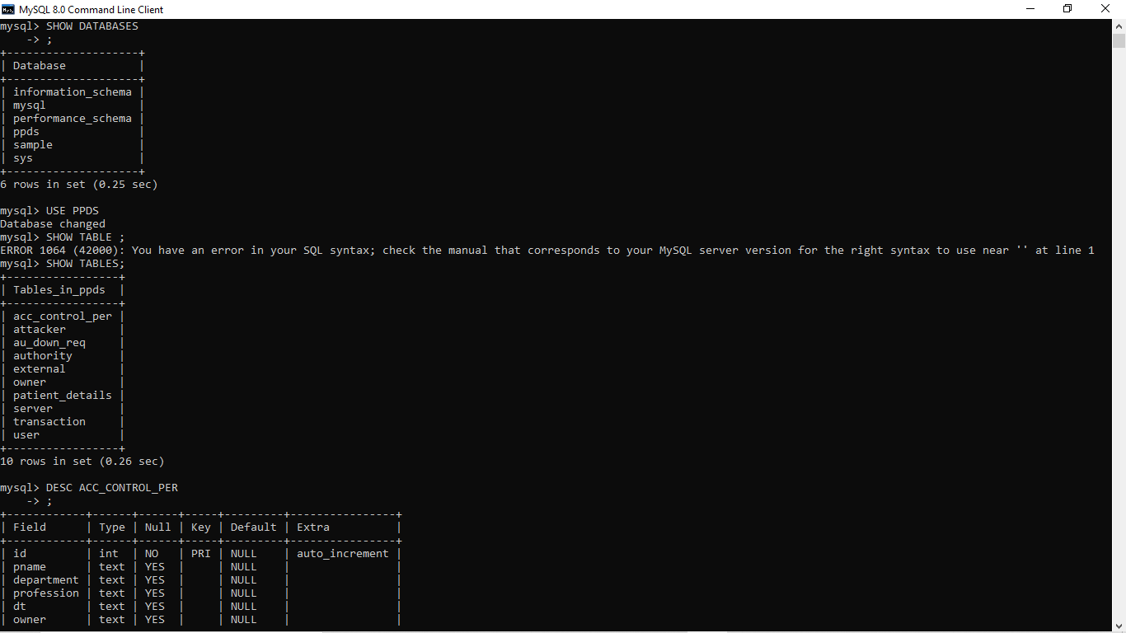

z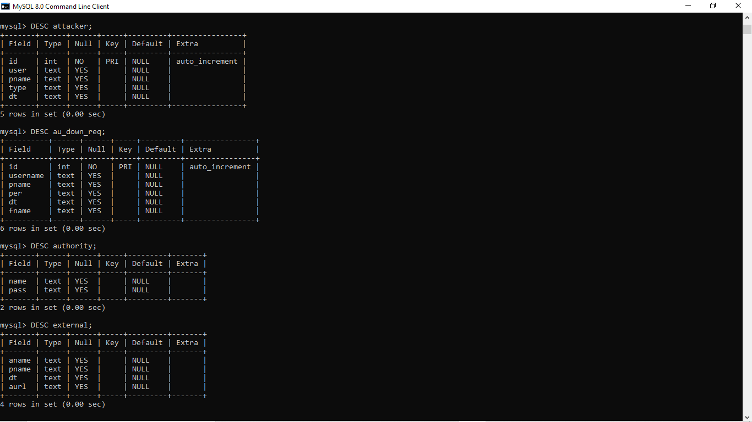

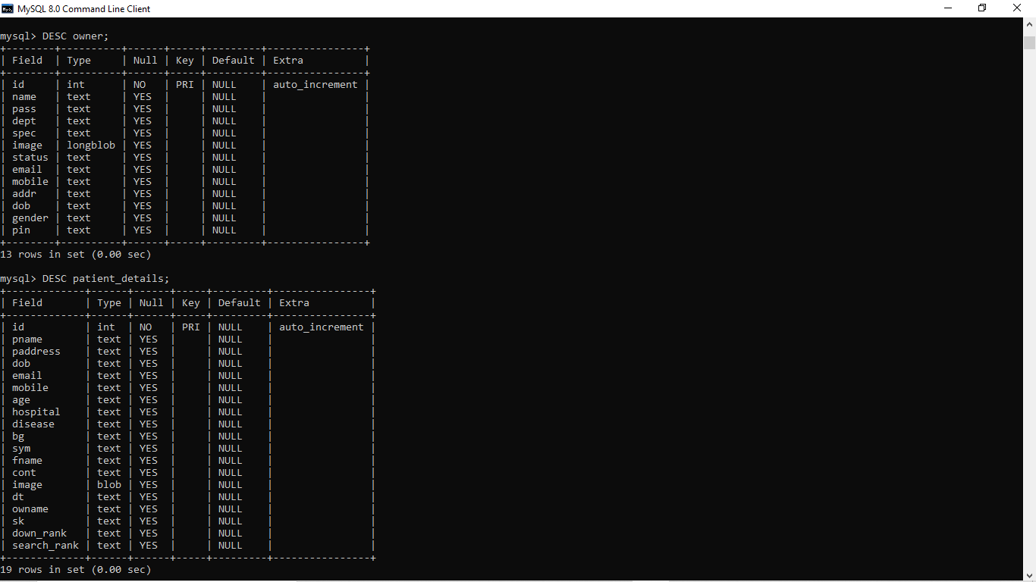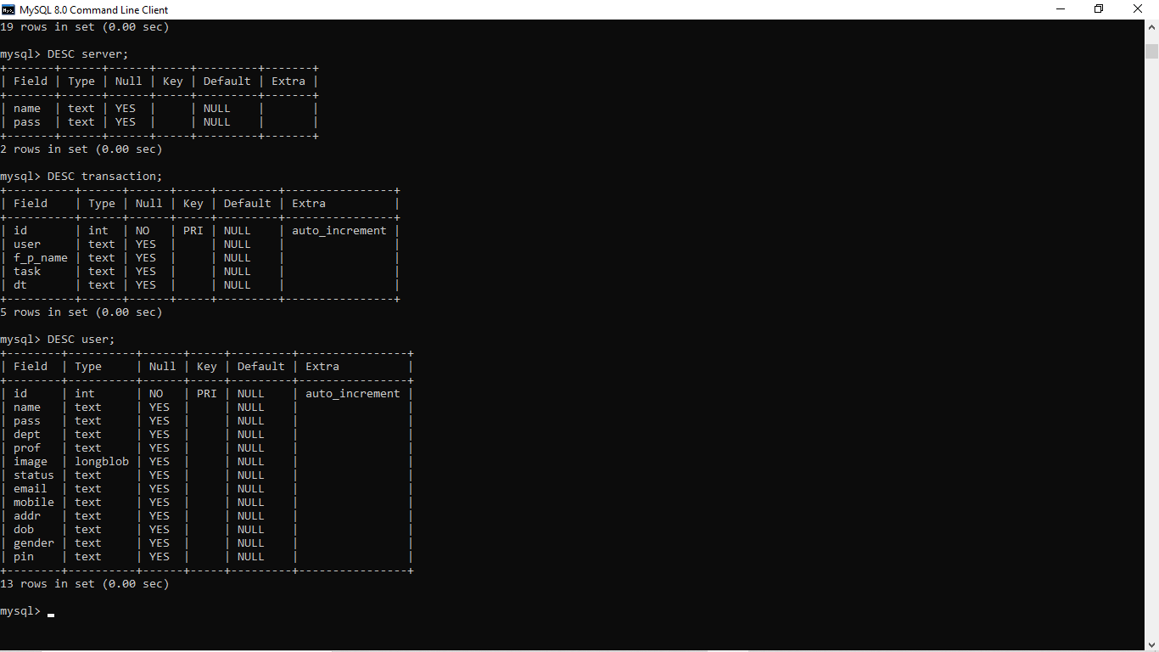

**7.2 JAVA SERVER PAGES OUTPUT:**

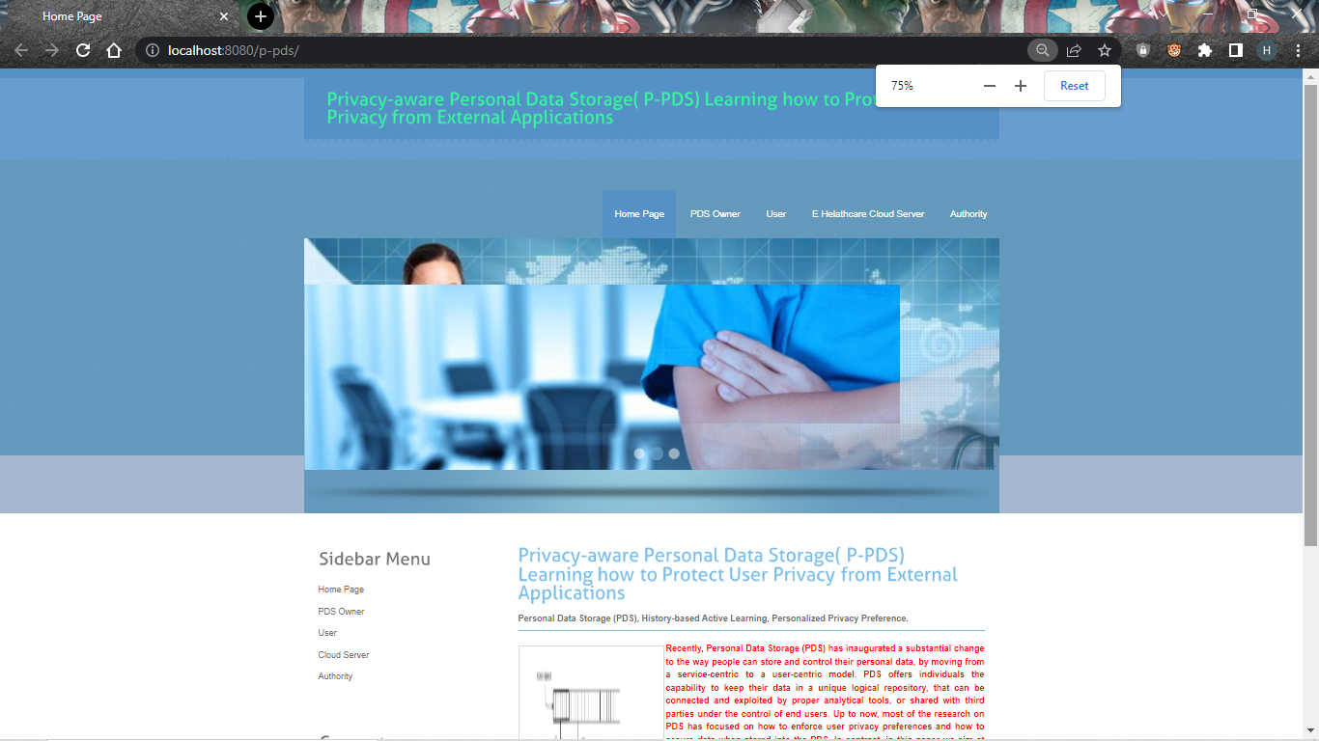

**1.HOME PAGE**

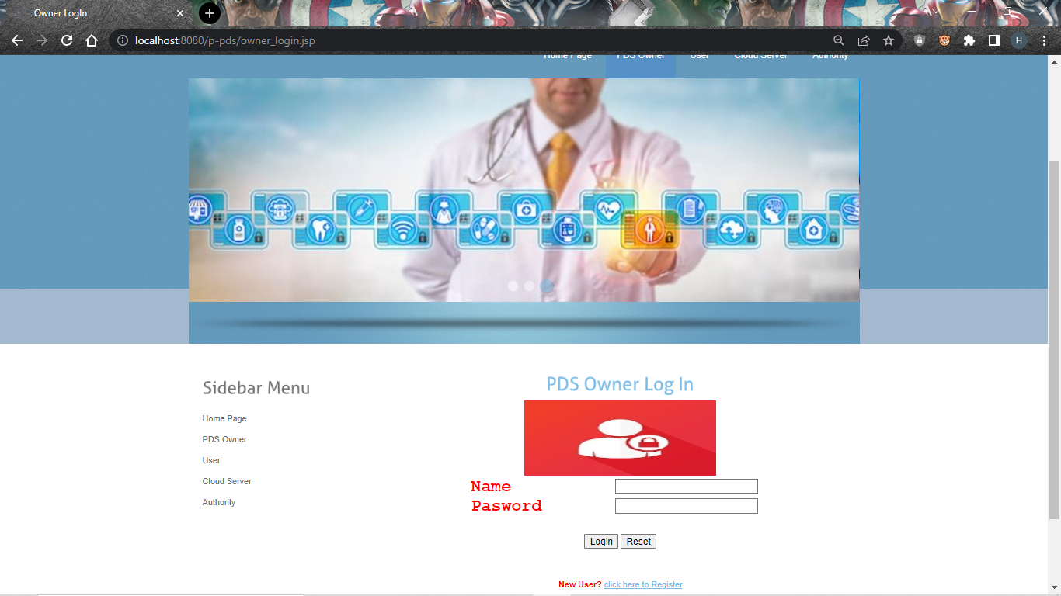

**2.PDS OWNER LOGIN PAGE**

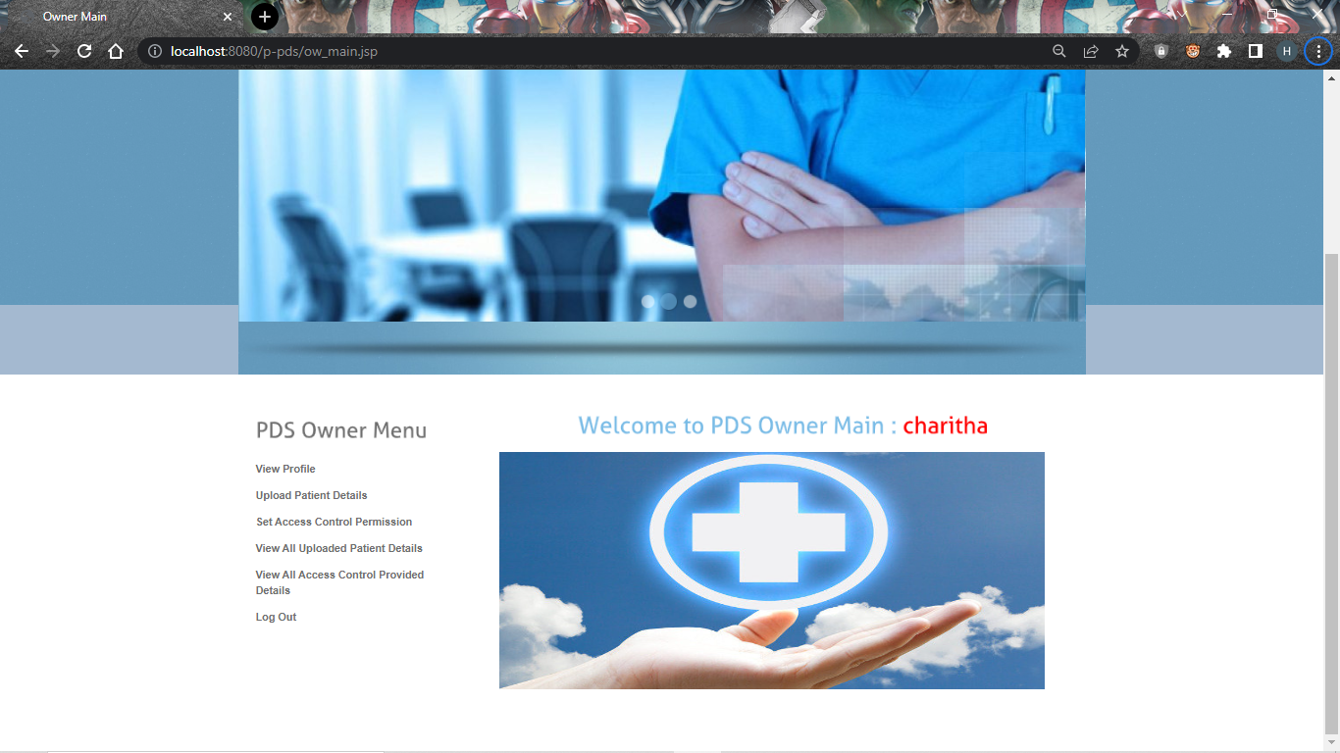

**3.PDS OWNER MAIN PAGE**

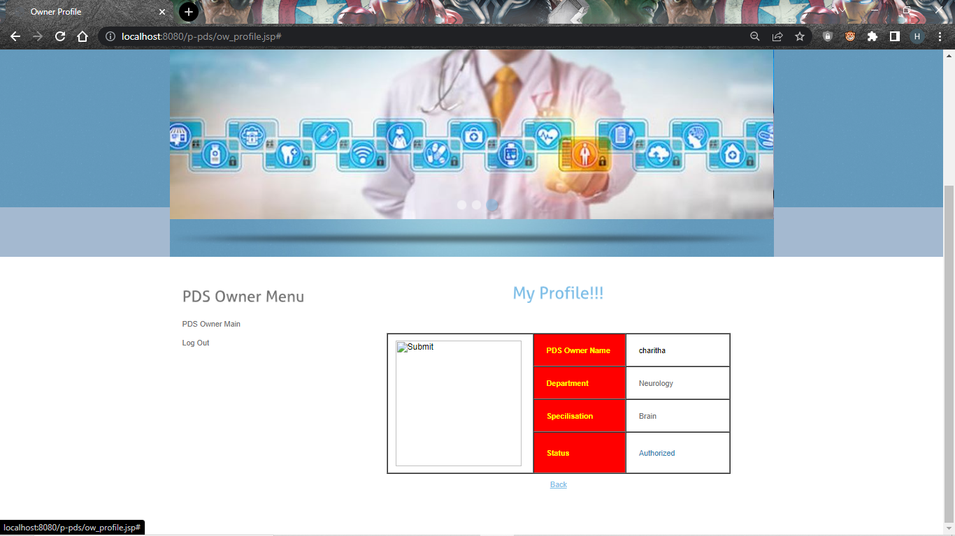

**4.PDS OWNER PROFILE**

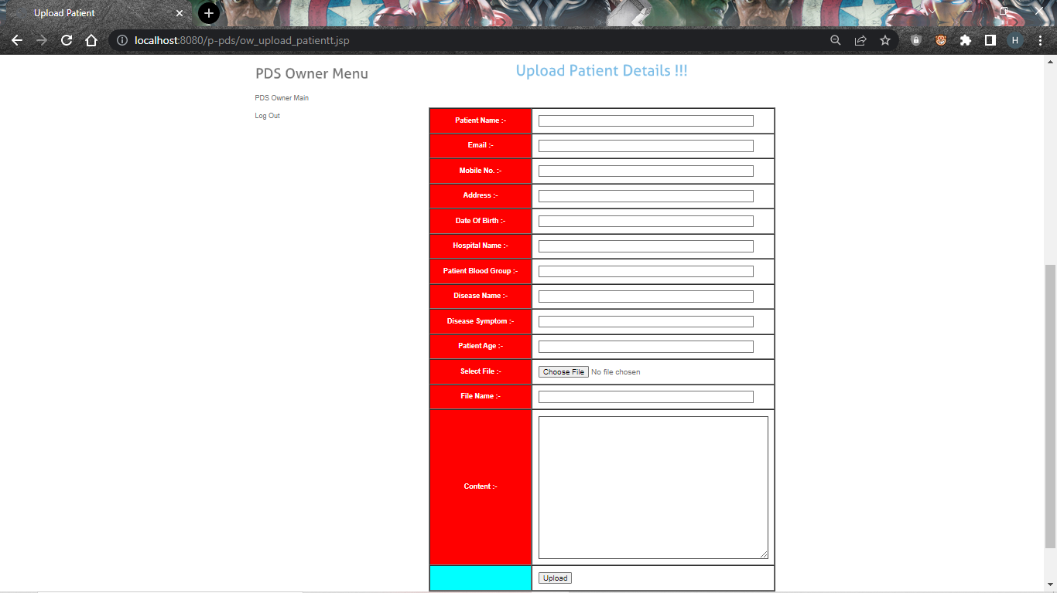

**5.UPLOAD PATIENT DETAILS**

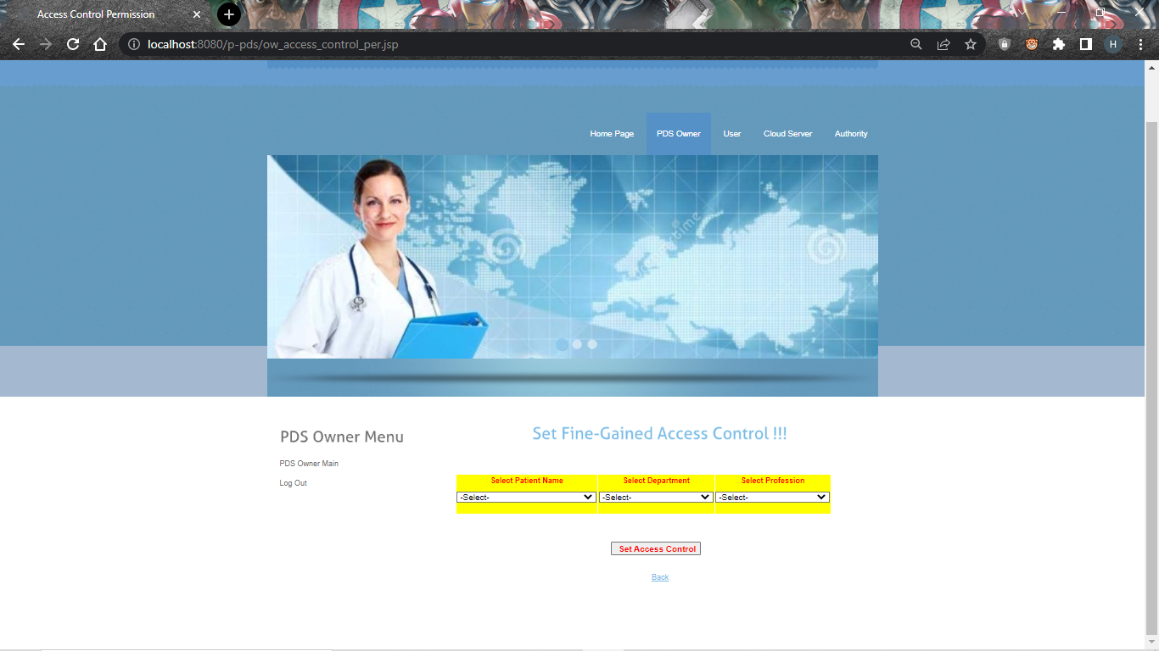

**6.SET FINE GAINED ACCESS CONTROL**

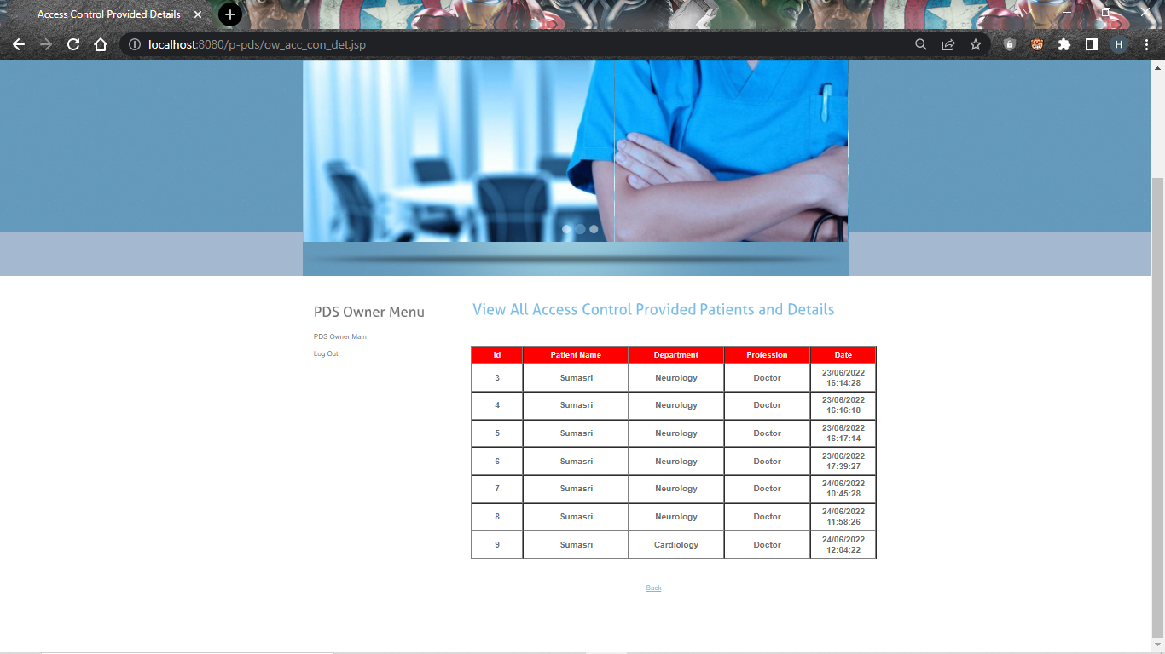

**7.VIEW ALL ACCESS CONTROL PROVIDED PA TIENT AND DETAILS**

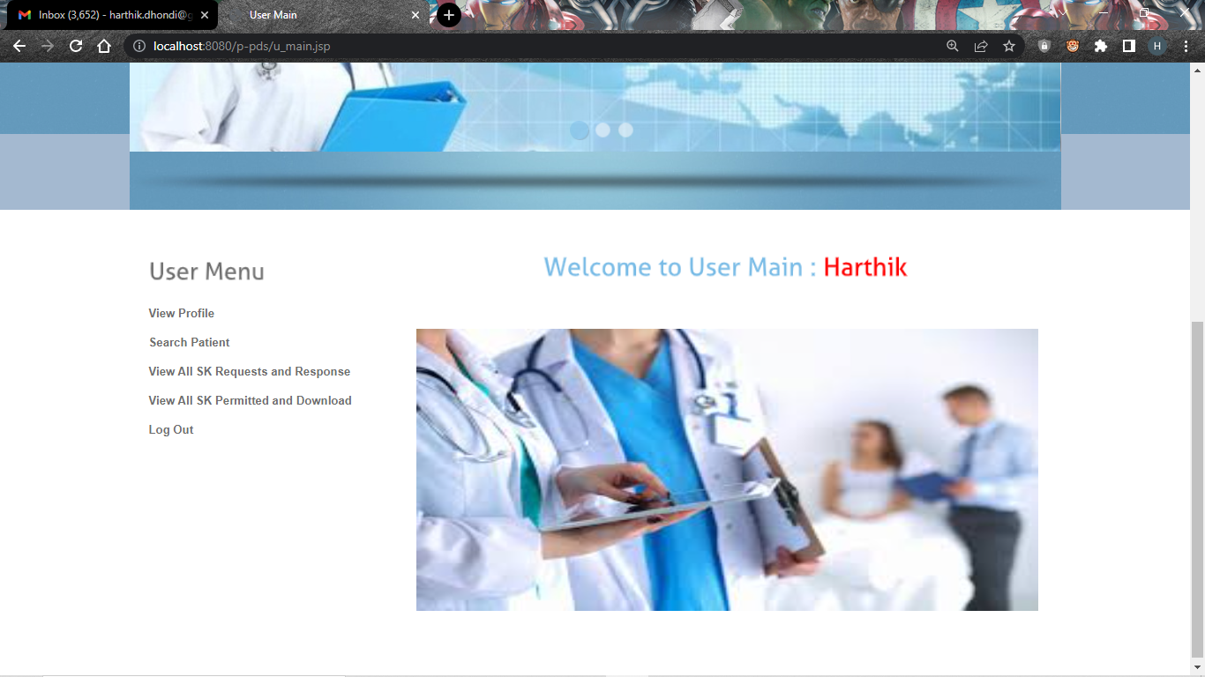

**8.USER MAIN**

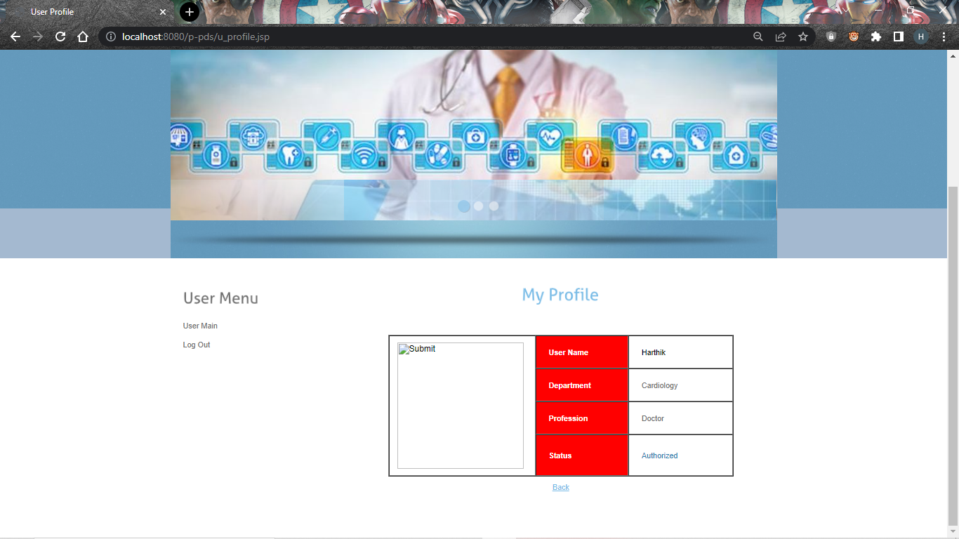

**9.USER PROFILE**

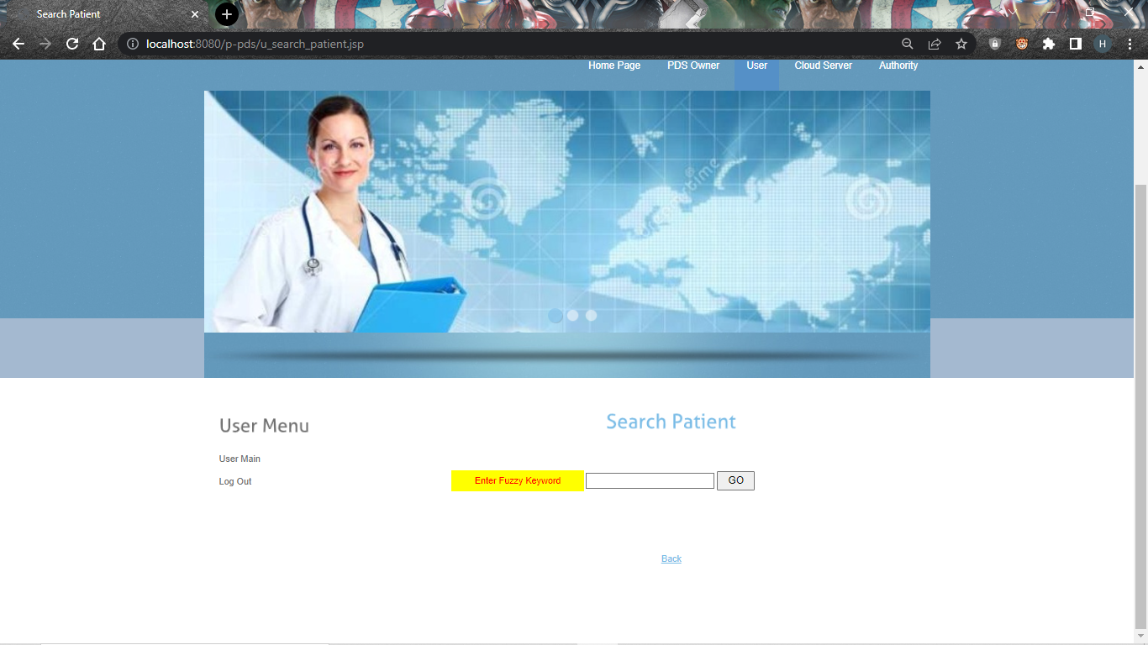

**10.SEARCH PATIENT**

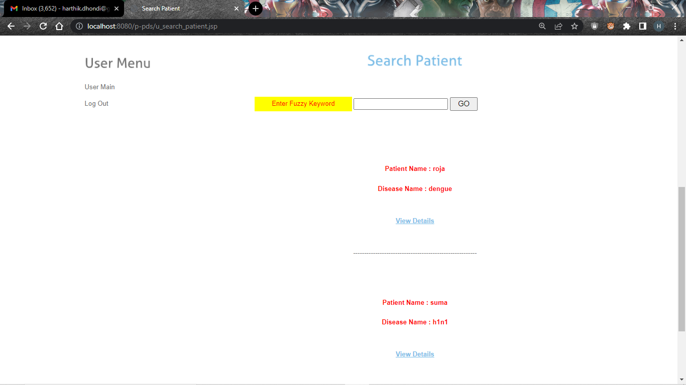

**11.AFTER SEARCHING PATIENT**

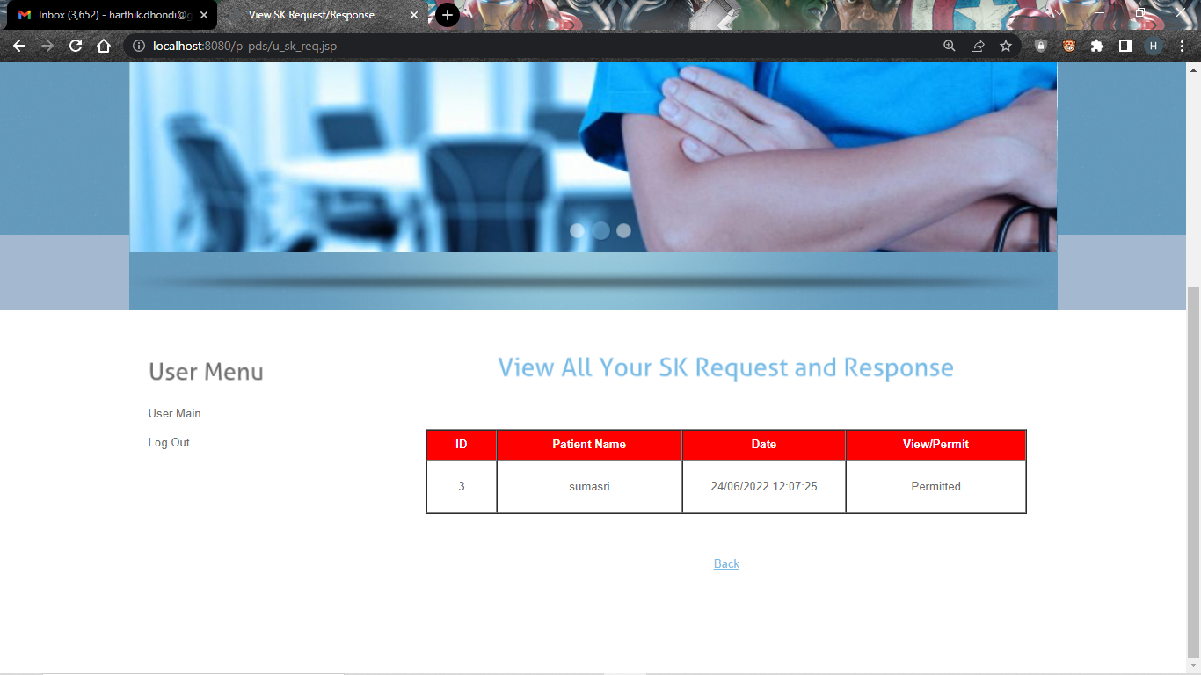

**12.VIEW ALL YOUR SECRET KEY REQUEST & RESPONSE**

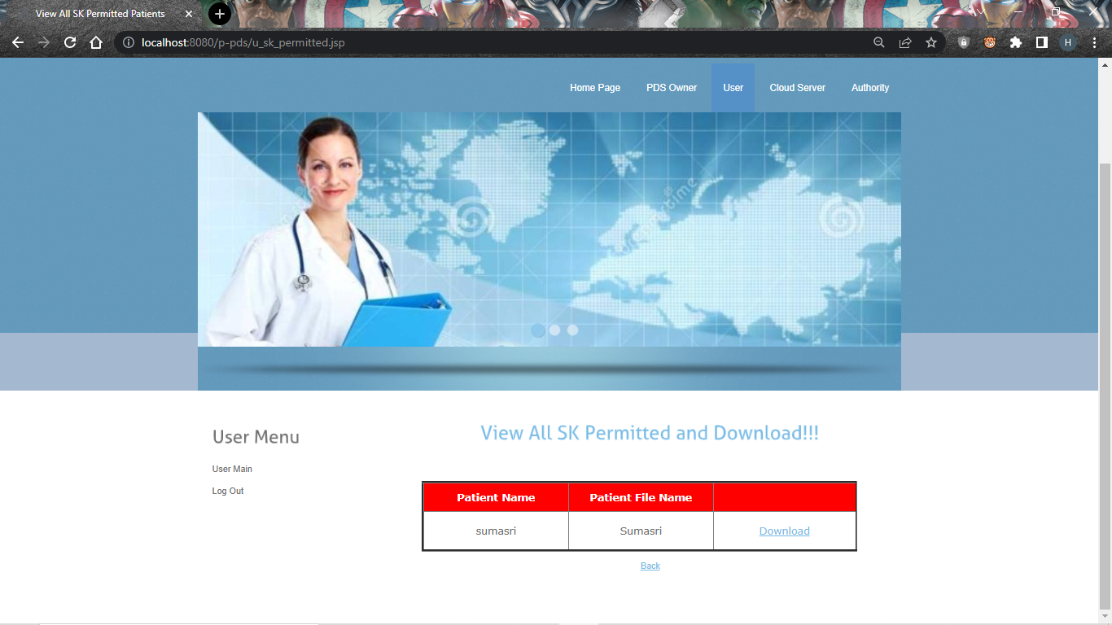

**13.VIEW ALL SECRET KEY PERMITTED AND DOWNLOAD**

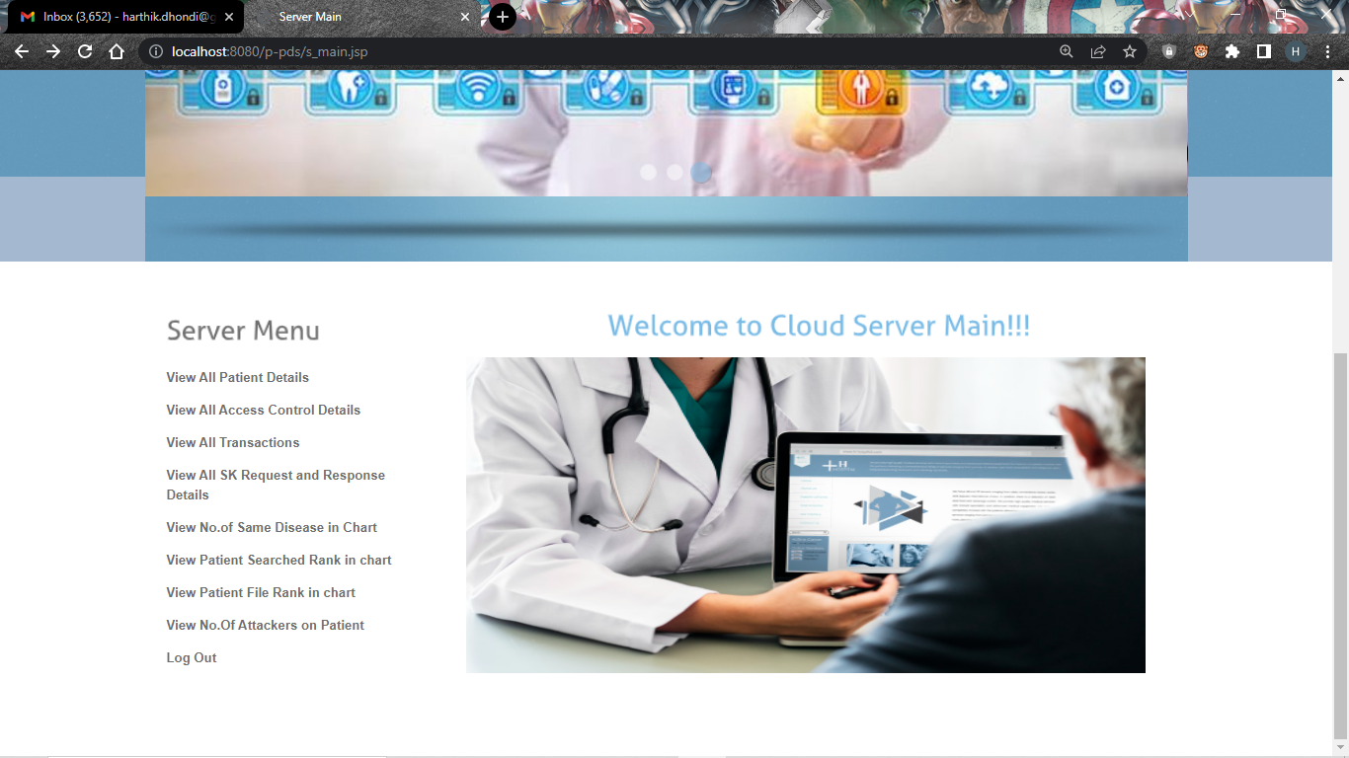

**14.CLOUD SERVER MAIN**

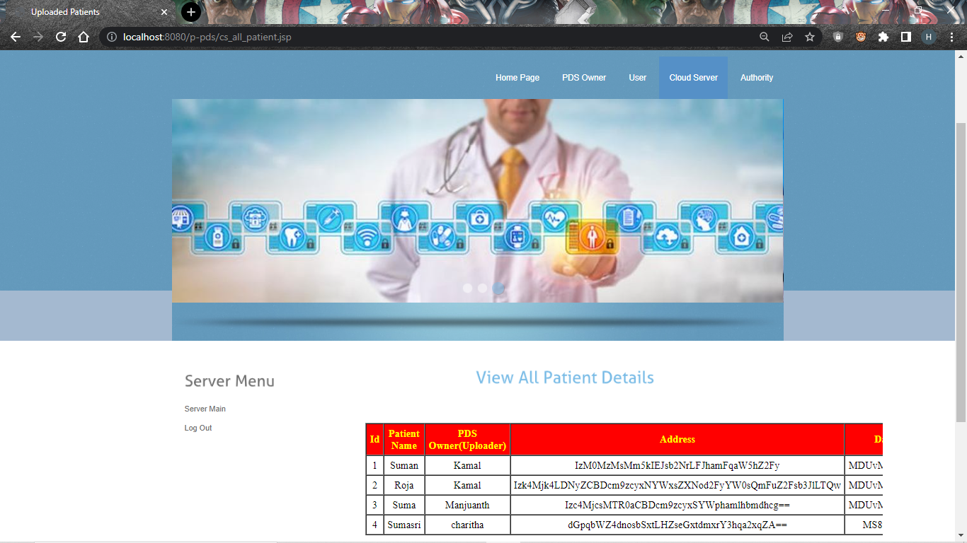

**15.VIEW ALL PATIENT DETAILS IN CLOUD SERVER**

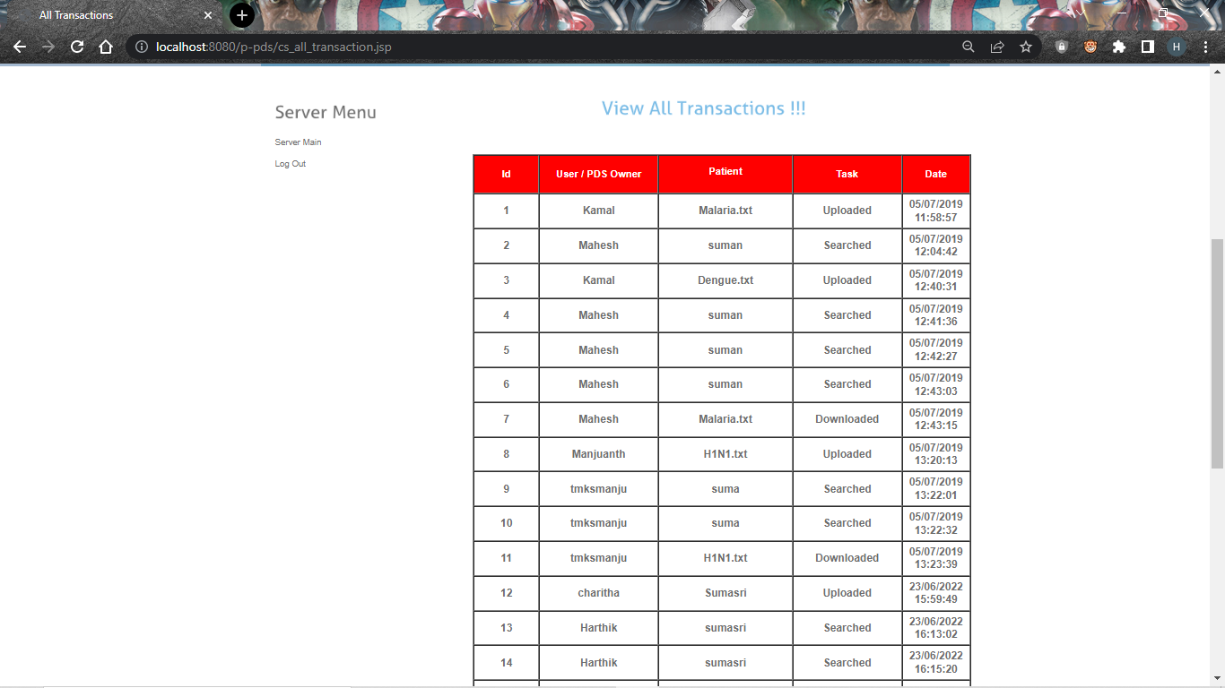

**16.VIEW ALL TRANSACTION IN CLOUD SERVER**

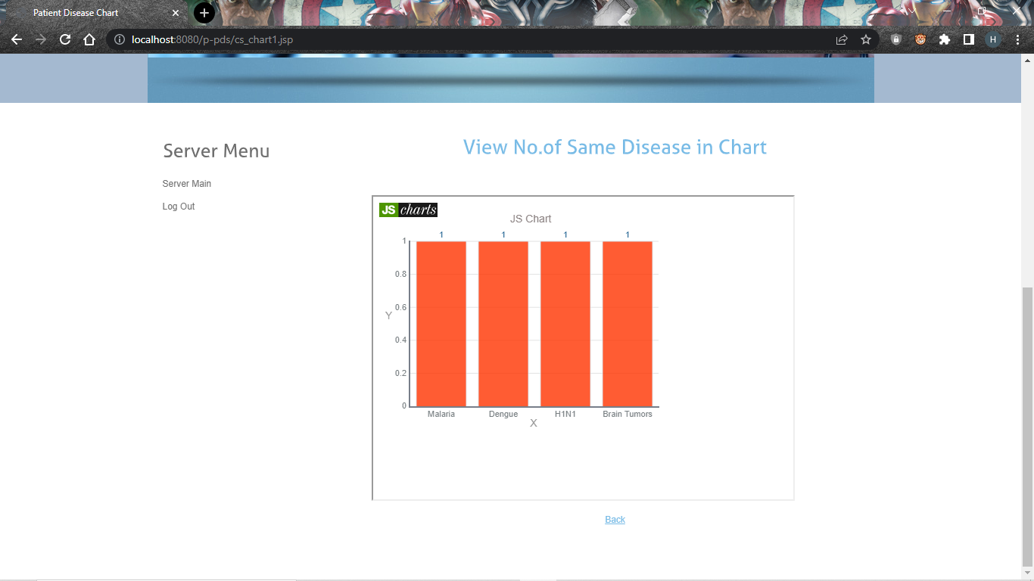

**17.VIEWING NO. OF SAME DISEASE IN CHART**

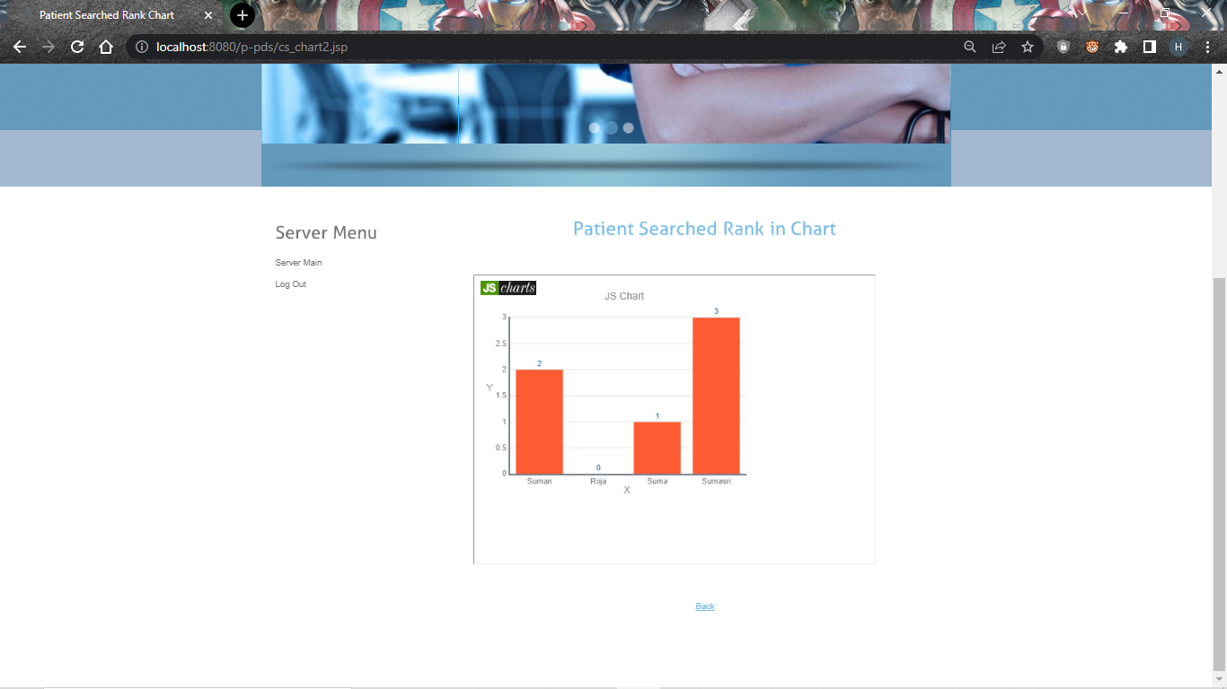

**18.PATIENT SEARCHED RANK IN CHART**

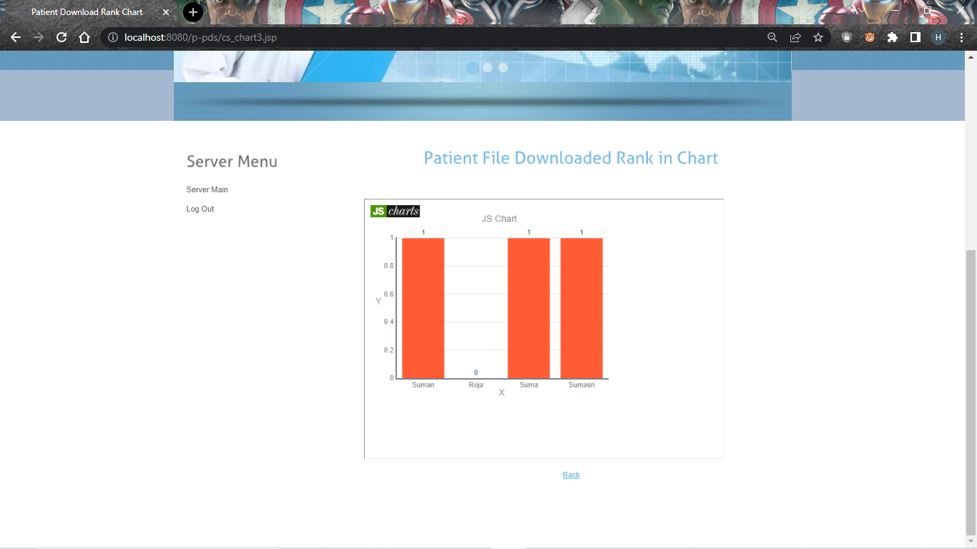

**19.PATIENT FILE DOWNLOAD RANK IN CHART**

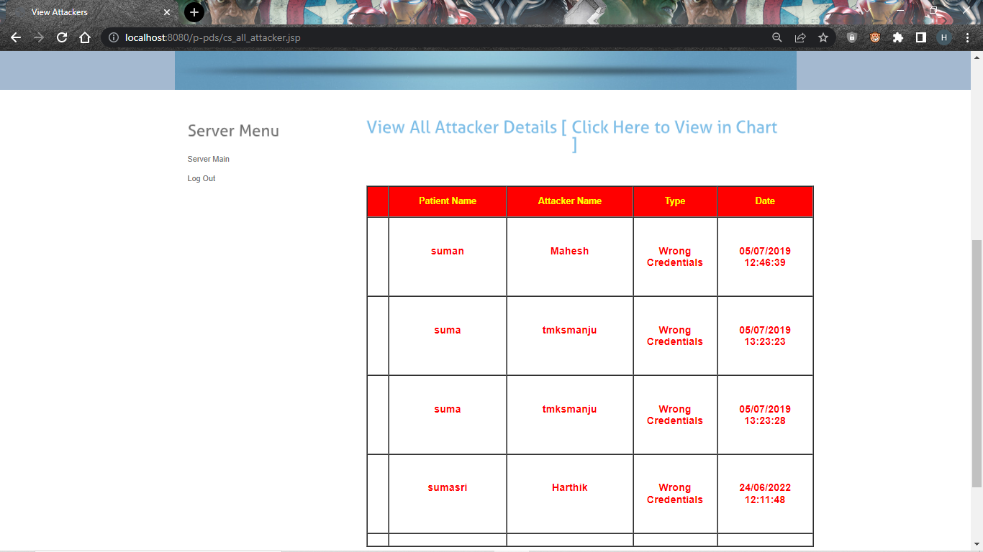

**20.VIEW ALL ATTACKER DETAILS**

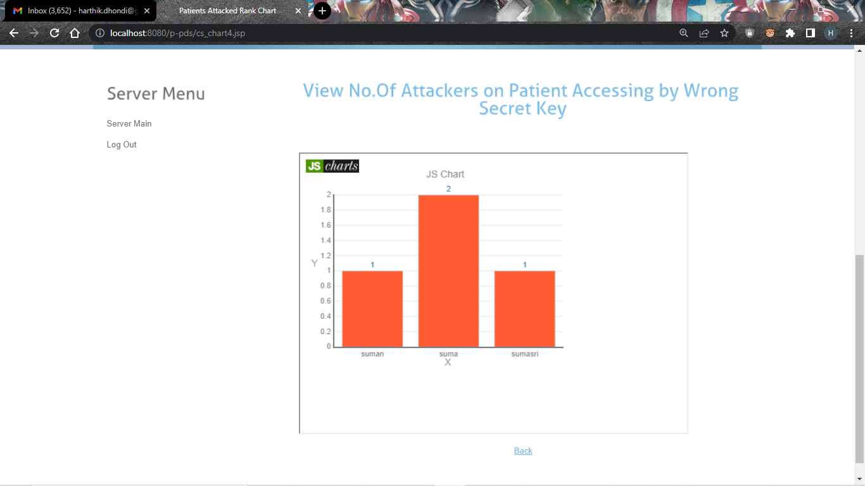

**21.VIEW NO. OF ATTACKER ON PATIENT ACCESSING BY WORNG SECRET KEY**

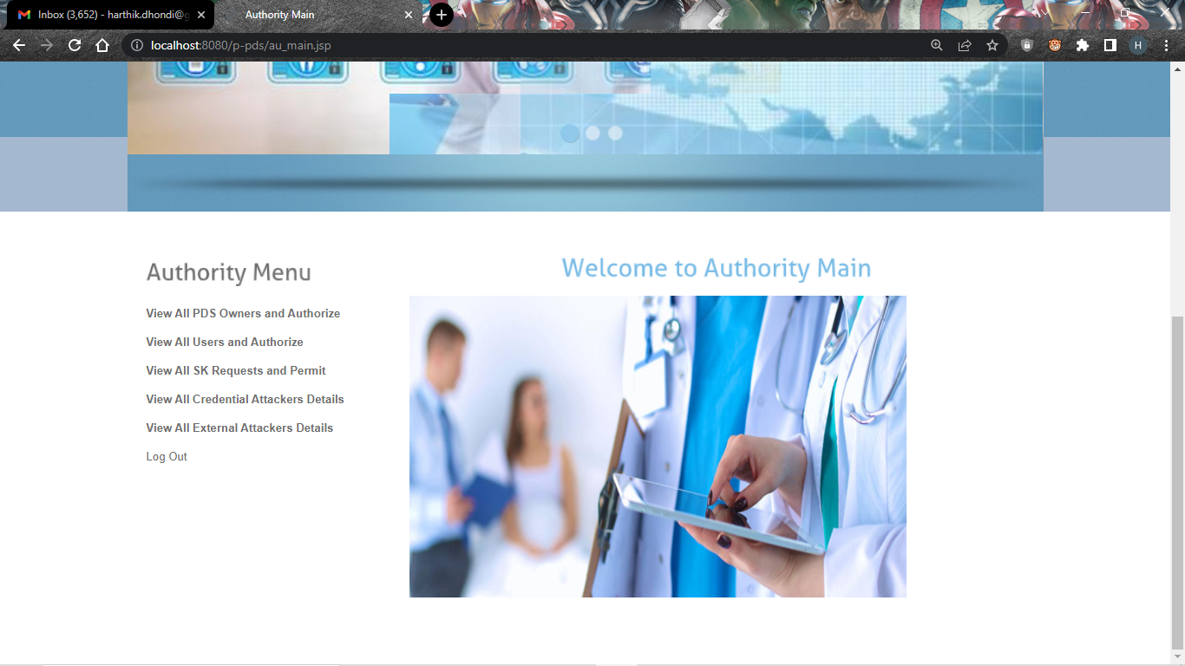

**22.AUTHORITY MAIN**

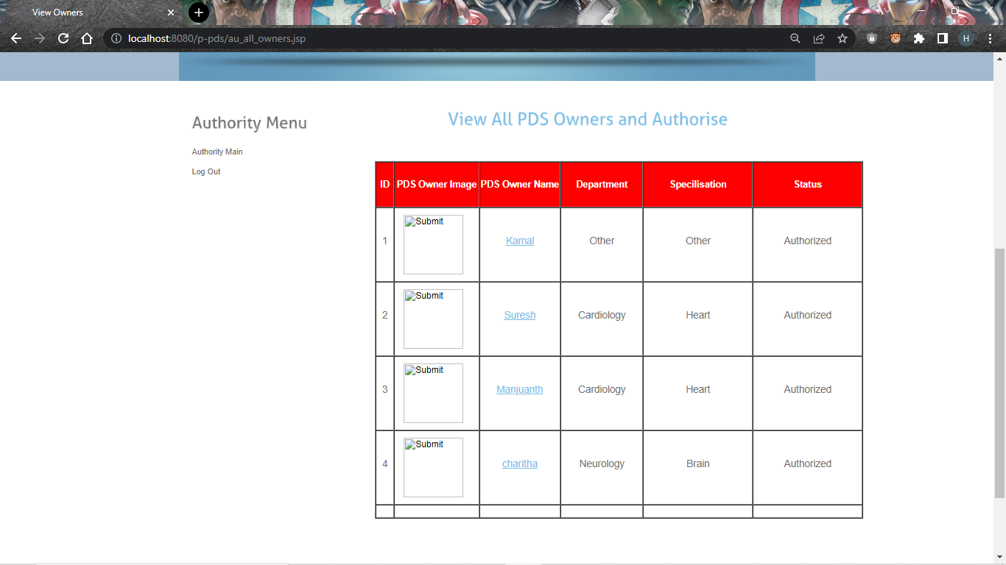

**23.VIEW ALL PDS OWNERS AND AUTHORISE**

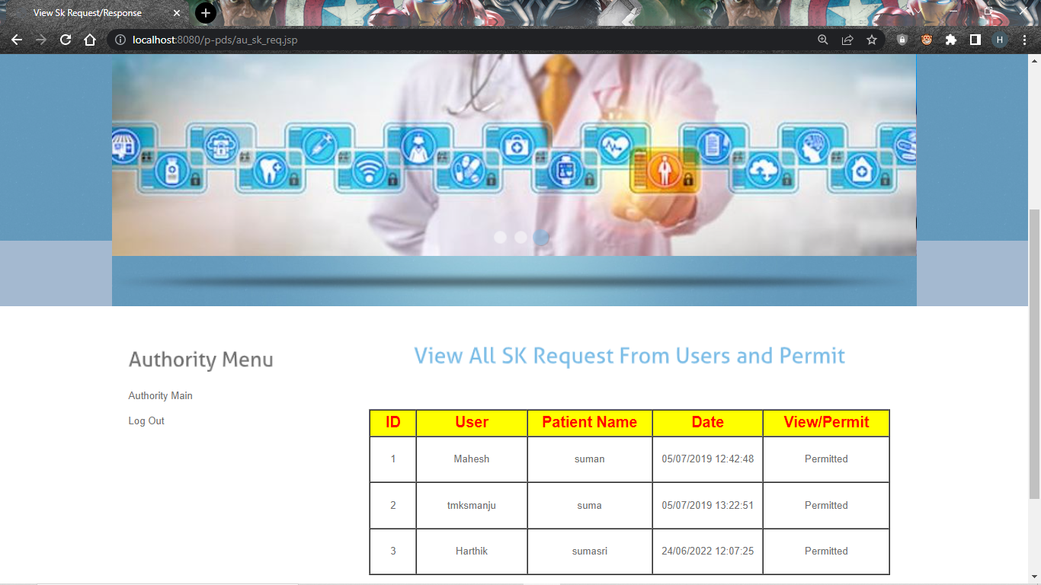

**24.VIEW ALL SECRET KEY REQUEST FROM USERS AND PERMIT**

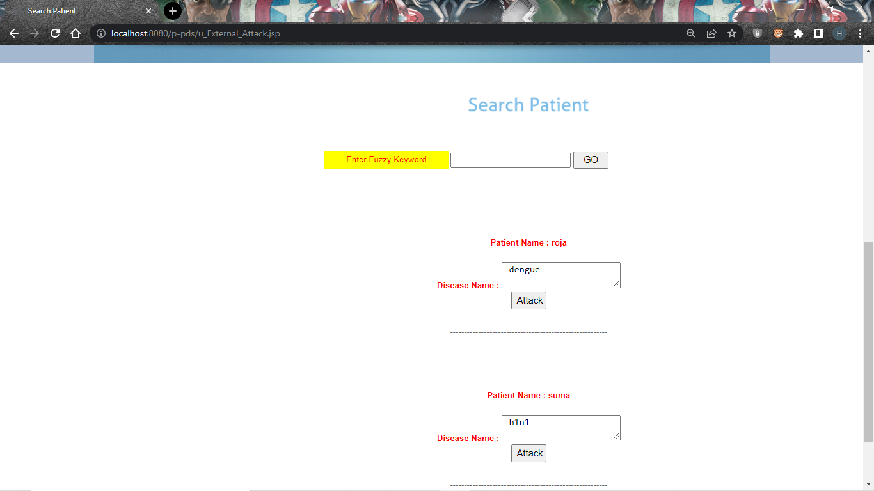

**25.EXTERNAL ATTACK FOR PATIENTS**

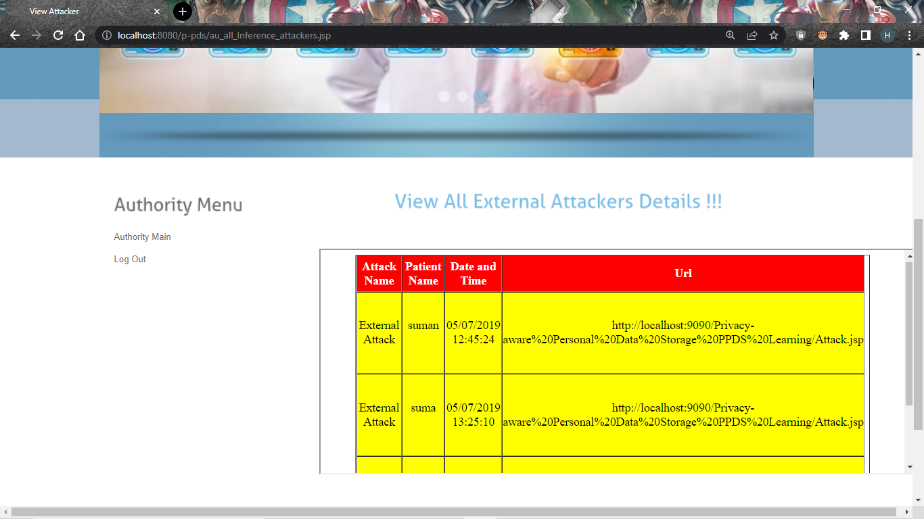

**26.VIEW ALL EXTERNAL ATTACKER DETAILS**

**8.CONCLUSION**

This project proposes a Privacy-aware Personal Data Storage, able to automatically take privacy aware decisions on third parties access requests in accordance with user preferences. The system relies on active learning complemented with strategies to strengthen user privacy protection. As discussed in the project, we run several experiments on a realistic dataset exploiting a group of 360 evaluators. The obtained results show the effectiveness of the proposed approach. We plan to extend this work along several directions. First, we are interested to investigate how P-PDS could scale in the IoT scenario, where access requests decision might depend also on contexts, not only on user preferences. Also, we would like to integrate P-PDS with cloud computing services (e.g., storage and computing) so as to design a more powerful P-PDS by, at the same time, protecting users privacy.

**BIBLIOGRAPHY**

[1] B. C. Singh, B. Carminati, and E. Ferrari, “Learning privacy habits of pds owners,” in Distributed Computing Systems (ICDCS), 2017 IEEE 37th International Conference on. IEEE, 2017, pp. 151–161.

[2] Y.-A. de Montjoye, E. Shmueli, S. S. Wang, and A. S. Pentland, “openpds: Protecting the privacy of metadata through safeanswers,” PloS one, vol. 9, no. 7, p. e98790, 2014.

[3] B. M. Sweatt et al., “A privacy-preserving personal sensor data ecosystem,” Ph.D. dissertation, Massachusetts Institute of Technology, 2014.

[4] B. C. Singh, B. Carminati, and E. Ferrari, “A risk-benefit driven architecture for personal data release,” in Information Reuse and Integration (IRI), 2016 IEEE 17th International Conference on. IEEE, 2016, pp. 40–49.

[5] M. Madejski, M. Johnson, and S. M. Bellovin, “A study of privacy settings errors in an online social network,” in Pervasive Computing and Communications Workshops (PERCOM Workshops), 2012 IEEE International Conference on. IEEE, 2012, pp. 340–345.

[6] L. N. Zlatolas, T. Welzer, M. Hericko, and M. H ˇ olbl, “Privacy an- ¨ tecedents for sns self-disclosure: The case of facebook,” Computers in Human Behavior, vol. 45, pp. 158–167, 2015.

[7] D. A. Albertini, B. Carminati, and E. Ferrari, “Privacy settings recommender for online social network,” in Collaboration and Internet Computing (CIC), 2016 IEEE 2nd International Conference on. IEEE, 2016, pp. 514–521. [8] A. Acquisti and R. Gross, “Imagined communities: Awareness, information sharing, and privacy on the facebook,” in International workshop on privacy enhancing technologies. Springer, 2006, pp. 36– 58.

[9] R. Gross and A. Acquisti, “Information revelation and privacy in online social networks,” in Proceedings of the 2005 ACM workshop on Privacy in the electronic society. ACM, 2005, pp. 71–80.

[10] Y. Liu, K. P. Gummadi, B. Krishnamurthy, and A. Mislove, “Analyzing facebook privacy settings: user expectations vs. reality,” in Proceedings of the 2011 ACM SIGCOMM conference on Internet measurement conference. ACM, 2011, pp. 61–70.

[11] P. Nyoni and M. Velempini, “Privacy and user awareness on facebook,” South African Journal of Science, vol. 114, no. 5-6, pp. 27–31, 2018.

[12] R. Polikar, “Ensemble learning,” in Ensemble machine learning. Springer, 2012, pp. 1–34.

[13] T. G. Dietterich et al., “Ensemble methods in machine learning,” Multiple classifier systems, vol. 1857, pp. 1–15, 2000.

[14] B. Settles, “Active learning literature survey,” University of Wisconsin, Madison, vol. 52, no. 55-66, p. 11, 2010.

[15] X. Zhu, “Semi-supervised learning literature survey,” Computer Science, University of Wisconsin-Madison, vol. 2, no. 3, p. 4, 2006.

[16] S. B. Kotsiantis, I. Zaharakis, and P. Pintelas, “Supervised machine learning: A review of classification techniques,” Emerging artificial intelligence applications in computer engineering, vol. 160, pp. 3–24, 2007.

[17] S. Borman, “The expectation maximization algorithm-a short tutorial,” Submitted for publication, pp. 1–9, 2004.

[18] D. Cohn, L. Atlas, and R. Ladner, “Improving generalization with active learning,” Machine learning, vol. 15, no. 2, pp. 201–221, 1994.

[19] M.-R. Bouguelia, Y. Bela¨ıd, and A. Bela¨ıd, “A stream-based semisupervised active learning approach for document classification,” in Document Analysis and Recognition (ICDAR), 2013 12th International Conference on. IEEE, 2013, pp. 611–615.

[20] A. K. McCallumzy and K. Nigamy, “Employing em and poolbased active learning for text classification,” in Proc. International Conference on Machine Learning (ICML). Citeseer, 1998, pp. 359– 367.

[21] I. Muslea, S. Minton, and C. A. Knoblock, “Active+ semisupervised learning= robust multi-view learning,” in ICML, vol. 2, 2002, pp. 435–442.

[22] D. Martin, M. Paolucci, S. McIlraith, M. Burstein, D. McDermott, D. McGuinness, B. Parsia, T. Payne, M. Sabou, M. Solanki et al., “Bringing semantics to web services: The owl-s approach,” in International Workshop on Semantic Web Services and Web Process Composition. Springer, 2004, pp. 26–42.

[23] D. Martin, M. Burstein, J. Hobbs, O. Lassila, D. McDermott, S. McIlraith, S. Narayanan, M. Paolucci, B. Parsia, T. Payne et al., “Owl-s: Semantic markup for web services,” W3C member submission, vol. 22, pp. 2007–04, 2004. [24] P. Jaccard, “Etude comparative de la distribution florale dans une ´ portion des alpes et des jura,” Bulletin del la Soci´et´e Vaudoise des Sciences Naturelles, vol. 37, pp. 547–579, 1901.

[25] S. M. Mohammad and G. Hirst, “Distributional measures of semantic distance: A survey,” arXiv preprint arXiv:1203.1858, 2012.

[26] I. Zliobaite, A. Bifet, B. Pfahringer, and G. Holmes, “Active learning with drifting streaming data,” IEEE transactions on neural networks and learning systems, vol. 25, no. 1, pp. 27–39, 2014.

[27] T. Chajed, J. Gjengset, M. F. Kaashoek, J. Mickens, R. Morris, and N. Zeldovich, “Oort: User-centric cloud storage with global queries,” 2016.

[28] F. Wang, J. Mickens, N. Zeldovich, and V. Vaikuntanathan, “Sieve: Cryptographically enforced access control for user data in untrusted clouds.” in NSDI, 2016, pp. 611–626.

[29] T. Chajed, J. Gjengset, J. Van Den Hooff, M. F. Kaashoek, J. Mickens, R. Morris, and N. Zeldovich, “Amber: Decoupling user data from web applications.” in HotOS, vol. 15, 2015, pp. 1–6.

[30] R. Mortier, J. Zhao, J. Crowcroft, L. Wang, Q. Li, H. Haddadi, Y. Amar, A. Crabtree, J. Colley, T. Lodge et al., “Personal data management with the databox: What’s inside the box?” in Proceedings of the 2016 ACM Workshop on Cloud-Assisted Networking. ACM, 2016, pp. 49–54.

[31] Z. Yan, G. Gan, and K. Riad, “Bc-pds: Protecting privacy and selfsovereignty through blockchains for openpds,” in Service-Oriented System Engineering (SOSE), 2017 IEEE Symposium on. IEEE, 2017, pp. 138–144.

[32] L. Fang and K. LeFevre, “Privacy wizards for social networking sites,” in Proceedings of the 19th international conference on World wide web. ACM, 2010, pp. 351–360.

[33] G. Danezis, “Inferring privacy policies for social networking services,” in Proceedings of the 2nd ACM workshop on Security and artificial intelligence. ACM, 2009, pp. 5–10.

[34] N. Sadeh, J. Hong, L. Cranor, I. Fette, P. Kelley, M. Prabaker, and J. Rao, “Understanding and capturing peoples privacy policies in a mobile social networking application,” Personal and Ubiquitous Computing, vol. 13, no. 6, pp. 401–412, 2009.

[35] I. Bilogrevic, K. Huguenin, B. Agir, M. Jadliwala, M. Gazaki, and J.-P. Hubaux, “A machine-learning based approach to privacyaware information-sharing in mobile social networks,” Pervasive and Mobile Computing, vol. 25, pp. 125–142, 2016.

[36] T. Nakamura, S. Kiyomoto, W. B. Tesfay, and J. Serna, “Easing the burden of setting privacy preferences: A machine learning approach,” in International Conference on Information Systems Security and Privacy. Springer, 2016, pp. 44–63.